**Title of work: Money Test**

**Name:** **Shani Patel**

**Section Code: NEE**

**Date submitted: 18/06/2021**

**Professor's name: Tevin Apenteng**

**Question 1**

Complete a **Class diagram** to support what your team has learned so far about Samuel's Fabric distribution business

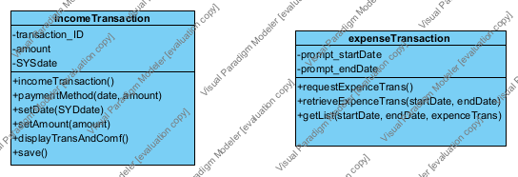

**Question 2**

Complete **Object Level Sequence** diagrams to support the above scenarios.

* **Record Income Transaction**

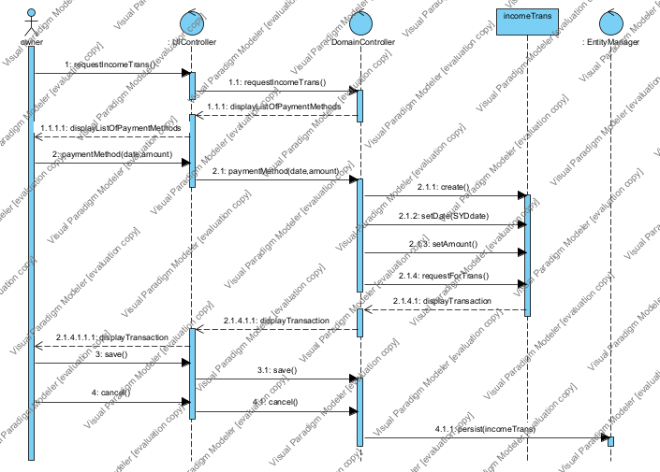

* **Query Expense transactions**

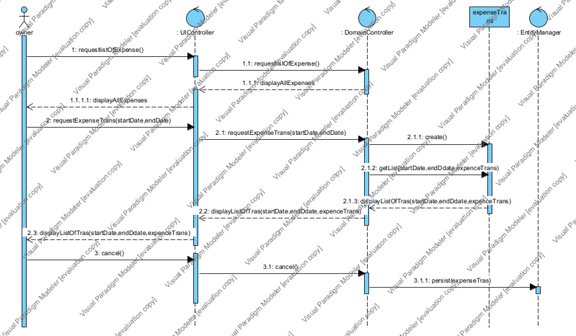

**Question 3**

Samuel’s been approached to provide fabric for a client’s that is on Georgina Island Reserve. This client has tax exempt status as part of belonging to Indigenous people. What are tax implications? Does this affect your model? Please describe in English.

**As an indigenous people, they have to pay the taxes on all. So, I think that its definitely affect our model. In our model we have the Income Transaction and Expense transaction, which have the amount value and its change the base on the client’s paying taxes, so I believe That it affects our model.**

**Question 4**

Should Samuel use his debit card or his credit card for purchases? Why? Please describe in English.

**Here, Samuel cannot use his debit card or credit card because. Samuel’s team members record his financial transaction and according to his payment method, they are he categories his company’s income and expense transaction.**

**Question 5**

One of Samuel’s customer pays him in USD. What should Samuel do? How could you change your model to support this? Please describe in English.

**If any customer pays in USD dollars, so Samuel can accept the that Payment. To support my model, I accept the amount in dollars (In my income transaction and expense transaction I entered the transaction amount in dollars). otherwise other part of the model has as it is.**

**Question 6**

How long are businesses required to keep records of financial transactions for taxation purposes? Why is it important to Samuel’s company? Please describe in English.

**Well, here I believe that financial transactions in ay business it saves for long times. Because the need financial transactions in business is anytime. However, here specifically taxation purposes, I think that the record of the financial transaction save to minimum one year because at the of the year every companies (Samuel’s company also) return their tax files.**

**Question 7 (worth 3 marks)**

Samuel’s Fabricdistribution company is documenting the business’s requirements for a new system. We’ve looked at Agile and Waterfall (Predictive) Project Management methodologies. You are a team of 3 analysts and a Project Manager. If you were the Project Manager, what Project Management Methodology would you use for this project? And why? Please describe in English.

**My team and I decided that we pick the agile Project Management methodologies. Because of its advancement we chosen Agile System. it’s brings quick changes in business and another most important benefits are that we can make number of times in the project There are other many benefits. Such as it planning we bring many future advancements.**