**Title of work:** Sales and Scheduling test

**Name :** Shani Patel

**Student number :**152243192

**Section Code:** NEE

**Date submitted:** 30/07/2021

**Professor's name:** Tevin Apenteng

**Question 1** (worth 15 marks)

Complete a **class diagram** to support what your team has learned about invoicing for *Halton Hills Tutors.* Class diagrams must include any associations, association names, multiplicity, and reference attributes (including any sets).

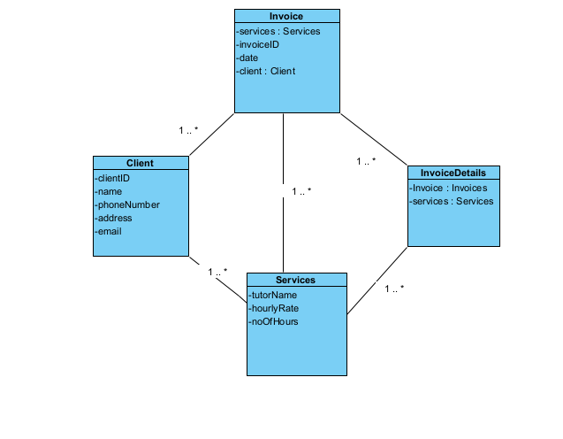

**Question 2** (worth 20 marks)

Complete an **object level sequence** diagram for the above scenario.

**retriveClients**

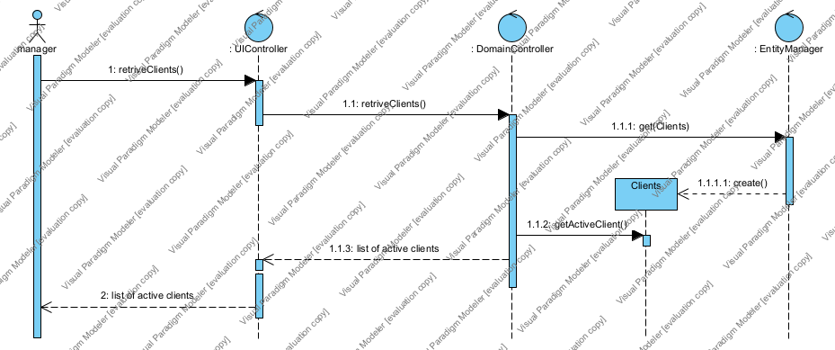

**retriveServices**

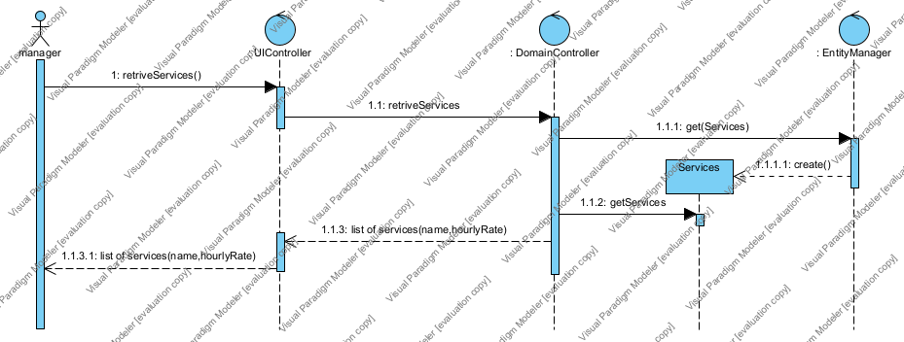

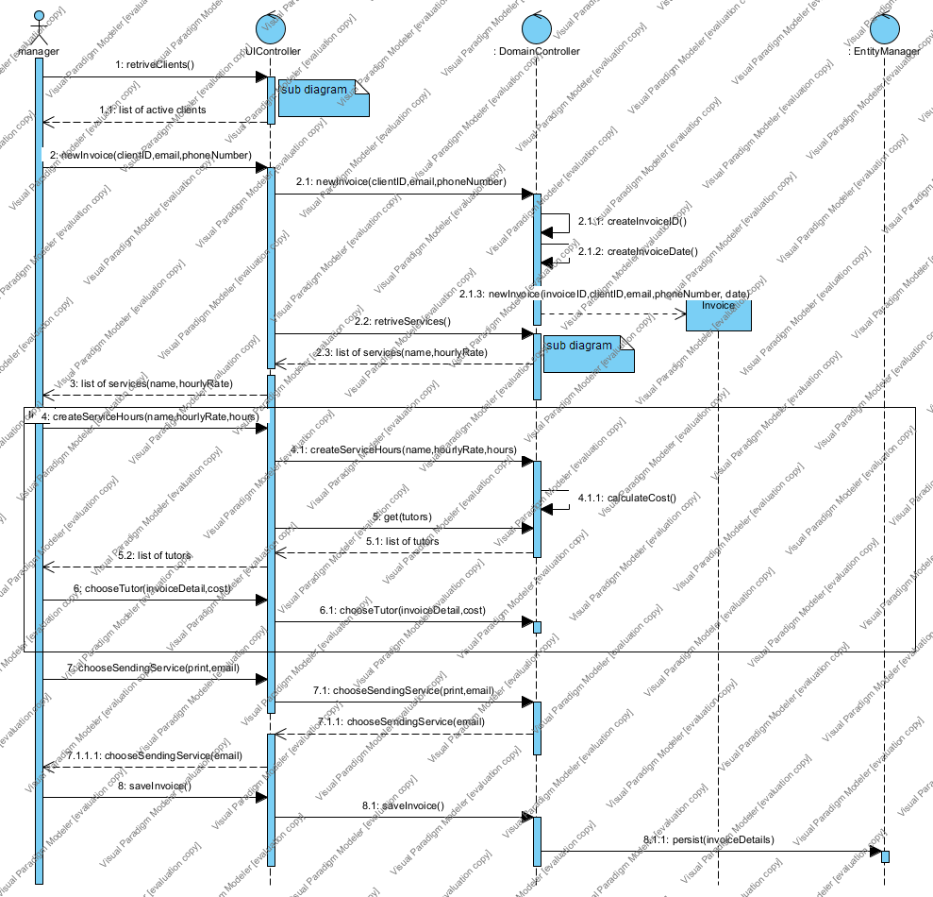

*Answer all the following questions in clear English.*

**Question 3** (worth 2 marks)

The above scenario assumes that the hourly cost for a service is the same for each tutor. What would happen if the hourly cost changed for each tutor providing the tutoring service? How would you change your model?

In this above diagram if I want to save the different hourly cost of each tutor then I also have to take hourly cost with the hours data from the tutor. This is the only way to save different tutor hourly cost.

**Question 4** (worth 2 marks)

*Halton Hills Tutors* is thinking of offering a gift certificate for clients to purchase to give to their friends. How would you change your model to support this?

Here in my model I entered one more field related to refer friends. Which take the data from the client that when client refer to their friends than it save this in that fields so it makes easy work for the Halton Hills to give a certificate to their clients.

**Question 5** (worth 10 marks)

Create a **class diagram** to support the activity and the scenario described above. You may use implied data from the description and Schedule Module lab, as necessary.

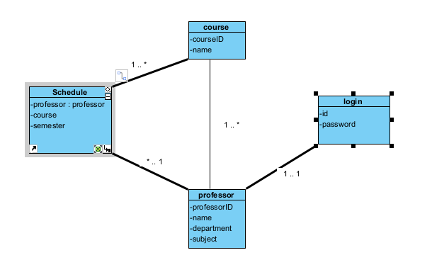

**Question 6** (worth 5 marks)

Complete an **object level sequence** diagram for the above scenario.

