**Lab 02**

**Part 1: Class Diagram**

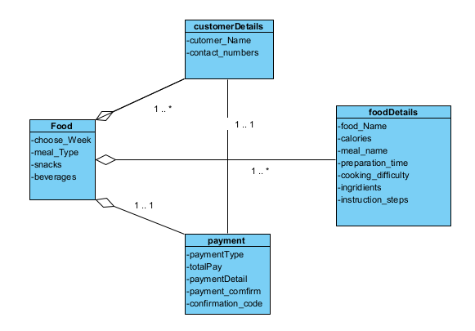

**Part 2: Sequence Diagrams**

**Scenario 1: Order food for a specific week**

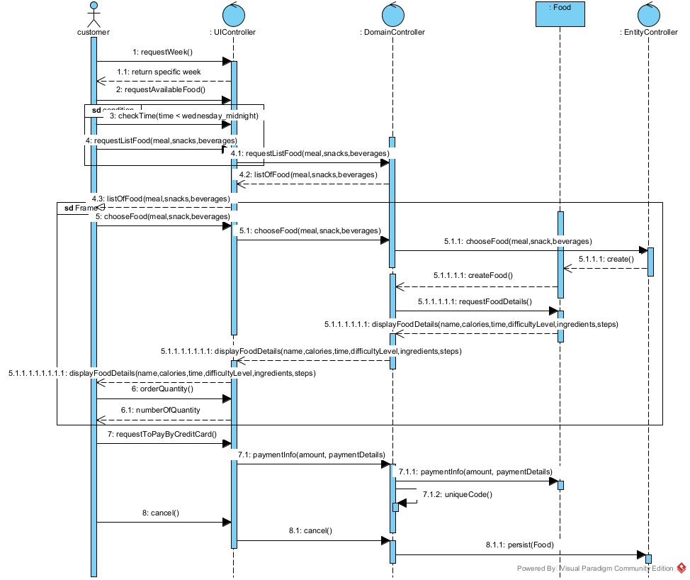

**Scenario 2: Add a new ingredients** 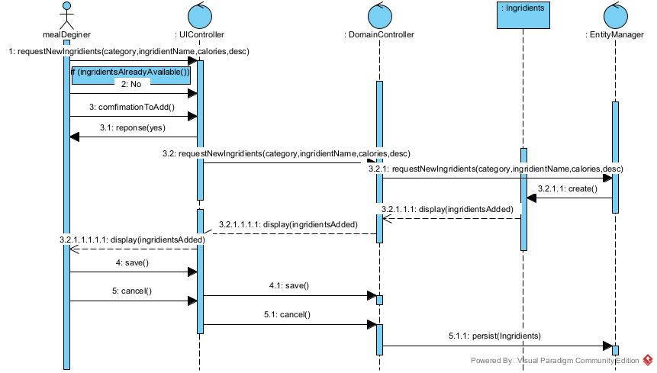

**Scenario 3: Create a meal recipe**

