Exploratory Data Analysis Report
Project: Healthcare Cost Estimator

Dataset Overview
Original dataset records: 1338. Cleaned dataset records: 1337. Columns: age, sex, bmi, children, smoker, region, charges.

Dataset Statistics
index | age | bmi | children | charges
count | 1337.0000 | 1337.0000 | 1337.0000 | 1337.0000
mean | 39.2221 | 30.6635 | 1.0957 | 13279.1215
std | 14.0443 | 6.1005 | 1.2056 | 12110.3597
min | 18.0000 | 15.9600 | 0.0000 | 1121.8739
25% | 27.0000 | 26.2900 | 0.0000 | 4746.3440
50% | 39.0000 | 30.4000 | 1.0000 | 9386.1613
75% | 51.0000 | 34.7000 | 2.0000 | 16657.7174
max | 64.0000 | 53.1300 | 5.0000 | 63770.4280

Age Analysis
Age ranges from 18 to 64 years, with a mean of 39.22.
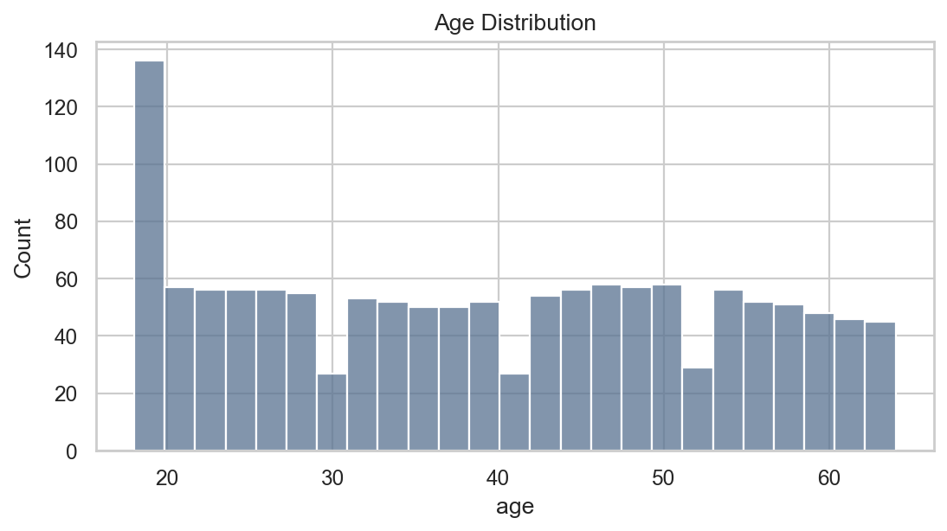

BMI Analysis
BMI ranges from 15.96 to 53.13, with a mean of 30.66.
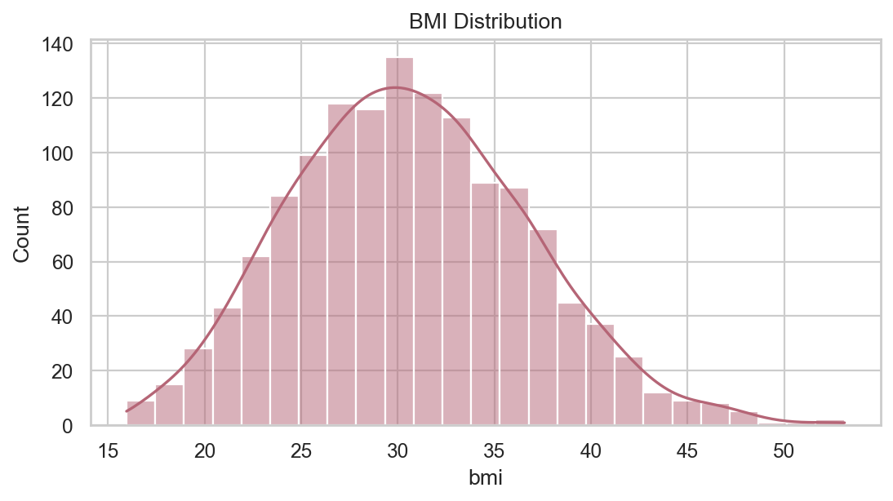

Smoking Impact Analysis
smoker | count | mean | median
no | 1063 | 8440.6603 | 7345.7266
yes | 274 | 32050.2318 | 34456.3485
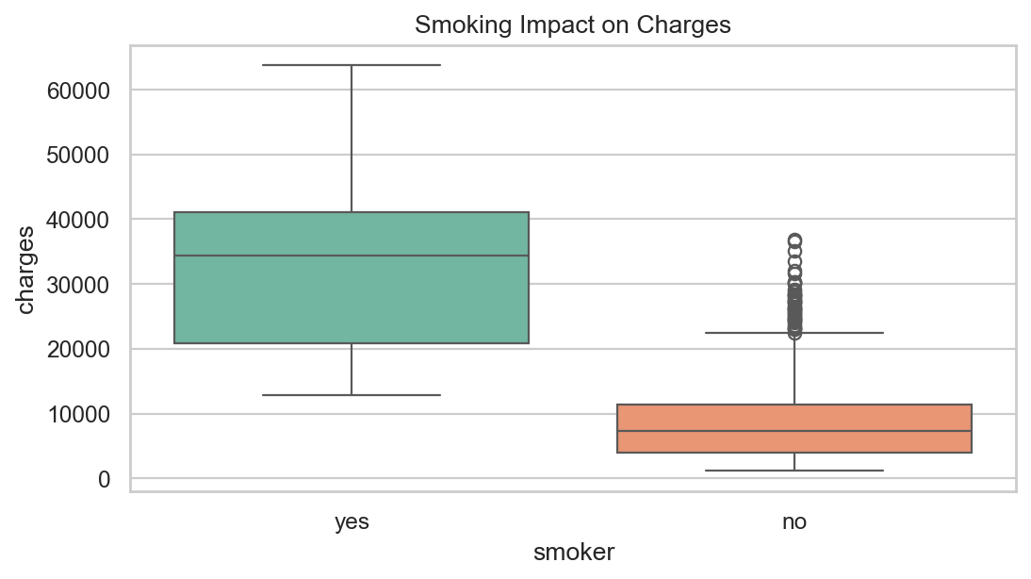

Region Analysis
region | count | mean | median
northeast | 324 | 13406.3845 | 10057.6520
northwest | 324 | 12450.8408 | 8976.9772
southeast | 364 | 14735.4114 | 9294.1319
southwest | 325 | 12346.9374 | 8798.5930
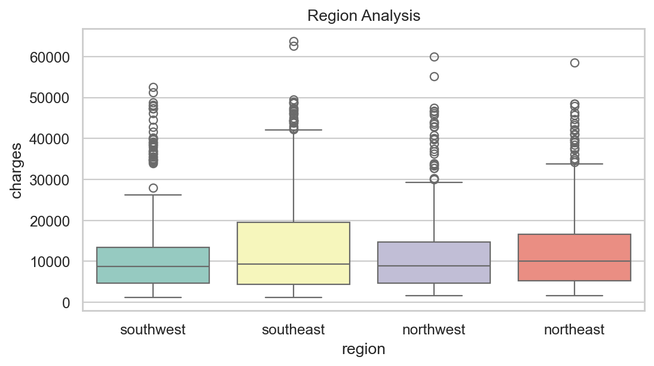

Cost Distribution and Correlation
