Feature Importance / Explainability Report
Project: Healthcare Cost Estimator

Feature Importance Analysis
Feature | Importance
smoker_yes | 0.7775
bmi | 0.1120
age | 0.0681
bmi_age_interaction | 0.0162
children | 0.0129
sex_male | 0.0061
region_southwest | 0.0054
region_northwest | 0.0018
region_southeast | 0.0000
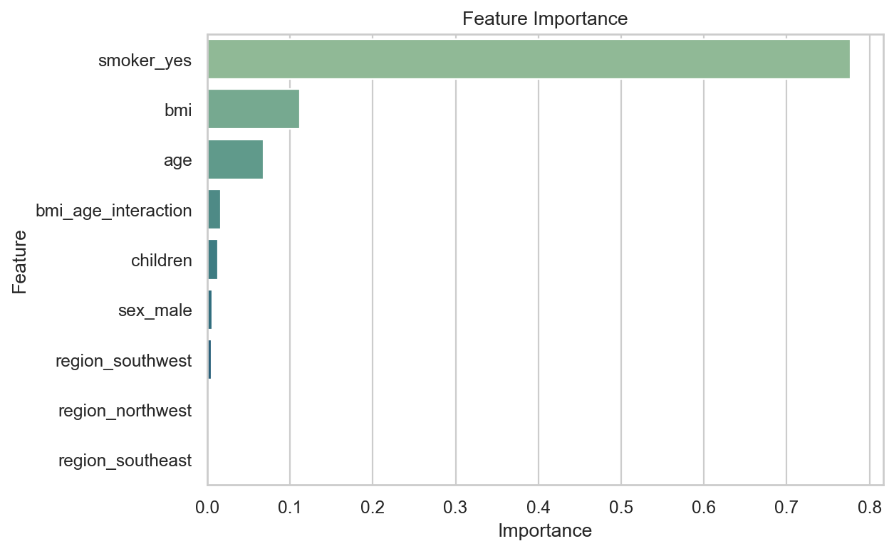

Cost-Driving Factors
- smoker_yes: importance 0.777549
- bmi: importance 0.111987
- age: importance 0.068083
- bmi_age_interaction: importance 0.016179
- children: importance 0.012923
Feature importance values are read from the saved trained model artifact and are not manually estimated.

