**GUJARAT TECHNOLOGICAL UNIVERSITY**

**Chandkheda, Ahmedabad**

**Affiliated**

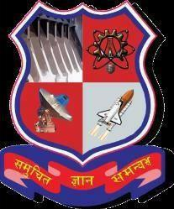



**BABARIA INSTITUTE OF TECHNOLOGY**

A report on

**T & NT Event Info**

Under subject of

DESIGN ENGINEERING – 1B

B. E. II, Semester – IV

(Computer Science Engineering Branch)

Submitted By

Group ID:-105627

|  |  |  |
| --- | --- | --- |
| **Sr. No.** | **Name of student** | **Enrolment number** |
| 1 | Shruti Rana | 180053107020 |
| 2 | Ravi Pandya | 180053107503 |
| 3 | Tanmay Patel | 180053107505 |
| 4 | Jay Togadiya | 180053107506 |

Prof. Pragna Makwana

**Faculty Guide**

Dr.Avani Vasant

**Head Of The Department**

**Acknowledgement**

We hereby acknowledge with deep gratitude for the cooperation and help given to us by all those who pour their magnificent efforts in making our project.

We are glad to express our heartfelt thanks and due respect to our lecture Assistant professor Miss. Pragna Makwana for her great support, inspiration, motivation and underable guidance the entire project was completed. We take this opportunity to express our profound gratitude and thanks to our H.O.D Dr .Avani R.Vasant.

We are very much thankful to our college students who cooperated with us. At last we are extremely thankful to our parents for their moral support.

**ABSTRACT**

We are going to create a web site T&NT EVENT INFO our web-site is used to manage all the technical and non-technical events organization by different collages. Event organization can register in our web-site and also important for event organizer that he/she has add all the contact details of this service provides. The student user also register themselves in our web-site and choose the events which one they like to participate. The upcoming events will be notify them. The student user will also be register them self and also pay for that event.

**CONTENT**

|  |  |  |
| --- | --- | --- |
| **Chapter 1** | **Introduction** | |
|  | a. | What is Design Thinking? Your understanding |
|  | b. | Its importance, Socio-economical relevance |
|  | c. | Team building and Log book exercises and importance |
| **Chapter 2** | **AEIOU Canvas** | |
|  | a. | Activity |
|  | b. | Environment |
|  | c. | Interactions |
|  | d. | Objects |
|  | e. | Users |
| **Chapter 3** | **Mind Mapping Canvas** | |
| **Chapter 4** | **Empathy Canvas** | |
| **Chapter 5** | **Ideation Canvas** | |
| **Chapter 6** | **Product Development Canvas** | |
| **Chapter 7**  **Chapter 8** | **LNM Canvas**  **Research Paper Summary** | |
| **Chapter 9** | **Prototype** | |
| **Chapter 10** | **Conclusion** | |
| **Chapter 11** | **References** | |

**1. Introduction**

The course aims to validate the learnings from previous semester of the understanding Design Thinking, by translating the concepts into exercises. Here branch specific topics need to be selected by students and refine their learning for Design Thinking phases.

Each group has to select one branch specific component/product/artefact/program for design engineering activity for their DE-2 project and modify the same based on extracted information as per User’s needs. This activity is to learn about some basic technical aspects involved in designing something related to particular branch.

After Design Engineering phase, Students must have to verify their revised concepts of selected artefact/component with the user before investing their time and efforts further. This will help students to verify their concepts and help in clarifying the insights that they need for implementing their idea.

**2. AEIOU CANVAS**

The AEIOU framework includes:

* A:-Activity
* E:-Environment
* I:-Interaction
* O:-Object
* U:-User

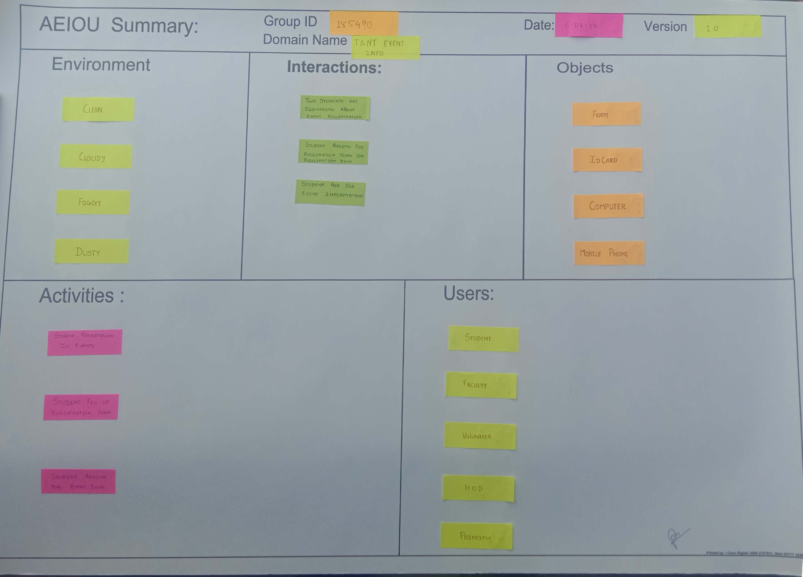

**ACTIVITY**

Activities are goal-directed sets of actions—paths towards things people want to accomplish. What are the modes people work in, and the specific activities and processes they go through.

Activities include: If someone (User) is involved…

* How?
* What actually is going on?
* Why it is going on?
* How it is going on?
* What is involved?

According to our domain activities included:-

* Student registering in event.
* Student fill-up the registration form.

**ENVARONMENT**

Environments include the entire arena where activities take place. What is the character and function of the space overall, of each individual's spaces, and of shared spaces.

This canvas includes:

* Where (Activity) is happening?
* What are circumstances?
* Time effects, any?
* Seasonal effects, any?
* Person effects, any?
* Operational effects, any?

According to our domain, Environment includes:-

* Clean
* Cloudy
* Foggy
* Dusty

**INTERACTION**

Interactions are between a person and someone or something else; they are the building blocks of activities. What is the nature of routine and special interactions between people, between people and objects in their environment, and across distance.

Interaction canvas includes:

* Who are involved? Why? How?
* What (users) are holding/ operating/using…
* How the contacts are inaction?
* Action vs. Reaction…

According to our domain, Interactions include:-

* Two students are discussing about event registration.
* Student asking for registration form on registration desk.
* Student ask to event organizer about event information.

**OBJECT**

Objects are building blocks of the environment, key elements some times put to complex or un-intended uses(thus changing their function, meaning and context). What are the objects and devices people have in their environments and how do they relate to their activities?

According to our domain, Objects include :-

* Form
* ID card
* Computer
* Mobile phone

**USER**

Users are the people whose behaviors, preferences and needs are being observed. Who is there? What are their roles and relationships? What are their values and prejudices?

According to our domain, Users include:-

* Student
* Principle
* HOD
* Faculty

**3. MIND MAPPING**

A mind map is an easy way to brainstorm thoughts organically without worrying about order and structure. It allows you to visually structure your ideas to help with analysis and recall.

A mind map is a diagram for representing tasks, words, concepts, or items linked to and arranged around a central concept or subject using a non-linear graphical layout that allows the user to build an intuitive framework around a central concept. A mind map can turn a long list of monotonous information into a colourful, memorable and highly organized diagram that works in line with your brain's natural way of doing things.

A mind map can be used as a simplified content management system (CMS). It allows you to store all your data in a centralized location to stay organized. With the various mind mapping software programs out today, you can attach files to different branches for even more flexibility. You can also change to various different views in order to find one that suits you best.

We also made a mind map collecting all idea together and putting it into a single blank paper.

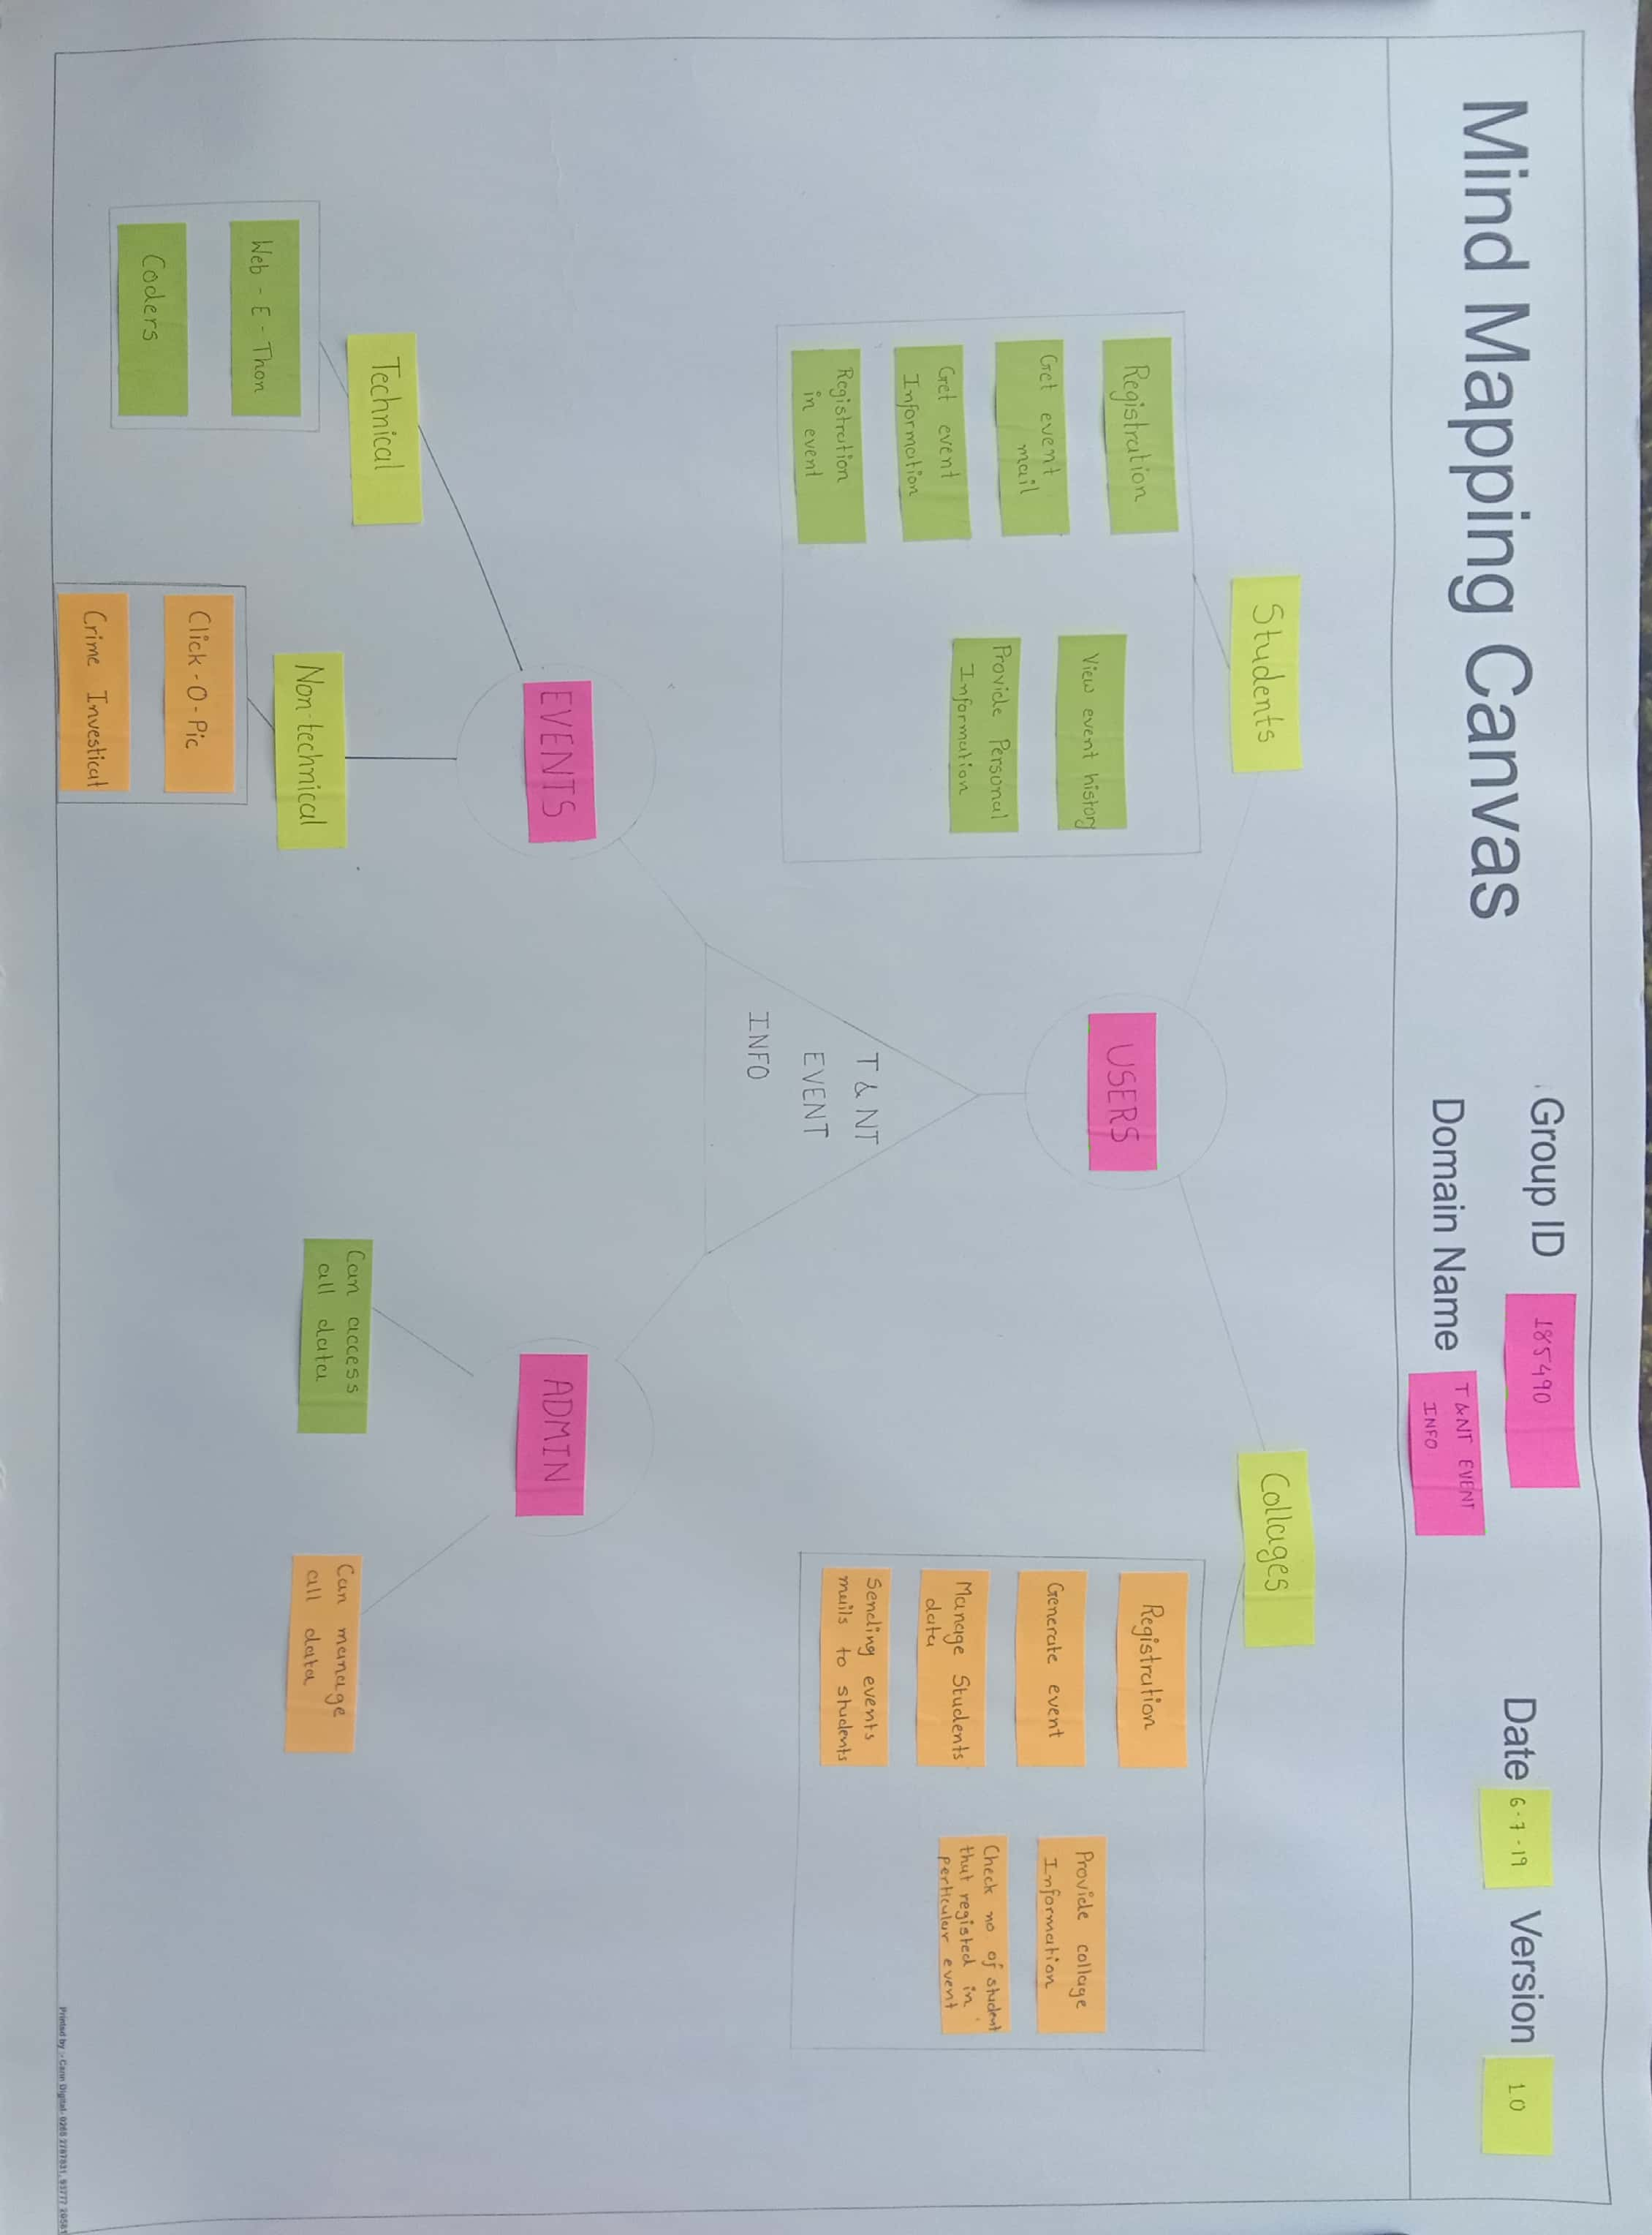

**4. EMPATHY CANVAS**

An empathy map is a collaborative tool teams can use to gain a deeper insight into their customers. Much like a user persona, an empathy map can represent a group of users, such as a customer segment. The empathy map was originally created by Dave Gray and has been gaining popularity with the agile community.

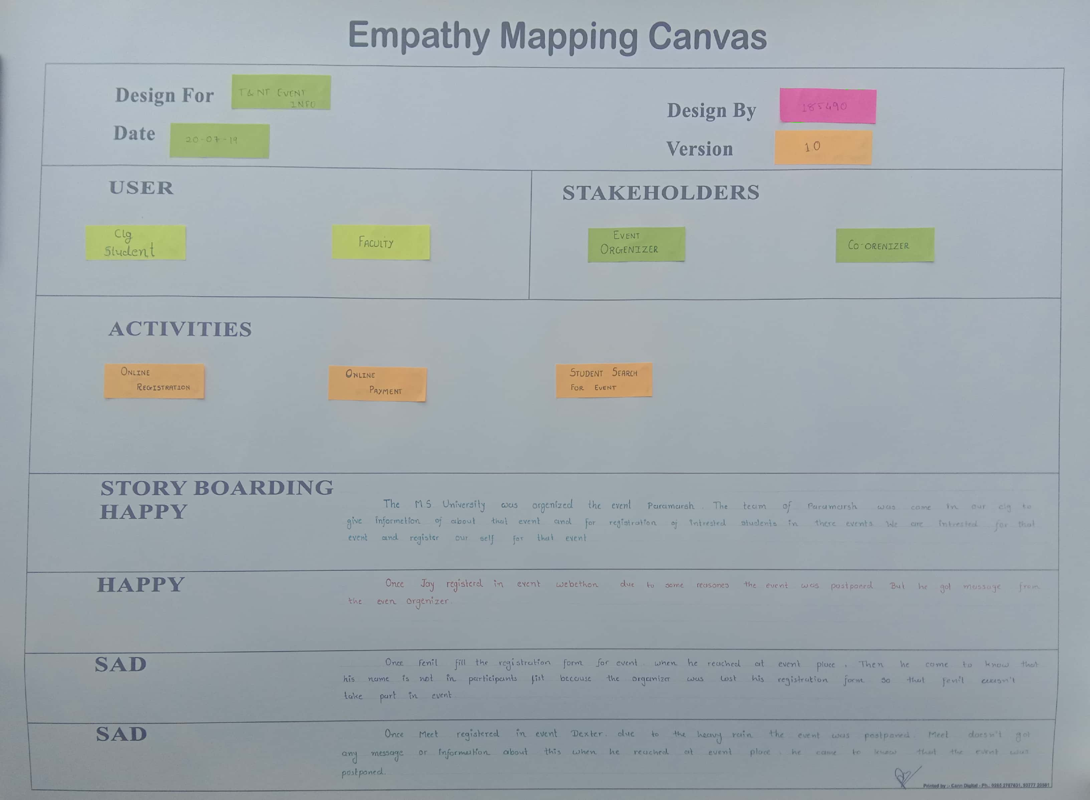

User include:-

* Student of college
* Faculty

Stakeholder include:-

* Event organizer
* Co-Ordinates

Activity include:-

* Online Registration
* Online payment
* Student search for event

**5:-IDEATION CANVAS**

An ideation canvas is a rough whiteboard where ideas can be stretched into any limits or dimensions. Ideation session is not aimed at finding solutions to the defined problem. But to define the best possible problem and stretch out its possible scope. The field is set and the overall agenda is to build the clones of the ideas and pivot them throughout the canvas so as to discover new possibilities.

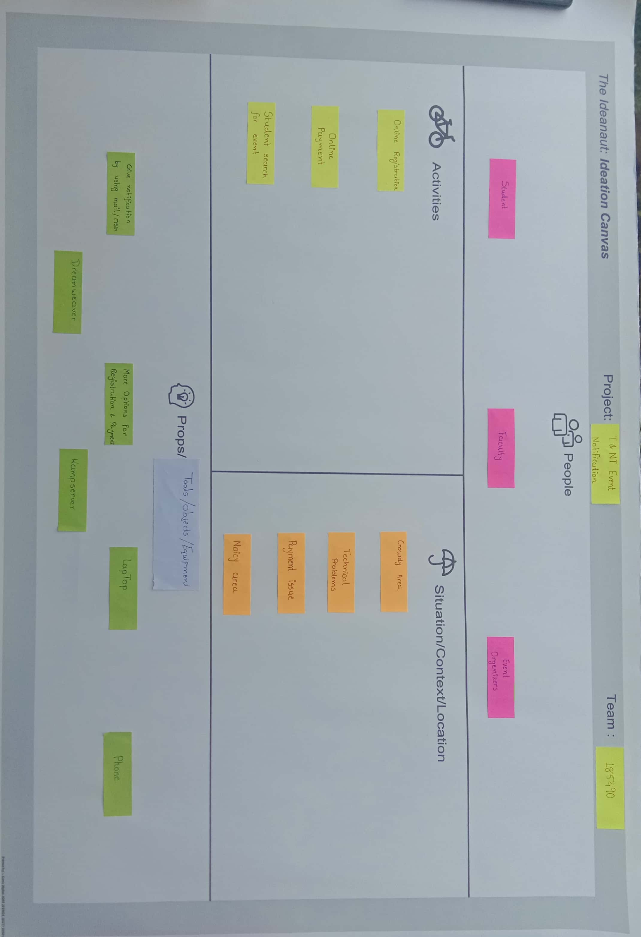

Activities include:-

* Online registration
* Online payment
* Student search for event

People include :-

* Student
* Faculty

Situations include:-

* Crowdie area
* Technical problems
* Payment issue
* Very noisy area

Possible Solution / Tools / Equipment

* Give notification using mail/message.
* Dreamweaver.
* More option for registration and payment
* WAMP server
* Laptop.

**6:-Product Development Canvas**

A product development canvas is the ground where in the best possible ideas after the ideation session are pitched and nurtured to develop.

The creation of productswith new or different characteristics that offer new or additional benefits to the customer.

Product developmentmay involve modification of an existing or formulation of an entirely new productthat satisfies a newly defined customer want or marketneed.

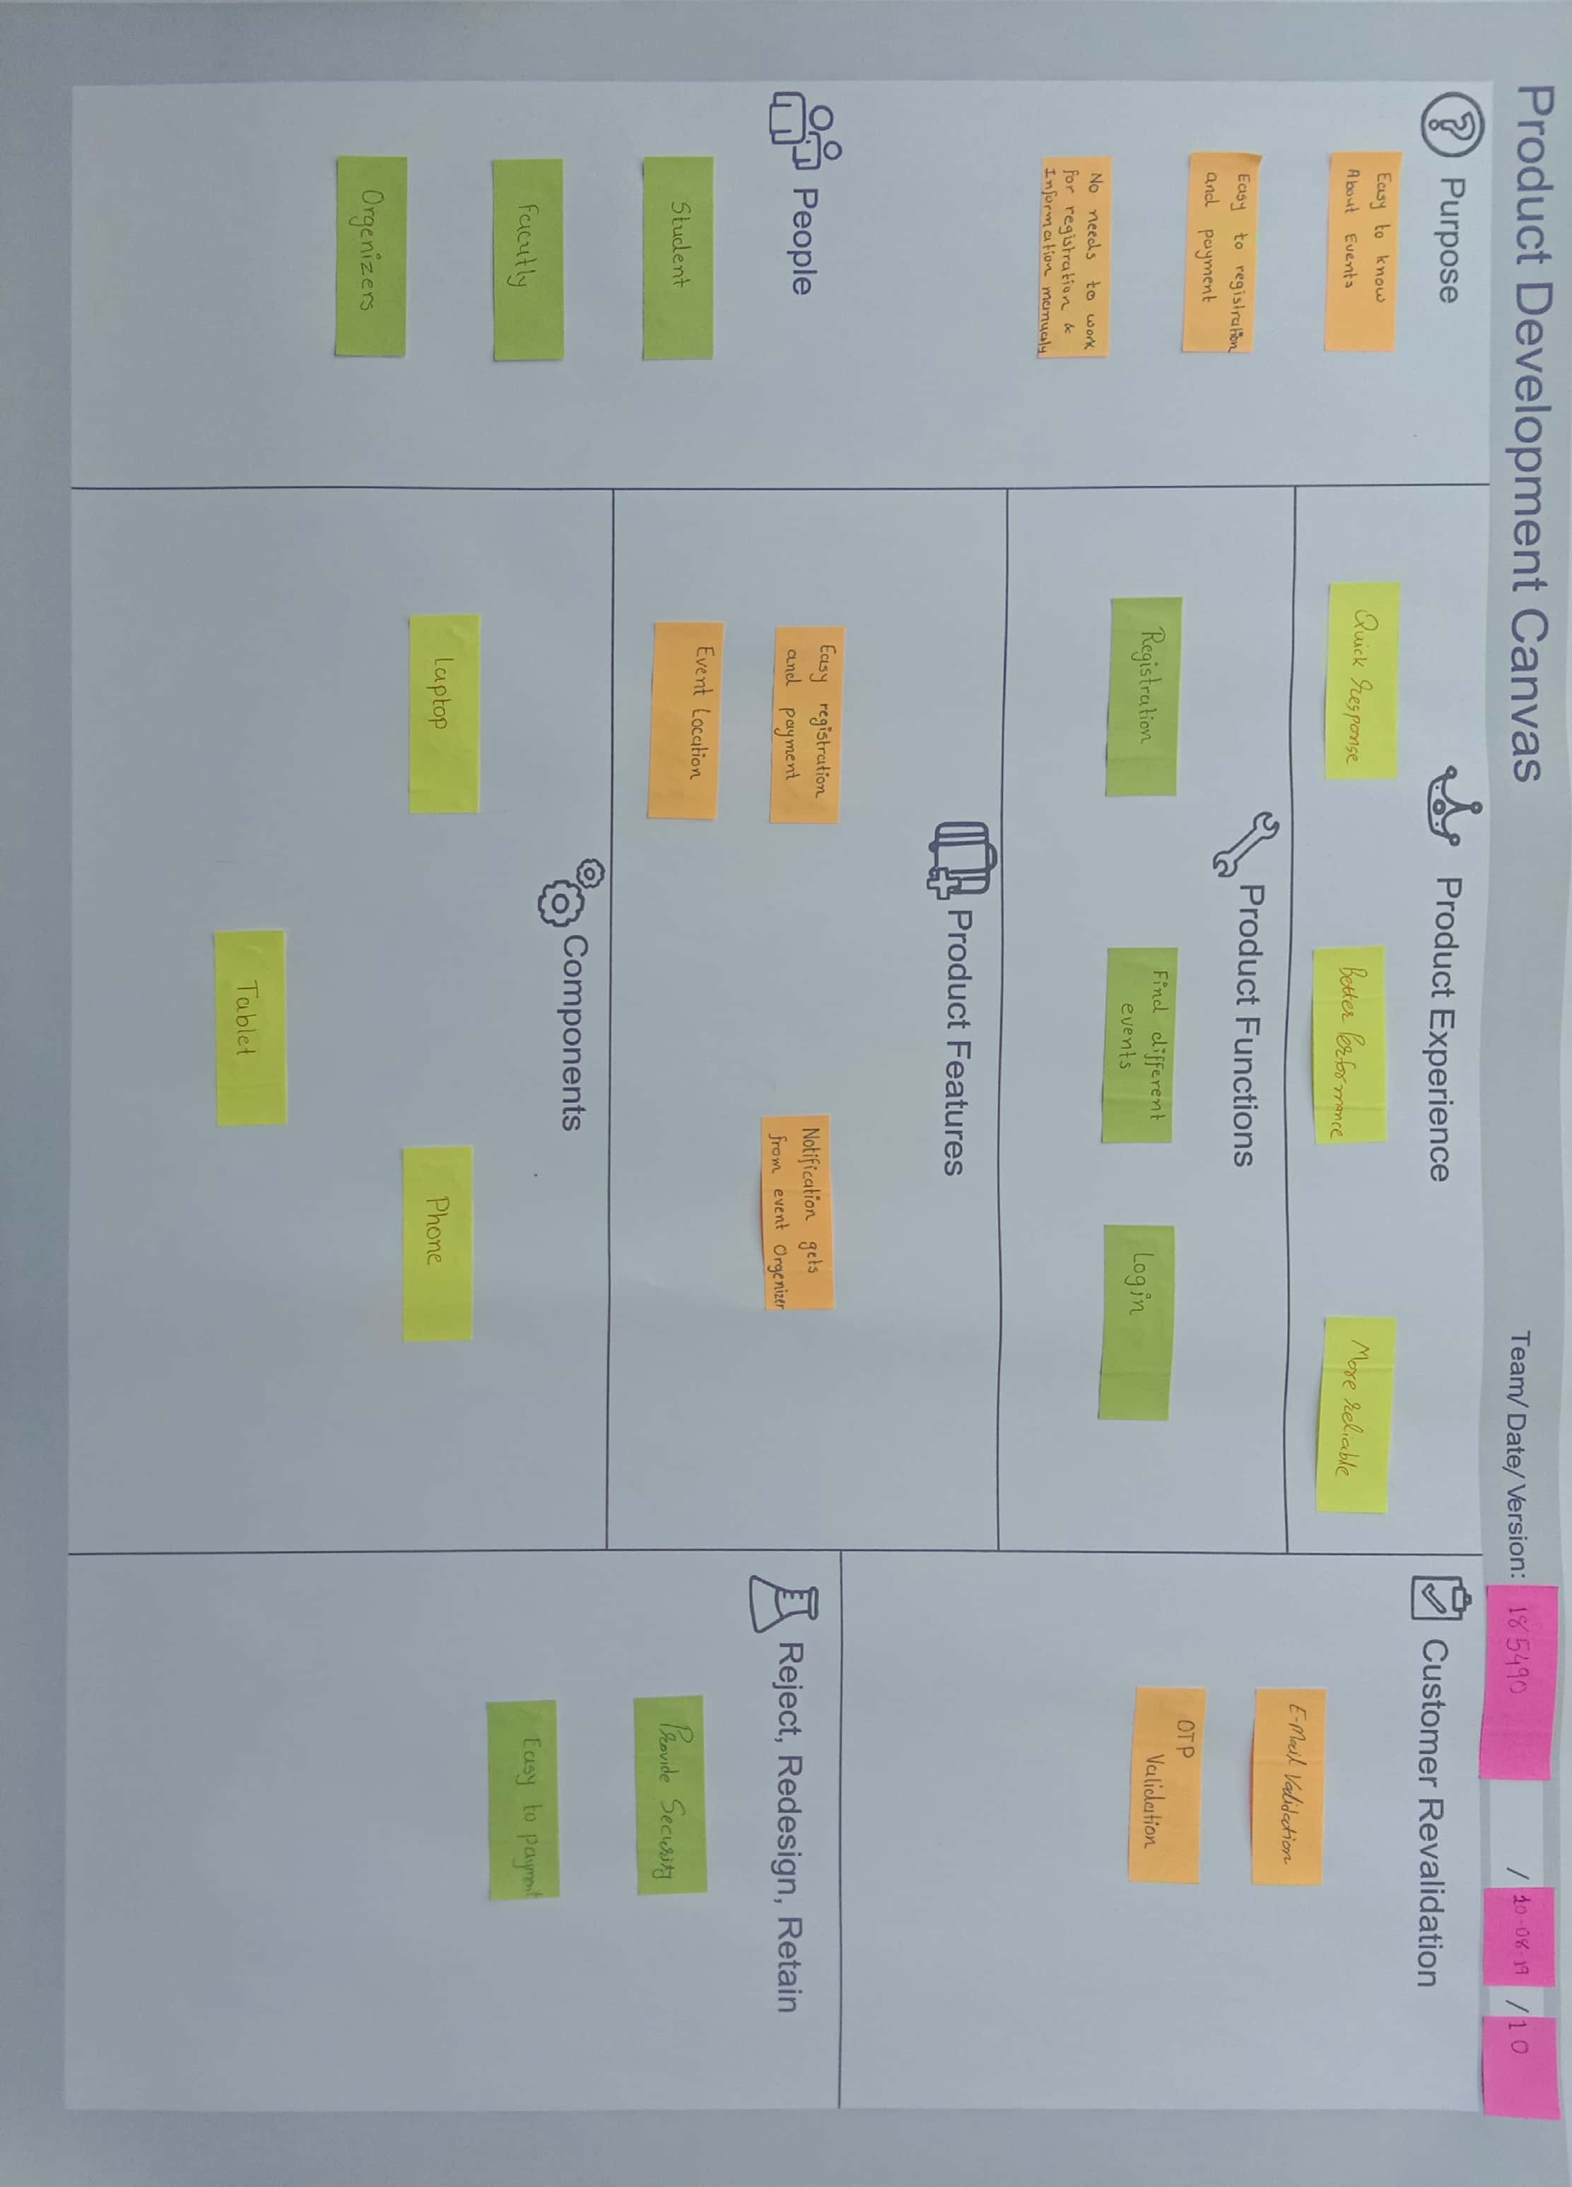

Purpose:-

* Easy to know about event.
* Easy to registration and payment.
* No need to manually work for registration and event information.

People

* Student
* Faculty
* Organizer
* HOD
* Principle

Product Experience

* Easy to use
* Provide useful information
* Quick response

Product Function

* + Registration
  + Find different events
  + Login

Components

* + Mobile
  + Computer
  + Server
  + Internet

Product Features

* Easy registration and payment
* Event location
* Notification gets from event organizer

Customer Revalidation

* Email Validation
* OTP validation

Reject/Retain

* Provide security
* Easy to payment

## 7: LNM [Learning need matrix]

## The purpose of LNM is to identify the requirements of learning among the team members. While a new product/process is under development based on a unique idea (to reduce the level of difficulty faced by a user), the team members need to learn and explore a lot of new skills and documents, methods and guidelines

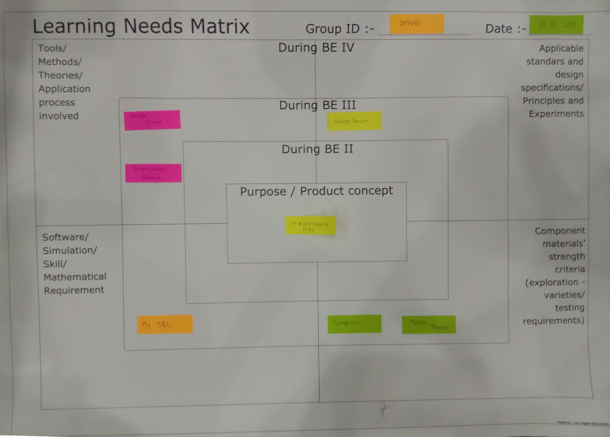

**8:-RESEARCH PAPER SUMMURY**

# TITLE: Event Management System

# Author: Vinay Mishra, Madhuri Dubey, Priya Banarjee, Ajvita Jumle, Pallavi Raipure and Pooja Wankhede.

# ****Published in**: November – December 2016**

#### RESEARCH PAPER SUMMARY

**-By Tanmay Patel**

**Abstract:**

Online event management system is an online event management system software project that serves the functionality of an event manager. The system allow only registered user login and new user are allowed to register on the application .This proposed to be a web application. The project provides most of the basic functionality required for an event type e.g. [marriage, Dance Show birthday party, etc.], the system then allows the user to select date and time of event, place and the event equipment. All the data is logged in the database and the user is given a receipt number for his booking. The data is then send to administrator (website owner) and they may interact with the client as per his requirement.

# TITLE : EVENT MANAGEMENT SYSTEM: DESIGN AND IMPLEMENTATION USING AOP METHODOLOGY IN ECLIPSE-AJDT ENVIRONMENT

**Author:**AMITA SHARMA

# ****Published in:**January 2011**

#### RESEARCH PAPER SUMMARY

**-BY Tanmay Patel**

**Abstract:**

Aspect-Oriented Programming (AOP) methodology has been investigated in the design and implementation of a representative Event Management System Software. Eclipse-AJDT environment has been used as open source enhanced IDE support for programming in AOP language – AspectJ. Twelve crosscutting concerns have been identified and modularized into highly cohesive modular units – aspects, thus reducing the complexity of the design due to elimination of code scattering and tangling. The impact of using this methodology on various quality factors of the software has been examined. The study concludes that AOP methodology in Eclipse-AJDT environment can help in evolving efficient, cost-effective and quality ‘Event Management System Software’.

**TITLE: Event Notification System**

# Author: J Voos, G Riva, C Zerbini, C Centeno

**Published in:** January 2015

**Research Paper Summary**

**-By Jay Togadiya**

**Abstract**:

This paper presents a medical event notification system implementation using short message service (SMS) over the cellular network. The main objective is the announcement for vaccination campaigns and availability of a particular medical attention at health sites where these services are not regularly provided. In this way, it provides a tool that facilitates healthcare in remote locations without medical assistance infrastructure. Since the main requirement of these systems is to achieve its massive adoption, SMS service is used to guarantee reaching all recipients regardless of their mobile device technology.

**TITLE: Events-Based Notification System for University's/ Collage Events.**

**Published in:** December 2009

**Research Paper Summary**

**-By Jay Togadiya**

**Abstract:**

Mobile phone plays a very important role in people life today; its functionality has been extended from voice communication only devices to internet surfing and data transfer. UUM as a higher education institute, hold and organize numerous events throughout the academic year and it relies on email communications for notifying its staff. Using the email notification to announce the staff for the function is suffering from two main problems which are: First, some of the staff do not check his/her email periodically, so they may miss read the notification email about the function and therefore they will not attend the function. Second, sometimes internet service is not available or staffs are at some place where they can not access internet which will lead also to make them unaware about the function or the notification about that function. This study has successfully designed and developed a notification system in order to be used by UUM to send the notifications direct to the staff mobile phones via SMS and thus helps in make sure that the notification is delivered to all interested staff. Successfully implementing this notification system in UUM will provide the university a reliable and convenient inter communication channel.

**TITLE: Review on College Event Organizer**

# Author: Sandeep Misal, Sagar Jadhav , Tushar Jore , Archana Ugale Published in: March 2017

**Research Paper Summary**

**-By Ravi Pandya**

**Abstract:**

In these days almost every college is conducting technical / non-technical events where we can gain some knowledge by participating. College, which is conducting events, this project can be organizer for the various events offered by them. This provides college management to schedule events online and assign student volunteers for an event. Event Managers can upload information related to the event in the form of text, audio, video files. The students and participants can view these files online and download.

**TITLE: An event based notification for delivery of patient medical information.**

# Author: Francisco P. Maturana, Juan L. Asenjo.

**Published in:** January 2015

**Research PaperSummary**

**-By Ravi pandya**

**Abstract:**

This paper proposes an architecture for an effective asynchronous notification of clinical documents. Our intention is to bridge the gap between primary and secondary care, and between the clinical personnel and the administrators. The proposed solution is based on a publish/subscribe service, properly extended to allow us to jointly notify collections of correlated documents. Moreover, it has been implemented by means of a web service-based platform in accordance with the Web Service Notification specification so as to obtain a solution easy to integrate and manage. A systematic analysis has been carried out to assess the suitability of the implemented solution to satisfy the requirements for notifying medical documents, and to evaluate the notification latency in different use conditions.

**TITLE: Trend of Event Management Research**

**Author:** **Kwangsoo Park, Seunghyun Brain Park**

**Published in:** April 2016

**Research Paper Summary**

**-By Shruti Rana**

**Abstract:**

In spite of increasing numbers of publications and newly established journals in event management, research topics and themes have not drawn much attention among event scholars. This research note reports on research trends in event management journals and makes suggestions for future research. A total of 463 research articles published in the four event management journals and 78 event management articles in the leading hospitality and tourism journals were collected. The results showed that topics for event studies have changed over time. Recent studies heavily focus on visitor experiences, investigating motivation, satisfaction, and behavioral intention, while past studies paid more attention to the economic impact of events or volunteer motivation.

# TITLE: Events Management Research: State of the Art

**Author:** [Rhodri Thomas](https://www.researchgate.net/profile/Rhodri_Thomas5)

**Published in:** April 2012

**Research Paper Summary**

**-By Shruti Rana**

**Abstract:**

The articles in this special issue illustrate the richness and diversity of contemporary research associated with planned events. Based on the work submitted to the Global Events Congress, we have argued that they are the tip of a large iceberg. The volume and quality of work presented, and the vibrancy of the discussion that ensued, suggests that there are good reasons to be sanguine about the future prospects for events research. The papers also signal gaps in existing knowledge. Sometimes this is explicit but most often it is by inference. In so doing, they collectively highlight potentially productive avenues for future research activity by events scholars.

**9:- PROTOTYPE**

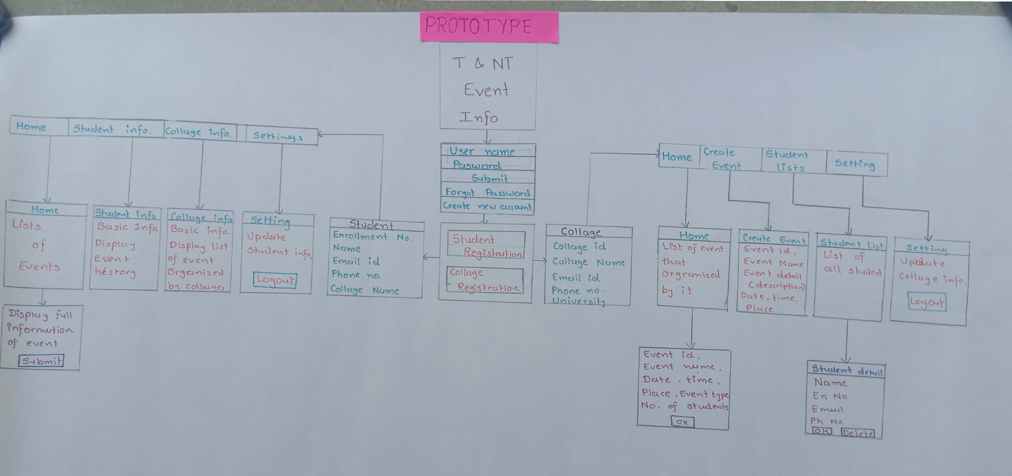

**10. CONCLUSION**

By making this website we can solve problem of providing information about particular event to students.

Student can get information without being misguided.

**11. References:**

We are using following websites for research:

* <http://www.ijtrd.com/papers/IJTRD5392.pdf>
* <https://www.researchgate.net/publication/50392015_EVENT_MANAGEMENT_SYSTEM_DESIGN_AND_IMPLEMENTATION_USING_AOP_METHODOLOGY_IN_ECLIPSE-AJDT_ENVIRONMENT>
* <https://iopscience.iop.org/article/10.1088/1742-6596/477/1/012015>
* <https://pdfs.semanticscholar.org/90e4/8af809508c8d62a3a1c6286baa2332588546.pdf>
* <https://www.irjet.net/archives/V4/i3/IRJET-V4I3121.pdf>
* <https://www.sciencedirect.com/science/article/abs/pii/S0306437913000987>
* <https://www.researchgate.net/publication/301334692_Topic_Trend_of_Event_Management_Research>
* <https://www.researchgate.net/publication/262895335_Events_Management_Research_State_of_the_Art>