Name | Patel Tej
ID | 25AIML057
Subject and code | Object Oriented Programming  CEUE203

Practical 1: -
Code:
import java.util.Scanner;
class Item{
private final String name;
private final int price;

Item(String name,int price){
this.name=name;
this.price=price;
}
String getName(){
return name;
}
int getPrice(){
return price;
}
static Item findItem(char code){
return switch(Character.toUpperCase(code)){
case 'T' -> new Item("Tea",10);
case 'C' -> new Item("Coffee",15);
case 'S' -> new Item("Samosa",12);
case 'P' -> new Item("Puff",20);
default -> null;
};
}
}
class Order{
private int tokenNo;
private Item item;
private int quantity;
static int nextToken=101;
static int totalOrders=0;
static int totalSales=0;
Order(Item item,int quantity){
this.item=item;
this.quantity=quantity;
this.tokenNo=nextToken++;
totalOrders++;
totalSales+=getAmount();
}
int getAmount(){
return item.getPrice()*quantity;
}
static int getTotalOrders(){
return totalOrders;
}
static int getTotalSales(){
return totalSales;
}
public String toString(){
return "Token " + tokenNo + ": " + item.getName()+ " x " + quantity + " = " + getAmount();
}
}

public class CanteenBilling{
public static void main(String[] args){
Scanner sc=new Scanner(System.in);
System.out.println("=======================");
System.out.println(" WELCOME TO CANTEEN ");
System.out.println("=======================");
System.out.println("[T] Tea - Rs. 10");
System.out.println("[C] Coffee - Rs. 15");
System.out.println("[S] Samosa - Rs. 12");
System.out.println("[P] Puff - Rs. 20");
System.out.println("=======================");
System.out.print("Enter number of orders: ");
int n=sc.nextInt();
for (int i=0;i<n;i++) {
System.out.println("--- Order "+(i+1)+ " ---");
System.out.print("Enter item code (T/C/S/P): ");
char code=sc.next().charAt(0);
System.out.print("Enter quantity: ");
int quantity=sc.nextInt();
Item item=Item.findItem(code);
if(item==null || quantity<=0){
System.out.println("Invalid order: " + code + " " + quantity);
}
else{
Order order = new Order(item,quantity);
System.out.println(order);
}
}
System.out.println("=======================");
System.out.println("Total orders: " + Order.getTotalOrders()+ ", Total sales: Rs. " + Order.getTotalSales());
System.out.println("=======================");
sc.close();
}
}

Output:
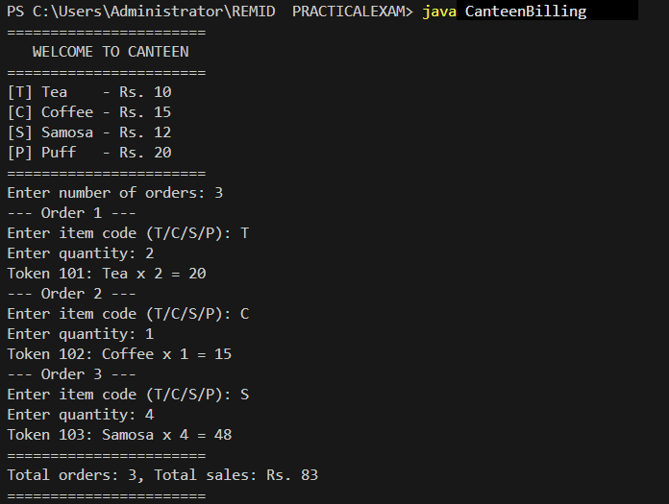

Practical 2: -

Code:
import java.util.Scanner;
class FeedbackFormatter{
public static void main(String[] args) {
Scanner sc=new Scanner(System.in);
System.out.print("Enter sentence: ");
String sentence=sc.nextLine().trim();
System.out.print("Enter keyword: ");
String keyword=sc.nextLine();
String[] words=sentence.split(" +");
StringBuilder formatted=new StringBuilder();
StringBuilder acronym=new StringBuilder();
String longest="";
int count=0;
for (String word : words) {
String w=word.toLowerCase();
w=w.substring(0, 1).toUpperCase() + w.substring(1);
if (formatted.length()>0){
formatted.append(" ");
}
formatted.append(w);
acronym.append(w.charAt(0));
if (w.length()>longest.length()){
longest=w;
}
if (word.equalsIgnoreCase(keyword)){
count++;
}
}
System.out.println("Formatted: " + formatted);
System.out.println("Words: " + words.length);
System.out.println("Longest word: " + longest);
System.out.println("Keyword count: " + count);
System.out.println("Acronym: " + acronym);
sc.close();
}
}

Output:
