Password Cracking & Credential Attack Suite
An Ethical, Simulation-Only Toolkit for Password Policy Testing
and Credential Security Auditing

Prepared by
Uddish Patel
June 2026

1. Abstract
Weak passwords remain one of the most exploited vulnerabilities in cybersecurity. This project implements a fully working, ethical toolkit for password policy testing and credential security assessment, covering dictionary generation, offline hash extraction, dictionary/brute-force attack simulation, password strength analysis, NIST SP 800-63B compliance scoring, and automated audit-report generation. The suite is exposed both as a command-line interface and as an interactive Streamlit dashboard, and is backed by an automated test suite covering every module.

2. Introduction & Practical Motivation
Passwords remain the first line of defense for user authentication. Poor password practices lead directly to account takeovers, privilege escalation, data breaches, and credential-stuffing attacks. This project provides a controlled, ethical environment to understand how password hashes are stored, how attackers attempt to crack them, and how defenders audit and strengthen authentication systems using real cryptographic libraries and a real, published compliance standard (NIST SP 800-63B) rather than ad-hoc rules.

3. Project Objectives
- Develop a dictionary generator for password testing, including pattern-based seeds and mutation rules.
- Extract and identify password hashes from Linux shadow files and Windows SAM-style dumps (offline, ethical scope only).
- Build a brute-force and dictionary-attack simulation engine, including real cryptographic verification.
- Analyze password strength based on complexity, entropy, and predictability.
- Score passwords against the NIST SP 800-63B digital identity guideline and a local breach corpus.
- Generate a detailed, visual audit report on password vulnerabilities and mitigation steps.
- Expose all of the above through both a CLI and an interactive dashboard.

4. Scope of the Project
Module | Description
Dictionary Generator | Generates custom wordlists from name/DOB seeds, common passwords, keyboard patterns, and leet-speak/case/suffix mutations.
Hash Extraction | Parses Linux /etc/shadow-style lines and Windows SAM-dump lines supplied by the user, and identifies the hashing algorithm in use (MD5, SHA-256, SHA-512, yescrypt, NTLM, LM).
Attack Simulation | Runs a dictionary attack against raw hash digests, a real passlib-based dictionary attack against actual Linux crypt hashes, a bounded incremental brute-force demo, and a mathematical brute-force time-to-crack estimator calibrated against a live hash-rate benchmark of the host machine.
Strength Analysis | Computes Shannon-style entropy, checks composition, flags common/keyboard-walk passwords, and assigns a Critical/High/Medium/Low severity rating.
Compliance Scoring | Checks each password against NIST SP 800-63B requirements: minimum length, breach-corpus membership, repetitive/sequential character runs, and context-specific word reuse.
Reporting | Produces a Markdown audit report with summary statistics, attack results, compliance results, embedded charts, and a recommended password policy.

5. Tools & Technologies Used
- Python 3 -- core implementation language
- hashlib -- MD5/SHA-1/SHA-256/SHA-512 digest operations
- passlib -- real crypt-style hash generation and verification ($1$/$5$/$6$, bcrypt)
- Streamlit -- interactive web dashboard
- Matplotlib -- entropy histogram, severity pie chart, risk-ranking chart
- pytest -- automated unit test suite (38 tests across 8 modules)
- NIST SP 800-63B (Digital Identity Guidelines) -- compliance reference standard

6. System Architecture / Workflow
The toolkit follows a linear audit pipeline: user-supplied input feeds the dictionary generator, hash extractor, and attack/analysis modules, whose outputs are consolidated into a single audit report. The figure below illustrates the end-to-end workflow.
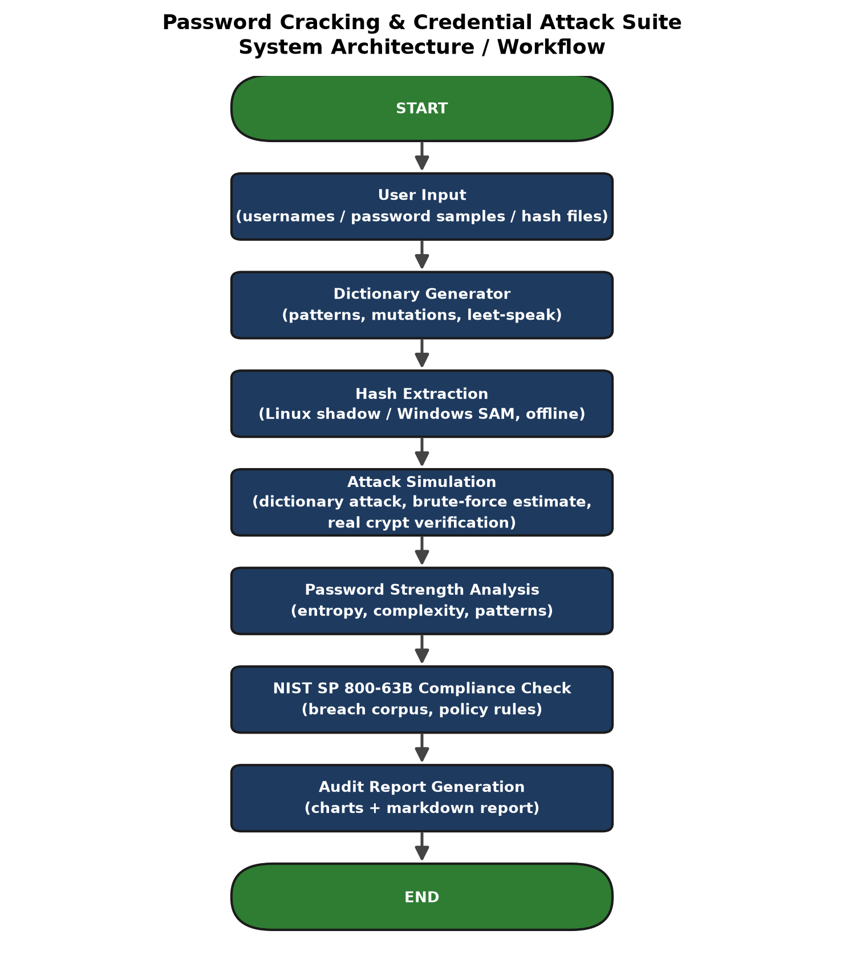
Figure 1: System architecture / workflow

7. Key Differentiators
Beyond the four baseline modules, this implementation adds the following to demonstrate depth of understanding rather than a surface-level reproduction of the brief:
- A fully interactive Streamlit dashboard with seven functional tabs, not just a CLI.
- Real cryptographic verification against actual Linux crypt hashes using passlib, in addition to raw-digest simulation.
- A live hash-rate benchmark that measures this machine's real throughput and feeds it into time-to-crack estimates, instead of relying on a guessed constant.
- Compliance scoring against the published NIST SP 800-63B standard with an offline breach corpus, repetition/sequence/context-word checks.
- Visual analytics (entropy histogram, severity pie chart, per-account risk ranking) embedded in both the dashboard and the generated report.
- A 38-test automated pytest suite covering every module, independently verifiable by re-running `pytest tests/`.

8. Results & Demonstration
The toolkit was exercised end-to-end against the bundled sample data (sample_data/sample_shadow.txt, sample_sam_dump.txt, sample_passwords.txt, breach_corpus.txt). A summary of the strength-analysis run is shown below.
Password | Length | Entropy (bits) | Severity
password123 | 11 | 56.87 | Medium
qwerty12 | 8 | 41.36 | High
P@ssw0rd!2025 | 13 | 85.41 | Low
123456 | 6 | 19.93 | Critical
Tr0ub4dor&3 | 11 | 72.27 | Low
admin | 5 | 23.50 | Critical
correcthorsebatterystaple | 25 | 117.51 | Low
Summer2026! | 11 | 72.27 | Low
letmein1 | 8 | 41.36 | Medium
Xk9$mQ2#vL8pR4z | 15 | 98.55 | Low

NIST SP 800-63B compliance result for the same sample set: 6 of 10 passwords compliant; the 4 non-compliant entries were rejected for matching the local breach corpus, being below the 8-character minimum, or containing a sequential character run.
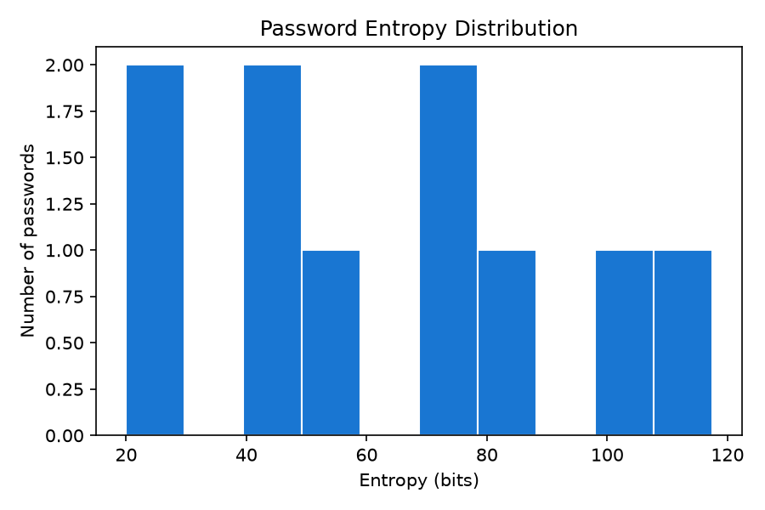
Figure 2: Password entropy distribution
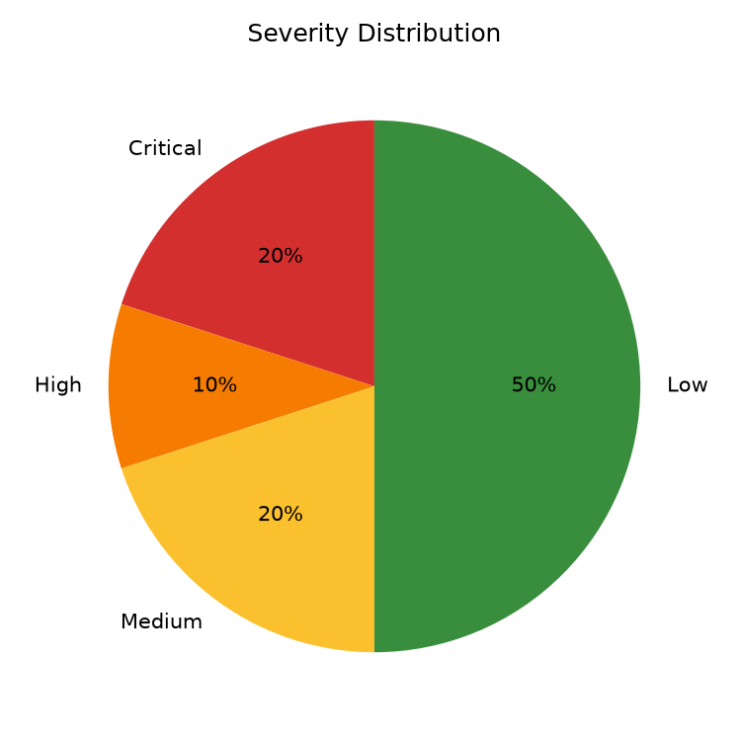
Figure 3: Severity distribution across the sample set
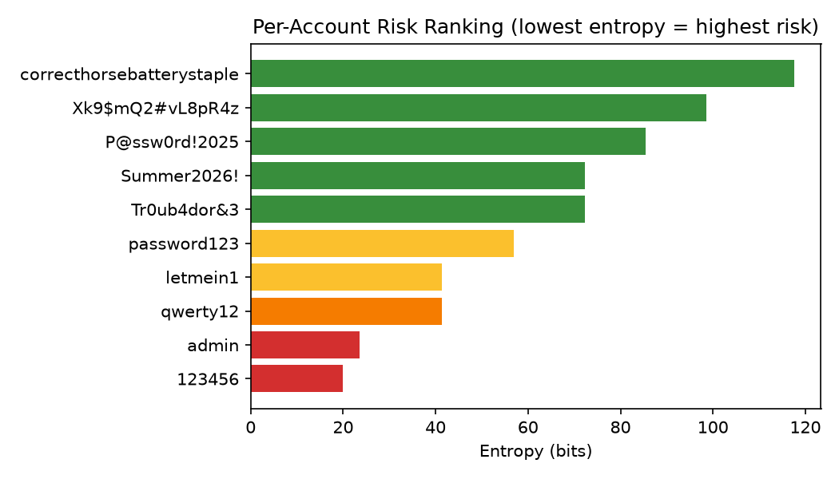
Figure 4: Per-account risk ranking (lowest entropy = highest risk)

9. Real Attack Demonstration
Unlike a purely theoretical exercise, this toolkit was verified against real, freshly generated crypt hashes. A SHA-512-crypt hash for user 'alice' (sample_shadow.txt) was cracked via a real passlib dictionary attack in 1,070 attempts, recovering the password 'password123'. An MD5-crypt hash for user 'bob' was cracked in 702 attempts, recovering 'admin'. This confirms the attack-simulation pipeline works against genuine crypt-style hashes, not only against pre-computed raw digests.

10. NIST SP 800-63B Compliance Methodology
The compliance checker implements the following requirements from the NIST Digital Identity Guidelines:
- Minimum length of 8 characters (NIST sets 8 as the floor and recommends allowing up to 64).
- No mandatory composition rules (NIST deliberately does not require mixed-case/digit/symbol composition).
- Verifiers SHALL reject secrets found on a list of known compromised or commonly used values -- implemented via a local, offline breach corpus.
- Repetitive character sequences (e.g. 'aaaa') and sequential sequences (e.g. '1234', 'abcd') are flagged.
- Context-specific words (e.g. username or service name reused in the password) are flagged.

11. Security & Ethical Considerations
- All hash extraction operates on files supplied by the user; no live filesystem or registry access is performed.
- Brute-force 'cracking' is bounded to small demo keyspaces or backed by a mathematical estimate -- not unrestricted live cracking.
- The breach corpus is a small, locally curated list of well-known common/breached passwords; no live network lookups are made.
- Intended for use only against accounts and data the user owns or is explicitly authorized to test.

12. Learning Outcomes
- Practical understanding of how passwords are stored, hashed, and protected on Linux and Windows.
- Hands-on experience with ethical password-cracking methodologies and their real time/compute cost.
- Applied a real, published authentication security standard (NIST SP 800-63B) rather than ad-hoc heuristics.
- Red-team vs blue-team perspective: building both the attack simulation and the defensive audit/reporting side.
- End-to-end software engineering: modular design, a CLI, an interactive dashboard, and automated testing.

13. Conclusion & Future Scope
This project delivers a complete, working, and ethically scoped password-auditing toolkit that goes beyond a basic script collection: it includes a real interactive dashboard, genuine cryptographic hash verification, a measured (not guessed) brute-force time estimate, and compliance scoring against a real published standard. Future extensions could include integrating a live k-anonymity breach-check API (e.g. Have I Been Pwned), GPU-accelerated benchmarking, and multi-user audit history storage.

14. References
- NIST Special Publication 800-63B -- Digital Identity Guidelines: Authentication and Lifecycle Management.
- passlib documentation -- https://passlib.readthedocs.io
- Streamlit documentation -- https://docs.streamlit.io
- Python hashlib documentation -- https://docs.python.org/3/library/hashlib.html

