Introduction to Version Control 05-Feb-2019

Q1.

To install git

sudo apt-get install git
To check version of git

git --version

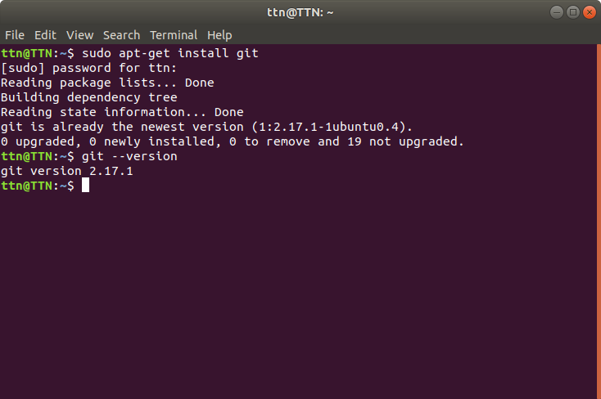

Q2.

To initialise git

git init

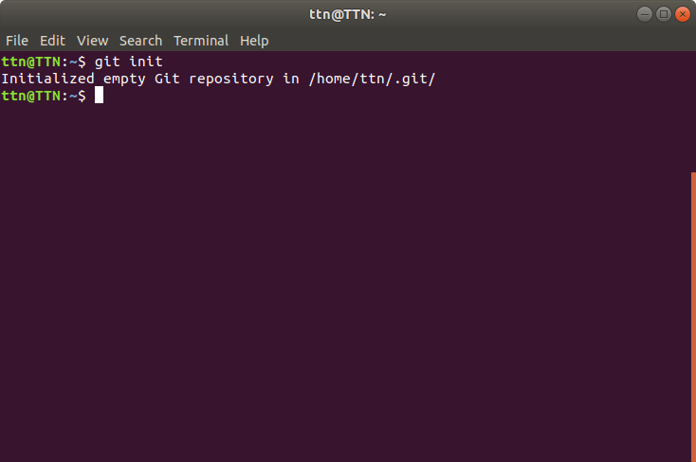

Q3.

Add the files in your new local repository

firstly create a file

touch file1

add Command

git add file1

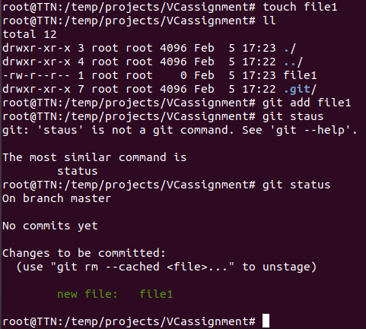

Q4.

command

git rm --cached file1

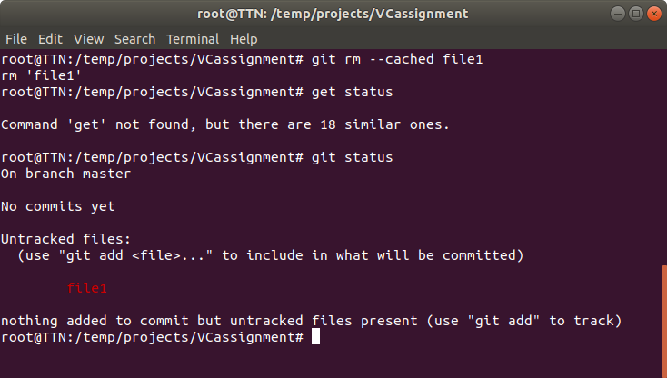

Q5.

command for localhost

git comit -m “Message”

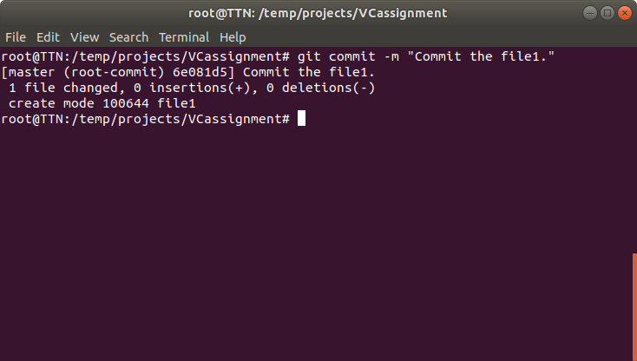

command for server

git remote add/set-url remote repo

Q6.

command

git remote add origin git@github.com:patelutkarsh97/Version_Control_Assignment.git

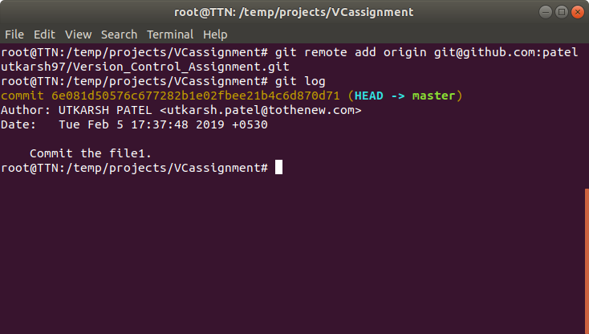

Q7.

command

git checkout -- file1

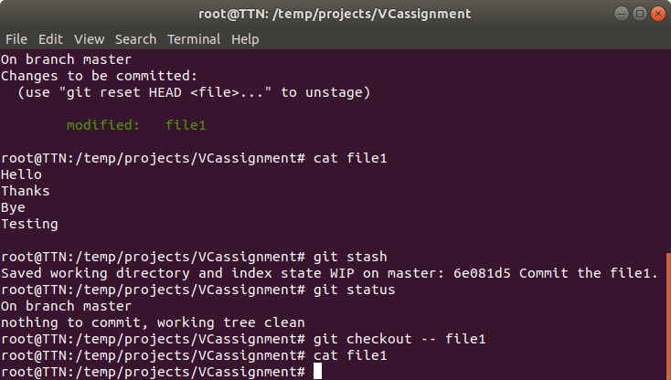

Q8.

command

git push origin master

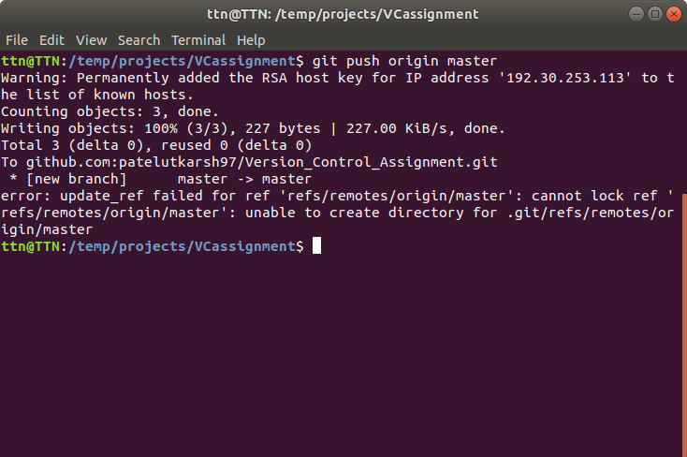

Q9.

command

git clone git@github.com:patelutkarsh97/Version_Control_Assignment.git

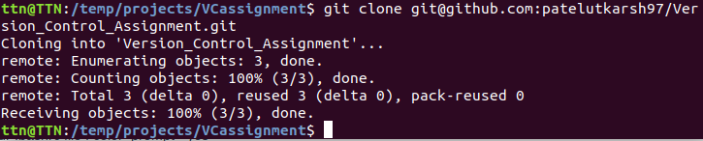

Q10.

Command

mkdir -p newfolder

git clone git@github.com:patelutkarsh97/Version_Control_Assignment.git

now go to original (Vcassignment) folder and pull allthe changes

git pull origin master

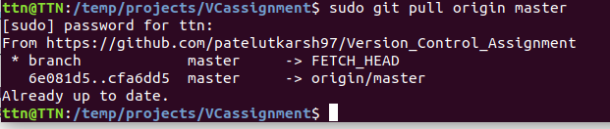

Q11.

Command

git diff --staged HEAD file1

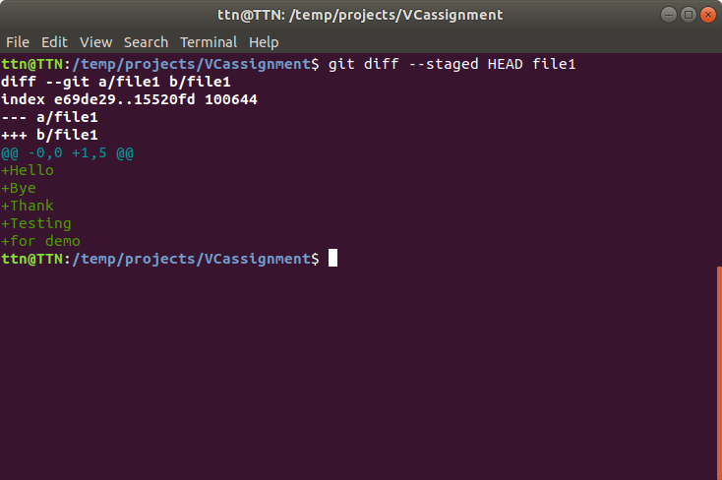

Q12.

Prerequisites
sudo apt-get install git-extras

Command

git ignore filename

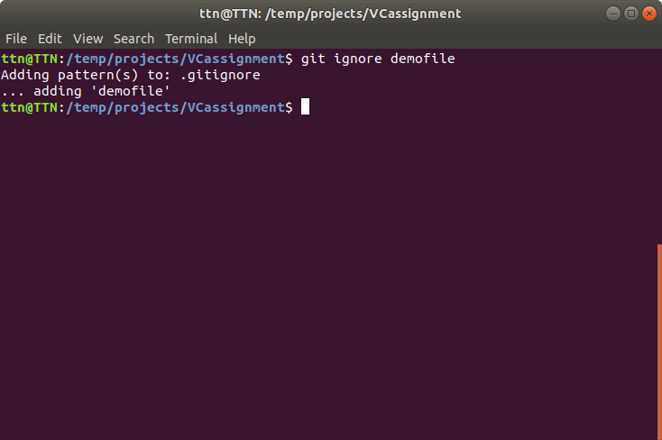

Q13.

Command

git checkout -b [name_of_new_branch]

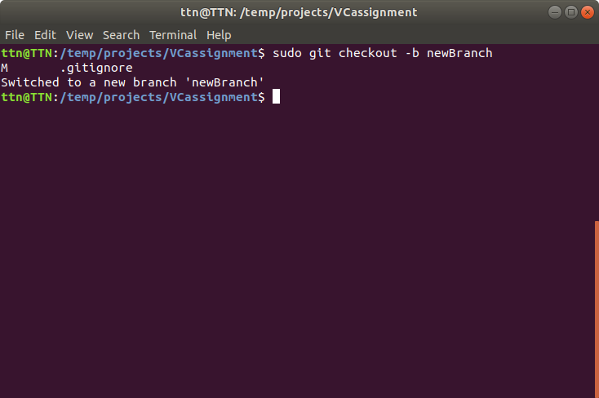

Q14.

adding file2 in newbranch and then checking the master branch

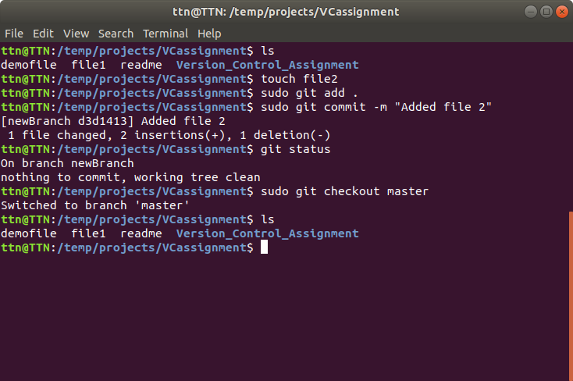

Q15.

Follow the command on terminal

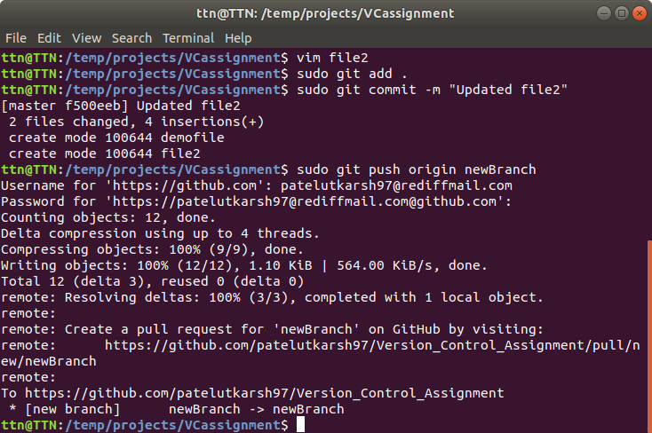
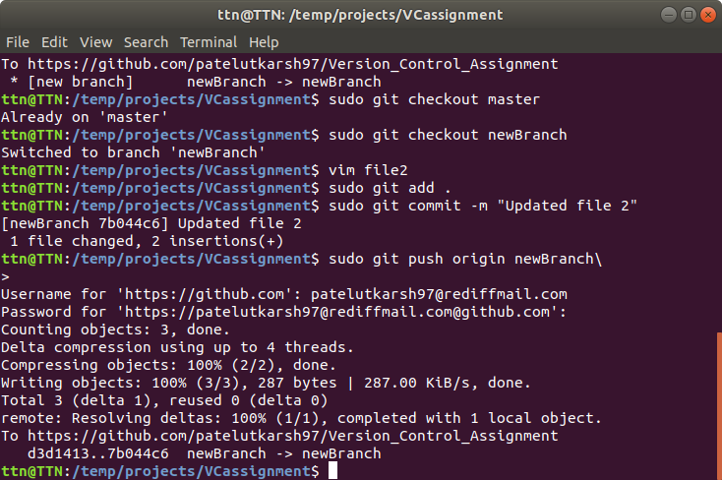

Q16.

Try to merge using command

git merge master
and then resolve the conflict

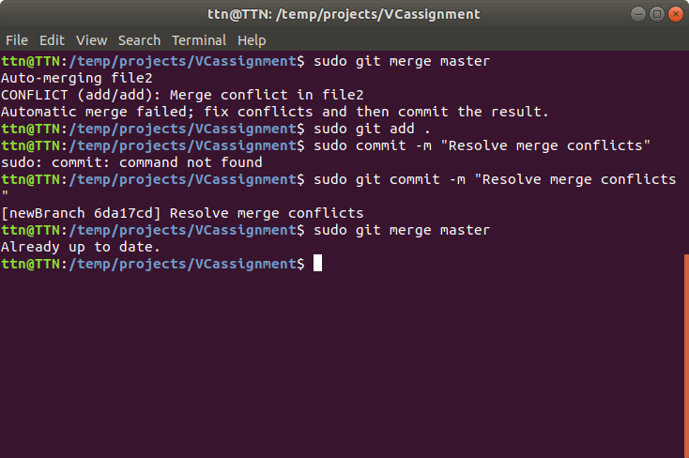

Q17.

Firstly modify any file to create conflict
then check the

git status

then put the confilicting file into stash using command

git stash save -u

after that drop the stash using command

git stash pop

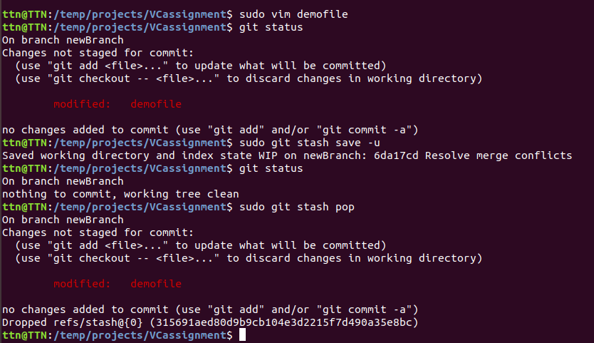

Q18.

Command to edit .bashrc file using vim

vim ~/.bashrc

then to insert press i

and to save and quit vim press

ESC :wq

