Session : 1

Task : 1 Open Instagram's home page in Chrome, right-click on a post image, and use Inspect Element to find the exact HTML tag and CSS class used for the image container. Write down the tag name and class.
HTML Tags:- html, head, body, tle, meta, div, main, ar cle, img, a, bu on, svg, path.

CSS Class:- x78zum5 xdt5y xg6iff7 xippug5 x1n2onr6, x1lliihq x1n2onr6 x9bdzbf, x5yr21d xu96u03 x10l6tqk x13vifvy x87ps6o xh8yej3.

Task: 3 Use Chrome DevTools to change the background color of your name (in myprofile.html) to any color you like, live in the browser, without edi ng the HTML file.

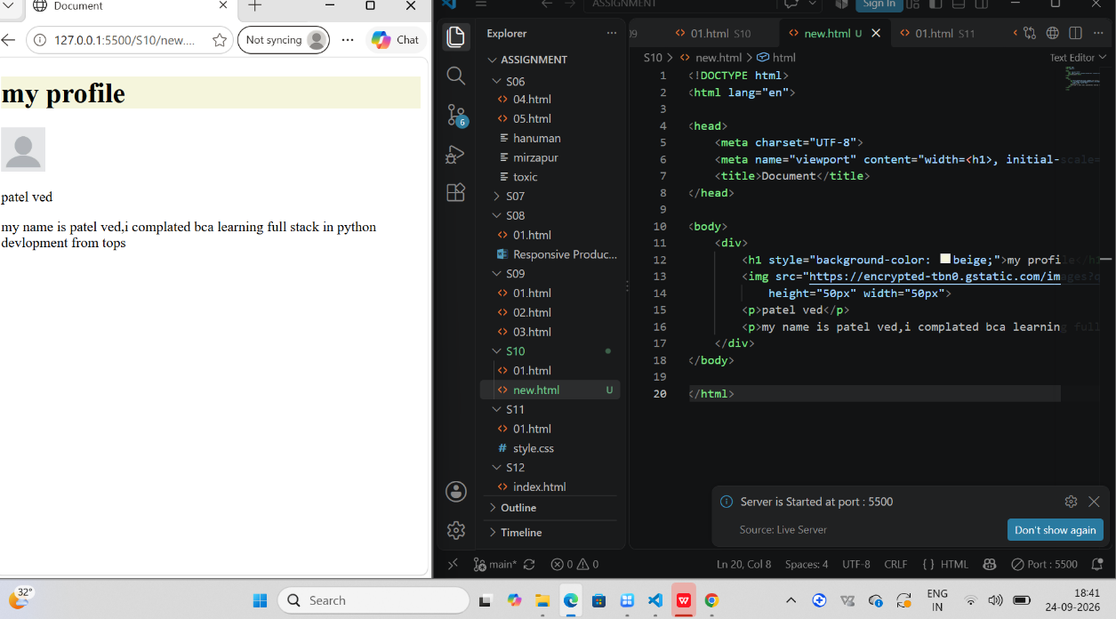

: 4 Draw a diagram or write a list showing the DOM structure (parent-child rela onships) of your myprofile.html page. Include at least 3 levels (html > body > your content). what is the task says to do and how
HTML
│
├── <html lang="en">
│ │
│ ├── <head>
│ │ │
│ │ ├── <meta charset="UTF-8">
│ │ │
│ │ ├── <meta name="viewport" ...>
│ │ │
│ │ └── < tle>
│ │ └── my profile
│ │
│ └── <body>
│ │
│ └── <div>
│ │
│ ├── <h1>
│ │ └── My Profile
│ │
│ ├── <img>
│ │ ├── src = "profile.jpg"
│ │ ├── alt = "profile image"
│ │ ├── height = "50px"
│ │ └── width = "50px"
│ │
│ ├── <p>
│ │ └── ved patel
│ │
│ └── <p>
│ └── my name is patel ved,i complated bca learning full stack in python development
│ from tops
│
│
└── </html>

