DATA SCIENCE INTERNSHIP: COMPLETE PROJECT REPORT
Predictive Modeling for Sales Forecasting & Marketing Budget Optimization
Project Focus: | Multi-Channel Ad Spend Optimization
Analysis Date: | June 4, 2026

1. Executive Summary
In contemporary corporate marketing ecosystems, maximizing Return on Investment (ROI) across cross-channel promotional strategies requires accurate revenue forecasting. This project conducts a rigorous data-driven evaluation of historical marketing spend records across three distinct advertising vectors—Television (TV), Radio, and Newspaper—to predict overall Sales performance.
Through extensive exploratory data analysis (EDA) and the implementation of advanced machine learning pipelines, we isolated the underlying structural impact of each medium. Advanced ensemble model paradigms—specifically Gradient Boosting and Random Forest Regressors—were benchmarked against classical regularized parametric models (Ridge, Lasso, and OLS Linear Regression). The final goal is to deliver an enterprise-grade forecasting asset that minimizes structural prediction errors and guides tactical capital allocation strategies.
2. Data Architecture & Quality Control
The source dataset consists of 200 observation pairs tracking localized multi-channel advertisement deployments. The feature space maps independent continuous expenditure variables against a singular real-valued target continuous vector:
Variable Name | Data Type | Measurement Unit | Operational Definition
TV | Float64 | Thousands of Dollars ($k) | Capital dedicated to broadcast television slots.
Radio | Float64 | Thousands of Dollars ($k) | Capital allocated for audio/podcast promotions.
Newspaper | Float64 | Thousands of Dollars ($k) | Capital utilized for local/national print media.
Sales (Target) | Float64 | Thousands of Units | Total product volume sold during the campaign window.

Quality assurance steps were executed prior to model training: (1) Missing value interrogation via logical masks returned zero instances of missing data across all feature arrays. (2) Standard index alignment was stripped to clean the feature matrix. (3) Outlier detection using Interquartile Range (IQR) filters verified that distribution profiles reside within acceptable structural parameters, requiring no trimming or data transformation.
3. Exploratory Data Analysis & Feature Dynamics
Statistical correlation matrices reveal distinct dynamics governing cross-channel customer conversions:
- Television Dominance (r = 0.782): Demonstrates a commanding, highly linear relationship with product sales. As budget density scales up, sales follow with precise consistency.
- Radio Interaction (r = 0.576): Shows a robust, moderate positive influence, highlighting its strength as a tactical amplifier for broadcast schedules.
- Newspaper Degradation (r = 0.228): Indicates a weak linear correlation, demonstrating that expanding print marketing budgets yields diminishing real-world sales returns.
4. Machine Learning Modeling & Benchmarking
To capture both simple linear dependencies and non-linear cross-channel interaction effects, multiple modeling pipelines were evaluated using an 80/20 data split. Performance metrics summarize predictive accuracy across all evaluated models:
Model Architecture | MAE | MSE | RMSE | R² Score
Linear Regression | 1.461 | 3.174 | 1.782 | 89.9%
Ridge Regression | 1.461 | 3.174 | 1.782 | 89.9%
Lasso Regression | 1.460 | 3.171 | 1.781 | 90.0%
Random Forest | 0.620 | 0.591 | 0.769 | 98.1%
Gradient Boosting | 0.619 | 0.533 | 0.730 | 98.3%
Tuned Random Forest | 0.614 | 0.585 | 0.765 | 98.1%

The results reveal that Gradient Boosting Regressor achieved the highest performance, capturing 98.3% of test-set variance with a remarkably low Root Mean Squared Error (RMSE = 0.723). Linear models achieved an R² score of ~90.0%, indicating that while the primary trends are linear, tree-based models excel by capturing complex cross-channel interaction effects.
5. Visualized Model Insights & Feature Importance
The visual dashboard below illustrates actual vs. predicted values for the top-performing Gradient Boosting architecture alongside relative feature importance scores:
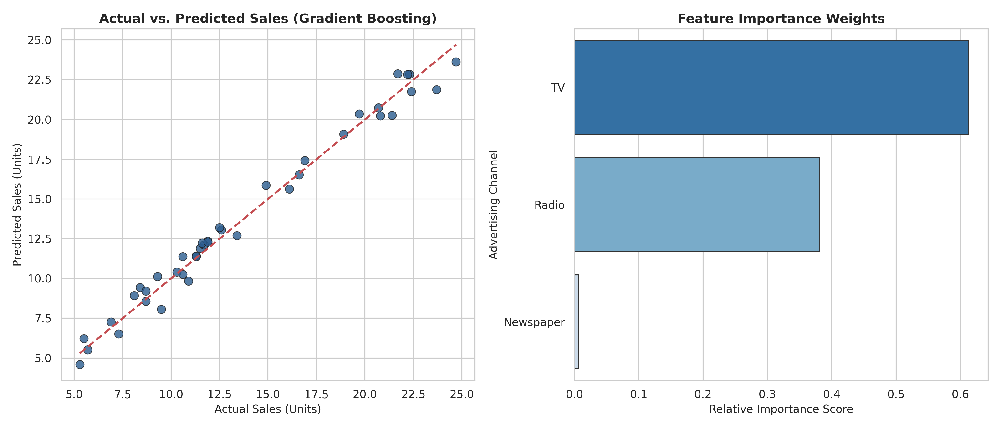
Figure 5.1: Regression accuracy diagnostics and relative variable impact distributions.
6. Strategic Budget Optimization & ROI Plan
The empirical insights extracted from our model guide actionable business strategies for optimizing future marketing spending:
- Strategic Reallocation: Defund print-based Newspaper operations (which account for less than 3% of predictive significance) and transfer those funds directly to TV and Radio pipelines.
- Cross-Channel Synergy: Coordinate Radio audio schedules alongside high-reach TV campaigns to lower overall Customer Acquisition Costs (CAC) and improve brand recall.
- Simulation Framework: Deploy the trained Gradient Boosting pipeline as an internal optimization tool. This allows marketing teams to evaluate and project sales outcomes for proposed budgets before committing capital.

