EE3-19 Real Time Digital Signal Processing

Project Report – Speech Enhancement

Julia Booth jb1613

Patrick Engelbert pe313
20/03/2016

Introduction
The objective of this project was to design and implement a real time system to reduce the background noise on a speech signal. The inspiration for this project was the speech enhancement implemented on mobile phones, which have to remove background noise from a speech signal without knowledge of what that noise will be. In order to do this we needed to make an estimation of the background noise and subtract it from the input signal. To estimate the background noise we made the assumption that a person stops speaking to breathe at least once every 10 seconds, at this moment in time the input signal will be just the background noise. We then subtract the frequency spectrum of this estimated background noise from the input signal to produce an output signal that is just the speaker’s voice.

Experiment
In this project we used a Texas Instruments C6713 DSP to implement the processing. The input analogue audio signal is sampled by an analogue to digital converter on the board containing the DSP chip. This sampled signal in separated into frames so that the frames can be stored in an input buffer, then each frame can be processed and then placed in the output buffer. The problem that can arise from this is that, if these frames do not overlap, when they are put back together there could be discontinuities at the frame boundaries, causing a “crackle” in the audio output. To combat this we window each frame, however this changes the data so we must then overlap the frames when we add them together at the output so that the result adds to a constant, to ensure that we do not lose information.
Once the input signal has been framed and windowed, we must convert the signal frames to the frequency spectrum as when we come to subtracting the noise, we will want to do this in the frequency domain. This requires implementing a Fast Fourier Transform (FFT) before doing the noise estimation and subtraction and then doing an Inverse Fast Fourier Transform (IFFT) once the processing is complete to return the signal to the time domain.
When the signal is in the frequency domain, we can then estimate the background noise. Using our assumption that a person stops speaking to breathe at least once every 10 seconds we can find the minimum input over the last 10 seconds and estimate that that signal is the background noise. We are then able to subtract the spectrum of the estimated noise from the input signal spectrum to remove the background noise and just leave the spectrum for the speech. This signal is then transformed back into the time domain, windowed again and then converted back to an analogue signal using the digital to analogue converter on the board.
The implementation of the processes described above is given below.

Frame Extraction
In order to process the input signal in real time, rather than storing the entire input signal before processing it, we need to split the signal into smaller frames that can then be stored in the input buffer. When choosing the length of the frame we must consider the fact that long frames provide good frequency resolution but bad time resolution, require more processing and increase the overall delay from input to output. Whereas short frames have good time resolution but bad frequency resolution. We must also consider that the FFT will be most efficient for frames with a length that is a power of 2. Therefore we used a frame length of 256 samples which meant that each frame represented 32ms of the input signal (given 8 kHz sampling rate), having a good compromise between time and frequency resolution. The frame also does not require too much memory space to store. We use a processing buffer that contains 4 frames (plus 1 extra frame used in overlap add, see below), representing the last 10 seconds of input, this design choice will become clear when it comes to estimating the noise.
The implementation of frame extraction in our code is given below:
Figure 1: Definitions at the head of the code used for frame extraction
Figure 2: Interrupt handler placing input samples into input buffer
Figure 3: ProcessFrame function (called in main) executing frame extraction

Input samples are read into the input buffer by the interrupt handler. When the previous frame has been filled with samples from the input buffer, the next frame begins to be filled. In our implementation we also window the values as we extract them into the frames.

Fast Fourier Transform and Inverse Fast Fourier Transform
The estimation and the subtraction of the noise must be conducted in the frequency domain. We have used FFT to transform the frames in the input buffer from the time domain to the frequency domain and place it into the processing buffer and the FFT is the least computationally expensive way in which to do this. It is important for this to be as fast as possible for the processing to be in real time. The FFT uses multiply accumulate operations to implement a faster version on the Discrete Fourier Transform (DFT):
$$DFT: X\left(k\right)= \sum_{n=0}^{N-1}{x\left(n\right)W_{N}^{nk} }where k=0 to (N-1) and W=e^{-j2π/N}$$

For 2 samples, DFT can be written as:
x(0)
x(1)
X(0)
X(1)
-1
Figure 4: Butterfly diagram of FFT implementation
$$X\left(k\right)=x\left(0\right)W_{2}^{0}+x\left(1\right)W_{2}^{k}$$
$$X\left(0\right)=x\left(0\right)+x(1)$$
$$X\left(1\right)=x\left(0\right)-x(1)$$

The IFFT implements the reverse multiply accumulate:
$$x\left(0\right)=X\left(0\right)+X(1)$$
$$x\left(1\right)=X\left(0\right)-X(1)$$
Code (need CCS linker) and implementation

Noise Spectrum Estimation
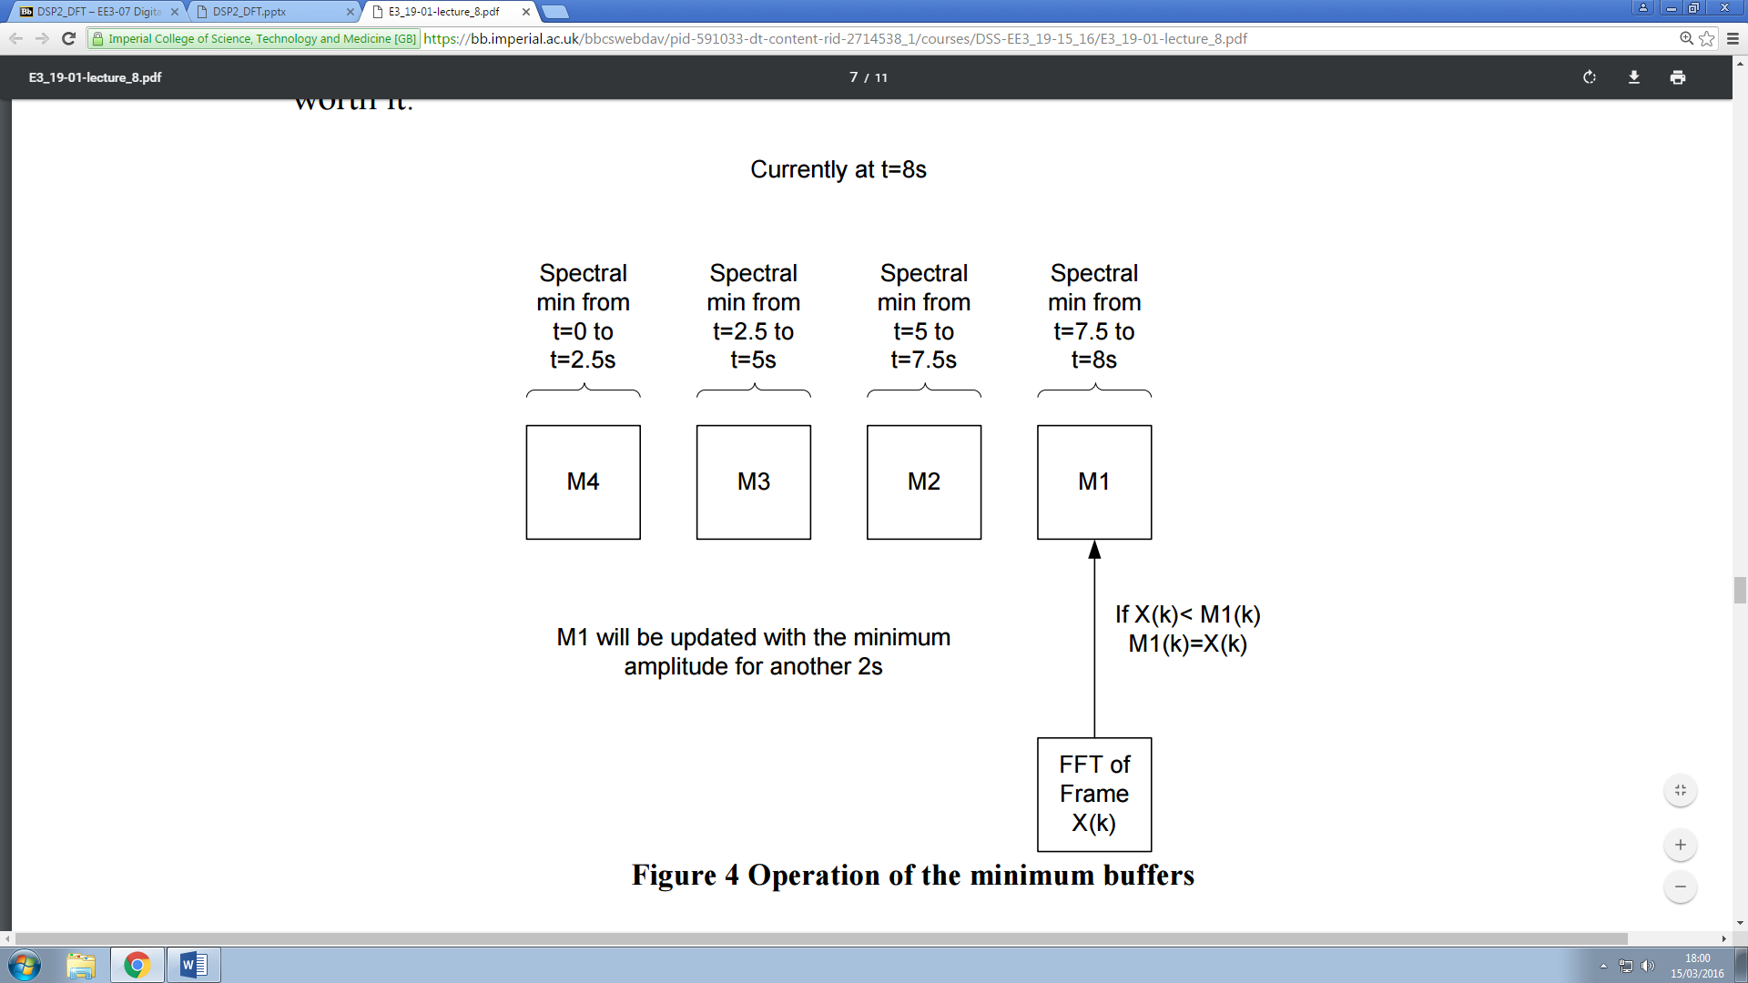
Using the assumption that a person stops talking at least once every 10 seconds to breathe, we can estimate the background noise. We know that when there is a pause in the speech the input signal will just contain the background noise. Therefore if we find the minimum input signal in the last 10 seconds we can assume that that is the noise spectrum that we need to subtract. To find this minimum we can store and transform all of the frames for the last 10 seconds of input and compare them all with each other, but this will be slow and require a large amount of memory. In our implementation we use a processing buffer of 4 frames, each representing a previous input in a period of 2.5 seconds. The newest frame is read from the input buffer and is compared with the frame stored in the current index in the processing buffer. The minimum is taken and stored in that position in the processing buffer. This continues to happen for every new input frame for 2.5 seconds, at the end of the 2.5 seconds the processing buffer index is incremented and the new input frame is placed into the different position in the processing buffer:
Figure 6: Noise minimum buffer implementation
The noise is then estimated from the minimum spectrum of the 4 frames in the processing buffer. Our implementation is given below:
Figure 7: Noise estimation implementation in code (part of processFrame function)
In our implementation, if you have just started a new 2.5 second block (ie. a new frame in the buffer) load the frame from the FFT of the input into the corresponding noise estimation frame. For each subsequent frame, compare with the current minimum of the current 2.5 second period and put store the minimum frame. Using the frame you have just stored as the minimum for the current 2.5 second period, take the minimum of the 4 frames in the noise estimation buffer representing the last 10 seconds, and use this as the estimate for the noise. Subtract the estimated noise spectrum using the spectralSubtraction function (see below).

Noise Spectrum Subtraction
Once we have the spectrum of the estimated noise we can subtract it from the spectrum of the input to leave the speech as the output. However, because we do not want the subtraction to have any effect on the phase of the signal, we must subtract the magnitudes.
$$\left|Y(k)\right|= \left|X(k)\right|- \left|N(k)\right|$$
To maintain the phase of the input signal in the output we have to do the following:
$$Y\left(k\right)= X(k)\left(\frac{\left|X(k)\right|- \left|N(k)\right|}{\left|X(k)\right|}\right)$$
$$Y\left(k\right)= X(k)\left(1- \frac{\left|N(k)\right|}{\left|X(k)\right|}\right)$$
$$Y\left(k\right)= X(k)G(k)$$
However, if G(k) is 0 it gives rise to “musical notes” in the output. Therefore, when G(k) is close to 0 we should use a value a little above 0:
$$G\left(k\right)=max⁡\left\{λ, \left(1- \frac{\left|N(k)\right|}{\left|X(k)\right|}\right)\right\}$$
We usually use a multiplication factor for $\frac{\left|N(k)\right|}{\left|X(k)\right|}$ to estimate the average noise, giving a better $G\left(k\right)$:
$$G\left(k\right)=max⁡\left\{λ, \left(1- α\frac{\left|N(k)\right|}{\left|X(k)\right|}\right)\right\}$$
Our implementation of spectral subtraction in code is given below:
Using the noise estimation (see above) we calculate the value of $\frac{\left|N(k)\right|}{\left|X(k)\right|}$ and calculate the output spectrum as explain above.
Figure 8: Implementation of spectral subtraction (called by processFrame function)

Overlap Add and Hamming window
In order to remove “crackle” in the output caused by spectral artifacts at the edges of frames, we used windowing and overlap add processing. The windowing removes the discontinuities and the end of frames but it also changes the signal data, to remove this problem we overlap the frames and add them together. For this to work we need the windows, when added, to sum to 1. We therefore use the square root of the Hamming window:
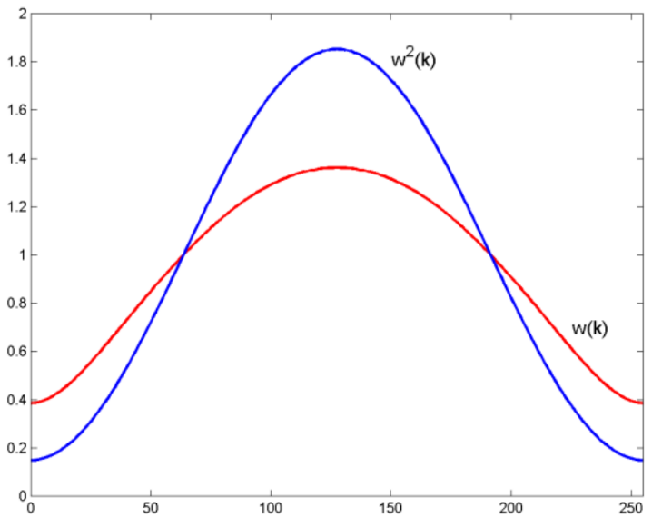

$$w^{2}\left(k\right)=Hamming window$$

$$w\left(k\right)=\sqrt{1-0.85185\cos{(\frac{\left(2k+1\right)π}{N})}}$$
$$where k=0 to (N-1)$$
Figure 9: Plot of Hamming window and its square root

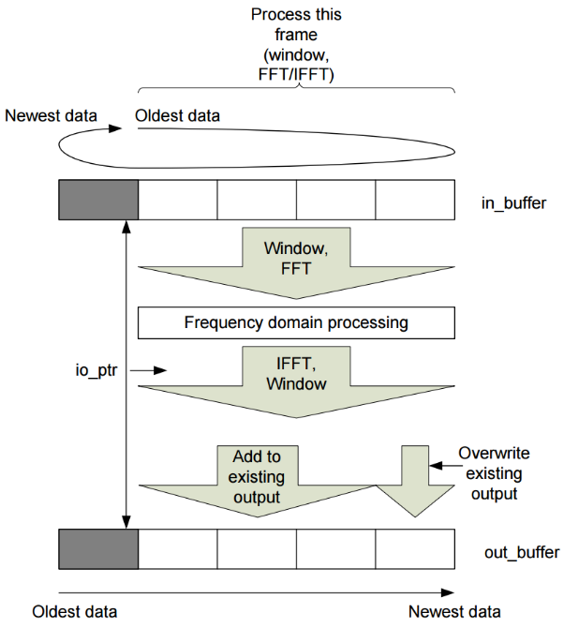
Once the windowing has occurred the frames must be added to create the output. The most recent input frame that has now had its noise removed is written to the top frame of the output buffer. The 3 other frames in the processing buffer are added to the corresponding frames in the output buffer:
Figure 10: Implementation of the overlap add process

Our implementation is shown below:
The windowing of the input can be seen in the frame extraction code (see above). For the output, the output buffer is overlapped with the frames in the buffer resulting from the IFFT which is windowed.
Figure 11: Implementation of the overlap add (in processFrame function)

Enhancements and Optimizations

Results
Scope traces and FFTs
Listening test
“You can use Windows to replay the test signals via the soundcard.”

Potential Future Developments

Conclusion

References
RTDSP
DSP

Appendix
code

