**Supplementary Information for**

**Insect herbivores drive sex allocation in angiosperm flowers**

Carlos Roberto Fonseca, Martin M. Gossner, Johannes Kollmann, Martin Brändle, Gustavo Brant Paterno

Carlos Roberto Fonseca, Email: fonseca@gmail.com

Gustavo Brant Paterno, Email: paternogbc@gmail.com

**This PDF file includes:**

Supplementary Text

Supplementary References

Supplementary Figures 1 to 11

Supplementary Tables 1 to 9

Legends for Dataset S1

**Other supplementary materials for this manuscript include the following:**

Datasets S1

Data and R code supporting all findings of this study are available in the GitHub repository: https://github.com/paternogbc/ms_redqueen_plant_herbivores

**Supplementary Text**

**The plant data set**

The plant data set, containing 141 species (Table S1), included flower maleness (defined as the ratio of the androecium dry biomass to the dry biomass of androecium plus gynoecium), besides maximum plant height (m), specific leaf area (SLA, mm2 mg-1), pollinator guild, flower colour, flower shape, and nectar amount (Kleyer *et al*. 2008, Kühn *et al*. 2004). Pollinator guild followed a simplified version of the classification system proposed by Müller (1881), with nine classes of pollinators (Table S2). Flower shape followed a simplified version of the classification system of Kugler (1955, 1970), with ten types of flower shape (Table S3). Flower colour followed a system with 12 types, but flower categories with less than nine species in the data set were grouped into ‘other’. Nectar amount was classified into four categories: none, little, present, and plenty. Literature sources for outcrossing rate is presented in Table S4.

**The insect data set**

The insect data-set, containing 4340 plant-herbivore records for 2487 insect species (137 families and seven orders) associated with the 141 plant species of the plant data-set, was compiled by an extensive review of the published literature and online sources for the German flora (Table S5; for the complete list of the literature sources, see SI Dataset S1). The search started by downloading insect species lists for Germany of relevant phytophagous and xylophagous taxa from the Fauna Europaea web service (Fauna Europaea 2020), except for beetles where we used the records and taxonomy according to the Palaearctic Catalogue (Löbl & Smetana 2013). These lists and their nomenclature formed the taxonomic backbone for our compilation. We subsequently screened monographs and electronic resources for host-plant records. For a number of taxa, we used multiple sources that partly listed host-records on different taxonomic resolutions. Here we considered all provided entries. For the hemimetabolous orders, we included host plants of larvae and adults that are mostly identical, while for the holometabolous orders the host plants of the larvae and adults often differ but were both accepted. Host-plant records were available on different taxonomic resolutions, but we only considered entries on species level here. After entering the host records, we checked the plant names according to The Plant List (2020). Since, short-lived herbivores of other invertebrate groups have been recorded, we also extracted data for 51 Arachnida species (62 records; Trombidifomes, Prosigmata) and nine Nematoda species (47 records; Secernentea: Aphelenchida, Tylenchida).

**Feeding guild and specialization categories**

The guilds described the combination of ten insect feeding modes (i.e. chewing, chewing-vagrant, sucking, sucking-vagrant, gall, gall inquiline, miner, borer, spuner, and oviposition scar) and 13 plant organs or tissues eaten by the herbivores (i.e. leaf, stem, shoot, wood, phloem, xylem, mesophyll, bud, root, root collar, ripe seed, and reproductive organs). In total, 44 feeding guild categories were recorded. Notice that a single insect species can be classified in more than one feeding guild category. We calculated the number of guilds associated with each plant species as the sum of all categories represented by the interacting insect herbivores. Feeding guild diversity was calculated based on the number of insect species within each guild category using Shannon index (natural-base logarithmic). In order to include plant species with no recorded association, we added a dummy feeding guild with a single insect species to all plant species.

In order to investigate the effect of host specialization on flower maleness, each insect species was classified in three categories of feeding specialization: (i) monophagous–insects feeding on a single plant species, (ii) family specialists–insects feeding on several species within a single plant family, and (iii) generalists–insects feeding on more than one plant family. Thus, we derived three additional explanatory variables: number of monophagous, family specialist, and generalist insect herbivores. To evaluate the sensitivity of the results to feeding specialization categories, we also performed the analyses with just two classes: specialists (i.e. insects feeding on one or more species from a single plant genus) and generalists (i.e. insects feeding on multiple genera or families).

**Sensitivity analyses**

The robustness of the relationship between flower maleness and number of insect herbivore species was confirmed by a series of sensitivity analyses performed in the R package sensiPhy (Paterno et al. 2018).

(a) Sampling effort and species set–simulated phylogenetic regressions were performed after the random deletion of 5, 10, 20, 30, 40, and 50% of the species from the full dataset (S = 141 species). For each percentage of species removal, we performed 1000 runs. Then, the estimate distributions from the simulated regressions were compared with estimates from the full dataset.

(b) Influential clades–simulated phylogenetic regressions were performed after the removal of the most speciose (>10 species) families and orders, and their estimates were compared with the estimates of the full dataset. Since the removal of a taxonomic group decreases the sample size from *S* to *s* species, the simulated estimates were compared with a null model distribution generated by phylogenetic regressions with s species (n = 1000 runs).

(c) Phylogenetic uncertainty–the estimates of the full dataset obtained by our working phylogeny were compared to regression estimates obtained by phylogenetic regressions using 300 alternative phylogenies. For the list of species with uncertain phylogenetic position, see Table S6.

**Working phylogeny and its uncertainties**

For the main comparative analyses, we used a working phylogenetic tree including 141 study species from 106 genera, 44 families, and 22 orders (Fig. S3). The phylogeny was generated with the R package “V.PhyloMaker” v0.1.0 (Jin & Qian 2019), that uses a combination of two published mega trees as backbone phylogeny (Zanne et al. 2014; Smith & Brown 2018). In the working phylogeny, 22 species not represented within the megatree (Table S6) were added to the basal node of their genera following scenario 3 of Qian & Jin (2016). From those, however, only 12 species had an uncertain phylogenetic position due to the presence of other species in their genera. To evaluate the uncertainty created by such arbitrary decision, we generated 300 alternative trees in the R package V.PhyloMaker v0.1.0 (Jin & Qian 2019) by binding each missing species in the megatree at a random position below their genus basal node, following scenario 2 of Qian & Jin (2016). These 300 trees reflect the uncertainty in missing species placement in the backbone tree (Fig. S4a).

**Intraspecific uncertainty**

In comparative studies, when data come from field/lab work, there is a clear trade-off between describing more species less precisely or less species well. In our sampling design we decided to collect flower data from ten individuals from a single population in order to increment the number of plant lineages and gain degrees of freedom in the comparative analyses. Thus, we have information on the within-population variance but we lack information on the variance between-populations. In order to investigate the effect of this sampling limitation, we performed the analysis between flower maleness and number of insect herbivore species under three different scenarios: one, 1.5, and 2 times the observed intra-population variance on flower maleness. The first scenario incorporated the intra-population variation while the last two scenarios simulated the addition of increasing levels of potential between-population variation. The simulations, with 10,000 runs each, were performed with the function intra.phylm in the R-package sensiPhy (Paterno et al. 2018). The results indicated that the relationship between flower maleness and number of insect herbivore species remained unaffected by both the incorporation of the observed intra-population variation (βmean = 0.23, P = 0.0028, Fig. S5a–c) and addition of simulated lower (βmean = 0.23, P = 0.0149, Fig. S5d–f) and higher (βmean = 0.23, P = 0.0316, Fig. S5g–i) inter-population variation.

**Supplementary References**

Fauna Europaea (2020). Fauna Europaea. Available at: http://www.faunaeur.org/. Last accessed 27 APRIL 2021.

Jin, Y. & Qian, H. (2019). V.PhyloMaker: an R package that can generate very large phylogenies for vascular plants. *Ecography*, 42, 1353–1359.

Kleyer, M., Bekker, R.M., Knevel, I.C., Bakker, J.P., Thompson, K., Sonnenschein, M. et al. (2008). The LEDA Traitbase: a database of life-history traits of the Northwest European flora. *J. Ecol*., 96, 1266–1274.

Kugler, H. (1955). *Blütenökologie*. 1st edn. Gustav Fischer, Jena.

Kugler, H. (1970). *Blütenökologie*. 2nd edn. Gustav Fischer, Jena.

Kühn, I., Durka, W. & Klotz, S. (2004). BiolFlor – a new plant-trait database as a tool for plant invasion ecology. *Divers. Distrib.*, 10, 363–365.

Löbl, I. & Smetana, A. (1971). *Catalogue of Palearctic Coleoptera*. Apollo Books, Stenstrup.

Müller, H. (1881). *Alpenblumen, ihre Befruchtung durch Insekten und ihre Anpassungen an Dieselben*. Engelmann, Leipzig.

Paterno, G., Penone, C. & Werner, G.D.A. (2018). sensiPhy: An r- package for sensitivity analysis in phylogenetic comparative methods. *Methods* *Ecol*. *Evol*., 9, 1461–1467.

Qian, H. & Jin, Y. (2016). An updated megaphylogeny of plants, a tool for generating plant phylogenies and an analysis of phylogenetic community structure. *J. Plant Ecol.*, 9, 233–239.

Smith, S.A. & Brown, J.W. (2018). Constructing a broadly inclusive seed plant phylogeny. *Am. J. Bot.*, 105, 302–314.

The Plant List (2020). The Plant List. Available at: http://www.theplantlist.org. Last accessed 27 APRIL 2021.

Zanne, A.E., Tank, D.C., Cornwell, W.K., Eastman, J.M., Smith, S.A., FritzJohn, R.G. et al. (2014). Three keys to the radiation of angiosperms into freezing environments. *Nature*, 506, 89–92.

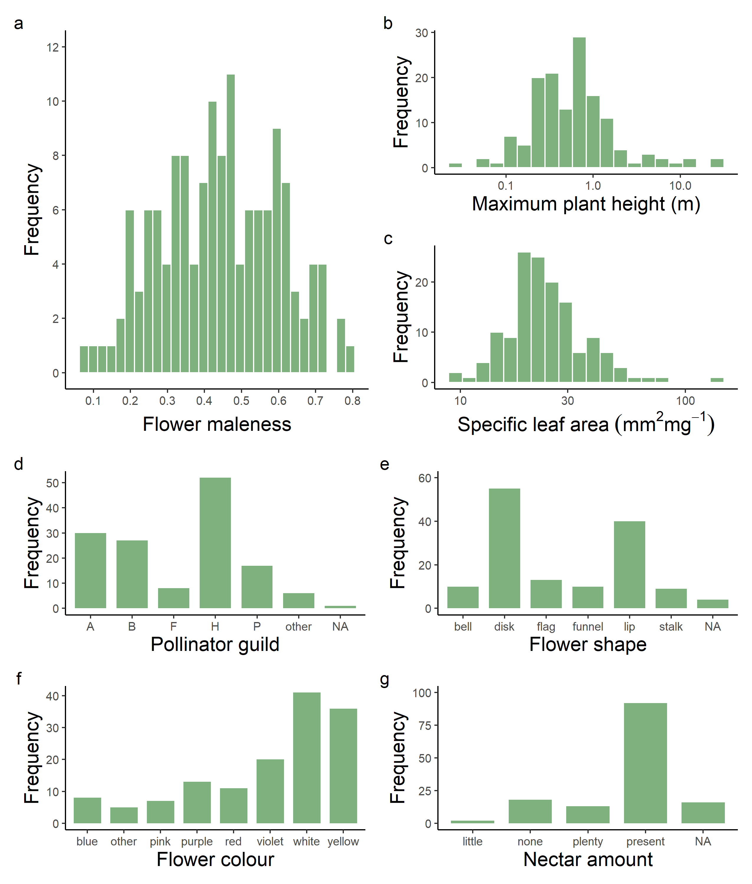

Fig. S1. Plant trait distributions. Frequency distribution of (a) flower maleness, (b) maximum plant height (m), (c) specific leaf area–SLA (mm2mg-1), (d) pollinator guild, (e) flower shape, (f) flower colour, and (g) nectar amount across 141 angiosperm species. Flower maleness was calculated dividing the dry biomass of androecium divided by the dry biomass of the primary sexual organs (androecium plus gynoecium).

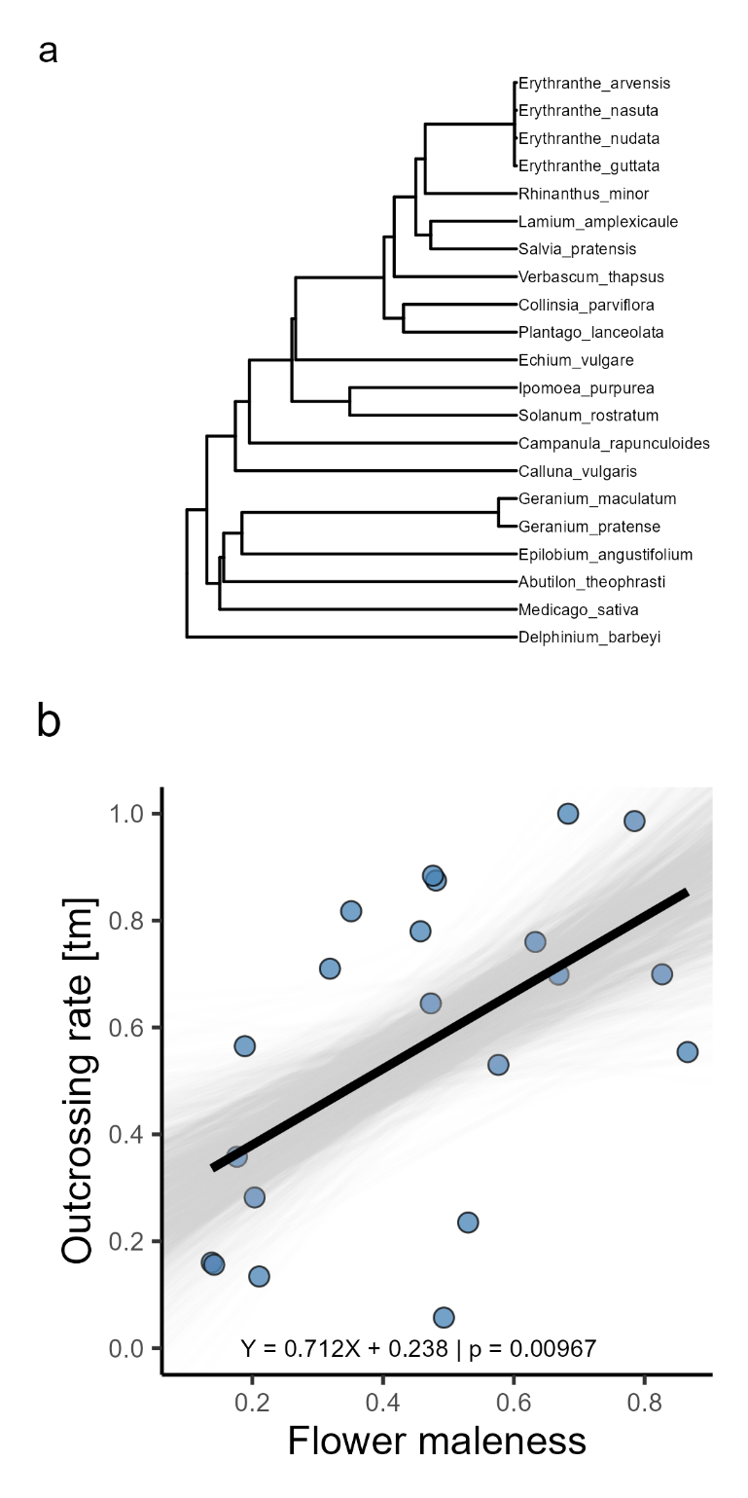

Fig. S2. Literature data supporting the use of maleness as proxy for outcrossing effort (N = 21 angiosperm species). (a) Phylogenetic hypothesis of the 21 plant species, (b) Relationship between flower maleness and outcrossing rate. Of the 21 plant species, only ten are included in our original plant data-set. Considering only those ten species, the relationship is also significant (Y = 1.062X + 0.263, p = 0.01892). The thick black regression line was generated by PGLS while the thin grey lines represent their uncertainty (i.e. 1000 bootstrap estimates).

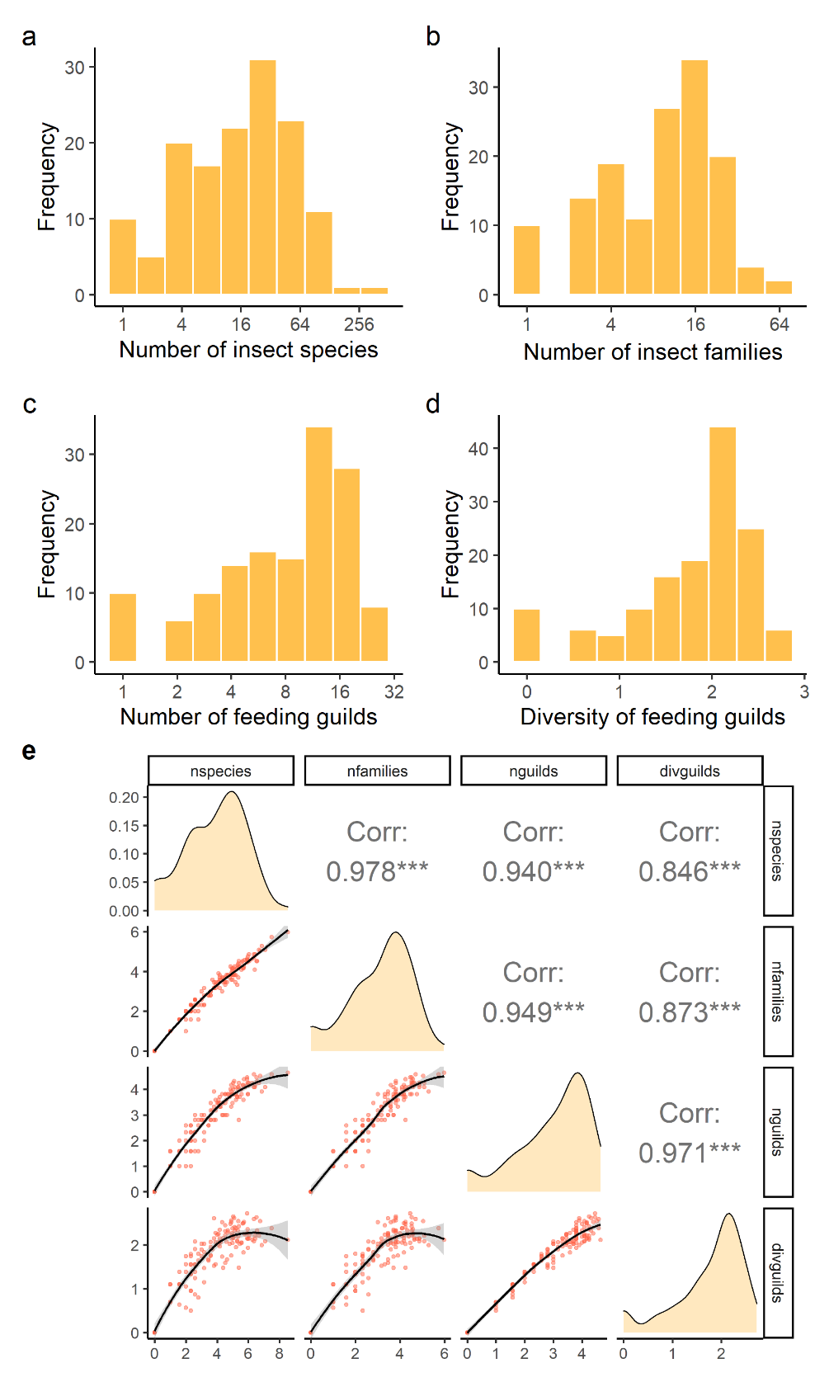

Fig. S3. Insect trait distributions and their cross-correlations. Frequency distribution of (a) number of insect herbivore species (range: 0–369, median = 17), (b) number of insect families (0–62, median = 10), (c) number of feeding guilds (0–24, median = 9), and (d) diversity of feeding guilds (0–2.72, median = 2), across the 141 angiosperm species. In (e) Pearson correlation (Corr) among the insect herbivore descriptors. The three first explanatory variables were log-transformed (log2 x + 1); diversity of feeding guilds was calculated by ln-based Shannon index (H’).

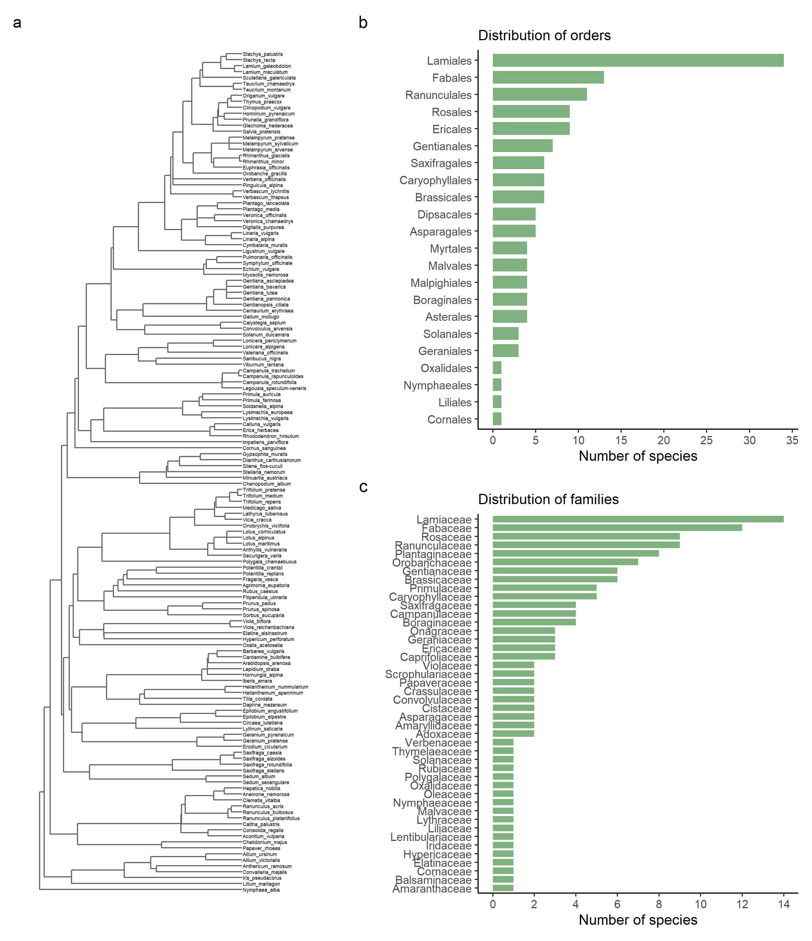

Fig. S4. Working phylogeny and taxonomic distribution. (a) Working phylogeny of the 141 hermaphrodite angiosperm species of the study, and species distribution across (b) 22 orders, and (c) 44 families.

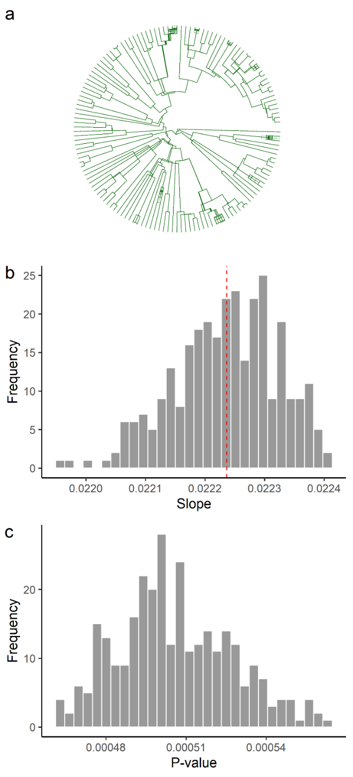

Fig. S5. Sensitivity analysis for phylogenetic uncertainty. (a) Overlap of 300 alternative trees to illustrate the phylogenetic uncertainty due to 12 species of uncertain positioning. Frequency distribution of (b) slopes and (c) associated P-values of PGLS regressions between flower maleness and number of insect herbivore species performed with 300 alterative phylogenetic trees. The red dashed line represents the average estimated slope across trees.

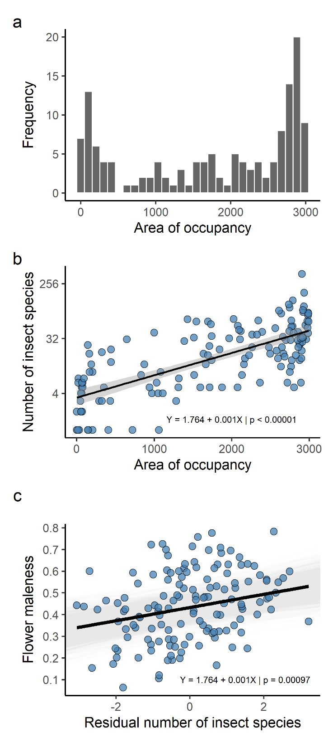

Fig. S6. Controlling for the plant geographic distribution. (a) Frequency distribution of the area of occupancy of the plant species, (b) effect of the area of occupancy on the number of insect herbivore species, (c) effect of the residual number of insect species (i.e. residual of Fig. 7b) on flower maleness. Area of occupancy was estimated as the number of TK25 quadrats across Germany (see methods). In (b) the thick black line represents a standard regression and the grey shade its standard error. In (c) the thick black regression line was generated by PGLS while the thin grey lines represent their uncertainty (i.e. 1000 bootstrap estimates). N = 140 angiosperm species.

~~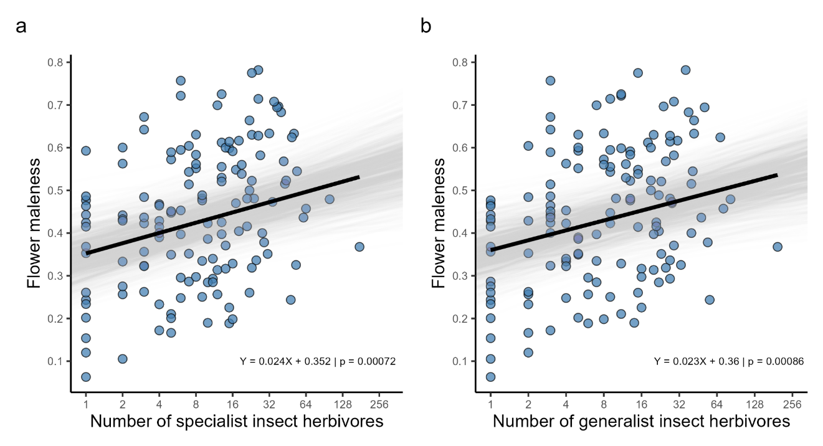~~

**Fig. S7.** Evolutionary relationship between flower maleness and (a) number of specialist herbivores, (B) generalist herbivores. Notice that the slope for specialist herbivores (β = 0.024 [CI: 0.010, 0.037]) are very similar than for generalist herbivores (β = 0.023 [CI: 0.009, 0.035]). In this figure, specialist herbivores are defined as insects feeding on one or more species from a single plant genus while generalist herbivores feed on species from more than a genera or family. The thick black regression lines were generated by Phylogenetic Generalized Least Square (PGLS) to consider the phylogenetic structure of the data, while the thin grey lines represent their uncertainty (1000 bootstrap estimates). Flower maleness was calculated as the ratio between the dry biomass of androecium by the dry biomass of the primary sexual organs (androecium plus gynoecium). All explanatory variables were log-transformed (log2 x + 1).

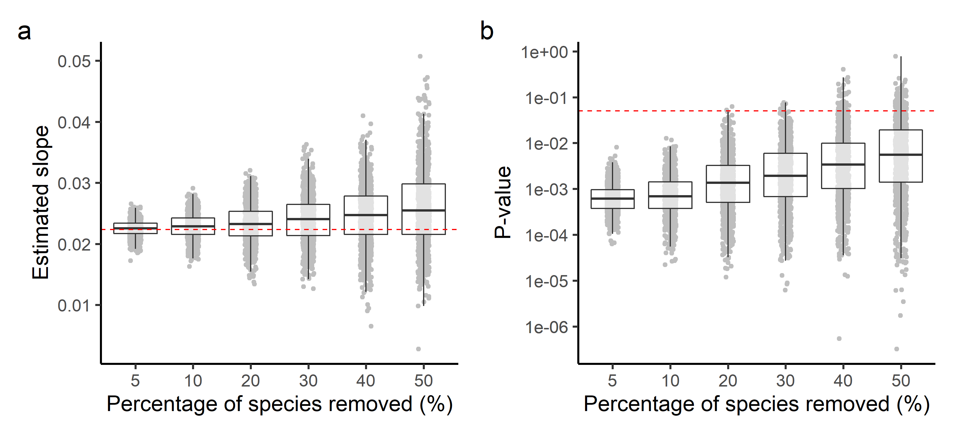

Fig. S8. Sensitivity analysis for sampling uncertainty. Box-plot of (a) slopes and (b) associated probabilities of the relationship between flower maleness and number of insect herbivore species as estimated by simulations performed with random subsets of the full data-set. In the simulations, 5–50% of the species were removed (N = 1000 trials for each percentage level). The orange line in (a) represents the estimated slope with the full dataset, while the red dashed line in (b) represents the significance level of 0.05.

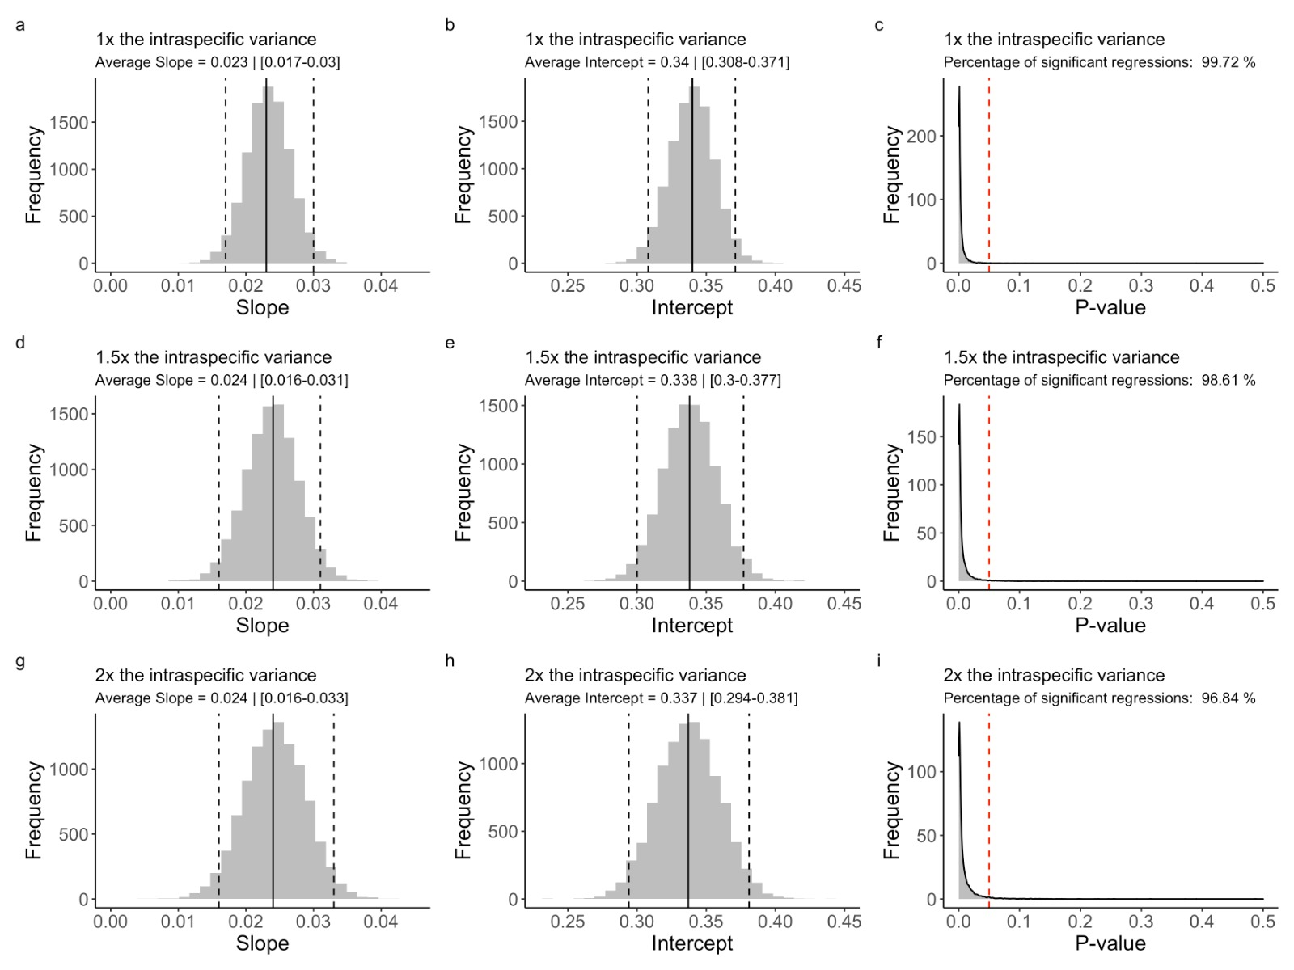

Fig. S9 Sensitivity analyses testing the effect of different intraspecific variation scenarios on the slope, intercept and P-value of the relationship between number of insect herbivore species and flower maleness. Scenario 1 - incorporation of the observed intra-populational variance (top row). Scenario 2 – incorporation of one and a half times the observed intra-populational variance. Scenario 3 – incorporation of two times the observed intra-populational variance. The last two scenarios simulated the addition of increasing levels of potential between-population variation. The histograms represent the results of the simulated runs. The vertical black lines represent the average slope (a,d, g) and intercept (b, e, h) of the simulations while the vertical dashed lines represent the 95% confidence interval. The vertical red dashed lines (c, d, i) represent the alpha value of 0.05. The percentage of significant runs are indicated in the subtitles of Fig. S9c, f, i. The sensitivity analysis of each one of the three scenarios were performed with 10,000 runs of Phylogenetic Generalized Least Square regression (PGLS) on the R-package sensiPhy (Paterno et al. 2018).

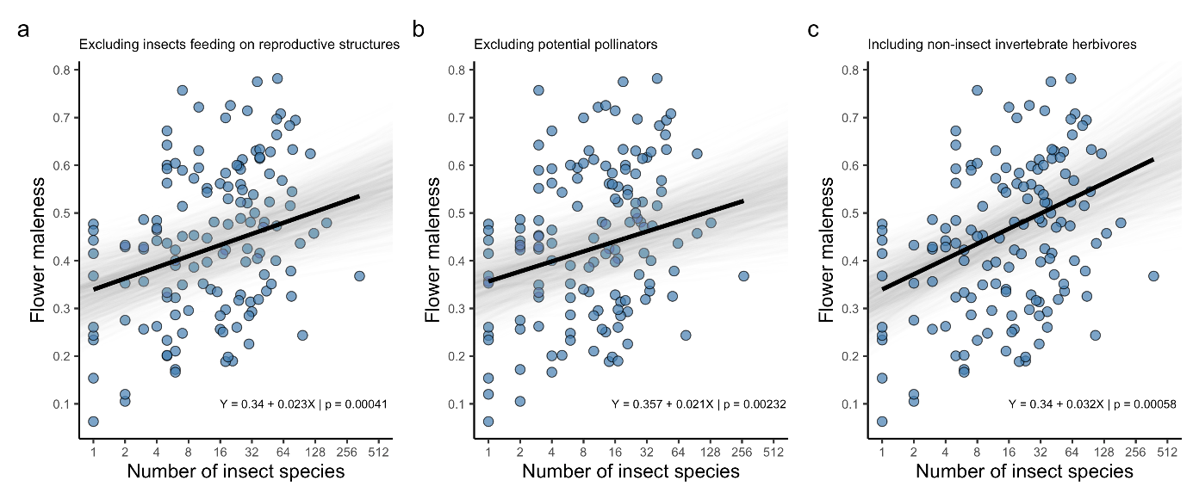

Fig. S10. Testing the main hypothesis with alternative data-sets. Phylogenetic generalized least squares (PGLS) regressions between flower maleness and the number of insect herbivores after (a) the exclusion of insect herbivores feeding on reproductive structures (i.e. including insect herbivores feeding exclusively on vegetative structures), (b) the exclusion of potential pollinator species, and (c) the inclusion of records of non-insect invertebrate herbivores (i.e. 62 galling Arachnida and 47 root nematodes, see Supplementary information). The thick black regression lines were generated by PGLS, while the thin grey lines represent their uncertainty (i.e. 1000 bootstrap estimates).

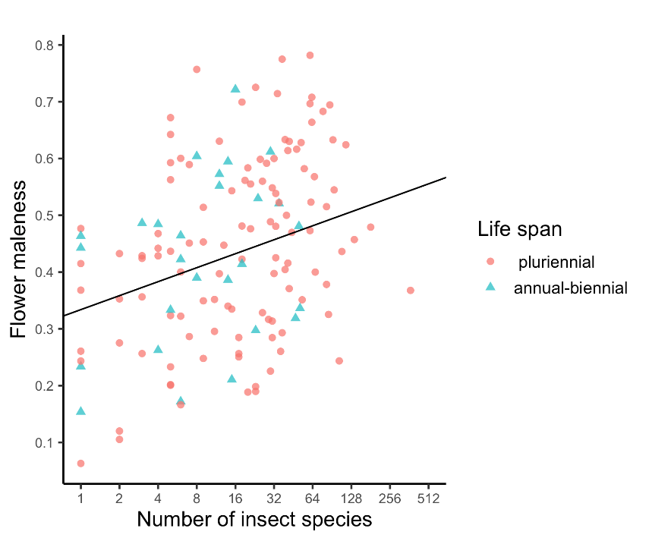

Fig. S11 Testing the effect of life span on the relationship between number of insect herbivore species and flower maleness. A single regression model is shown (PGLS, β = 0.0224 ± 0.0062, P = 0.00047, n = 141 plant species, r2 = 0.35), since the intercepts of the two relationships are similar (difference = 0.0339 ± 0.0604, t = 0.576, P = 0.609) as well as their slopes (difference = -0.0165 ± 0.0160, t = -1.03, P = 0.304). The species were classified as annual-biennials (N = 27 species) and pluriennials (N = 114 species) according to the BiolFlor database (Kühn et al. 2004).

Table S1. Taxonomic classification of the 141 angiosperm species included in this study.

|  |  |  |  |  |
| --- | --- | --- | --- | --- |
| **Order** | **Family** | **Species** | **Authority** | **ID\*** |
| Asparagales | Amaryllidaceae | *Allium ursinum* | L. | kew-296893 |
| Asparagales | Amaryllidaceae | *Allium victorialis* | L. | kew-296917 |
| Asparagales | Asparagaceae | *Anthericum ramosum* | L. | kew-299665 |
| Asparagales | Asparagaceae | *Convallaria majalis* | L. | kew-303076 |
| Asparagales | Iridaceae | *Iris pseudacorus* | L. | kew-322261 |
| Asterales | Campanulaceae | *Campanula rapunculoides* | L. | kew-365789 |
| Asterales | Campanulaceae | *Campanula rotundifolia* | L. | kew-365918 |
| Asterales | Campanulaceae | *Campanula trachelium* | L. | kew-366545 |
| Asterales | Campanulaceae | *Legousia speculum-veneris* | (L.) Durande ex Vill. | kew-358587 |
| Boraginales | Boraginaceae | *Echium vulgare* | L. | kew-2784423 |
| Boraginales | Boraginaceae | *Myosotis nemorosa* | Besser | kew-2358116 |
| Boraginales | Boraginaceae | *Pulmonaria officinalis* | L. | kew-2413004 |
| Boraginales | Boraginaceae | *Symphytum officinale* | L. | kew-2475636 |
| Brassicales | Brassicaceae | *Arabidopsis arenosa* | (L.) Lawalrée | kew-2645201 |
| Brassicales | Brassicaceae | *Barbarea vulgaris* | R.Br. | kew-2669712 |
| Brassicales | Brassicaceae | *Cardamine bulbifera* | (L.) Crantz | kew-2699536 |
| Brassicales | Brassicaceae | *Hornungia alpina* | (L.) O.Appel | kew-2853403 |
| Brassicales | Brassicaceae | *Iberis amara* | L. | kew-2859697 |
| Brassicales | Brassicaceae | *Lepidium draba* | L. | kew-2342458 |
| Caryophyllales | Amaranthaceae | *Chenopodium album* | L. | kew-2716945 |
| Caryophyllales | Caryophyllaceae | *Dianthus carthusianorum* | L. | kew-2763976 |
| Caryophyllales | Caryophyllaceae | *Gypsophila muralis* | L. | kew-2836754 |
| Caryophyllales | Caryophyllaceae | *Minuartia austriaca* | (Jacq.) Hayek | kew-2370880 |
| Caryophyllales | Caryophyllaceae | *Silene flos-cuculi* | (L.) Greuter & Burdet | kew-2485564 |
| Caryophyllales | Caryophyllaceae | *Stellaria nemorum* | L. | kew-2482625 |
| Cornales | Cornaceae | *Cornus sanguinea* | L. | kew-47495 |
| Dipsacales | Adoxaceae | *Sambucus nigra* | L. | kew-2486519 |
| Dipsacales | Adoxaceae | *Viburnum lantana* | L. | kew-2455932 |
| Dipsacales | Caprifoliaceae | *Lonicera alpigena* | L. | kew-2340042 |
| Dipsacales | Caprifoliaceae | *Lonicera periclymenum* | L. | kew-2357110 |
| Dipsacales | Caprifoliaceae | *Valeriana officinalis* | L. | kew-2464616 |
| Ericales | Balsaminaceae | *Impatiens parviflora* | DC. | kew-2862981 |
| Ericales | Ericaceae | *Calluna vulgaris* | (L.) Hull | kew-2692970 |
| Ericales | Ericaceae | *Erica herbacea* | L. | kew-2793460 |
| Ericales | Ericaceae | *Rhododendron hirsutum* | L. | kew-2419508 |
| Ericales | Primulaceae | *Lysimachia europaea* | (L.) U.Manns & Anderb. | kew-2896575 |
| Ericales | Primulaceae | *Lysimachia vulgaris* | L. | kew-2492070 |
| Ericales | Primulaceae | *Primula auricula* | L. | kew-2564954 |
| Ericales | Primulaceae | *Primula farinosa* | L. | kew-2564807 |
| Ericales | Primulaceae | *Soldanella alpina* | L. | kew-2599168 |
| Fabales | Fabaceae | *Anthyllis vulneraria* | L. | ild-7194 |
| Fabales | Fabaceae | *Lathyrus tuberosus* | L. | ild-8888 |
| Fabales | Fabaceae | *Lotus alpinus* | (DC.) Ramond | ild-8898 |
| Fabales | Fabaceae | *Lotus corniculatus* | L. | ild-7260 |
| Fabales | Fabaceae | *Lotus maritimus* | L. | ild-7292 |
| Fabales | Fabaceae | *Medicago sativa* | L. | ild-8536 |
| Fabales | Fabaceae | *Onobrychis viciifolia* | Scop. | ild-5130 |
| Fabales | Fabaceae | *Securigera varia* | (L.) Lassen | ild-33053 |
| Fabales | Fabaceae | *Trifolium medium* | L. | ild-9039 |
| Fabales | Fabaceae | *Trifolium pratense* | L. | ild-8127 |
| Fabales | Fabaceae | *Trifolium repens* | L. | ild-8135 |
| Fabales | Fabaceae | *Vicia cracca* | L. | ild-9103 |
| Fabales | Polygalaceae | *Polygala chamaebuxus* | L. | kew-2566629 |
| Gentianales | Gentianaceae | *Centaurium erythraea* | Rafn | kew-2708639 |
| Gentianales | Gentianaceae | *Gentiana asclepiadea* | L. | kew-2819987 |
| Gentianales | Gentianaceae | *Gentiana bavarica* | L. | kew-2820041 |
| Gentianales | Gentianaceae | *Gentiana lutea* | L. | kew-2820867 |
| Gentianales | Gentianaceae | *Gentiana pannonica* | Scop. | kew-2821117 |
| Gentianales | Gentianaceae | *Gentianopsis ciliata* | (L.) Ma | kew-2822421 |
| Gentianales | Rubiaceae | *Galium mollugo* | L. | kew-86839 |
| Geraniales | Geraniaceae | *Erodium cicutarium* | (L.) L'Hér. | kew-2798183 |
| Geraniales | Geraniaceae | *Geranium pratense* | L. | kew-2823842 |
| Geraniales | Geraniaceae | *Geranium pyrenaicum* | Burm.f. | kew-2823898 |
| Lamiales | Lamiaceae | *Clinopodium vulgare* | L. | kew-43704 |
| Lamiales | Lamiaceae | *Glechoma hederacea* | L. | kew-90109 |
| Lamiales | Lamiaceae | *Horminum pyrenaicum* | L. | kew-100217 |
| Lamiales | Lamiaceae | *Lamium galeobdolon* | (L.) L. | kew-107452 |
| Lamiales | Lamiaceae | *Lamium maculatum* | (L.) L. | kew-107516 |
| Lamiales | Lamiaceae | *Origanum vulgare* | L. | kew-143954 |
| Lamiales | Lamiaceae | *Prunella grandiflora* | (L.) Scholler | kew-165955 |
| Lamiales | Lamiaceae | *Salvia pratensis* | L. | kew-183565 |
| Lamiales | Lamiaceae | *Scutellaria galericulata* | L. | kew-189114 |
| Lamiales | Lamiaceae | *Stachys palustris* | L. | kew-195411 |
| Lamiales | Lamiaceae | *Stachys recta* | L. | kew-195519 |
| Lamiales | Lamiaceae | *Teucrium chamaedrys* | L. | kew-202772 |
| Lamiales | Lamiaceae | *Teucrium montanum* | L. | kew-203119 |
| Lamiales | Lamiaceae | *Thymus praecox* | Opiz | kew-205262 |
| Lamiales | Lentibulariaceae | *Pinguicula alpina* | L. | kew-2537533 |
| Lamiales | Oleaceae | *Ligustrum vulgare* | L. | kew-353907 |
| Lamiales | Orobanchaceae | *Euphrasia officinalis* | L. | kew-2804277 |
| Lamiales | Orobanchaceae | *Melampyrum arvense* | L. | tro-29202417 |
| Lamiales | Orobanchaceae | *Melampyrum pratense* | L. | tro-29200344 |
| Lamiales | Orobanchaceae | *Melampyrum sylvaticum* | Hook. | kew-2507238 |
| Lamiales | Orobanchaceae | *Orobanche gracilis* | Sm. | kew-2395655 |
| Lamiales | Orobanchaceae | *Rhinanthus glacialis* | Personnat | tro-29205530 |
| Lamiales | Orobanchaceae | *Rhinanthus minor* | L. | kew-2900773 |
| Lamiales | Plantaginaceae | *Cymbalaria muralis* | P.Gaertn., B.Mey. & Scherb. | kew-2750549 |
| Lamiales | Plantaginaceae | *Digitalis purpurea* | L. | kew-2768087 |
| Lamiales | Plantaginaceae | *Linaria alpina* | (L.) Mill. | kew-2497933 |
| Lamiales | Plantaginaceae | *Linaria vulgaris* | Mill. | kew-2498895 |
| Lamiales | Plantaginaceae | *Plantago lanceolata* | L. | kew-2569834 |
| Lamiales | Plantaginaceae | *Plantago media* | L. | kew-2569797 |
| Lamiales | Plantaginaceae | *Veronica chamaedrys* | L. | kew-2453651 |
| Lamiales | Plantaginaceae | *Veronica officinalis* | L. | kew-2463283 |
| Lamiales | Scrophulariaceae | *Verbascum lychnitis* | L. | kew-2454783 |
| Lamiales | Scrophulariaceae | *Verbascum thapsus* | L. | kew-2453334 |
| Lamiales | Verbenaceae | *Verbena officinalis* | L. | kew-212527 |
| Liliales | Liliaceae | *Lilium martagon* | L. | kew-279985 |
| Malpighiales | Elatinaceae | *Elatine alsinastrum* | L. | kew-2786510 |
| Malpighiales | Hypericaceae | *Hypericum perforatum* | L. | kew-2858676 |
| Malpighiales | Violaceae | *Viola biflora* | L. | kew-2464036 |
| Malpighiales | Violaceae | *Viola reichenbachiana* | Jord. ex Boreau | kew-2459911 |
| Malvales | Cistaceae | *Helianthemum apenninum* | (L.) Mill. | kew-2842251 |
| Malvales | Cistaceae | *Helianthemum nummularium* | (L.) Mill. | kew-2842625 |
| Malvales | Malvaceae | *Tilia cordata* | Mill. | kew-2518181 |
| Malvales | Thymelaeaceae | *Daphne mezereum* | L. | kew-2757105 |
| Myrtales | Lythraceae | *Lythrum salicaria* | L. | kew-2354139 |
| Myrtales | Onagraceae | *Circaea lutetiana* | L. | kew-2721837 |
| Myrtales | Onagraceae | *Epilobium alpestre* | (Jacq.) Krock. | kew-2790071 |
| Myrtales | Onagraceae | *Epilobium angustifolium* | L. | kew-2790112 |
| Nymphaeales | Nymphaeaceae | *Nymphaea alba* | L. | kew-2383355 |
| Oxalidales | Oxalidaceae | *Oxalis acetosella* | L. | kew-2394737 |
| Ranunculales | Papaveraceae | *Chelidonium majus* | L. | kew-2716702 |
| Ranunculales | Papaveraceae | *Papaver rhoeas* | L. | kew-2561554 |
| Ranunculales | Ranunculaceae | *Aconitum vulparia* | Rchb. | kew-2619756 |
| Ranunculales | Ranunculaceae | *Anemone nemorosa* | L. | kew-2638482 |
| Ranunculales | Ranunculaceae | *Caltha palustris* | L. | kew-2693856 |
| Ranunculales | Ranunculaceae | *Clematis vitalba* | L. | kew-2726964 |
| Ranunculales | Ranunculaceae | *Consolida regalis* | Gray | kew-2735708 |
| Ranunculales | Ranunculaceae | *Hepatica nobilis* | Mill. | tro-27100409 |
| Ranunculales | Ranunculaceae | *Ranunculus acris* | L. | kew-2524461 |
| Ranunculales | Ranunculaceae | *Ranunculus bulbosus* | L. | kew-2524688 |
| Ranunculales | Ranunculaceae | *Ranunculus platanifolius* | L. | kew-2527138 |
| Rosales | Rosaceae | *Agrimonia eupatoria* | L. | rjp-408 |
| Rosales | Rosaceae | *Filipendula ulmaria* | (L.) Maxim. | rjp-1024 |
| Rosales | Rosaceae | *Fragaria vesca* | L. | rjp-23 |
| Rosales | Rosaceae | *Potentilla crantzii* | (Crantz) Beck ex Fritsch | rjp-19 |
| Rosales | Rosaceae | *Potentilla reptans* | L. | rjp-527 |
| Rosales | Rosaceae | *Prunus padus* | L. | rjp-45 |
| Rosales | Rosaceae | *Prunus spinosa* | L. | rjp-43 |
| Rosales | Rosaceae | *Rubus caesius* | L. | rjp-8 |
| Rosales | Rosaceae | *Sorbus aucuparia* | L. | rjp-68 |
| Saxifragales | Crassulaceae | *Sedum album* | L. | kew-2484837 |
| Saxifragales | Crassulaceae | *Sedum sexangulare* | L. | kew-2484527 |
| Saxifragales | Saxifragaceae | *Saxifraga aizoides* | L. | kew-2583407 |
| Saxifragales | Saxifragaceae | *Saxifraga caesia* | L. | kew-2584783 |
| Saxifragales | Saxifragaceae | *Saxifraga rotundifolia* | L. | kew-2585115 |
| Saxifragales | Saxifragaceae | *Saxifraga stellaris* | L. | kew-2584970 |
| Solanales | Convolvulaceae | *Calystegia sepium* | (L.) R. Br. | tro-8500113 |
| Solanales | Convolvulaceae | *Convolvulus arvensis* | L. | tro-8500005 |
| Solanales | Solanaceae | *Solanum dulcamara* | L. | tro-29600249 |

* ID represents The Plant List v1.1 record ID.

Table S2. Pollinator guild classification.

|  |  |  |
| --- | --- | --- |
| **Müller class** | **Pollinator guild** | **description** |
| A | A | Flowers with open nectar. Typical pollinators: beetles, flies, syrphids, wasps, and medium tongued bees |
| AB | A | Flowers with partly hidden nectar. Typical pollinators: syrphids, and bees |
| B | B | Flowers with totally hidden nectar. Typical pollinators: bees, bumblebees, wasps, bombylides, syrphids |
| B` | B | Flower associations with totally hidden nectar. Typical pollinators: bees, bumble bees, wasps, bombylides, syrphids |
| H | H | Hymenoptere flowers. Typical pollinators: hymenopterans |
| Hb | H | Bee flowers. Typical pollinators: bees |
| Hh | H | Bumble bee flowers. Typical pollinators: bumble bees |
| Hw | H | Wasp flowers. Typical pollinators: wasps |
| Hi | H | Ichneumonide flowers. Typical pollinators: Ichneumonidae |
| F | F | Butterfly flowers. Typical pollinators: butterflies, long tongued bees, syrphids |
| Ft | F | Butterfly flowers. Typical pollinators: butterflies |
| Fn | F | Moth flowers. Typical pollinators: moths |
| D | D | Fly flowers. Typical pollinators: flies |
| De | D | Nasty flowers. Typical pollinators: Muscidae |
| Dke | D | Trap flowers. Typical pollinators: very small dipterans |
| Dkl | D | Clamp trap flowers. Typical pollinators: flies, bees |
| Dt | D | Deceptive flowers. Typical pollinators: flies |
| Ds | D | Syrphid flowers. Typical pollinators: syrphids |
| Kl | K | Small insect flowers. Typical pollinators: small ichneumonide, flies, beetles |
| Po | P | Pollen flowers. Typical pollinators: short tongued bees, syrphids, flies, beetles |
| W | W | Wind flowers |
| Wb | W | Wind flowers occasionally visited by insect. Typical pollinators: Short tongued bees, syrphids, flies, beetles |
| Hy | H | Water flowers: pollination on or under water |
| ABDe | A | Transition type flowers with partly hidden nectar – nasty flowers. Typical pollinators: flies, beetles |
| AD | A | Transition type flowers with open nectar – fly flowers. Typical pollinators: flies |
| ADe | A | Transition type flowers with open nectar – nasty flowers. Typical pollinators: flies, beetles |
| B`F | B | Transition type flower associations with totally hidden nectar – butterfly flowers. Typical pollinators: bumble bees, lepidoptera |
| BD | B | Transition type flowers with totally hidden nectar – fly flowers. Typical pollinators: flies |
| BF | B | Transition type flowers with totally hidden nectar – butterfly flowers. Typical pollinators: bees, flies |
| BH | B | Transition type flowers with totally hidden nectar – bee flowers. Typical pollinators: hymenopteres |
| BHb | B | Transition type flowers with totally hidden nectar – bee flowers in a narrow sense. Typical pollinators: bees, tongue < 7 mm |
| BHh | B | Transition type flowers with totally hidden nectar – bumble bee flowers. Typical pollinators: bees, tongue > 7 mm |
| BHw | B | Transition type flowers with totally hidden nectar – wasp flowers Typical pollinators: wasps |
| DsB | D | Transition type syrphid flowers – flowers with totally hidden nectar. Typical pollinators: syrphids |
| FD | F | Transition type butterfly flowers – fly flowers. Typical pollinators: lepidoptera, flies |
| FHb | F | Transition type butterfly flowers – bee flowers in a narrow sense. Typical pollinators: lepidoptera, bees |
| FHh | F | Transition type butterfly flowers – bumble bee flowers. Typical pollinators: lepidoptera, bumble bees |
| FnH | F | Transition type moth flowers – bee flowers. Typical pollinators: moths, hymenoptera |
| HF | H | Transition type bee flowers – butterfly flowers Typical pollinators: bees, lepidoptera |
| HFt | H | Transition type bee flowers – butterfly flowers. Typical pollinators: bees, butterflies |
| HhDs | H | Transition type bumble bee flowers – syrphid flowers. Typical pollinators: bumblebees, syrphids |
| HhF | H | Transition type bumble bee flowers – butterfly flowers. Typical pollinators: bumblebees, lepidoptera |
| HhFn | H | Transition type bumble bee flowers – moth flowers Typical pollinators: bumblebees, moths |
| HhFt | H | Transition type bumble bee flowers – butterfly flowers. Typical pollinators: bumblebees, butterflies |
| PoA | P | Transition type pollen flowers – flowers with open nectar. Typical pollinators: beetles, flies, syrphids, wasps, medium tongued bees |
| PoAB | P | Transition type pollen flowers – flowers with partly hidden nectar. Typical pollinators: beetles, flies, syrphids, wasps, medium tongued bees |
| PoDe | P | Transition type pollen flowers – nasty flowers. Typical pollinators: short tounged bees, syrphids, muscids, beetles |
| PoWb | P | Transition type pollen flowers – wind blossoms occasionally visited by insect. Typical pollinators: short tongued bees, syrphids, muscids, beetles |

The pollinator guild classification adopted in this study considered only the first letter of the pollinator classification proposed by Müller (1881). Data were obtained from the BiolFlor database (Kühn et al. 2004).

Table S3. Flower shape classification.

|  |  |  |  |
| --- | --- | --- | --- |
| **Kugler type** | **Flower shape** | **Label** | **Description** |
| 1 | 1 | disk | disk- and bowlshaped flowers |
| 1.1 | 1 | disk | pollen flower |
| 1.2 | 1 | disk | disk flowers with nectar |
| 1.2a | 1 | disk | disk flowers with nectar open |
| 1.2b | 1 | disk | disk flowers with nectar ± hidden |
| 1.2ba | 1 | disk | disk flowers with nectar ± hidden in centre of flower |
| 1.2bb | 1 | disk | disk flowers with nectar ± hidden nectaries at base of stamens |
| 1.2bc | 1 | disk | disk flowers with nectar ± hidden nectaries at base of petals |
| 1.2bd | 1 | disk | disk flowers with nectar ± hidden nectaries at or in ovary |
| 1.2be | 1 | disk | disk flowers with nectar ± hidden Reseda-type |
| 1.2bf | 1 | disk | disk flowers with nectar ± hidden petaloid nectaries |
| 2 | 2 | funnel | funnel flowers |
| 2.1 | 2 | funnel | funnel flowers, large |
| 2.2 | 2 | funnel | funnel flowers, small |
| 3 | 3 | bell | bell shaped flowers |
| 3.1 | 3 | bell | bell shaped flowers with powdery pollen |
| 3.2 | 3 | bell | bell shaped flowers with sticky pollen |
| 4 | 4 | stalk | stalk disc flowers |
| 4.1 | 4 | stalk | stalk disc flowers, stamina and pistil within tube |
| 4.2 | 4 | stalk | stalk disc flowers, stamina and pistil outside tube |
| 5 | 5 | lip | lip flowers |
| 5.1 | 5 | lip | true lip flowers |
| 5.2 | 5 | lip | lip flowers, throat flowers |
| 5.3 | 5 | lip | lip flowers, mask flowers |
| 5.4 | 5 | lip | lip flowers, Orchis type |
| 5.5 | 5 | lip | lip flowers, Viola type |
| 5.6 | 5 | lip | lip flowers, Verbascum type |
| 6 | 6 | flag | flag blossom |
| 6.1 | 6 | flag | flag blossom, Fabaceae type |
| 6.1a | 6 | flag | flag blossom, Fabaceae type, valvular mechanism |
| 6.1b | 6 | flag | flag blossom, Fabaceae type, explosive mechanism |
| 6.1c | 6 | flag | flag blossom, Fabaceae type, brush mechanism |
| 6.1d | 6 | flag | flag blossom, Fabaceae type, piston mechanism |
| 6.2 | 6 | flag | non Fabaceae flag blossom |
| 7 | 7 |  | flower heads |
| 7.1 | 7 |  | flower heads, non-Asteraceae |
| 7.2 | 7 |  | flower heads, Asteraceae |
| 7.2a | 7 |  | flower heads, Asteraceae, only disk flowers |
| 7.2b | 7 |  | flower heads, Asteraceae, only ray flowers |
| 7.2c | 7 |  | flower heads, Asteraceae, ray and disk flowers |
| 8 | 8 |  | spike flowers |
| 9 | 8 |  | brush flowers |
| 10 | 10 |  | trap flowers |
| 10.1 | 10 |  | vessel trap flowers |
| 10.2 | 10 |  | jam trap flowers |
| 0 | 0 |  | not applicable |

## The flower shape classification adopted in this study considered only the first number of the flower type classification proposed by Kugler (1955, 1970). Data were obtained from the BiolFlor database (Kühn et al. 2004).

Table S4. Outcrossing rate (tm) data gathered in the literature

|  |  |  |
| --- | --- | --- |
| **Species** | **Outcrossing rate** | **Reference** |
| *Abutilon theophrasti* | 0.057 | Andersen, R.N. (1988). Outcrossing in velvetleaf (*Abutilon theophrasti*). *Weed Sci*., 36, 599–602. |
| *Calluna vulgaris* | 0.78 | Mahy, G. & Jacquemart, A.L. (1998). Mating system of *Calluna vulgaris*: self-sterility and outcrossing estimations. *Can. J. Bot*., 76, 37–42. |
| *Campanula rapunculoides* | 0.565 | Good-Avila, S.V., Frey, F. & Stephenson, A.G. (2001). The effect of partial self-incompatibility on the breeding system of *Campanula rapunculoides* L. (Campanulaceae) under conditions of natural pollination. *Int. J. Plant Sci.*, 162, 1081–1087. |
| *Collinsia parviflora* | 0.53 | Moeller, D.A., Runquist, R.D.B., Moe, A.M., Geber, M.A., Goodwillie, C., Cheptou, P.-O., Eckert, C.G., Elle, E., Johnston, M.O., Kalisz, S., Ree, R.H., Sargent, R.D., Vallejo-Marin, M. & Winn, A.A. (2017). Global biogeography of mating system variation in seed plants. *Ecol. Lett.*, 20, 375–384. |
| *Delphinium barbeyi* | 0.554 | Williams, C.F., Ruvinsky, J., Scott, P.E. & Hews, D.K. (2001). Pollination, breeding system, and genetic structure in two sympatric *Delphinium* (Ranunculaceae) species. *Am. J. Bot.*, 88, 1623–1633. |
| *Echium vulgare* | 0.875 | Rademaker, M.C.J., De Jong, T.J. & Van der Meijden, E. (1999). Selfing rates in natural populations of *Echium vulgare*: a combined empirical and model approach. *Funct. Ecol.*, 13, 828–837. |
| *Epilobium angustifolium* | 0.8175 | Ozimec, B. & Husband, B.C. (2011). Effect of recurrent selfing on inbreeding depression and mating system evolution in an autopolyploid plant. *Evolution*, 65, 2038–2049. |
| *Geranium maculatum* | 0.98625 | Van Etten, M.L., Deen, A.C., Hamrick, J.L. & Chang, S.M. (2014). Mating system contributes only slightly to female maintenance in gynodioecious *Geranium maculatum* (Geraniaceae). *Heredity*, 113, 464–470. |
| *Geranium pratense* | 0.884 | Michalski, S.G. & Durka, W. (2012). Assessment of provenance delineation by genetic differentiation patterns and estimates of gene flow in the common grassland plant *Geranium pratense*. *Conserv. Genet.*, 13, 581–592. |
| *Ipomoea purpurea* | 0.699 | Ennos, R.A. (1981). Quantitative studies of the mating system in two sympatric species of *Ipomoea* (Convolvulaceae). *Genetica*, 57, 93–98. |
| *Lamium amplexicaule* | 0.235 | Stojanova, B., Cheptou, P.O. & Maurice, S. (2014). Does cleistogamy variation translate into outcrossing variation in the annual species *Lamium amplexicaule* (Lamiaceae). *Plant Syst. Evol.*, 300, 2105–2114. |
| *Medicago sativa* | 0.76 | Knapp, E.E. & Teuber, L.R. (1993). Outcrossing rate of alfafa populations differing in ease of floret tripping. *Crop Sci.*, 33, 1181–1185. |
| *Mimulus micranthus* | 0.16 | Dudash, M.R. & Carr, D.E. (1998). Genetics underlying inbreeding depression in *Mimulus* with contrasting mating systems. *Nature*, 393, 682–684. |
| *Mimulus nasutus* | 0.358 | Ritland, K. & Leblanc, M. (2004). Mating system of four inbreeding monkeyflower (*Mimulus*) species revealed using 'progeny-pair' analysis of highly informative microsatellite markers. *Plant Species Biol.*, 19, 149–157. |
| *Mimulus nudatus* | 0.282 | Ritland, K. & Leblanc, M. (2004). Mating system of four inbreeding monkeyflower (*Mimulus*) species revealed using 'progeny-pair' analysis of highly informative microsatellite markers. *Plant Species Biol.*, 19, 149–157. |
| *Mimulus platycalyx* | 0.156 | Dole, J. & Ritland, K. (1993). Inbreeding depression in two *Mimulus* taxa measured by multigenerational changes in the inbreeding coefficient. *Evolution*, 47, 361–373. |
| *Plantago lanceolata* | 1 | Wolff, K. (1991). Analysis of allozyme variability in three *Plantago* species and a comparison to morphological variability. *Theor. Appl. Genet.*, 81, 119–126. |
| *Rhinanthus minor* | 0.134 | Ducarme, V. & Wesselingh, R.A. (2013). Outcrossing rates in two self-compatible, hybridising *Rhinanthus* species: implications for hybrid formation. *Plant Biol.*, 15, 541–547. |
| *Salvia pratensis* | 0.645 | vanTreuren, R., Bijlsma, R., Ouborg, N.J. & vanDelden, W. (1993). The effects of population size and plant density on outcrossing rates in locally endangered *Salvia pratensis*. *Evolution*, 47,1094–1104. |
| *Solanum rostratum* | 0.6995 | Vallejo-Marin, M., Solis-Montero, L., Vilaros, D.S. & Lee, M.Y.Q. (2013). Mating system in Mexican populations of the annual herb *Solanum rostratum* Dunal (Solanaceae). *Plant Biol.*, 15, 948–954. |
| *Verbascum thapsus* | 0.71 | Carromero, W. & Hamrick, J.L. (2005). The mating system of *Verbascum thapsus* (Scrophulariaceae): The effect of plant height. *Int. J. Plant. Sci.*,166, 979–983. |

Table S5. Taxonomic distribution of the associated fauna.

|  |  |  |  |  |
| --- | --- | --- | --- | --- |
| **Phylum** | **Class** | **Order** | **Family** | **Number of species** |
| Arthropoda |  |  |  | 2538 |
|  | Insecta |  |  | 2487 |
|  |  | Coleoptera |  | 555 |
|  |  |  | Alleculidae | 1 |
|  |  |  | Anobiidae | 3 |
|  |  |  | Anthribidae | 3 |
|  |  |  | Apionidae | 59 |
|  |  |  | Attelabidae | 1 |
|  |  |  | Bruchidae | 11 |
|  |  |  | Buprestidae | 11 |
|  |  |  | Byturidae | 1 |
|  |  |  | Cerambycidae | 13 |
|  |  |  | Chrysomelidae | 201 |
|  |  |  | Curculionidae | 204 |
|  |  |  | Elateridae | 1 |
|  |  |  | Eucnemidae | 1 |
|  |  |  | Nanophyidae | 8 |
|  |  |  | Nemonychidae | 1 |
|  |  |  | Nitidulidae | 31 |
|  |  |  | Oedemeridae | 1 |
|  |  |  | Platypodidae | 1 |
|  |  |  | Rhynchitidae | 7 |
|  |  |  | Scraptiidae | 1 |
|  |  |  | Tenebrionidae | 1 |
|  |  | Diptera |  | 308 |
|  |  |  | Agromyzidae | 139 |
|  |  |  | Anthomyiidae | 10 |
|  |  |  | Cecidomyiidae | 140 |
|  |  |  | Chironomidae | 1 |
|  |  |  | Drosophilidae | 2 |
|  |  |  | Ephydridae | 1 |
|  |  |  | Psilidae | 1 |
|  |  |  | Scathophagidae | 2 |
|  |  |  | Sciaridae | 2 |
|  |  |  | Syrphidae | 8 |
|  |  |  | Tephritidae | 2 |
|  |  | Hemiptera |  | 461 |
|  |  |  | Acanthosomatidae | 1 |
|  |  |  | Aleyrodidae | 6 |
|  |  |  | Alydidae | 2 |
|  |  |  | Aphididae | 169 |
|  |  |  | Aphrophoridae | 4 |
|  |  |  | Asterolecaniidae | 1 |
|  |  |  | Berytidae | 6 |
|  |  |  | Caliscelidae | 1 |
|  |  |  | Cercopidae | 1 |
|  |  |  | Cerococcidae | 1 |
|  |  |  | Cicadellidae | 89 |
|  |  |  | Cixiidae | 7 |
|  |  |  | Coccidae | 11 |
|  |  |  | Coreidae | 5 |
|  |  |  | Cydnidae | 3 |
|  |  |  | Diaspididae | 11 |
|  |  |  | Eriococcidae | 6 |
|  |  |  | Issidae | 1 |
|  |  |  | Lygaeidae | 23 |
|  |  |  | Margarodidae | 1 |
|  |  |  | Membracidae | 1 |
|  |  |  | Miridae | 40 |
|  |  |  | Ortheziidae | 2 |
|  |  |  | Pentatomidae | 18 |
|  |  |  | Piesmatidae | 3 |
|  |  |  | Plataspididae | 1 |
|  |  |  | Pseudococcidae | 9 |
|  |  |  | Psyllidae | 13 |
|  |  |  | Rhopalidae | 2 |
|  |  |  | Tibicinidae | 1 |
|  |  |  | Tingidae | 10 |
|  |  |  | Triozidae | 9 |
|  |  |  | Ulopidae | 3 |
|  |  | Hymenoptera |  | 148 |
|  |  |  | Argidae | 10 |
|  |  |  | Cephidae | 2 |
|  |  |  | Cimbicidae | 8 |
|  |  |  | Cynipidae | 5 |
|  |  |  | Pamphiliidae | 8 |
|  |  |  | Tenthredinidae | 115 |
|  |  | Lepidoptera |  | 996 |
|  |  |  | Acrolepiidae | 1 |
|  |  |  | Adelidae | 8 |
|  |  |  | Alucitidae | 2 |
|  |  |  | Bedelliidae | 1 |
|  |  |  | Bucculatricidae | 3 |
|  |  |  | Chimabachidae | 2 |
|  |  |  | Choreutidae | 3 |
|  |  |  | Coleophoridae | 59 |
|  |  |  | Cosmopterigidae | 2 |
|  |  |  | Cossidae | 2 |
|  |  |  | Crambidae | 25 |
|  |  |  | Depressariidae | 8 |
|  |  |  | Douglasiidae | 3 |
|  |  |  | Drepanidae | 3 |
|  |  |  | Elachistidae | 14 |
|  |  |  | Erebidae | 9 |
|  |  |  | Gelechiidae | 76 |
|  |  |  | Geometridae | 152 |
|  |  |  | Glyphipterigidae | 3 |
|  |  |  | Gracillariidae | 35 |
|  |  |  | Heliozelidae | 2 |
|  |  |  | Hepialidae | 2 |
|  |  |  | Hesperiidae | 7 |
|  |  |  | Incurvariidae | 5 |
|  |  |  | Lasiocampidae | 13 |
|  |  |  | Lemoniidae | 1 |
|  |  |  | Limacodidae | 2 |
|  |  |  | Lycaenidae | 30 |
|  |  |  | Lyonetiidae | 7 |
|  |  |  | Lypusidae | 1 |
|  |  |  | Momphidae | 10 |
|  |  |  | Nepticulidae | 30 |
|  |  |  | Noctuidae | 179 |
|  |  |  | Nolidae | 1 |
|  |  |  | Notodontidae | 4 |
|  |  |  | Nymphalidae | 21 |
|  |  |  | Oecophoridae | 3 |
|  |  |  | Opostegidae | 1 |
|  |  |  | Papilionidae | 3 |
|  |  |  | Peleopodidae | 1 |
|  |  |  | Pieridae | 11 |
|  |  |  | Plutellidae | 4 |
|  |  |  | Prodoxidae | 2 |
|  |  |  | Psilidae | 1 |
|  |  |  | Psychidae | 14 |
|  |  |  | Pterophoridae | 14 |
|  |  |  | Pyralidae | 15 |
|  |  |  | Riodinidae | 1 |
|  |  |  | Roeslerstammiidae | 1 |
|  |  |  | Saturniidae | 3 |
|  |  |  | Scythrididae | 9 |
|  |  |  | Sesiidae | 9 |
|  |  |  | Sphingidae | 13 |
|  |  |  | Thyrididae | 1 |
|  |  |  | Tischeriidae | 3 |
|  |  |  | Tortricidae | 121 |
|  |  |  | Xyloryctidae | 7 |
|  |  |  | Yponomeutidae | 16 |
|  |  |  | Ypsolophidae | 8 |
|  |  |  | Zygaenidae | 15 |
|  |  | Orthoptera |  | 2 |
|  |  |  | Acrididae | 2 |
|  |  | Thysanoptera |  | 21 |
|  |  |  | Aeolothripidae | 1 |
|  |  |  | Phlaeothripidae | 1 |
|  |  |  | Thripidae | 19 |
|  | Arachnida |  |  | 51 |
|  |  | Trombidiformes |  | 51 |
|  |  |  | Diptilomiopidae | 2 |
|  |  |  | Eriophyidae | 45 |
|  |  |  | Phytoptidae | 1 |
|  |  |  | Tarsonemidae | 1 |
|  |  |  | Tenuipalpidae | 1 |
|  |  |  | Tetranychidae | 1 |
| Nematoda |  |  |  | 9 |
|  | Secernentea |  |  | 9 |
|  |  | Aphelenchida |  | 1 |
|  |  |  | Aphelenchoididae | 1 |
|  |  | Tylenchida |  | 8 |
|  |  |  | Anguinidae | 1 |
|  |  |  | Heteroderidae | 4 |
|  |  |  | Meloidogynidae | 3 |
|  |  |  | Total | 2547 |

Table S6. List of 22 plant species that were missing in the backbone phylogeny.

|  |  |  |  |  |
| --- | --- | --- | --- | --- |
| Species | Genus | Species / Genus | family | status |
| *Aconitum vulparia* | *Aconitum* | 1 | Ranunculaceae | bind |
| *Allium ursinum* | *Allium* | 2 | Amaryllidaceae | bind |
| *Allium victorialis* | *Allium* | 2 | Amaryllidaceae | bind |
| *Cardamine bulbifera* | *Cardamine* | 1 | Brassicaceae | bind |
| *Gentiana lutea* | *Gentiana* | 4 | Gentianaceae | bind |
| *Gentiana pannonica* | *Gentiana* | 4 | Gentianaceae | bind |
| *Gypsophila muralis* | *Gypsophila* | 1 | Caryophyllaceae | bind |
| *Helianthemum apenninum* | *Helianthemum* | 2 | Cistaceae | bind |
| *Legousia speculum-veneris* | *Legousia* | 1 | Campanulaceae | bind |
| *Linaria alpina* | *Linaria* | 2 | Plantaginaceae | bind |
| *Lotus alpinus* | *Lotus* | 2 | Fabaceae | bind |
| *Lotus maritimus* | *Lotus* | 2 | Fabaceae | bind |
| *Melampyrum arvense* | *Melampyrum* | 3 | Orobanchaceae | bind |
| *Minuartia austriaca* | *Minuartia* | 1 | Caryophyllaceae | bind |
| *Myosotis nemorosa* | *Myosotis* | 1 | Boraginaceae | bind |
| *Oxalis acetosella* | *Oxalis* | 1 | Oxalidaceae | bind |
| *Potentilla reptans* | *Potentilla* | 2 | Rosaceae | bind |
| *Salvia pratensis* | *Salvia* | 1 | Lamiaceae | bind |
| *Scutellaria galericulata* | *Scutellaria* | 1 | Lamiaceae | bind |
| *Thymus praecox* | *Thymus* | 1 | Lamiaceae | bind |
| *Verbascum lychnitis* | *Verbascum* | 2 | Scrophulariaceae | bind |
| *Verbascum thapsus* | *Verbascum* | 2 | Scrophulariaceae | bind |

Table S7. Phylogenetic regressions of flower maleness against number of insect herbivore species and alternative insect descriptors.

|  |  |  |  |  |  |  |
| --- | --- | --- | --- | --- | --- | --- |
| **Explanatory variables** | **Estimate** | **SE** | **t** | **CIlower** | **CIupper** | **P** |
| *Number of insect species* |  |  |  |  |  |  |
| Slope (𝛽) | 0.0224 | 0.0062 | 3.58 | 0.0105 | 0.0339 | 0.00047 |
| Intercept | 0.3397 | 0.0474 | 7.17 | 0.2473 | 0.4356 | 4.06E-11 |
| *Number of insect families* |  |  |  |  |  |  |
| Slope (𝛽) | 0.0310 | 0.0084 | 3.69 | 0.0140 | 0.0471 | 0.00033 |
| Intercept | 0.3298 | 0.0483 | 6.83 | 0.2351 | 0.4338 | 2.50E-10 |
| *Number of feeding guilds* |  |  |  |  |  |  |
| Slope (𝛽) | 0.0315 | 0.0093 | 3.41 | 0.0135 | 0.0507 | 0.00086 |
| Intercept | 0.3325 | 0.0489 | 6.81 | 0.2326 | 0.4253 | 2.77E-10 |
| *Diversity of feeding guilds* |  |  |  |  |  |  |
| Slope (𝛽) | 0.0480 | 0.0163 | 2.95 | 0.0141 | 0.0799 | 0.00375 |
| Intercept | 0.3408 | 0.0504 | 6.76 | 0.2453 | 0.4452 | 3.50E-10 |

Estimates of intercept and slope (𝛽), their standard error (SE), t-value, lower and upper bootstrap 95% confidence interval (CI), and P-value are given. The model was fitted with lambda set by maximum likelihood and confidence intervals calculated from 1000 bootstrap replicates.The three first explanatory variables were log-transformed (log2 x + 1). Diversity of feeding guilds was calculated by ln-based Shannon index (H’). N = 141 hermaphrodite angiosperm species.

Table S8. Added power of the three alternative insect descriptors

|  |  |  |  |  |
| --- | --- | --- | --- | --- |
| **Explanatory variables** | **Estimate** | **SE** | **t** | **P** |
| *Number of insect families* |  |  |  |  |
| Slope (𝛽) | 0.00256 | 0.01480 | 0.17 | 0.86304 |
| Intercept | -0.00567 | 0.05272 | -0.11 | 0.91443 |
| *Number of feeding guilds* |  |  |  |  |
| Slope (𝛽) | -0.00045 | 0.01650 | -0.03 | 0.97807 |
| Intercept | 0.00097 | 0.05445 | 0.02 | 0.98583 |
| *Diversity of feeding guilds* |  |  |  |  |
| Slope (𝛽) | -0.00122 | 0.01606 | -0.08 | 0.93945 |
| Intercept | 0.00206 | 0.04967 | 0.04 | 0.96694 |

Phylogenetic regressions of the residuals of flower maleness against number of insect herbivore species (response variable) against the three alternative insect descriptors (explanatory variables). Estimates of slope (𝛽) and intercept, their standard error (SE), t-value, and P-value are given. The model was fitted with lambda set by maximum likelihood. The first two explanatory variables were log-transformed (log2 x + 1). Diversity of feeding guilds was calculated by ln-based Shannon index (H’). N = 141 hermaphrodite angiosperm species.

Table S9. Sensitivity analysis for influential clades.

|  |  |  |  |  |  |
| --- | --- | --- | --- | --- | --- |
| **Clade removed** | **Nspecies** | **Slope (β)** | **P** | **Change (%)** | **Pnull** |
| *Orders* |  |  |  |  |  |
| Lamiales | 34 | 0.0248 | 0.00022 | 10.7 | 0.364 |
| Fabales | 13 | 0.0216 | 0.00165 | 3.3 | 0.241 |
| Ranunculales | 11 | 0.0221 | 0.00064 | 1.4 | 0.344 |
| *Families* |  |  |  |  |  |
| Lamiaceae | 14 | 0.0266 | 0.00009 | 19.0 | 0.019 |
| Fabaceae | 12 | 0.0222 | 0.00117 | 1.0 | 0.350 |

Influence of the removal of speciose clades (>10 species) on the slope of the PGLS regression between flower maleness against number of insect herbivore species (log2 x + 1). The columns represent the clades removed (species-rich orders and families), their number of species (Nspecies), slope estimates (β) and associated probabilities (P). Change (%) represents the percentage of change of the slope of the regression (β) in comparison to the slope of the full model (βfull = 0.0224). Pnull tests if the estimated slope (β) differs from simulated slopes (βsim, 1000 runs) generated by regressions performed with the same number of data points chosen randomly from the full data-set (i.e. Nspecies = 141). Notice that the removal of Lamiaceae caused a non-random increase in the slope estimate.

Dataset S1 (separate file). Literature sources for the insect data-set.