**Steps to create and approach the project as per our requirement**

**Preface:**

We have already done some code in app.componet.html and app.component.ts

And output is

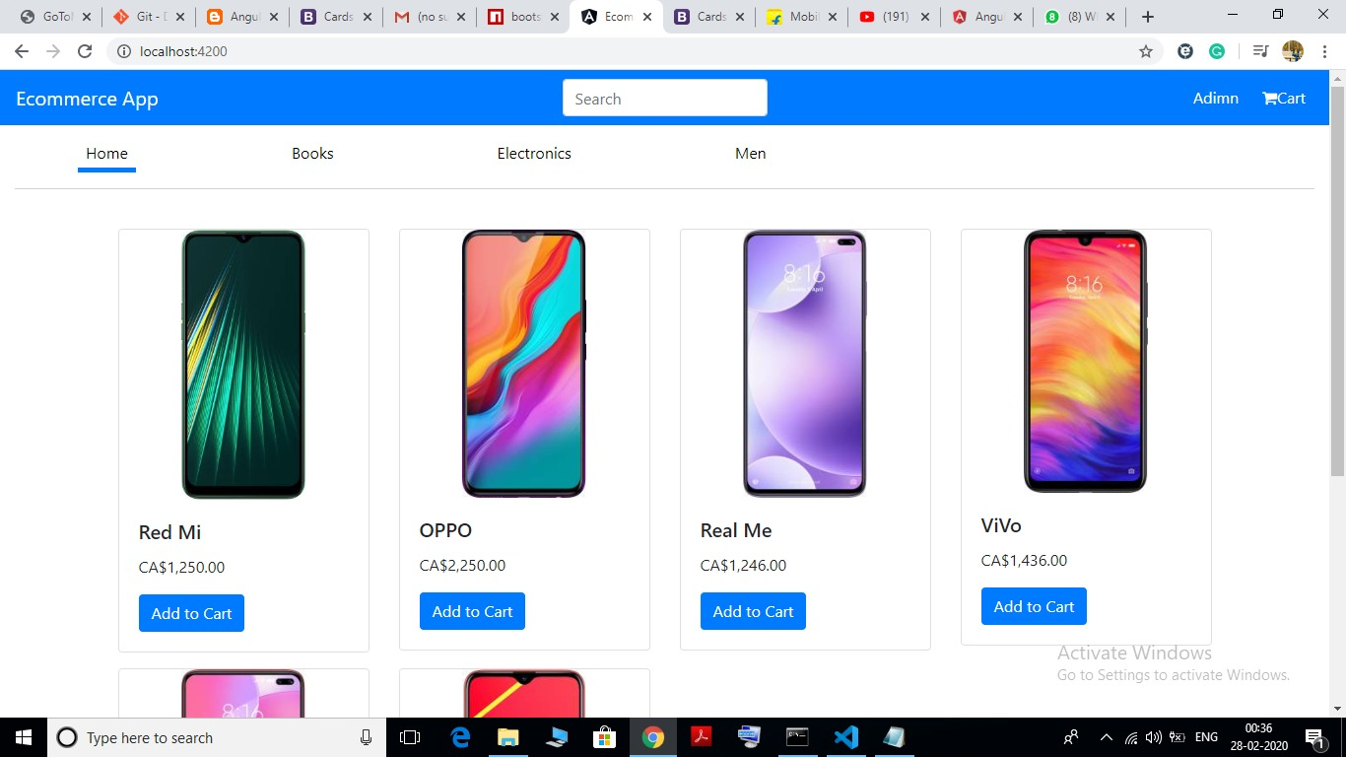

1. **we need 3 modules:**

* products module(which refers the users perspective)
* admin module(which refers the admin perspective)
* services module(from where data to served to above both modules through API’s)

1. **basic view of project file:**

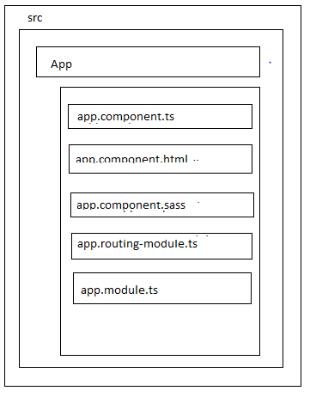

1. **steps to create the products module**

* Create one product folder inside the app
* 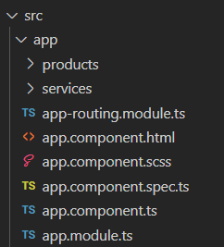
* Go to command prompt in product folder generate products module and inside that module create the product component
* 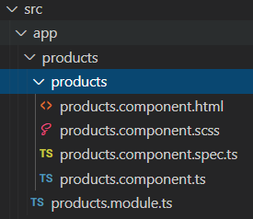
* Then already designed code , we need to move from app.cpomponet.html to products.componet.html
* 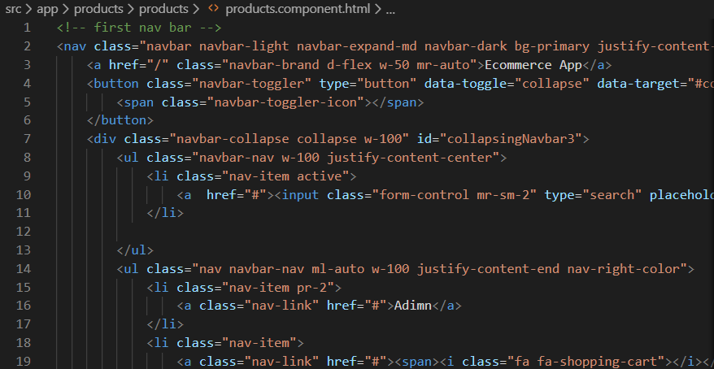
* Don’t remove <router-outlet> from app.component.html
* 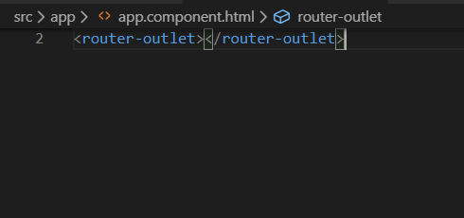
* Same as well we need to move app.component.ts code to product.component.ts
* If we run the code , we don’t get the output because we don’t imported the product module in app.module.ts .So, we need to do that.
* 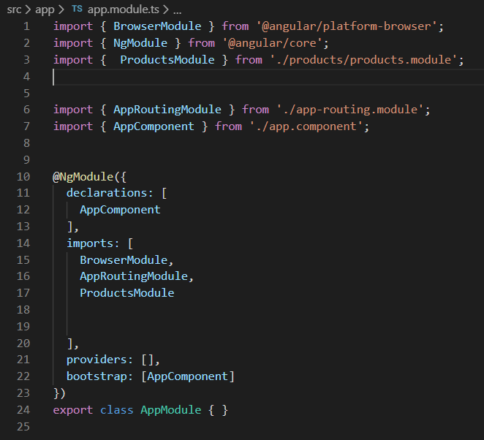
* Still we don’t get the output because we dont mention product.componet.html anywhere, so here we going give a path inside app.routing-module and import the component as well
* 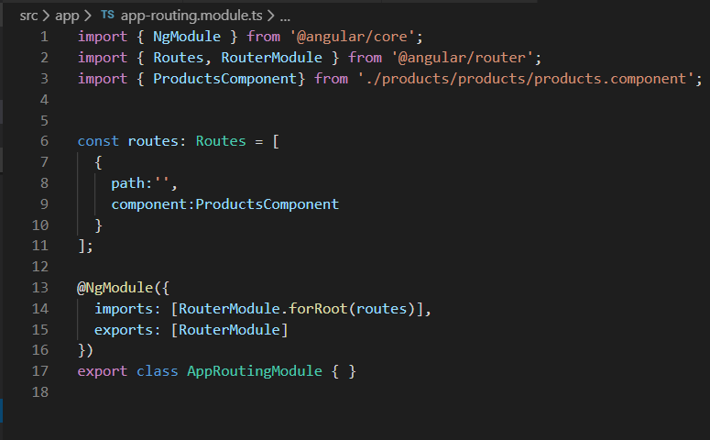
* Now we are getting the output and further process we are going to get the data services-module, so we crated services module and inside that one service named product-service has also to be created.
* 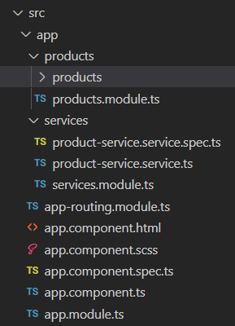
* Next process import service module inside app.module
* 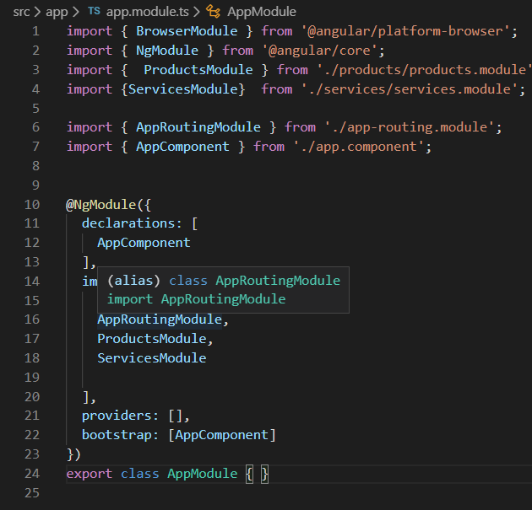
* So it’s a time to move the data from product.component.ts to product-service.service.ts
* For that we need to create a one method called getAllProducts() as hown below
* 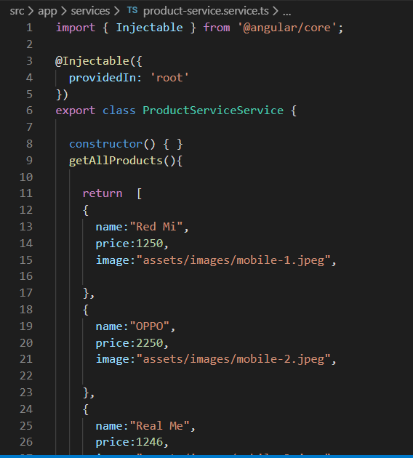
* So this data product-service.service.ts need to communicate with the app-component.ts
* For that we need to import product-service.service.ts in product.component.ts and inject the service and next call the method as wementioned as a getAllProducts() as shown below
* 