**PATFIN NURSERY AND PRIMARY SCHOOL, AKESAN, LAGOS STATE.**

**THIRD TERM EXAMINATION [ 2017 / 2018 ]**

**CLASS : K . G 1**

**NAME : ______________________________________ SUBJECT: COLOURING ACTIVITIES**

**INSTRUCTION : ANSWER ALL QUESTIONS DURATION : 1 HOUR**

**What object is this?**

**_____________________________**

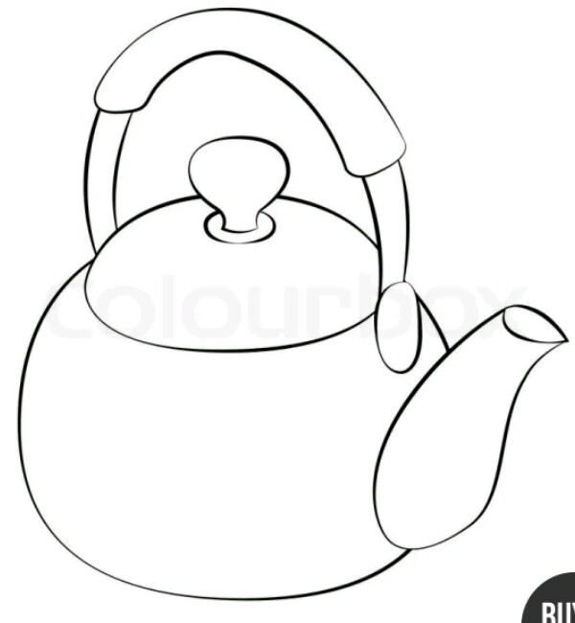

**What object is this?**

**_____________________**



**PATFIN NURSERY AND PRIMARY SCHOOL, AKESAN, LAGOS STATE.**

**THIRD TERM EXAMINATION [ 2017 / 2018 ]**

**CLASS : K . G 1**

**NAME : ______________________________________ _________ SUBJECT: HAND WRITING**

**INSTRUCTION : ANSWER ALL QUESTIONS DURATION : 1 HOUR**

E F G H