**PATFIN NURSERY AND PRIMARY SCHOOL, AKESAN, LAGOS STATE.**

**THIRD TERM EXAMINATION [ 2017 / 2018 ]**

**CLASS : K . G 2**

**NAME : ______________________________________ SUBJECT: COLOURING ACTIVITIES**

**INSTRUCTION : COLOUR CAREFULLY DURATION : 1 HOUR**

**What fruit is this? __________________**

**Colour it ________________**



**What fruit is this? __________________________.**

**Colour it _________________**

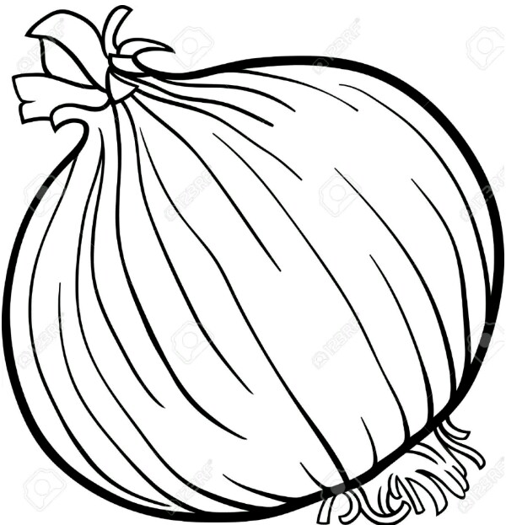

**PATFIN NURSERY AND PRIMARY SCHOOL, AKESAN, LAGOS STATE.**

**THIRD TERM EXAMINATION [ 2017 / 2018 ]**

**CLASS : K . G 2**

**NAME : ______________________________________ SUBJECT: PHONICS**

**INSTRUCTION : ANSWER ALL QUESTIONS DURATION : 1 HOUR**

1. Sound and write the first letters of these objects and colour each of them neatly.





 