**PATFIN NURSERY AND PRIMARY SCHOOL, AKESAN, LAGOS STATE.**

**THIRD TERM EXAMINATION [ 2017 / 2018 ]**

**CLASS : RECEPTION**

**NAME : ______________________________________ SUBJECT: NUMBER WORK**

**INSTRUCTION : WRITE AND IDENTIFY DURATION : 1 HOUR**

1. Identify and touch these numbers;

2 3

1. Identify and colour these numbers



1. Trace numbers “1 – 5 ”

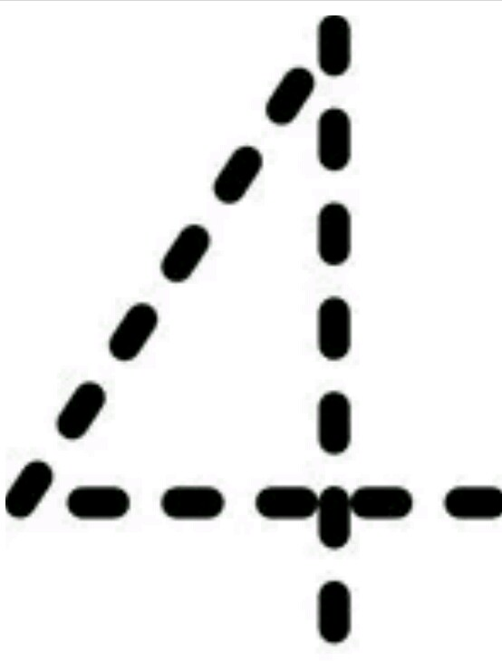

1. Count and write numbers “1 – 3 ”

_____________, ______________, ______________.

1. Match same numbers together

1 4

2 3

3 2

4 1

**PATFIN NURSERY AND PRIMARY SCHOOL, AKESAN, LAGOS STATE.**

**THIRD TERM EXAMINATION [ 2017 / 2018 ]**

**CLASS : RECEPTION**

**NAME : ______________________________________ SUBJECT: LETTER WORK**

**INSTRUCTION : WRITE AND IDENTIFY DURATION : 1 HOUR**

1. Sound letter “ ***a – e*** ”

 

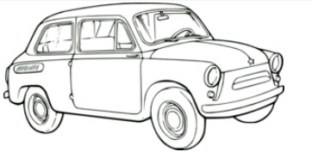 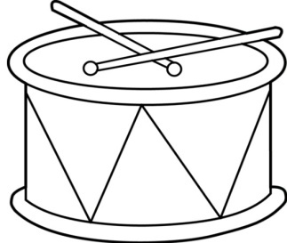

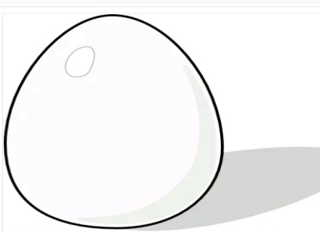

1. Identify and colour letter A



1. Trace letters A – C

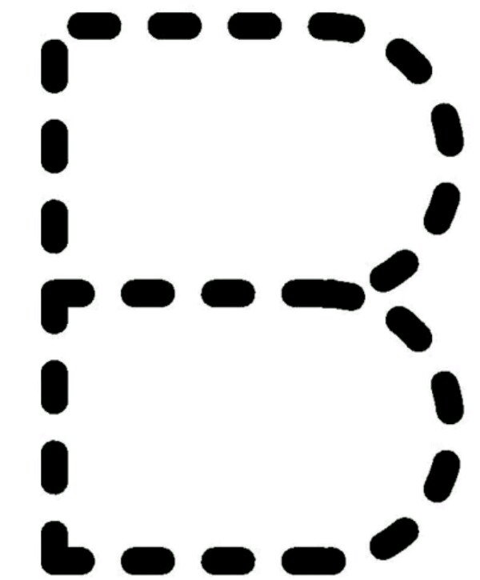

1. Read and write letters A – C

________________ , ________________ ____________________.

1. Match same letters

**A C**

**B A**

**C B**

**D E**

**E D**

**PATFIN NURSERY AND PRIMARY SCHOOL, AKESAN, LAGOS STATE.**

**THIRD TERM EXAMINATION [ 2017 / 2018 ]**

**CLASS : RECEPTION**

**NAME : ______________________________________ SUBJECT: SHAPES AND COLOURS**

**INSTRUCTION : IDENTIFY ALL SHAPES DURATION : 1 HOUR**

**What shapes are these;**



**Paint Me Blue**

It is a ___________________.



Paint Me Yellow

It is a ______________

It is a _______________.

It is a _____________.

It is a ______________.

**PATFIN NURSERY AND PRIMARY SCHOOL, AKESAN, LAGOS STATE.**

**THIRD TERM EXAMINATION [ 2017 / 2018 ]**

**CLASS : RECEPTION**

**NAME : ______________________________________ SUBJECT: RHYMES**

**INSTRUCTION : SING ALONG. DURATION : 1 HOUR**

1. I see the ____________ ,

The __________ sees _____________.

God __________ the moon and ____________ bless me.

1. There are ___________ days.

There are ____________ days in a __________.

Sunday _____________ Tuesday ___________

Thursday _____________ and Saturday.

**PATFIN NURSERY AND PRIMARY SCHOOL, AKESAN, LAGOS STATE.**

**THIRD TERM EXAMINATION [ 2017 / 2018 ]**

**CLASS : RECEPTION**

**NAME : ______________________________________ SUBJECT: P . H . E**

**INSTRUCTION : OBEY YOUR TEACHER. DURATION : 1 HOUR**

1. Run to the Gate

1. Touch the parts of your body {Eyes, Ears, Nose, Knees, Shoulders and Toes. }.
2. Jump up

1. Clap your hands together .
2. Jog on a spot.

**PATFIN NURSERY AND PRIMARY SCHOOL, AKESAN, LAGOS STATE.**

**THIRD TERM EXAMINATION [ 2017 / 2018 ]**

**CLASS : RECEPTION**

**NAME : ______________________________________ SUBJECT: COLOURING**

**INSTRUCTION : IDENTIFY AND COLOUR THESE OBJECTS DURATION : 1 HOUR**

**What Animal is this? ____________________________.**

**Colour the Animal**



**What fruit is this? ______________________.**

**Paint the fruit**

