**PATFIN NURSERY AND PRIMARY SCHOOL, AKESAN, LAGOS STATE.**

**THIRD TERM EXAMINATION [ 2018 / 2019 ]**

**CLASS : RECEPTION**

**NAME : __________________________________________ SUBJECT: RHYMES**

**INSTRUCTION : SING THE FOLLOWING RHYMES DURATION : 1 HOUR**

1. A circle is round.
2. Rain , Rain go away
3. When I was a baby
4. There were two black birds sitting on the wall .
5. Paw – Paw is a kind of fruit.
6. Jack be nimble.

**PATFIN NURSERY AND PRIMARY SCHOOL, AKESAN, LAGOS STATE.**

**THIRD TERM EXAMINATION [ 2018 / 2019 ]**

**CLASS : RECEPTION**

**NAME : __________________________________________ SUBJECT: RHYMES**

**INSTRUCTION : SING THE FOLLOWING RHYMES DURATION : 1 HOUR**

1. A circle is round.
2. Rain , Rain go away
3. When I was a baby
4. There were two black birds sitting on the wall .
5. Paw – Paw is a kind of fruit.
6. Jack be nimble.

**PATFIN NURSERY AND PRIMARY SCHOOL, AKESAN, LAGOS STATE.**

**THIRD TERM EXAMINATION [ 2018 / 2019 ]**

**CLASS : RECEPTION**

**NAME : __________________________________________ SUBJECT: NUMBER WORK**

**INSTRUCTION : DO THE FOLLOWING ; DURATION : 1 HOUR**

1. Sing the numbers song ( 1- 10 ).
2. Colour each number

 

 

1. Trace these number **1**

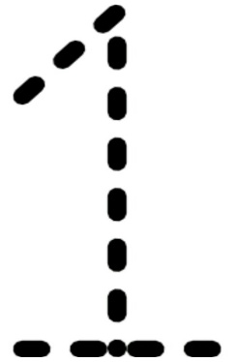 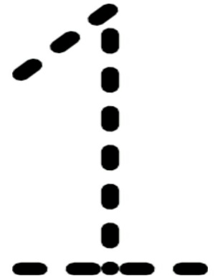 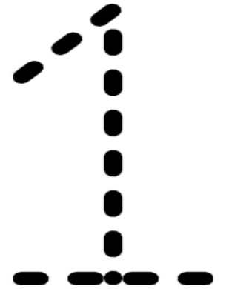

1. Trace these number **2**

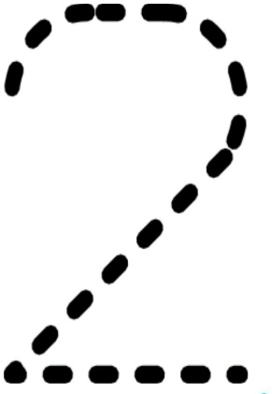 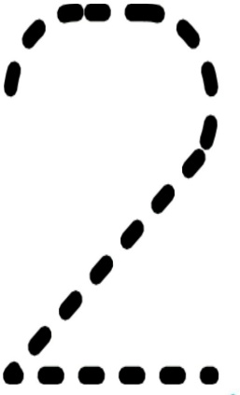 

**PATFIN NURSERY AND PRIMARY SCHOOL, AKESAN, LAGOS STATE.**

**THIRD TERM EXAMINATION [ 2018 / 2019 ]**

**CLASS : RECEPTION**

**NAME : __________________________________________ SUBJECT: LETTER WORK**

**INSTRUCTION : DO THE FOLLOWING ; DURATION : 1 HOUR**

1. Sing the alphabet song a – i.
2. Colour each alphabet

 

 

1. Trace these letter A

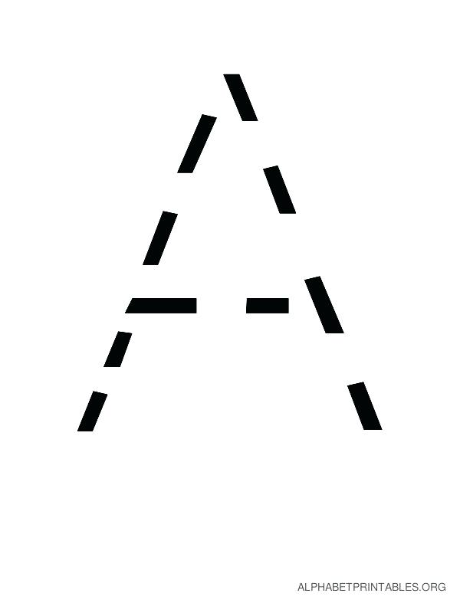  

1. Trace these letter B

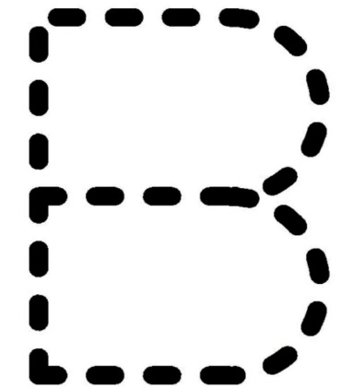  

**PATFIN NURSERY AND PRIMARY SCHOOL, AKESAN, LAGOS STATE.**

**THIRD TERM EXAMINATION [ 2018 / 2019 ]**

**CLASS : RECEPTION**

**NAME : __________________________________________ SUBJECT: SHAPES AND COLOUR**

**INSTRUCTION : DO THE FOLLOWING ; DURATION : 1 HOUR**

1. Colour the shape ________________ .
2. What shapes are these?

_______________ _______________ _____________

1. Identify these colours ;

 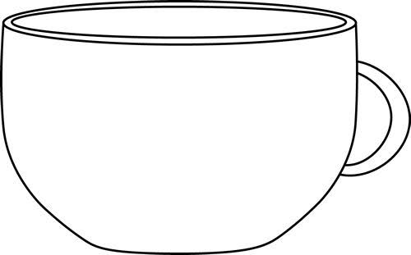

1. Colour the shape

_____________________________________________

**PATFIN NURSERY AND PRIMARY SCHOOL, AKESAN, LAGOS STATE.**

**THIRD TERM EXAMINATION [ 2018 / 2019 ]**

**CLASS : RECEPTION**

**NAME : __________________________________________ SUBJECT: SCIENCE**

**INSTRUCTION : DO THE FOLLOWING ; DURATION : 1 HOUR**

1. Identify this ;

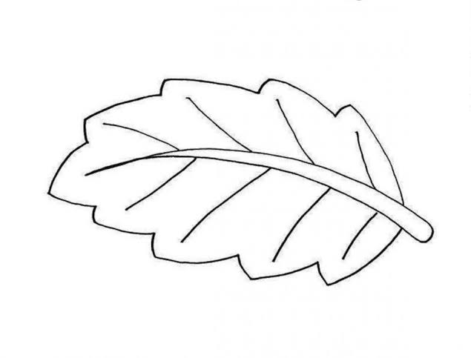

__________________________________

1. Colour this flower;

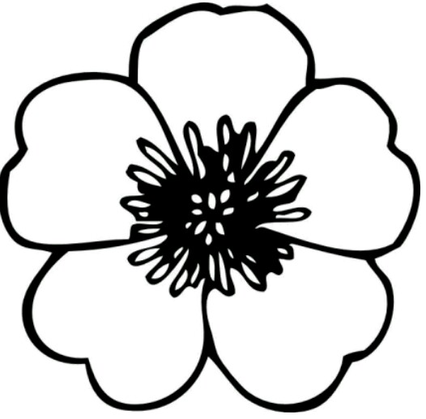

**PATFIN NURSERY AND PRIMARY SCHOOL, AKESAN, LAGOS STATE.**

**THIRD TERM EXAMINATION [ 2018 / 2019 ]**

**CLASS : RECEPTION**

**NAME : __________________________________________ SUBJECT: COLOURING**

**INSTRUCTION : SING THE FOLLOWING RHYMES DURATION : 1 HOUR**

This is a _____________________

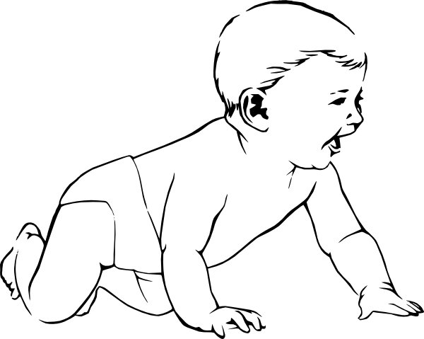

Paint him __________________