**PATFIN NURSERY AND PRIMARY SCHOOL, AKESAN, LAGOS STATE.**

**FIRST TERM EXAMINATION [ 2019 / 2020 ]**

**CLASS : HEADSTART**

**NAME : __________________________________________ SUBJECT: NUMBER WORK**

**INSTRUCTION : ANSWER ALL QUESTIONS DURATION : 1 HOUR**

Color the Numbers *[* ***1 – 5 ]***











**PATFIN NURSERY AND PRIMARY SCHOOL, AKESAN, LAGOS STATE.**

**FIRST TERM EXAMINATION [ 2019 / 2020 ]**

**CLASS : HEADSTART**

**NAME : __________________________________________ SUBJECT: LETTER WORK**

**INSTRUCTION : ANSWER ALL QUESTIONS DURATION : 1 HOUR**

Identify and Color these objects ;

What is this ?



It is an _____________________ ?

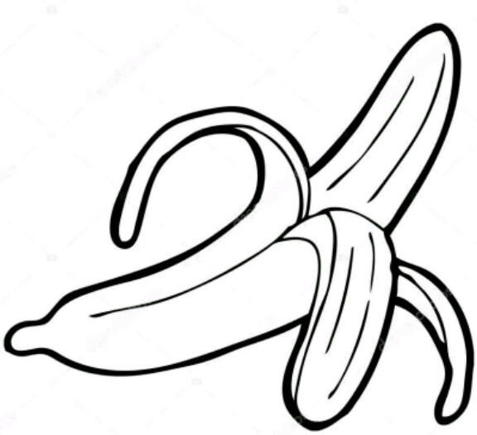 This is a _____________

What is this ?



It is a _____________________ ?

What is this ?



It is a _____________________ ?

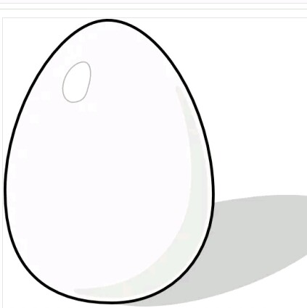 What is this ?

**PATFIN NURSERY AND PRIMARY SCHOOL, AKESAN, LAGOS STATE.**

**FIRST TERM EXAMINATION [ 2019 / 2020 ]**

**CLASS : HEADSTART**

**NAME : __________________________________________ SUBJECT: SCIENCE**

**INSTRUCTION : IDENTIFY AD COLOR PARTS OF THE BODY DURATION : 1 HOUR**

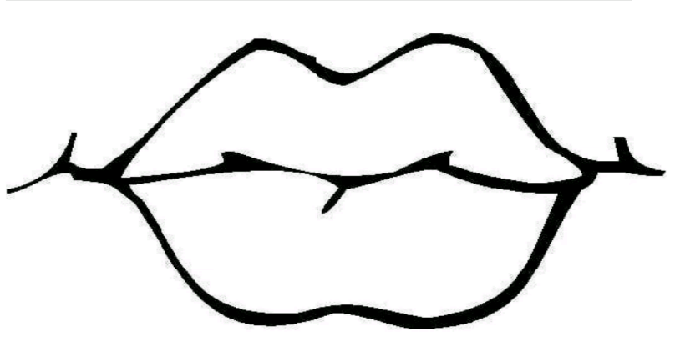 What is this ?

It is my ______________

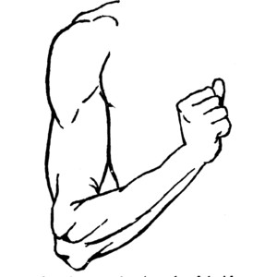

What is this ?

It is my _________________.

This is my ____________________.

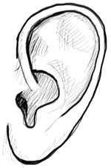

This is my_______________ .

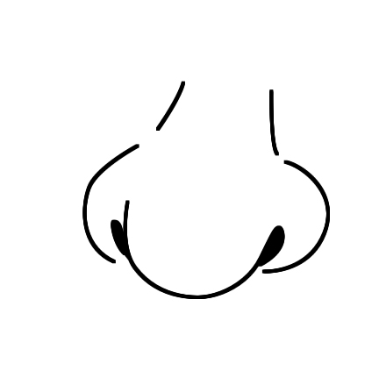

This is my ___________.

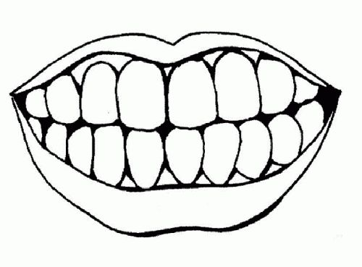

**PATFIN NURSERY AND PRIMARY SCHOOL, AKESAN, LAGOS STATE.**

**FIRST TERM EXAMINATION [ 2019 / 2020 ]**

**CLASS : HEADSTART**

**NAME : __________________________________________ SUBJECT: RHYMES**

**INSTRUCTION : RECITEE THE FOLLOWING RHYMES DURATION : 1 HOUR**

1. Roll , Roll gentle down the stream.
2. Baby , Baby
3. Ring – o –ring – o –rose
4. I have Joy
5. Paw , paw fruit.

**PATFIN NURSERY AND PRIMARY SCHOOL, AKESAN, LAGOS STATE.**

**FIRST TERM EXAMINATION [ 2019 / 2020 ]**

**CLASS : HEADSTART**

**NAME : __________________________________________ SUBJECT: P . H . E**

**INSTRUCTION : DO THE FOLLOWING DURATION : 1 HOUR**

1. Run to the gate
2. Jog on a spot
3. Hands up , hands down
4. Clap 10 times
5. Spin like a top.

**PATFIN NURSERY AND PRIMARY SCHOOL, AKESAN, LAGOS STATE.**

**FIRST TERM EXAMINATION [ 2019 / 2020 ]**

**CLASS : HEADSTART**

**NAME : __________________________________________ SUBJECT: COLOURING**

**INSTRUCTION : DO THE FOLLOWING DURATION : 1 HOUR**

Colour These Objects ;

Colour it Red

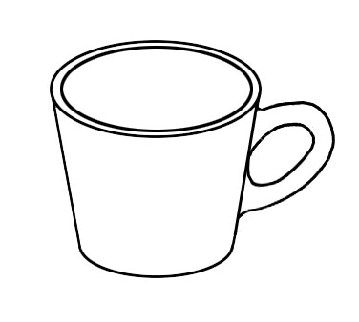

Colour it Blue

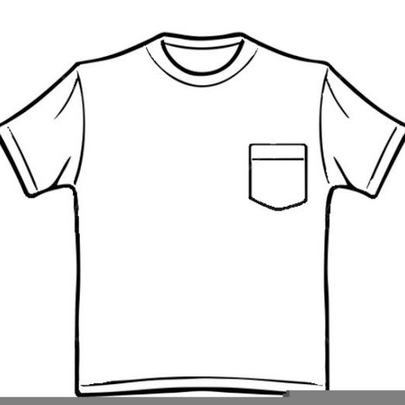

Colour it Brown

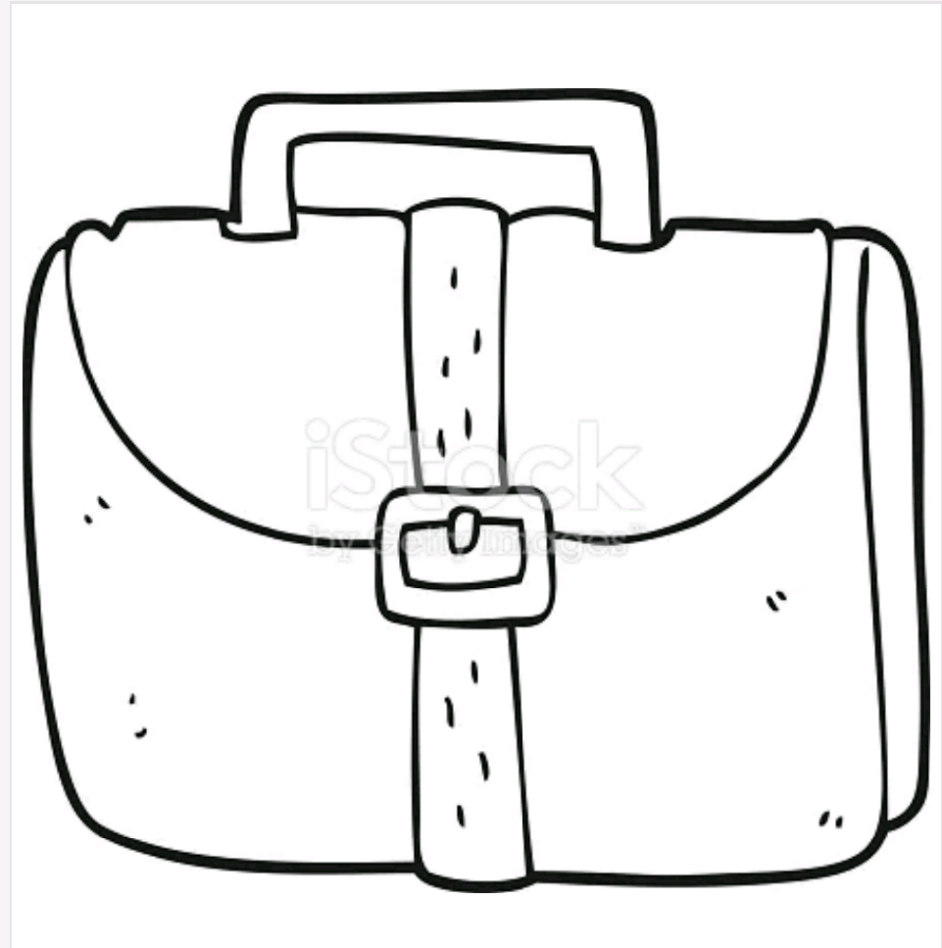

Colour it Green

