**PATFIN NURSERY AND PRIMARY SCHOOL, AKESAN, LAGOS STATE.**

**FIRST TERM EXAMINATION [ 2019 / 2020 ]**

**CLASS : KINDERGARTEN**

**NAME : ______________________________________ SUBJECT: HEALTH HABIT**

**INSTRUCTION : ANSWER ALL QUESTIONS DURATION : 1 HOUR**

1. Cleanliness is next to _______________. [a] Godliness [b] Laziness
2. Wash your hands after using the ____________ . [a] Bedroom [b] Toilet
3. A toilet is a place where we ____________. [a] Urinate [b] Eat
4. I use my mouth to ____________. [a] Write [b] Talk and Eat
5. Always put on your ___________. [a] Food Flask [b] Slippers

**PATFIN NURSERY AND PRIMARY SCHOOL, AKESAN, LAGOS STATE.**

**FIRST TERM EXAMINATION [ 2019 / 2020 ]**

**CLASS : KINDERGARTEN**

**NAME : ______________________________________ SUBJECT: SOCIAL NORMS**

**INSTRUCTION : ANSWER ALL QUESTIONS DURATION : 1 HOUR**

1. Transportation means movement from one place to ____________. [a] Everyone [b] Another
2. Cars move on ___________ . [a] Water [b] Land
3. Boats move on ___________. [a] Land [b] Water
4. Examples of buildings in our environments are _________ , __________ and _________. [a] Chairs , shoes and clock . [b] Church, schools and shops
5. Who provides for the family ? [a] My Daddy [b] My mummy

**PATFIN NURSERY AND PRIMARY SCHOOL, AKESAN, LAGOS STATE.**

**FIRST TERM EXAMINATION [ 2019 / 2020 ]**

**CLASS : KINDERGARTEN**

**NAME : ______________________________________ SUBJECT: MORAL INSTRUCTION**

**INSTRUCTION : ANSWER ALL QUESTIONS DURATION : 1 HOUR**

1. Being quiet is the opposite of ___________. [a] Noise Making [b] Sleeping
2. When you finish your food, always ______ your plates. [a] Throw away [b] Pack
3. Whenever someone gives you something we should always say __________. [a] You’re welcome [b] Thank You
4. If you fart in the class, always say ____________. [a] Thank you [b] Sorry, excuse me
5. Always ask for permission to do ________. [a] Anything [b] Cry

**PATFIN NURSERY AND PRIMARY SCHOOL, AKESAN, LAGOS STATE.**

**FIRST TERM EXAMINATION [ 2019 / 2020 ]**

**CLASS : KINDERGARTEN**

**NAME : ______________________________________ SUBJECT: K. O . W**

**INSTRUCTION : ANSWER ALL QUESTIONS DURATION : 1 HOUR**

1. Days of the week are ____________, ___________, __________, __________ , __________ , _________, ____________.
2. Months of the year are ;

________________ ________________ ________________

________________ ________________ ________________

________________ ________________ ________________

________________ ________________ ________________

1. What is the name of your country ? [a] Nigeria [b] Abia
2. The capital of Lagos State is _______________. [a] Ikeja [b] Igando
3. The Governor of Lagos State is ____________________. [a] Akinwumi Ambode [b] Babajide Sanwo-olu

**PATFIN NURSERY AND PRIMARY SCHOOL, AKESAN, LAGOS STATE.**

**FIRST TERM EXAMINATION [ 2019 / 2020 ]**

**CLASS : KINDERGARTEN**

**NAME : ______________________________________ SUBJECT: C . R . S**

**INSTRUCTION : ANSWER ALL QUESTIONS DURATION : 1 HOUR**

1. Jesus loves little children. [ Yes | No ]
2. God’s love is wonderful. [ Yes | No ]
3. Is it good to fight ? [ Yes | No ]
4. If you share with others , you are showing love . [ Yes | No ]
5. Always love your ___________ . [ Yes | No ]

**PATFIN NURSERY AND PRIMARY SCHOOL, AKESAN, LAGOS STATE.**

**FIRST TERM EXAMINATION [ 2019 / 2020 ]**

**CLASS : KINDERGARTEN**

**NAME : ______________________________________ SUBJECT: RHYMES**

**INSTRUCTION : ANSWER ALL QUESTIONS DURATION : 1 HOUR**

1. Jack be nimble
2. Johnny, Johnny yes Papa.
3. I’m a little tea pot
4. Baa, Baa , Black Sheep
5. 1,2,3,4,5, once I caught a fish alive .

**PATFIN NURSERY AND PRIMARY SCHOOL, AKESAN, LAGOS STATE.**

**FIRST TERM EXAMINATION [ 2019 / 2020 ]**

**CLASS : KINDERGARTEN**

**NAME : ______________________________________ SUBJECT: SCIENCE**

**INSTRUCTION : ANSWER ALL QUESTIONS DURATION : 1 HOUR**

1. ___________ are things that can grow. [a] Non-living [b] Living things
2. Dog is a ____________ animal. [a] Domestic [b] Wild
3. A Lion has a big ___________. [a] Belly [b] Head
4. Color the ***smaller*** object.





1. Color the ***bigger*** object.

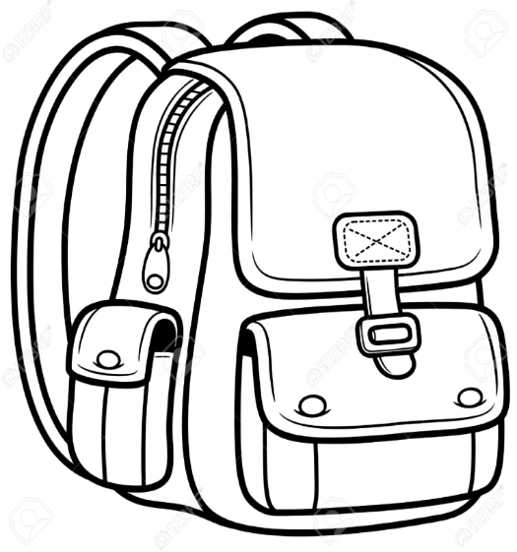 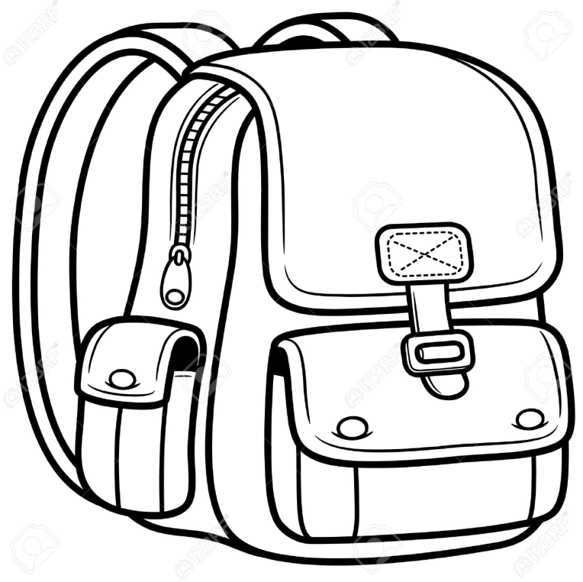

**PATFIN NURSERY AND PRIMARY SCHOOL, AKESAN, LAGOS STATE.**

**FIRST TERM EXAMINATION [ 2019 / 2020 ]**

**CLASS : KINDERGARTEN**

**NAME : ___________________________________________ SUBJECT: SHAPES AND COLORS**

**INSTRUCTION : ANSWER ALL SHAPES AND COLORS DURATION : 1 HOUR**

What shape is this ?

_________________________________

Color it Yellow

2.

What shape is this ?

_________________________________

Color it Blue

What shape is this ?

_________________________________

Color it Red

What shape is this ?

_________________________________

Color it Blue

**PATFIN NURSERY AND PRIMARY SCHOOL, AKESAN, LAGOS STATE.**

**FIRST TERM EXAMINATION [ 2019 / 2020 ]**

**CLASS : KINDERGARTEN**

**NAME : ___________________________________________ SUBJECT: LETTER WORK**

**INSTRUCTION : ANSWER ALL SHAPES AND COLORS DURATION : 1 HOUR**

1. Sound and demonstrate letters ***a – j***
2. Write letters *a – g*

|  |  |  |  |  |  |  |  |  |  |
| --- | --- | --- | --- | --- | --- | --- | --- | --- | --- |
|  |  |  |  |  |  |  |  |  |  |

1. Fill in the gaps. ***a – g***

*a _______ c ______ e __________ g*

1. Identify and color

 Letter **F**

1. Match items to letters.

c



d



b



a



**PATFIN NURSERY AND PRIMARY SCHOOL, AKESAN, LAGOS STATE.**

**FIRST TERM EXAMINATION [ 2019 / 2020 ]**

**CLASS : KINDERGARTEN**

**NAME : ___________________________________________ SUBJECT: NUMBER WORK**

**INSTRUCTION : ANSWER ALL SHAPES AND COLORS DURATION : 1 HOUR**

1. Count numbers 0 – 50 .
2. Count and write numbers 0 – 40

|  |  |  |  |  |  |  |  |  |  |
| --- | --- | --- | --- | --- | --- | --- | --- | --- | --- |
|  |  |  |  |  |  |  |  |  |  |
|  |  |  |  |  |  |  |  |  |  |
|  |  |  |  |  |  |  |  |  |  |
|  |  |  |  |  |  |  |  |  |  |

1. Fill in the gaps .

0 ____ 2 ______ 4 ____ 6 _____ 8 ______ 10 _____ 12 _______ 14 ______ 16 ______ 18 ________ 20 .

1. Count and match;

5

4

3

2

1