

PATFIN NURSERY AND PRIMARY SCHOOL.

11, OYELAMI STREET, AKESAN, LAGOS STATE, NIGERIA.

TEL: 08033324432, EMAIL: patfinschool@gmail.com

Ref: PPS|Yr 1|2018 Date: 17th, September, 2018.

*JOANNA* *OGHENEYEROVWO EBOSA.*  **Date Of Birth**: 11 - 9 – 2013

Dear Sir / Madam,

**Offer of A Provisional Admission**

**(2018|2019 Academic Session)**

We are pleased to offer you admission into one of our Nursery classes (Pre - School) after doing a thorough placement test for you.

You will be taught our rich curricular content which is a fusion of Nigerian, British and American curriculum. This will in turn, equip you for the outside world.

We hope you will like it here.

Yours Sincerely,

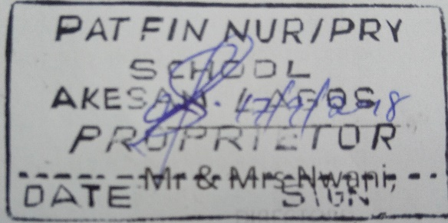 Mr & Mrs Nwani