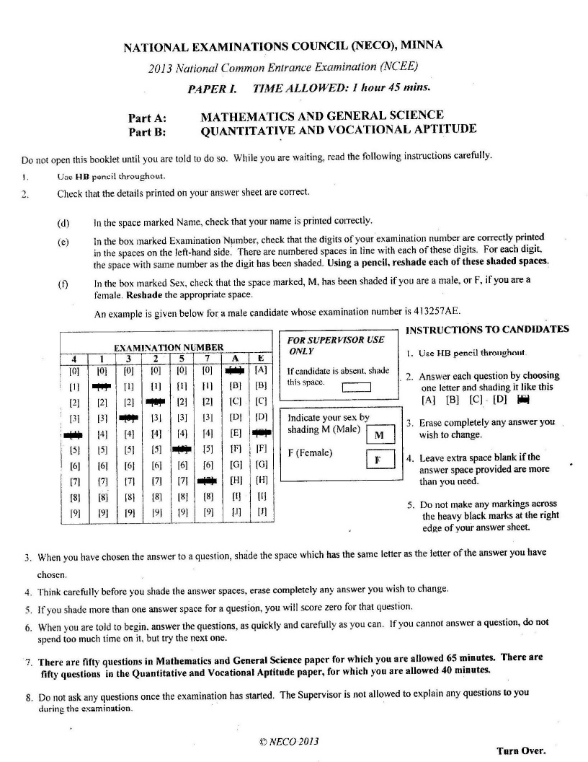
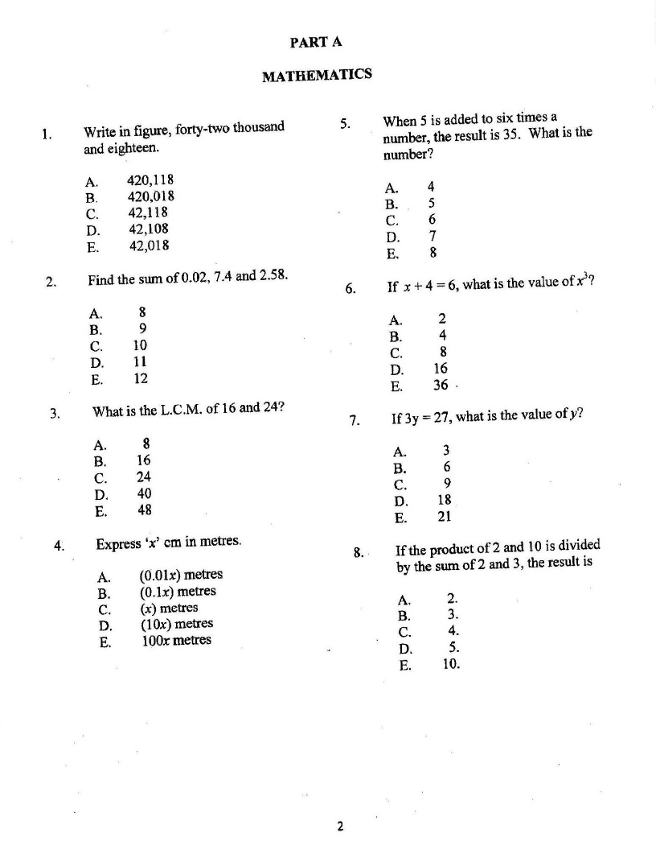
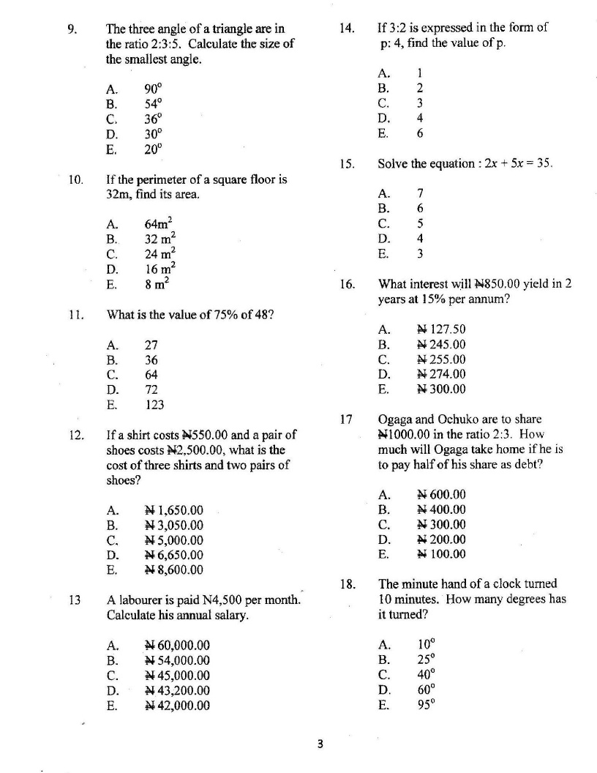

- Divide 48.48 by 12.
- 404 (b) 4.44 (c) 4.40 (d) 4.04 (e) 4.00
- If 2(3 + q) = 18; Find the value of q.
- 2 (b) 4 (c) 6 (d) 8 (e) 10
- What is the interest of N500 for 5years at the rate of 5% per annum?
- N125 (b) N115 (c) N105 (d) N100 (e) N75
- If 500 oranges were shared among Taiwo, Kehinde and Musa in the ratio of 3:3:4 respectively, What Musa’s share?
- 400 (b) 300 (c) 200 (d) 150 (e) 100

