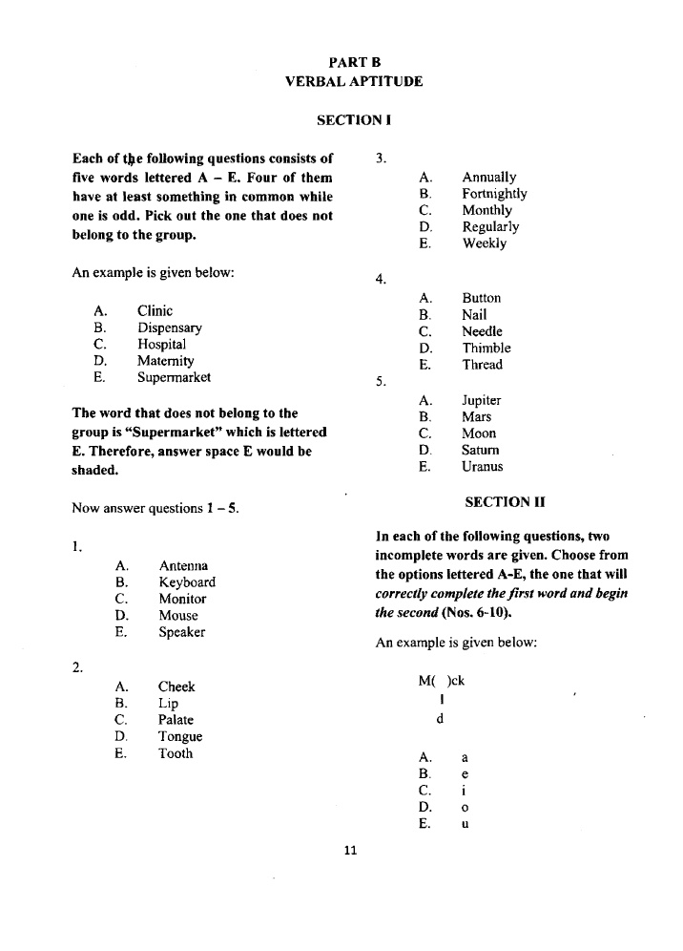

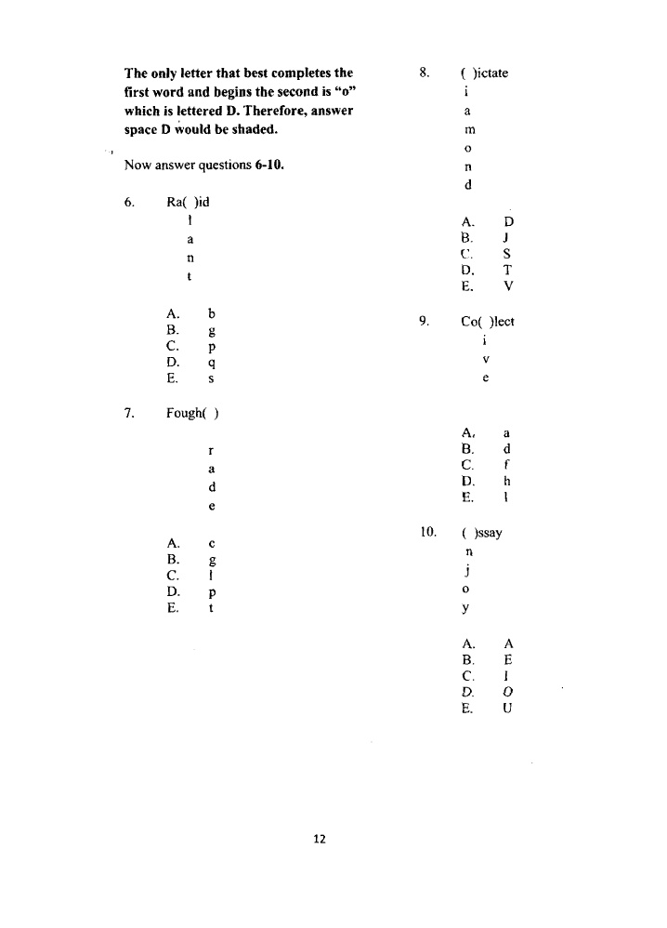
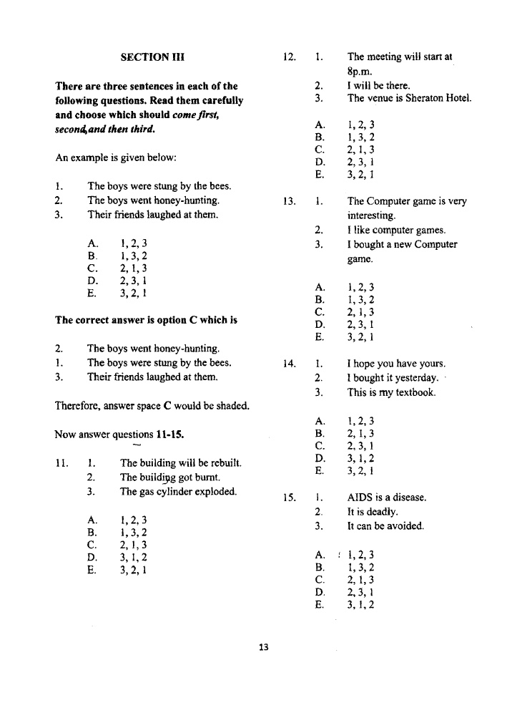

\
In each of the following sentences one or more words are missing. Choose from the options the one that most suitably fits that space.
EXAMPLE;
Ship and Harbor, Train and ___________
- Rail (b) Passengers (c) Coaches (d) Stations (e) Goods
:.. A train is kept in a Station so the answer is E
- Tongue and taste, Ear and ___________
- Hear (b) Eat (c) Smell (d) Taste (e) Feel
- Narrow and wide, Smooth and ___________.
- Straight (b) Rough (c) Sharp (d) Long (c) Round
- Rice and Grain, Coffee and __________.
- Sugar (b) Pot (c) Milk (d)
- Tree (e) Beverage
- Tapper and wine, Fisherman and ___________
- Net (b) Paddle (c) Fish (d) Canoe (e) Sea
- Sea and Blue, Grass and _________.
- Garden (b) Snake (c) Burn (d) hay (e) Green
In each of the following pick out the word that does not belong to the group.
EXAMPLE;
Orange Mango Apple Cassava Pawpaw.
The crop cassava does NOT belong to the group so we shade answer D.
- (a) Run (b) Skip (c) Shout (d) Walk (e) Jump
- (a) Den (b) House (c) Hut (d) Hole (e) Path
- (a) Car (b) Boat (c) Ship (d) Raft (e) Canoe
- (a) Lake (b) Ocean (c) Forest (d) River (e) Stream
- (a) Small (b) Big (c) Huge (d) Tiny (e) Fast
Read the sentences below carefully and answer the questions from the sentences below. Use the sentences in answering question 32 to 35.

Chinyere and Obiaku like Arithmetic
Ladidi and Chinyere like and Science
Obiaku and Ladidi Like English
Aliyah and Chinyere likes computer
Ladidi loves Physical Education

- Who likes both English and Arithmetics?
- Chinyere
- Ladidi
- Obiaku
- Aliyah
- None
- Who likes both Science and Arithmetics but not English ?
- Chinyere
- Ladidi
- Obiaku
- Aliyah
- None
- Who likes both science and English?
- Chinyere
- Ladidi
- Obiaku
- Aliyah
- None
- Who likes only one subject?
- Chinyere
- Ladidi
- Obiaku
- Aliyah
- None
- Who loves Physical Education?
- Aliyah
- Ladidi
- Basirat
- Chinyere
- None
Choose the word that will come first alphabetically from each of the words lettered A – D
- _____________
- Night (b) Ocean (c) Elbow (d) March
- __________
- Adult (b) Admit (c) Audience (d) Alike
- _____________
- Glory (b) Hedge (c) Label (d) Green

- _________________
- Impressive (b) Irritability (c) Information (d) Importance
- ____________________
- Anxiety (b) Astronaut (c) Analogy (d) Antagonist

From the list of words lettered A –D choose the correct word to complete each
of the sentences below;
- She sings like an/a _____________.
- Angel (b) American (c) Musician (d) Old woman
- The cloth is as white as _____________.
- Paper (b) Chalk (c) Snow (d) Sky
- They are as steady as _________.
- Man (b) Rock (c) Water (d) Cloth
- The hall is as silent as the _____________.
- School (b) House (c) Hotel (d) Grave
- As sharp as a ____________.
- Ruler ((b) Rake (c) Razor (d)

