Lesson 12

Title: pycnumanal version 0.13 – Graphically plotting program timings

Assumptions: gcc, Python 3, sqlite3 (Python module), and matplotlib (Python module) are installed

Reading:

I assume that you’re working from the ~/dev/pycnumanal/Lesson12 subdirectory.

Recall that our pycnumanal program does very little error/edge case checking and does not provide any functionality for modifying/deleting data previously stored. If the program crashes, run it again. If you make some mistakes entering the data, delete timings.db and enter the data gain. If you’re ambitious could run SQLite (sqlite3) and directly modify/delete data in timings.db using SQL commands.

l2vecnorm.c and three new C programs

In addition to l2vecnorm.c, I have provided three new external C programs. They don't do what we would normally consider useful work, but rather they compute timings directly from the problem size input n. linear_timing simply returns a timing of n. nlogn_timing returns a timing of n*log(n). nsquared_timing returns a timing of n^2. These timings from these new external programs will allow you to experiment with graphically plotting timings for multiple programs on a SINGLE plot.

Take a look at these new *.c files in your text editor!

Let's compile these C programs so that we can use them in our new pycnumanal 0.13 version that does graphical plotting!

gcc -o l2vecnorm l2vecnorm.c -std=gnu99 -lm
gcc -o linear_timing linear_timing.c -std=gnu99 -lm
gcc -o nlogn_timing nlogn_timing.c -std=gnu99 -lm
gcc -o nsquared_timing nsquared_timing.c -std=gnu99 -lm

Plotting l2vecnorm’s timings

Before examining the Python code underlying the version of our program, let's first engage the new version as a user of it. We’ll start with plotting the timings for a single program.

To make sure we have proper l2vecnorm timing data suited for plotting, I haven’t provide a timings.db file for this lesson. You’ll need to again enter the l2vecnorm program into the database and generate/store timings.

Run pycnumanal:

python3 pycnumanal.py

The standard informational messages and the top menu are displayed. Notice new option (6) for plotting timings.

working dirctory: /home/patrick/stuff/computing/dev/pycnumanal/Lesson12
Created database, setting up tables

(1) Add a program to the database
(2) Display all programs in the database
(3) Manually add a program's timings to the database
(4) Automatically generate and add a program's timings to the database
(5) Display a program's timings in the database
(6) Plot timings for programs

Enter selection number (0 to exit) :

Add the l2vecnorm program to the database. Then generate/add some timings for it (option #4). I suggest the following problem sizes:

10, 100, 1000

Now select the new option of

(6) Plot timings for programs

Sometimes one needs to make the plot window larger in order to see the whole plot. I have had to do this before when the vertical axis label “timing (seconds)” was obscured.

Your plot should look something like:
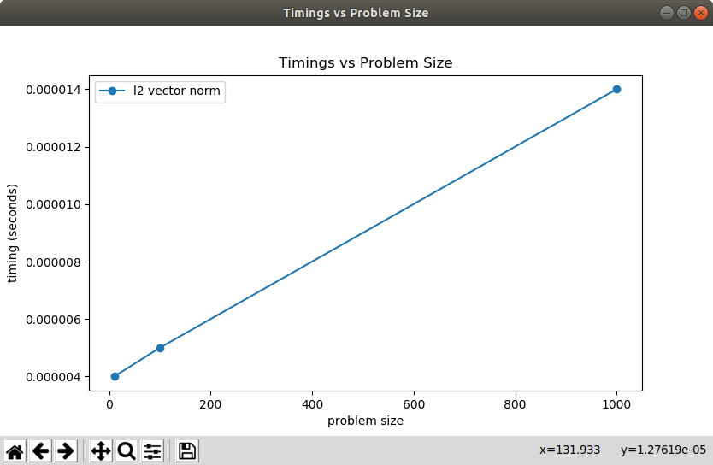

When done looking at the plot, close the plot window to go back to the pycnumanal text menu.

Plotting timings for multiple programs on a SINGLE plot

To enable the more useful scenario of plotting timings for multiple programs on the same plot (for example, to compare the performance of different algorithms solving the same programming problem), enter the “fake” timing programs that you compiled at the beginning of this lesson into the database:

Program Name Description Command line prefix
------------------ -------------- --------------------------
linear timing returns a linear timing linear_timing
nlogn timing returns an nlogn timing nlogn_timing
nsquared timing returns and n^2 timing nsquared_timing

For each of them generate timings for problem sizes 2, 4, 6, 8. These problem sizes aren’t real world, but they allow for a nice plot.

Select the plotting option

(6) Plot timings for programs

Assuming the “fake” program #’s are 2, 3, and 4, enter the #’s one at a time. Enter a 0 after you are done entering them.

Enter a program # to plot timings for (0 to stop) : 2
Enter a program # to plot timings for (0 to stop) : 3
Enter a program # to plot timings for (0 to stop) : 4
Enter a program # to plot timings for (0 to stop) : 0

You should see a plot looking something like the following:
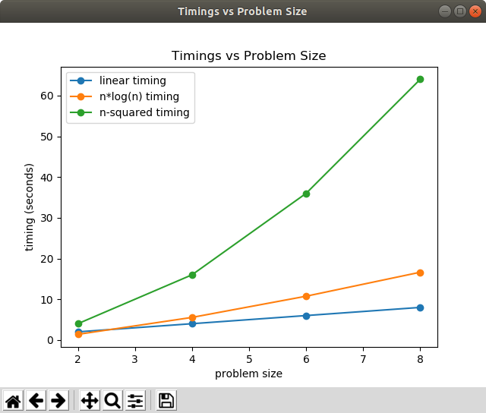

When done looking at the plot, close the plot window to go back to the pycnumanal text menu and enter 0 to exit.

You’re done with this lesson. We have one more lesson: Lesson 13. It will be the most “learn by doing programming” of all the lessons.

Git your code now to back up any changes you made! From the pycnumanal directory, issue the following commands:

git add -A .
git commit -m "Lesson 12 finished"
git push origin master

