THIS LESSON IS INCOMPLETE;
IT IS STILL BEING WORKED ON!

Lesson 9

Title: pycnumanal version 1.0!

Assumptions: gcc, sqlite3

Additional Files I'm Providing: pycnumanal.py, schema.sql, l2vecnorm.c, linear_timing.c,
nlogn_timing.c, nsquared_timing.c, ToDo.txt,
DevelopmentNotes.txt, README.md

Reading:

I'm assuming that you are working from ~/dev/pycnumnal and that you copied your previous Lesson 8 stuff to the ~/dev/pycnumanal/Lesson7 subdirectory.

This is a longer lesson because I have a added a lot of code in order to get to version 1.0 of our pycnumanl application. I will discuss the following:

1 – Three new C algorithms
2 – Engaging pycnumanal version 1.0 as a user of it
3 – Overall structure of the Python program
4 – Going through the Python program in execution order

Three new C algorithms

In addition to l2vecnorm.c, I have provided three new “algorithms” written in C. They don't actually do anything but compute a timing directly from the problem size input n. linear_timing simply returns a timing of n. nlogn returns the timing of n*log(n). nsquared_timing returns the timing of n^2.

Take a look at them!

Let's compile these C programs.

gcc -o l2vecnorm l2vecnorm.c -std=gnu99 -lm
gcc -o linear_timing linear_timing.c -std=gnu99 -lm
gcc -o nlogn_timing nlogn_timing.c -std=gnu99 -lm
gcc -o nsquared_timing nsquared_timing.c -std=gnu99 -lm

----------------

Engaging pycnumanal version 1.0 as a user of it

Before getting to the Python code underlying version 1.0 of our program, let's first engage the program as a user of it.

If you have a timings.db file in the current directory, I suggest that you delete or rename it so that we can start with an empty database. Recall that if timings.db is not found in the current working directory, it is created with the blank algorithms and timings tables inside of it.

Let's run pycnumanal:

python pycnumanl.py

The top menu comes up:

/home/patrick/dev/pycnumanal/Lesson9
Creating schema

(1) Display algorithms in database
(2) Input an algorithm into database
(3) Display timings for an algorithm
(4) Generate a timing for an algorithm
(5) Plot timings for an algorithm

Enter selection (0 to exit) :

Choose item (1).

There are no algorithms in the database to display.

Choose item (3).

There are no algorithms in the database to display timings for.

Choose item (4).

There are no algorithms in the database to generate timings for.

Choose item (5).

There are no algorithms in the database to plot timings for.

----------------

Now, let's now add an algorithm to the database.

Choose item (2) and enter the following:

New algorithm name : l2 vector norm
Description : l2 vector norm in C
Program name (e.g. "l2vecnorm") : l2vecnorm

Choose item (1). Output is:

Algorithms in database

Name Description Program
-------------------- ------------------------------ --------------------
1) l2 vector norm l2 vector norm in C l2vecnorm

Choose item (3) and algorithm #1.

No timings in database for l2 vector norm

Choose item (5) and algorithm #1 and then 0 to stop entering more algorithms.

No timings in database for l2 vector norm algorithm

Let's enter several timings for l2vecnorm:

Choose (4) and algorithm #1. Enter the problem size of 100.

New problem size (positive integer) : 100

Timing: 5e-06

Choose (3) and algorithm #1 to verify the timing has been stored.

Repeat for timings of 1000, 10000, and 1000000.

Choose (3) to verify all the timings have been stored.

Finally, to plot the timings, choose (5) and algorithm #1 then 0 to plot the timings.

You should get the following:

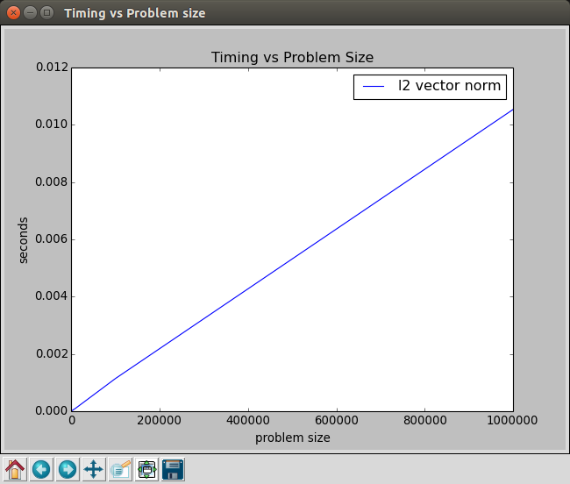

----------------

Let's enter the “fake” algorithms that I mentioned at the beginning of this lesson.

Name Description Program
------- -------------- -----------
linear timing generates linear timings linear_timing
nlogn timing generates nlogn timings nlogn_timing
nsquared timing generates n^2 timings nsquared_timing

For each of them generate timings for problem sizes: 2, 4, 6, 8.

You may have found it annoying to have to repeat the menu keystrokes to add multiple timings for the same algorithm. I've added the following capability to my to-do list in ToDo.txt:

- add capability to generate multiple different timings for an algorithm via just one menu sequence of keystrokes.

Finally, plot their timings using menu option (5). You should get something like the following:

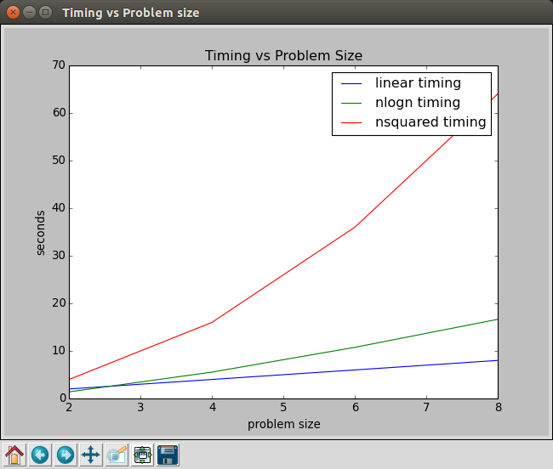

----------------

Overall structure of the Python program

Now let's take a look at the Python code in pycnumanl.py!

This code (version 1.0 of our pycnumanal applicaton) is far from perfect. There are many things I would have done differently, but I didn't do them because they would have reduced the effectiveness of these lessons for a learner of Python/C. There are, however, some good aspects of the code that I will point out below.

Let's look at the overall structure of the code by scrolling through it. Scroll through the code to see the following sections that the program is divided into:

1) introductory program comments.
2) change log
3) import statements (give access to python code/libraries outside the file)
4) function definitions (lines 38-319)
5) script Python code that starts the program running (lines 323-end)

While the overall structure doesn't have to be this way, it is a pretty standardized way of doing it and is fairly easy to follow.

One important feature of this code is that all of its parts are clearly marked with comment dividers (single or double dashed lines) aided by whitespacing before and after them. This makes it easier to find the code section one is looking for and easier to read after finding it.

Each function definition is of the following form:

def function_name(args) :
“”” Comment “””

function code

Python determines what is inside the function definition by indentation and doesn't need semicolons to end statements. Whereas, in C, starting and ending braces, { }, are required to mark the begin and end of the function definition body. C also requires semicolons at the ends of statements on a line.

Notice that after each Python function's definition, I add a comment marking the end of the function:

# end function: function_name

This is not mandatory, but makes it easier to read the program, especially with long function definitions.

Within the function definitions, you'll notice that I use a lot of whitespacing (vertical and horizontal) to make the code much easier to read.

As far as commenting individual lines/blocks of code, you'll notice that for smaller and more obvious ones, I often don't write comments; the code essentially comments itself. However, for longer functions and more challenging code, I comment them.

For longer functions there is a style of commenting that I use even if the individual lines of code are easy to understanding: I put in comments that describe what each code section is doing. For example, in pycnumanal's add_timing function definition, one could eliminate the code and have a clear idea of the steps that this function takes:

def add_timing(conn) :

""" Add a new timing for an algorithm in the database """

# get available algorithms

# check to see if any algorithms were found

display_algorithms( algs )

# choose the algorithm

# extract desired algorithm information

# display the algorithm's timings already in the database

# user inputs a new program size for the algorithm

# prepare OS command-line style command

# call the external program; it is assumed that the external program
# outputs only the timing in the first line of its console output

# get database table cursor

# insert the new timing into the timings table

# finalize the database data addition

# end function: add_timing

Creating a program with good commenting and whitespacing makes the program much easier to work with and understand now and/or later for both the original author and others examining/modifying it.

Going through the Python program in execution order

You don't have to follow my discussion of the code below. I've written the program carefully enough and with enough documentation about what it's trying to do that you can probably figure it out yourself. I suggest looking things up on the Internet if a line or lines of code are not clear to you.

Let's start at the beginning of execution at line 330.

While we'll be following the code by order of execution, I do not discuss every line of code. I just highlight some of what is new or important. As I get further along in the code, I don't have to discuss as much because a large part of the different types of Python code will already have been discussed in earlier parts of the code.

Lines 330-348 setup the database activity for the application. We've discussed it in a previous lesson.

Lines 351-375 represent the action of the applications text-based menuing system. “while 1” operates in an infinite loop until the “exit” option (chosen inside top_menu()) is acted upon by lines 355-357.

The display of the menuing system and user selection is handled by the “top_menu()” function call in line 353.

The action based on a selected menu item is handled by lines 359-375. Check out the use of if/elif/else statements. Notice how the database connection variable “conn” is passed a variable to those actions that will use the database.

0 – exit program
1 – display algorithms (in the database)
2 – add an algorithm (to the database)
3 – display an algorithm's timings (in the database)
4 – Add a timing for an algorithm (to the database)
5 – Plot timings for one more algorithms (in the database)

Note: while the version 1.0 code for the menuing system is relatively “clean,” it is a naïve way of setting up the visual interface to the program. We do it this way because it is easier at this point for the person learning how to program in Python. In a future series of lessons that produces version 2.0 of the Python application, we'll reorganize the code for the text-based menuing system according to standard software development principles. After that, there will be another series of lessons producing version 3.0 that will have a graphical-based interface (GUI).

Lines 38-58 (the top_menu() function) actually present the text-based top-level menu and obtain it's input.

There is an infinite loop until a valid selection is made by the user. At that point in line 53 the user selection is returned to the function call made in line 353.

In line 56, there is the “continue” statement. This simply causes the loop to immediately loop back to line 41. It doesn't have to done this way, but it is simpler. We could have had a variable called “bad_selection” that would be set to True (bad selection = True) for an invalid entry. The while statement would be changed to “while bad_selection = True :” or “while bad_selection :”.

Lines 355-357

If the 0 (exit) option is chosen, these lines are these executed. The “print” statement simple prints a blank line to give the output nice spacing. “exit()” exits the Python application, going back to the OS command line.

Lines 359-360

If the 1 (display algorithms) option is chosen, these lines are excuted. Specifically the “do_display_algorithms(conn)” function is called.

Lines 131-145 are the “do_display_algorithms(conn)” function. It gets the list of algorithms to chose from by calling “get_algorithms(conn)”, whose actual code could have been inside the “do_display_algorithms(conn)” function, but isn't because this same work is needed in another part of the program that also calls “get_algorithms(conn)”. If we didn't have the “get_algorithms(conn)” function, we would have to duplicate code. Sometimes we chose to duplicate code, but there has to be a good reason for it. Here we don't have any such reason!

Lines 62-73 are the “get_algorithms(conn)” function definition). It uses the database connection variable “conn” to get a database cursor that is stored in “cur”. A database cursor is an object that is used to act upon the database and store the results. Here, it is used to execute a SQL SELECT query for all algorithms in the database. “cur” is then used to fetch all the algorithm records that were returned from the database. These records are then returned to the calling function.

When the algorithm records are returned to the “do_display_algorithms(conn)” function, they are checked to see if indeed any were returned. If not, an error message is output and the function returns so that the top menu can be displayed again. If there are algorithm records, the are sent to the “display_algorithms(algs)” function.

Lines 77-93: I don't discuss the whole the “display_algorithms(algs)” function, but just highlight a few aspects of it.

The “ \t” characters in line 81 print statement string operate as escape characters that are given special interpretation in Python. “\t” tells Python to output a “tab” to the screen (i.e., 4, 8, or some other # of spaces; it depends on the system Python is running on).

Notice the loop code in lines 86-89. It loops through each algorithm record in the list of algorithms that sent to the function. Python has an “iterator” functionality that makes it easy to cycle through the algorithms in the “algs” variable (

The print statement in line 88 uses an output formatting methodology that is enhanced in Python 2.7; it is much more flexible and powerful than previous versions. Pythong has several different ways to format text output. It can get confusing!

After the print word in line 88, there is a format string (“ … “). Each dual curly brace element ({…}) is a format specification for the matching variable inside the .format(...) method: “{:>2d}” matches up with “k”, “{:<20s}” matches up with “alg_info[0]”, and so on.

“{:>2d}”:
2 means the width to output within
> means right-aligned within that width
d means outputting an integer

“{:<20s}”:
20 means the width to output within
< means left-aligned within that width
s means outputting a string

and so on.

The “ \” characters in the line 117 print statement are necessary to print the double quotes to the screen. Double quotes are normally interpreted in Python as starting or ending strings. The “\” character, called the “escape” character, tells Python to interpret the double quote as part of the string rather than as an end to the string.

THIS LESSON IS INCOMPLETE;
IT IS STILL BEING WORKED ON!

----------------

Okay that's it for this lesson.

That's the end of this series of lessons. Refer back to the syllabus to see what's next

Make sure everything is saved (Ctrl-s) and create a Lesson 9 subdirectory and copy all this lesson's files into it.

Git your code now to back it up!

