**Introduction**

Our project is made for students to simplify their studying process. Using our webpage, they will easily find teammates, share the duties and follow the progress of the teamwork.

**Requirements**

* Team size is not fixed, but should update as more students join
* Teamwork can be edited by team members
* Teamwork can only be marked done when all connected tasks are marked done as well
* When a teamwork’s deadline is in less than a day, a notification should be sent to all team members
* Teamwork’s tasks must be listed by filters such as priority, estimated difficulty
* A student can join multiple teams
* Only registered users may interact with team works

**Use-Case Diagram**

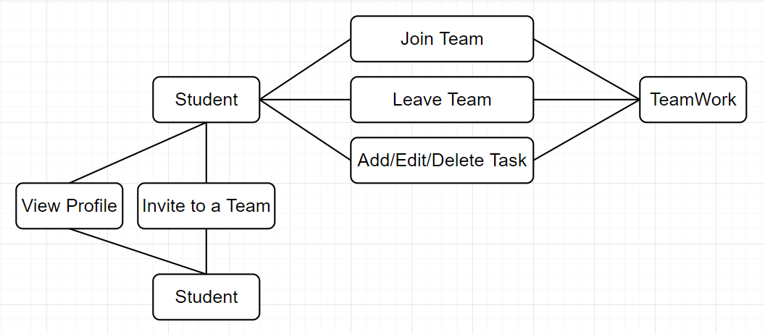

**Classes**

**Student** – class contains base regarding a student such as first name, last name, age etc.

**TeamWork** – class contains base regarding a teamwork such as deadline date, number of teammembers etc.