SJWH | STRENGTH CALCULATION FOR  AIR TANK |  |  | DOC.NO.SJWH2026031～032/0
SJWH |  |  |  | Page: |  | 21
Design Code : NB/T 47065.4-2018 “Vessels Support-Part 4:Bracket Support”
Calculation Conditions |  |  |  | Sketch
Design Pressure p_{c} |  | 1.10 | MPa | 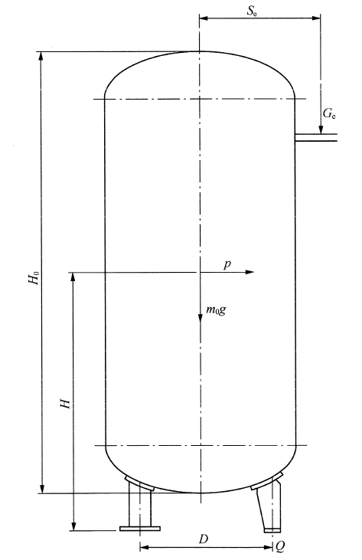
Design Temperature T |  | 110.00 | ℃
Inner Diameter D_{i} |  | 800.00 | mm
Type of Pressure Test |  | Hydrostatic Test
Test Pressure p_{T} |  | 1.50 | MPa
Seismic Intensity |  | 6(0.05g)
Maximum Value of Seismic Effect Factor α_{max} |  | 0.12
Damp Ratio |  | 0.03
Density of Operating medium |  | 10.00 | Kg/m³
Liquid-filled Height of Vessel |  | 2050.00 | mm
Attachment Mass Coefficient |  | 0.15 |  | Basic Wind Pressure q₀ | 300.00 |  | N/m²
Data of Lug Support
Whether or not Standard Support |  | No |  | Whether or not Lined Vessel | No
Type of Supports |  | Type A |  | Number of Supports n | 3 |  | pic
No. of Supports |  | 1 |  | Length of Base Plate l₁ | 130.00 |  | mm
Width of Rib b₂ |  | 110.00 | mm | Width of Base Plate b₁ | 90.00 |  | mm
Thickness of Rib δ₂ |  | 8.00 | mm | Thickness of Base Plate δ₁ | 8.00 |  | mm
Material of Rib |  | SA-516M Gr.485 | mm | Material of Base Plate | SA-516M Gr.485
Allowable Stress of Rib [σ]₂ |  | 138.00 |  | Allowable Stress of Base Plate [σ]₁ | 138.00 |  | MPa
Thickness of Backing Plate δ₃ |  | 8.00 | MPa | Allowable Load of Support [Q] | 16.50 |  | kN
Height of Support h |  | 265.00 | mm | Allowable Vertical Load of Type B Support [F] |  |  | kN
Distance between center of Anchor Bolts and short side of Base Plate s₁ |  | 280.00 | mm | Non-uniform Coefficient k | 1.00
Data of Cylinder Shell
Nominal Thickness of Cylinder |  | 8.00 |  |  |  |  | mm
Length of Cylinder |  | 1650.00 |  |  |  |  | mm

Data of Heads | Upper Head | Lower Head
Type of Head | ELLIPSOIDAL | ELLIPSOIDAL
Nominal Thickness | 8.00 | 8.00 | mm
Length of Straight Flange | 25.00 | 25.00 | mm
Depth of Curved Surface of Head | 200.00 | 200.00 | mm

SJWH | STRENGTH CALCULATION FOR  AIR TANK |  |  |  | DOC.NO.SJWH2026031～032/0
SJWH |  |  |  |  | Page: |  |  | 22
Calculation for Mass of Vessel
 |  | Installation Condition |  | Operating Condition |  |  | Hydraulic test Condition
Mass of Cylindrical Shell |  | 263.03 |  | 263.03 |  |  | 263.03 |  | kg
Mass of Upper Head |  | 47.14 |  | 47.14 |  |  | 47.14 |  | kg
Mass of Lower Head |  | 47.14 |  | 47.14 |  |  | 47.14 |  | kg
Attachment Mass |  | 53.60 |  | 53.60 |  |  | 53.60 |  | kg
Mass of Liquid Filled in Vessel |  | 0.00 |  | 9.83 |  |  | 988.56 |  | kg
Insulation Mass |  | 0.00 |  | 0.00 |  |  | 0.00 |  | kg
Total Mass of Eccentric Load |  | 0.00 |  | 0.00 |  |  | 0.00 |  | kg
Total Mass(Besides Eccentric Load) |  | 410.90 |  | 420.73 |  |  | 1399.46 |  | kg
Calculation for Seismic Loads
 |  | Installation Condition |  | Operating Condition |  |  | Hydraulic test Condition
Natural Vibration Period T₁ |  | 0.56 |  | 0.56
Damping Modification Factor η₂ |  | 1.16 |  | 1.16
Horizontal seismic influence coefficient α₁ |  | 0.05 |  | 0.05
Horizontal seismic force p_{e}  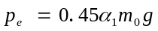 |  | 95.03 |  | 97.31 |  |  |  |  |  | N
Calculation for Wind Loads
Height variation factor of wind pressure f_{i} |  | 1.00 |  | 1.00 |  |  | 1.00
Total Height of Vessel Shell H₂ |  | 2116.00 |  | 2116.00 |  |  | 2116.00 |  |  | mm
Outside Diameter of Vessel D₀  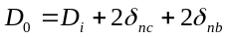 |  | 816.00 |  | 816.00 |  |  | 816.00 |  |  | mm
Horizontal wind load p_{w}  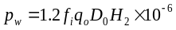 |  | 621.60 |  | 621.60 |  |  | 205.13 |  |  | N
Calculation and Check for Actual Bearing Load of Support
 |  | Installation Condition | Operating Condition |  |  | Hydraulic test Condition
Horizontal Force p |  | 621.60 | 621.60 |  |  | 205.13 |  |  |  | N
Height between Horizontal Force and Base Plate H |  | 1249.83 | 1249.67 |  |  | 1249.83 |  |  |  | mm
Installation dimension of support D |  | 560.00 | 560.00 |  |  | 560.00 |  |  |  | mm
Actual Bearing Load Q  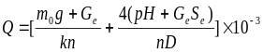 |  | 3.19 | 3.23 |  |  | 5.19 |  |  |  | kN
Allowable Value [Q] |  | 16.50 | 16.50 |  |  | 16.50 |  |  |  | kN
Check Condition |  | Q≤[Q] | Q≤[Q] |  |  | Q≤[Q]
Conclusion |  | It is safe | It is safe |  |  | It is safe

