**Database Data Schema & Attributes**

**Restaurant**

* Restaurant name & restaurant id

**Item**

* Items name
* Restaurant – foreign key relationship with restaurant
* Price – price of items
* Count – counter to keep track of no of time its purchased
* Updated & created at timestamps (automatic by default)

**Order**

* Updated & created at timestamps

**OrderItem**

* Item, a foreign key relationship to item table
* Order, a foreign key relationship to order table
* Quantity keep track of number of items needed
* Updated & created at timestamps (automatic by default**)**

**Recently Purchase Items Sorting Algorithm**

* Recently purchased item is obtained sorting the items based updated time because when an items is initially created the count attribute is incremented which would caused updated time attributed to change
* 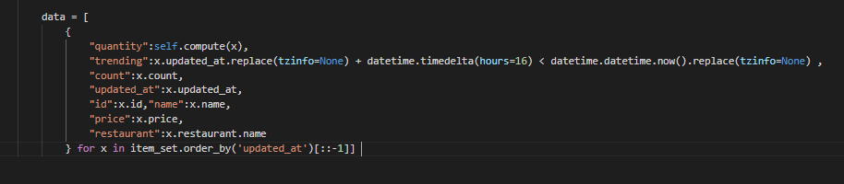The quantity is calculated by getting last record’s of Orderitem table associated to a specific item for which the quantity is to be calculated with help of foreign key relationship between Order Table and Item table

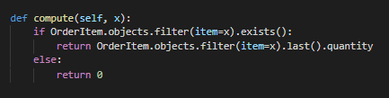

**Most Purchased Items Sorting Algorithm**

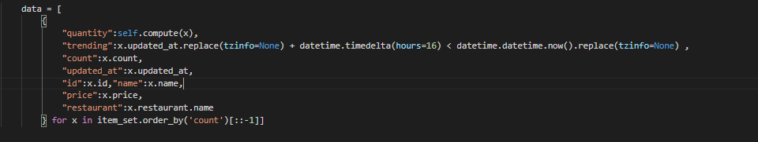

* Almost same as algorithm from most recent items except that the items are sorted in ascending order

**Ideas**

* Add Contact Information to Order table such as Name, Phone Number
* Add Location to Order Table

**SCREENSHOTS**

