**Online Store Sales Insights Report**

**Objective:**

* To provide insights and recommendations on whether the applied promotional campaigns has worked

**Problems Identified:**

ABC is an online store selling its range of products to different parts of the world. ABC has been running its promotional campaign for past seven months. The company is approaching a data analysis partner to seeking insights whether its promotional campaigns have made an impact.

**Acceptance Criteria:**

* Display key performance indicators like the revenue trend, trend of number of products sold,
* Dashboard to be user-friendly and easy to sort and filter

**General Approach to Solution:**

1. Get the data
2. Explore the data in Excel
3. Load the data into SQL Server
4. Clean the data with SQL
5. Test the data with SQL
6. Visualize the data in Power BI
7. Generate the findings based on the insights
8. Write the documentation + commentary
9. Publish the data to GitHub Pages

**Data Needed:**

* Transaction ID
* Date of product sold
* Product category
* Product name
* Number of units sold
* Region
* Revenue

**Data Cleaning and Validation :**

We need to add measures in place to confirm the dataset contains the data required without any issues – here are some of the data quality checks we need to conduct:

* Securing required columns only , i.e. Payment_Method and Unit_Price fields are not needed

SELECT

Transaction_ID, Date, Product_Category, Product_Name, Units_Sold, Total_Revenue, Region

FROM

OnlineStoreSalesInsights..OnlineStoreSales

* Rounding fields Total_Revenue to 2 decimal places only

SELECT

Transaction_ID, Date, Product_Category, Product_Name, Units_Sold,

CAST (Total_Revenue AS DECIMAL(10,2)) AS Total_Revenue,

Region

FROM

OnlineStoreSalesInsights..OnlineStoreSales

* Creating view and then checking the data type of the fields

CREATE VIEW ViewOnlineStoreSales AS

SELECT Transaction_ID,

Date,

CAST(Product_Category AS varchar(100)) AS Product_Category,

CAST(Product_Name AS varchar(100))AS Product_Name,

Units_Sold,

CAST(Total_Revenue AS DECIMAL(10,2)) AS Total_Revenue,

CAST(Region AS varchar(100)) AS Region

FROM OnlineStoreSalesInsights..OnlineStoreSales

SELECT

COLUMN_NAME,

DATA_TYPE

FROM

INFORMATION_SCHEMA.COLUMNS

WHERE

TABLE_NAME = 'ViewOnlineStoreSales'

* Checking for 0 duplicates

SELECT

Transaction_ID, COUNT(Transaction_ID) as cnt

FROM

ViewOnlineStoreSales

GROUP BY Transaction_ID

HAVING COUNT(Transaction_ID) >1

**Visualisation in Power BI:**

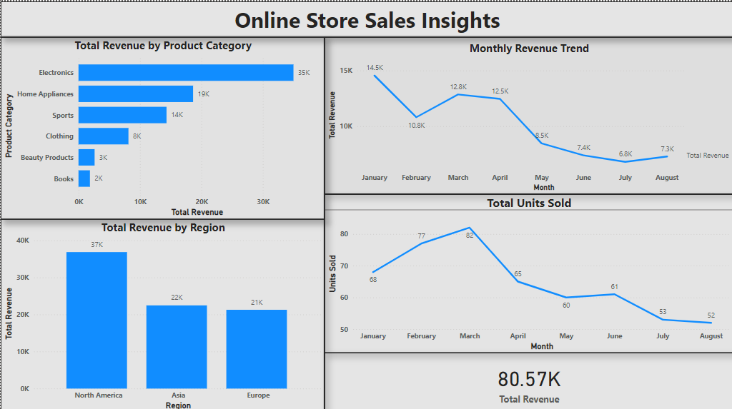

**Findings and Analysis:**

* North America generates the highest revenue mostly by selling expensive electronic products,
* Monthly revenue has dropped for all product category coming on the seventh month,
* Monthly revenue has dropped to about half at the end of the seventh month, but the total units of products sold has only dropped by few.

**Recommendations:**

* The promotional campaign, which is supposed to increase the number of units sold helping to boost up the revenue, has not worked out well.
* Marketing campaigns are to be double checked.
* Customer feedbacks and reviews have to be analysed to get an insight into the low selling of products.