Black Holes: The Mystery: Site Map, Wireframes and References
University of Canberra
Student ID: 0000000

Project overview
This document accompanies a six-page educational website titled “Black Holes: The Mystery”. The intended audience is a general reader who wants a clear introduction to black holes, their main categories, and the evidence astronomers use to study them. The site uses concise explanations, tables, navigation links, a demonstration form, and original SVG concept illustrations.
Scientific statements are supported by NASA and Event Horizon Telescope material. The illustrations are original diagrams and are not represented as scientific photographs. The contact form is demonstrative only: it does not send or store messages.

1. Site map
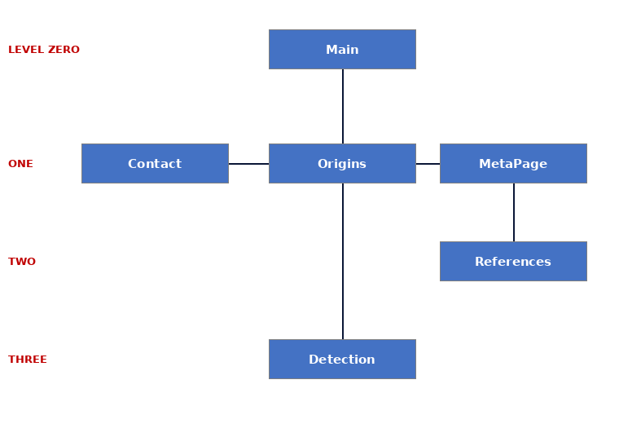
Main is level zero. Origins is the first content page; Contact and MetaPage sit at level one. References sits below MetaPage, and Detection (content page 2) is at level three. All pages share one menu in the nav element.

2. Wireframes
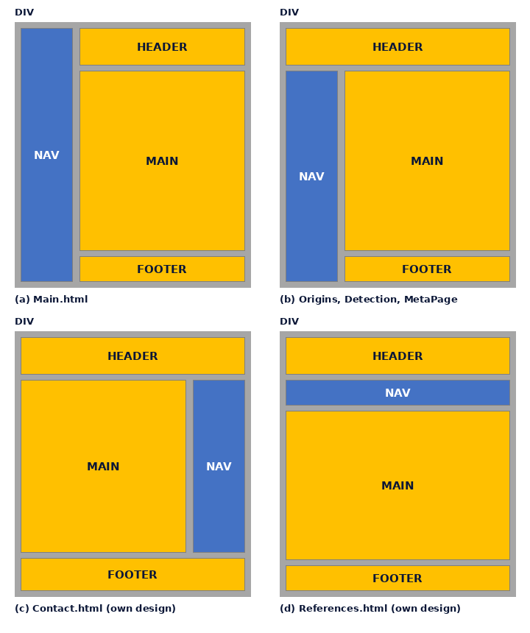
Wireframe (a) is used for Main, (b) for Origins, Detection and MetaPage. Wireframes (c) and (d) are my own designs for Contact and References.

3. References
Abbott, B.P. et al. (2016) 'Observation of gravitational waves from a binary black hole merger', Physical Review Letters, 116(6), 061102.
Anthropic (2026) Claude Sonnet 5.5 [Large language model]. Available at: https://claude.ai .
Artist's impressions of black holes (n.d.) [Images supplied by the author; original sources to be confirmed(pexel)].
Drljaca, U. (n.d.) Digital artwork of streaks circling a black hole [Photograph]. Pexels. Available at: https://www.pexels.com/photo/29431263/
Event Horizon Telescope Collaboration (2019) 'First M87 Event Horizon Telescope results. I. The shadow of the supermassive black hole', The Astrophysical Journal Letters, 875(1), L1.
Gahramanow, S. (n.d.) Andromeda galaxy [Photograph]. Pexels. Available at: https://www.pexels.com/photo/39076461/
Hawking, S.W. (1974) 'Black hole explosions?', Nature, 248(5443), pp. 30-31.
Hawking, S. (1988) A brief history of time. London: Bantam Press.
Lord, S. (n.d.) Galaxies in a purple nebula [Photograph]. Pexels. Available at: https://www.pexels.com/photo/37761980/
Mueller, J. (n.d.) Andromeda galaxy [Photograph]. Pexels. Available at: https://www.pexels.com/photo/5882866/
NASA (2026) Black holes. Available at: https://science.nasa.gov/universe/black-holes/
Nobel Prize Outreach (2020) The Nobel Prize in Physics 2020. Available at: https://www.nobelprize.org/prizes/physics/2020/summary/
Resic, A. (n.d.) Black hole with a glowing accretion disk [Photograph]. Pexels. Available at: https://www.pexels.com/photo/37149440/
Schwarzschild, K. (1916) 'Über das Gravitationsfeld eines Massenpunktes nach der Einsteinschen Theorie', Sitzungsberichte der Königlich Preussischen Akademie der Wissenschaften, pp. 189-196.
W3C (2026a) CSS validation service. Available at: https://jigsaw.w3.org/css-validator/
W3C (2026b) Markup validation service. Available at: https://validator.w3.org/

