Why We Love Vintage?: Site Map, Wireframes and References
Student ID: U3285064

1. Site map
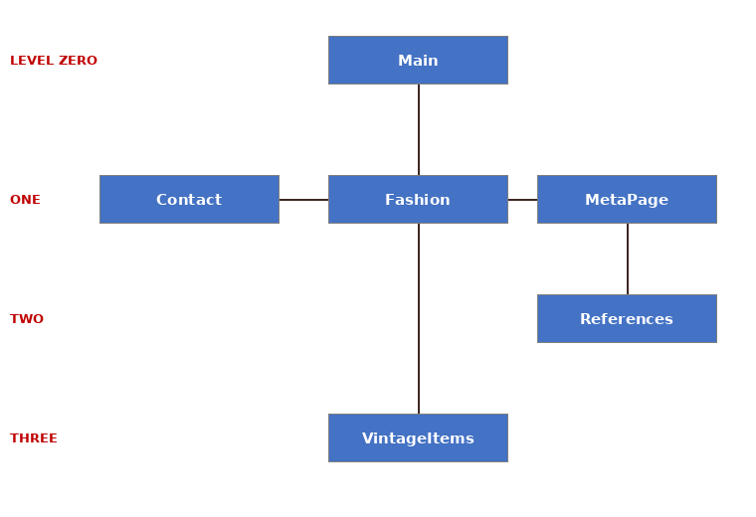
Main is level zero. Fashion is the first content page; Contact and MetaPage sit at level one. References sits below MetaPage, and VintageItems (content page 2) is at level three. All pages share one menu in the nav element.

2. Wireframes
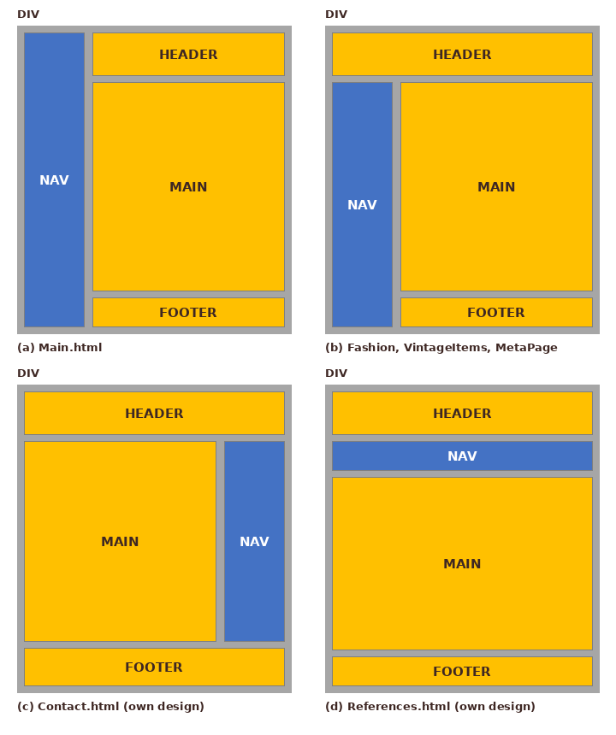
Wireframe (a) is used for Main, (b) for Fashion, VintageItems and MetaPage. Wireframes (c) and (d) are my own designs for Contact and References.

3. References
Anthropic (2026) Claude Sonnet 5.5 [Large language model]. Available at: https://claude.ai
Arias, V. (n.d.) Couple in 1940s-style clothing [Photograph]. Pexels. Available at: https://www.pexels.com/photo/13530144/
Brunxs (n.d.) Woman holding a vintage film camera [Photograph]. Pexels. Available at: https://www.pexels.com/photo/1858402/
Exclusive (n.d.) Interior of a vintage clothing shop [Photograph]. Pexels. Available at: https://www.pexels.com/photo/24843384/
Glitter, V. (n.d.a) Woman holding a vinyl record on a picnic [Photograph]. Pexels. Available at: https://www.pexels.com/photo/29554188/
Glitter, V. (n.d.b) Woman listening to a vinyl record player [Photograph]. Pexels. Available at: https://www.pexels.com/photo/6351027/
Gonullu, M. (n.d.) Neon sign reading Vintage Glasses [Photograph]. Pexels. Available at: https://www.pexels.com/photo/7317350/
Mercuri, J. (n.d.) Woman in a vintage dress with a bicycle [Photograph]. Pexels. Available at: https://www.pexels.com/photo/39164458/
Monurblc (n.d.) Mannequins wearing vintage clothing [Photograph]. Pexels. Available at: https://www.pexels.com/photo/37550158/
Mozilla Developer Network (MDN) (n.d.a) HTML: HyperText Markup Language. Available at: https://developer.mozilla.org/en-US/docs/Web/HTML
Mozilla Developer Network (MDN) (n.d.b) HTML table basics. Available at: MDN HTML table basics
O'Shea, S. (n.d.) Vintage clothing and shoes on display [Photograph]. Pexels. Available at: https://www.pexels.com/photo/30224016/
OpenAI (2026) ChatGPT [Large language model]. AI assistance used to develop and review website content. https://chatgpt.com/
Sevim, L. (n.d.) Antique shop with a mannequin and vintage objects [Photograph]. Pexels. Available at: https://www.pexels.com/photo/9704136/
Wikipedia (n.d.a) Phonograph record. Available at: https://en.wikipedia.org/wiki/Phonograph_record
Wikipedia (n.d.b) Vintage. Available at: https://en.wikipedia.org/wiki/Vintage
Wikipedia (n.d.c) Vintage clothing. Available at: https://en.wikipedia.org/wiki/Vintage_clothing
World Wide Web Consortium (W3C) (n.d.a) CSS Validation Service. Available at: https://jigsaw.w3.org/css-validator/
World Wide Web Consortium (W3C) (n.d.b) Markup Validation Service. Available at: https://validator.w3.org/

