DevOps Certification Training

# Certification Project



© Brain4ce Education Solutions Pvt. Ltd.

## Problem Statement

AppleBite Co. is using Cloud for one of their products. The project uses modular components, multiple frameworks and want the components to be developed by different teams or by 3rd-party vendors.

The company’s goal is to deliver the product updates frequently to production with High quality & Reliability. They also want to accelerate software delivery speed, quality and reduce feedback time between developers and testers.

As development progressed, they are facing multiple problems, because of various technologies involved in the project. Following are the problems:

* Building Complex builds is difficult
* Manual efforts to test various components/modules of the project
* Incremental builds are difficult to manage, test and deploy

To solve these problems, they need to implement Continuous Integration & Continuous Deployment with DevOps using following tools:

**Git** – For version control for tracking changes in the code files

**Jenkins** – For continuous integration and continuous deployment

**Docker** – For deploying containerized applications

**Puppet/Ansible** - Configuration management tools

**Selenium** - For automating tests on the deployed web application

This project will be about how to do deploy code to dev/stage/prod etc, just on a click of button.

Link for the sample PHP application: [https://github.com/edureka-devops/projCert.git](https://www.google.com/url?q=https://github.com/edureka-devops/projCert.git&sa=D&source=hangouts&ust=1529594204947000&usg=AFQjCNHLi_-tQcahU0SXmK-dbQu3oSMTqQ)

## Business challenge/requirement

As soon as the developer pushes the updated code on the GIT master branch, a new test server should be provisioned with all the required software. Post this, the code should be containerized and deployed on the test server.

The deployment should then be tested using a test automation tool, and if the build is successful, it should be pushed to the prod server.

All this should happen automatically and should be triggered from a push to the GitHub master branch.

Steps for executing the solution:

* Use the Master VM for Jenkins, Ansible, Puppet, GIT etc.
* Use the Clean Ubuntu VM image provided in the “Edureka Setup Guide” for Jenkins Slave Node (Test Server)
* Change the IP address of the VMs accordingly
* Add Build Pipeline Plugin and Post-build task plugin to Jenkins on the master VM
* Install python, openssh-server and git on the slave node manually
* Set up the necessary tools such as git, chromedriver(selenium), chromium browser(selenium) on the slave node through Ansible
* Use the image devopsedu/webapp and add your PHP website to it using a Dockerfile
* Create a Selenium Test for your PHP website. It should click on “About” and verify the text written in it. This will conclude the website is deployed and is running fine.
* Push the PHP website, Dockerfile and Selenium JAR to a git repository

Below tasks should be automated through Jenkins by creating a pipeline:

1. Install and configure puppet agent on the slave node (Job 1)
2. Sign the puppet certificate on master using Jenkins (Job 2)
3. Trigger the puppet agent on test server to install docker (Job 3)
4. Pull the PHP website, Dockerfile and Selenium JAR from your git repo and build and deploy your PHP docker container. After this test the deployment using Selenium JAR file. (Job 4)
5. If Job 4 fails, delete the running container on Test Server

**NOTE:** Jenkins may show Job 3 as Failed, even though Console Output is successful. Enable the next job to run even if this job fails, as a workaround.

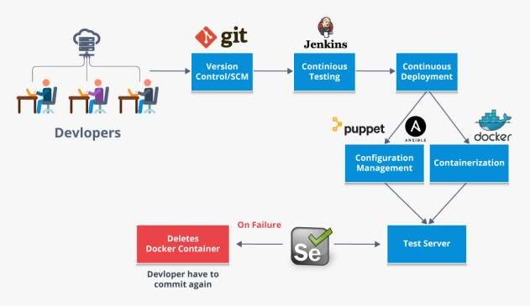

## Solution

Setting up Remote Node on Jenkins

1. Go to Manage Jenkins-> Configure Global Security and under Agents set the TCP port for JNLP agents to Random

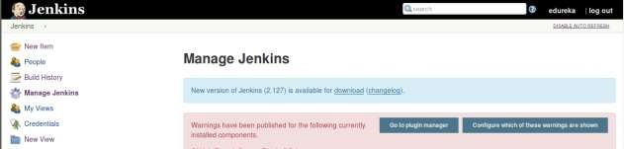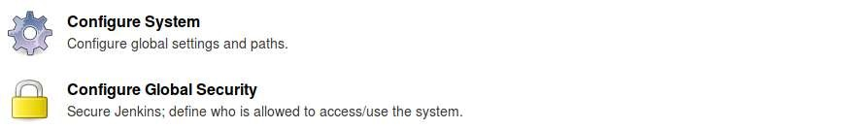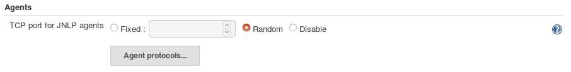

1. Go to Manage Jenkins -> Manage Nodes and create a new node

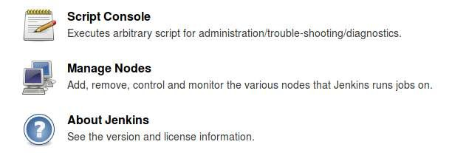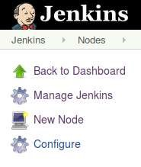

1. Now, set the “name”, “Remote root directory” and choose Launch agent via Java Web Start in Launch Method

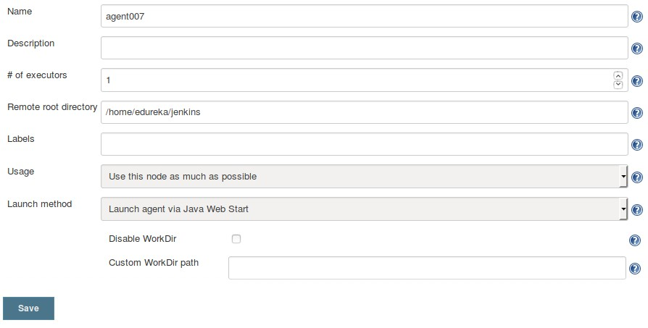

And under Node Properties check Tool Locations and give path to git directory and click on

save

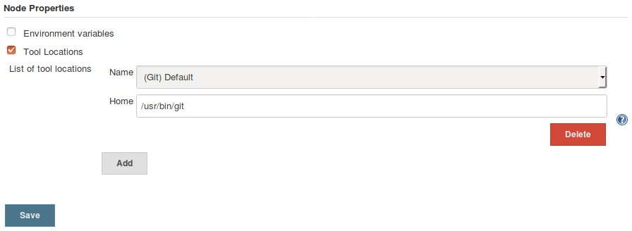

1. Now Select the newly created node and download the agent.jar file in your master node

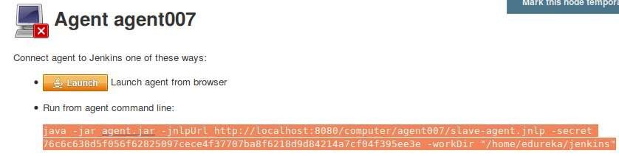

1. Copy the above highlighted code in your agent node’s terminal and replace the localhost with Master’s IP address



Configuring Remote machine using Ansible

1. Create an ansible playbook to configure the remote machine for the initial setup

|  |
| --- |
| ---   * hosts: agent become: true vars:   ansible_become_pass: edureka tasks:   * name: Install Git package: name: git state: present      * name: Run update apt:   update_cache: true     * name: Install jdk package:   name: default-jdk state: present     * name: Copy chromedriver copy:   src: /home/edureka/chromedriver dest: /home/edureka/     * name: Install chromium browser package:   name: chromium-browser state: present |

|  |
| --- |
| * name: Install chromium driver package:   name: chromium-chromedriver state: present       * name: Copy agent.jar file copy: src: /home/edureka/Downloads/agent.jar     dest: /home/edureka     * name: Run update apt:     update_cache: yes |

Creating Puppet Module to set up Docker on remote machine:

1. Generate a Puppet Module for docker

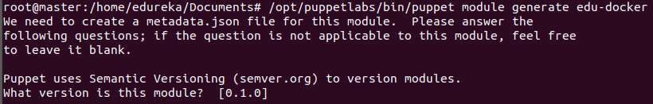

1. Create an Install.pp Manifest to set up docker

|  |
| --- |
| class docker::install {    package {'curl':  ensure => present,    }      exec {'apt-update':  command => '/usr/bin/apt-get update'  }        exec {'download_docker_key':  command => '/usr/bin/curl -fsSL  https://download.docker.com/linux/ubuntu/gpg | sudo apt-key add -' }    exec {'add_docker_repo':    command => '/usr/bin/add-apt-repository "deb [arch=amd64] https://download.docker.com/linux/ubuntu $(lsb_release -cs) stable"',    require => Exec['apt-update']    }      exec {'docker_cache':    command => '/usr/bin/apt-cache policy docker-ce'    }    exec {'install_docker': command => '/usr/bin/apt-get install -y docker-ce'    }        } |

1. Call this manifest inside init.pp file in the manifests directory

class docker {

class {'docker::install':}

}

1. Now Build and Install this Puppet Module

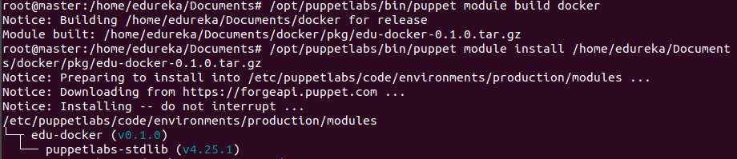

1. Call this Module inside the main Puppet manifest(i.e. site.pp)

class {'docker':}

1. Create a docker file to run the php application

-FROM devopsedu/webapp

-

-ADD proj /var/www/html

-

-RUN rm /var/www/html/index.html

-

-CMD apachectl -D FOREGROUND

**Docker images:**

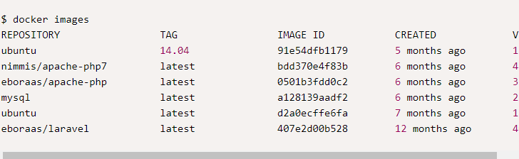

1. Write the following Selenium code and create a .jar file after compiling the code in eclipse(or any other java IDE

|  |
| --- |
| import static org.testng.Assert.assertEquals; import java.util.concurrent.TimeUnit;    import org.openqa.selenium.By; import org.openqa.selenium.WebDriver; import org.openqa.selenium.chrome.ChromeDriver; import org.testng.annotations.Test;  import org.openqa.selenium.chrome.ChromeOptions;    public class App  {  @Test  public static void main(String[] args) {      System.setProperty("webdriver.chrome.driver","/home/edureka/chromedriver");  ChromeOptions chromeOptions = new ChromeOptions(); chromeOptions.addArguments("--headless"); chromeOptions.addArguments("--no-sandbox");  WebDriver driver = new ChromeDriver(chromeOptions); chromeOptions.addArguments("--headless");      driver.get("[http://localhost:8081"](https://www.google.com/url?q=http://localhost:8081&sa=D&source=hangouts&ust=1529588649318000&usg=AFQjCNE4LV92kyei8r0uE350XC8x2gLkUQ));    driver.manage().timeouts().implicitlyWait(3, TimeUnit.SECONDS); driver.findElement(By.id("About Us")).click();    String test = driver.findElement(By.id("PID-ab2-pg")).getText();  assertEquals(test, "This is about page. Lorem Ipsum is simply dummy text of the printing and typesetting industry. Lorem Ipsum has been the industry's standard dummy text ever since the 1500s, when an unknown printer took a galley of type and scrambled it to make a type specimen book. It has survived not only five centuries, but also the leap into electronic typesetting, remaining essentially unchanged. It was popularised in the 1960s with the release of Letraset sheets containing Lorem  Ipsum passages, and more recently with desktop publishing software like Aldus  PageMaker including versions of Lorem Ipsum.");  System.out.println("Test Succeeded!!"); driver.quit();        }  } |

**Creating Jenkins Jobs:**

**Job to set up puppet agent on Remote Machine:**

1. Create a new Job on Jenkins and restrict it to run on Remote machine only

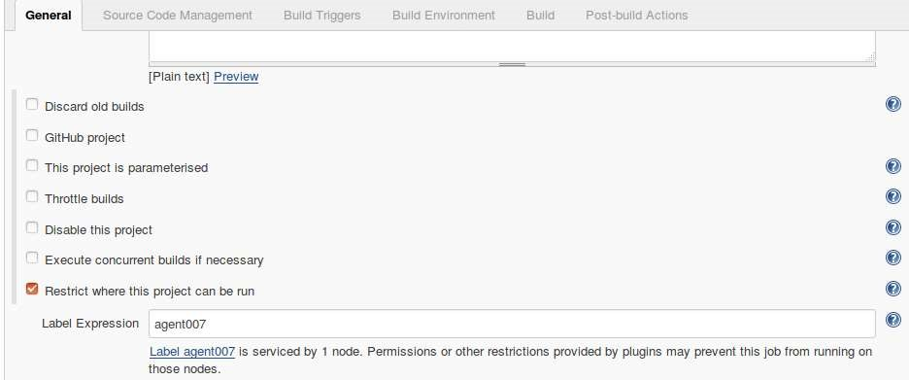

1. Now, In the build phase add a build step to execute shell commands and save the Job

|  |
| --- |
| wget https://apt.puppetlabs.com/puppetlabs -release-pc1-xenial.deb    sudo dpkg -i puppetlabs-release-pc1-xenial.deb    sudo apt-get update    sudo apt -get install -y puppet-agent sudo systemctl start puppet sudo systemctl start puppet |

### Job to Sign Puppet certificates of the newly connected nodes to puppet

16. Create a new Job and add a build step to execute shell command on the local master machine

sudo /opt/puppetlabs/bin/puppet cert sign --all

### Job to trigger puppet agent to pull and apply the catalog from master

1. Create a new job and restrict it to execute only on the remote machine

1. Add a build step to execute a shell command to trigger Puppet agent

sudo /opt/puppetlabs/bin/puppet agent -t

### Job to create a docker container, run the container and execute Selenium test case on it

1. Create a new job and restrict it to execute only on the remote machine

1. Add Your GitHub link in the GitHub Project and also make this job restricted to remote machine only

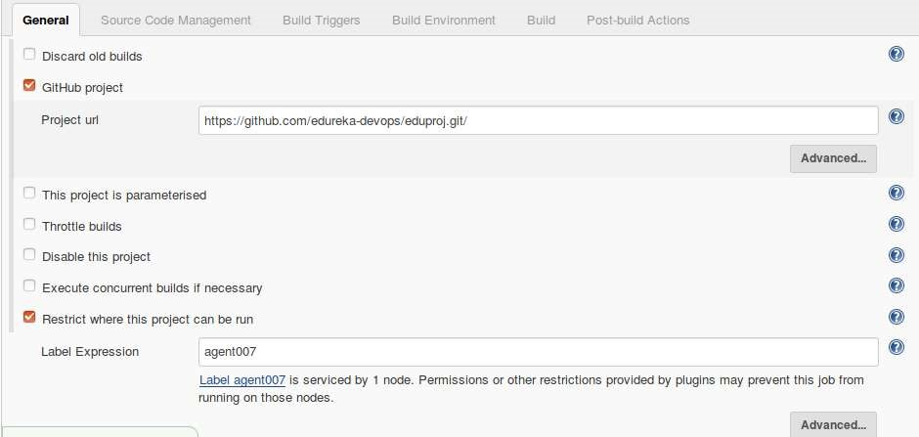

1. Under Source Code Management in the git section again add your GitHub url

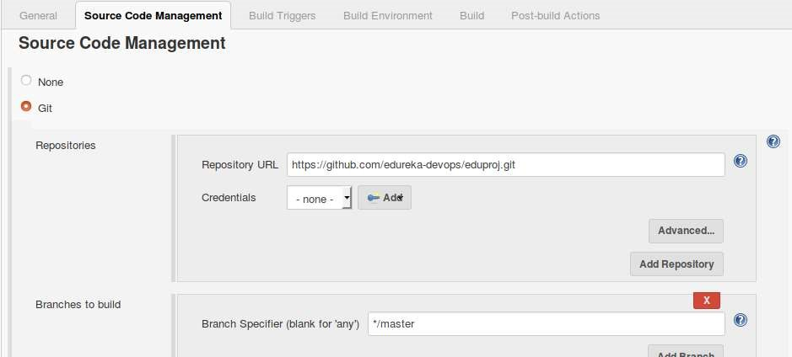

1. Under Build Triggers check poll SCM and give it appropriate time interval to poll GiHiub for changes

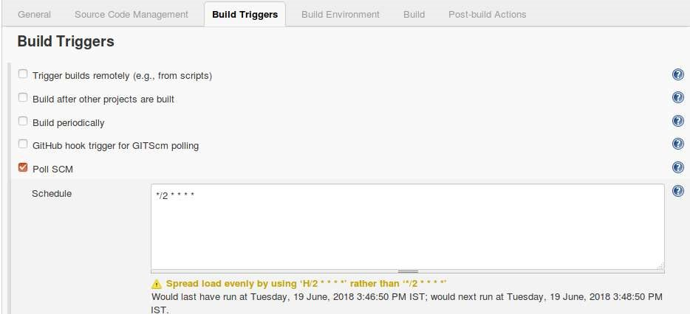

1. Now, add a build step to execute the following shell commands on the remote machine

|  |
| --- |
| sudo docker run busybox  sudo docker stop $(sudo docker ps -a -q) sudo docker rm $(sudo docker ps -a -q)    sudo docker build . -t appmain:latest    sudo docker run -it -p 8081:80 -d appmain:latest    sudo java -jar final11.jar |

1. Add a Post-build Actions -> Post build task to ensure that if the Selenium test fails, the docker containers are deleted. Here keep the Log text as failure and add the docker container removing commands in the script section

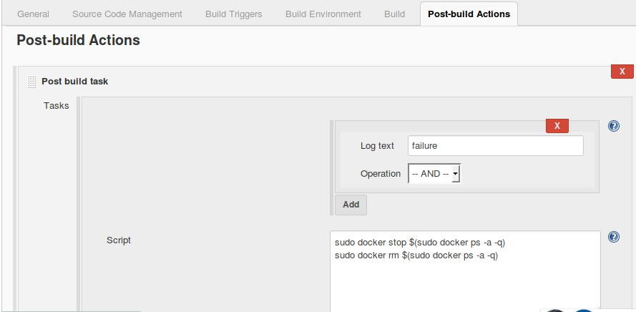

**Build a Jenkins Delivery Pipeline to run all the jobs:**

**Note:** While creating the Puppetagent trigger job Set the Post Build Action to Trigger even if the build fails. This is because for some reason Jenkins is considering Puppet agent Successful build to be a failure.

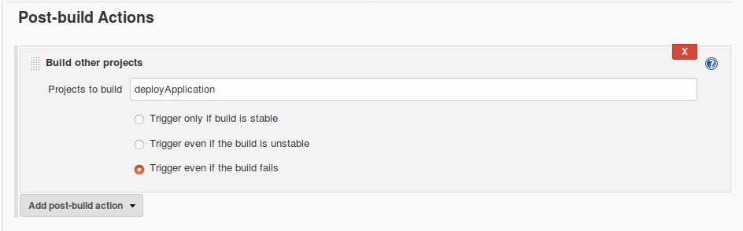

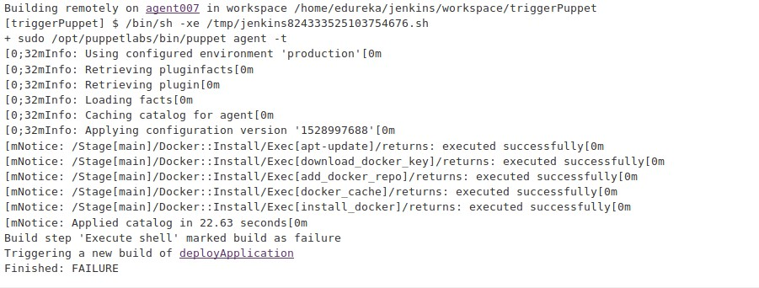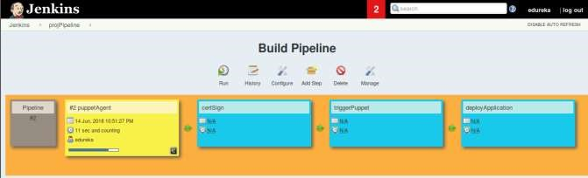

### Execution

1. Execute the Ansible Playbook for initial setup of the agent node

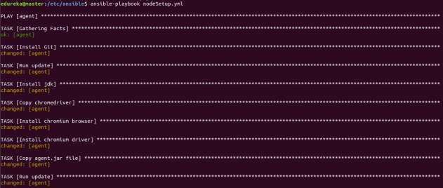

1. Execute the Jenkins Pipeline



