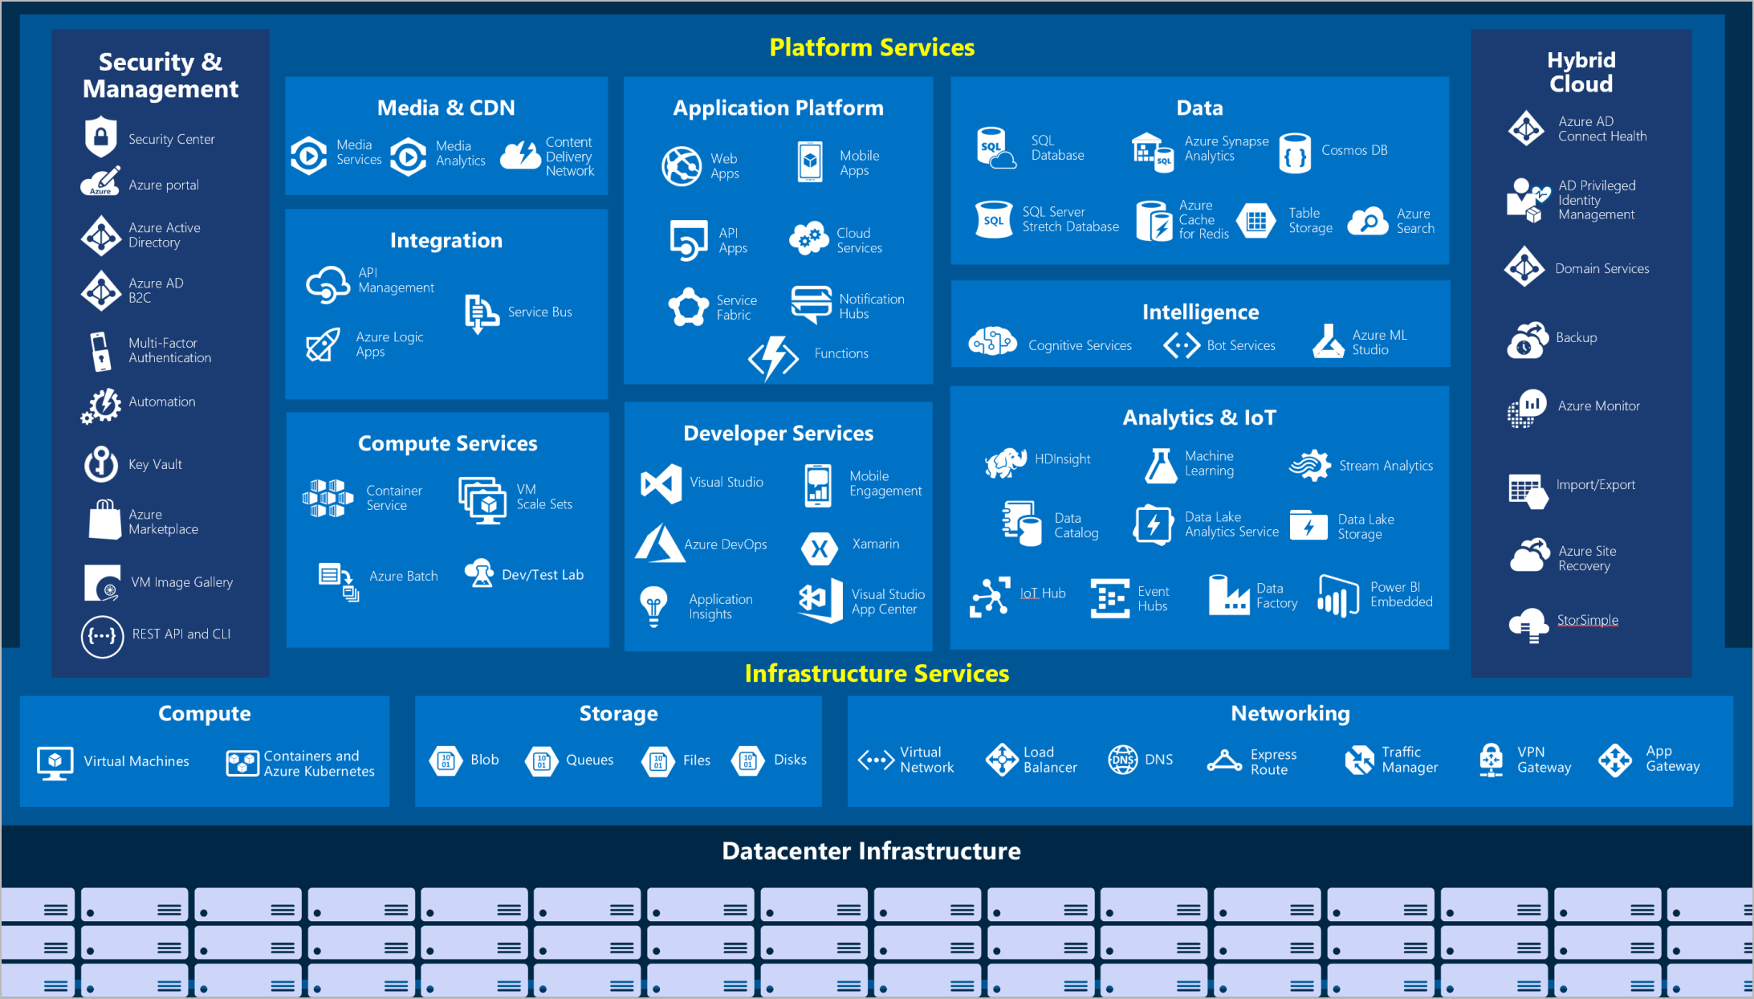

AZURE – 10,000 ft view

<https://www.microsoft.com/videoplayer/embed/RWBg9Q>

AZURE - Portal

<https://www.microsoft.com/videoplayer/embed/RE4ICN6>

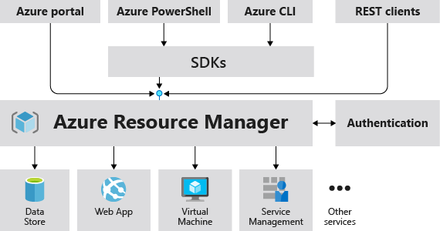

**Azure Resource Manager provides a consistent Management Layer**

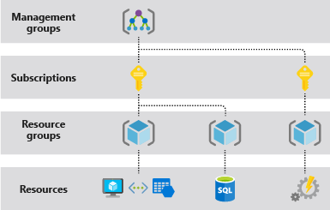

**Azure provides four levels of scope**

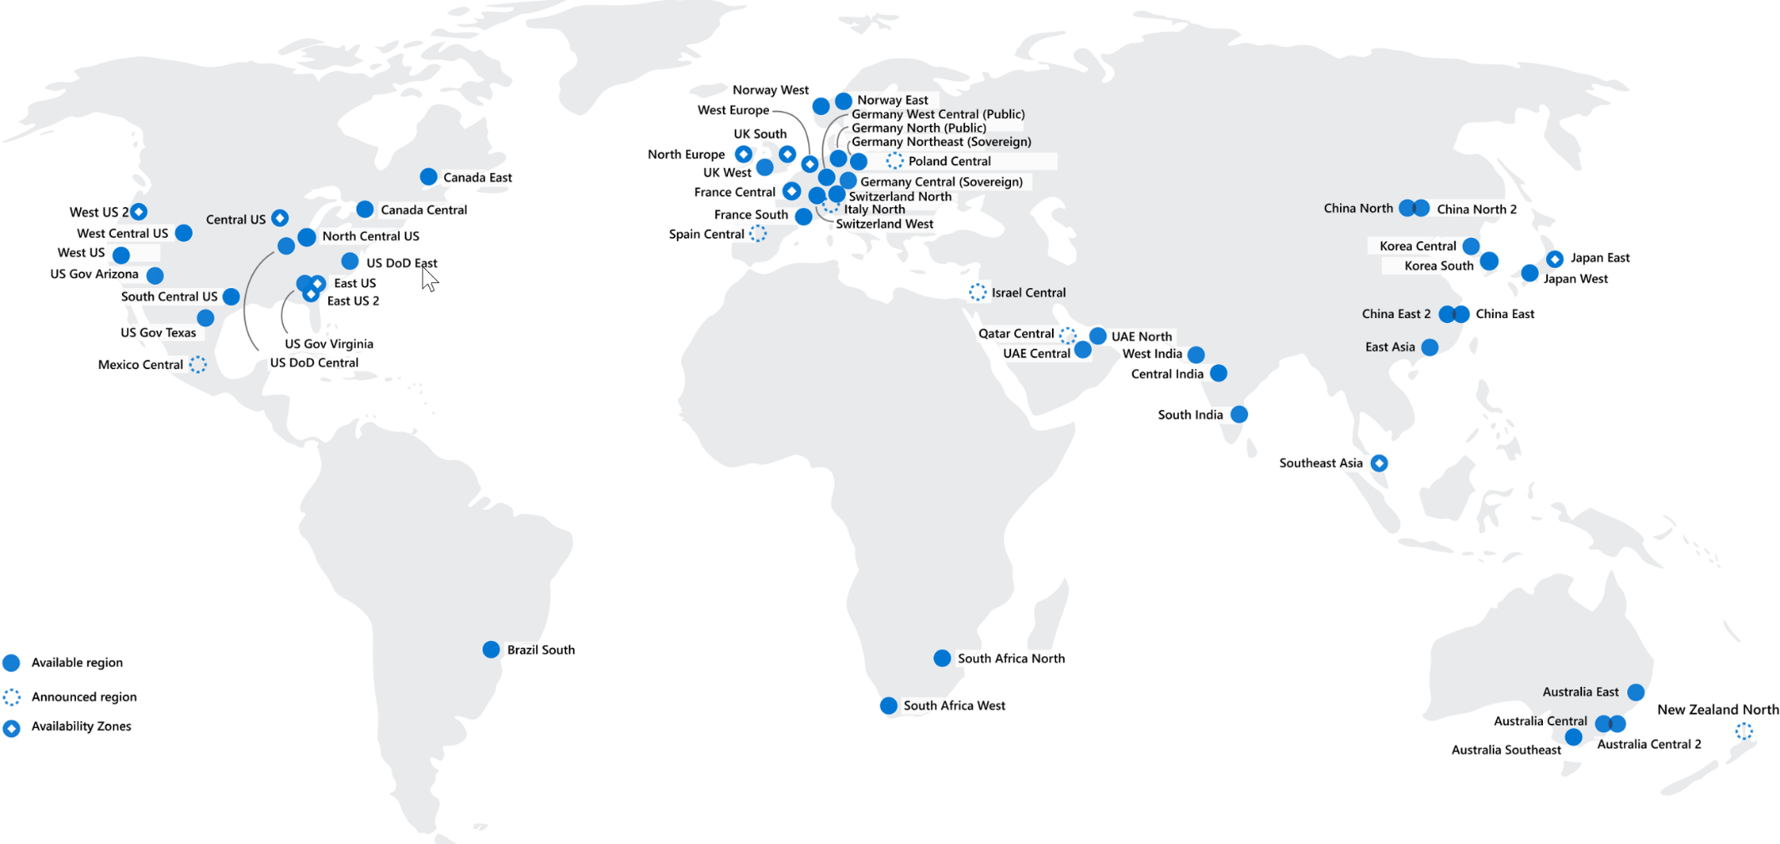

**AZURE REGION**

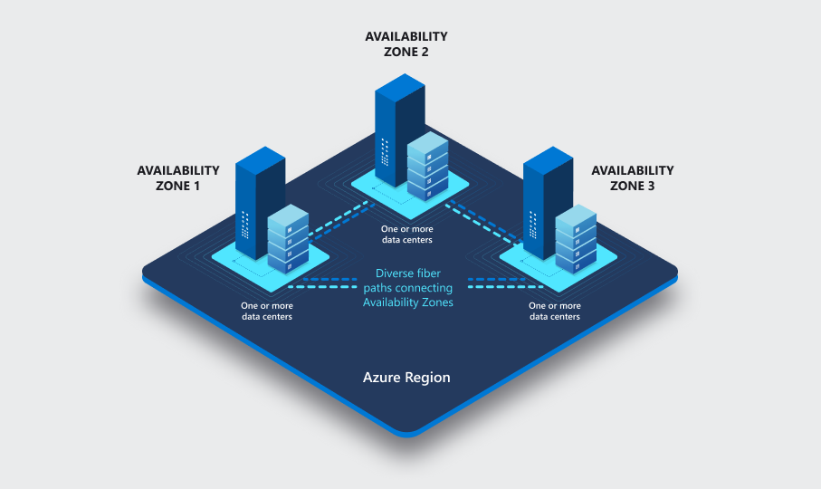

**DESIGNING FOR HA & DR**