Cloud computing is the delivery of computing services over the internet by using a pay-as-you-go pricing model. You typically pay only for the cloud services you use.

When you go to buy a laptop, the things that you will typically look for is Operating system, Memory (8 GB ram, 2 core CPU) (nothing but the computing power), how much disk space (called Storage in cloud vocabulary)

In today’s session we will be using Azure, which is Microsoft’s cloud service platform.

To create and use Azure services like compute or storage, you need an Azure Subscription. When you login thru PluralSight, it will automatically create a default Subscription for you (ep-labs-learn xxxx). After you've created an Azure subscription, you can start creating Azure resources within each subscription.  *For example, your company might use a single Azure account for your business and separate subscriptions for development, marketing, and sales departments*

In Azure, subscriptions are a unit of management, billing, and scale. You can have Subscriptions that indicate organizational structures such as say GBIS, Retail. IBFS etc or even granular ones. You can create addition subscriptions for billing purpose

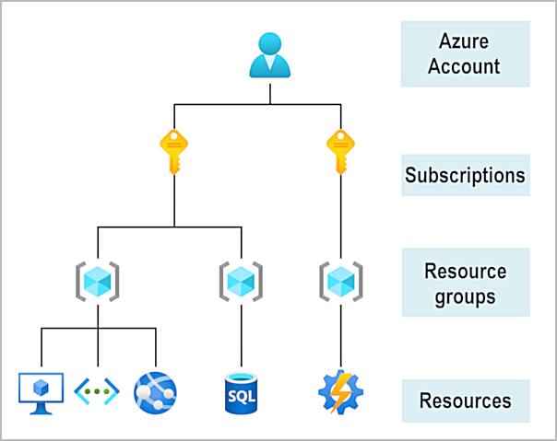

**Infrastructure as a service (IaaS)** is the most flexible category of cloud services, as it provides you the maximum amount of control for your cloud resources. In an IaaS model, the cloud provider is responsible for maintaining the hardware, network connectivity (to the internet), and physical security. You’re responsible for everything else: operating system installation, configuration, and maintenance; network configuration; database and storage configuration; and so on. With IaaS, you’re essentially renting the hardware in a cloud datacenter, but what you do with that hardware is up to you.

 In **a PaaS environment**, the cloud provider maintains the physical infrastructure, physical security, and connection to the internet. They also maintain the operating systems, middleware, development tools, and business intelligence services that make up a cloud solution. In a PaaS scenario, you don't have to worry about the licensing or patching for operating systems and databases.

**[Slide LAB – Create a Virtual Machine]**

With Azure Virtual Machines (VMs), you can create and use VMs in the cloud. VMs provide infrastructure as a service (IaaS) in the form of a virtualized server

When you provision a VM, you’ll also have the chance to pick the resources that are associated with that VM, including:

* Size (purpose, number of processor cores, and amount of RAM)
* Storage disks (hard disk drives, solid state drives, etc.)
* Networking (virtual network, public IP address, and port configuration)

***VM vs Containers***

<https://learn.microsoft.com/en-us/training/modules/describe-azure-compute-networking-services/5-containers>

<https://www.microsoft.com/videoplayer/embed/RE2yuaq> (Virtual machines vs Containers)

**VM’s virtualize the Hardware, while Containers virtualize the Operating system. Containers allow you to run multiple light weight containers on a single host without sacrificing the isolation that the VM’s offer**

VM’s provide a abstraction layer for CPU, Memory & Storage, that can be changed without investing in new Hardware

VM’s can only run one Operating system at a time, so if you have multiple apps that require different run-time environments, you may need additional VM’s.

Containers are a lighter weight that bundles (dependencies, libraries, configurations) a single app its dependencies in a host. a container is a fully packaged and portable computing environment. Everything an application needs to run is encapsulated and isolated in its container

*Containers share the machine’s OS kernel and therefore do not require an OS per application, driving higher server efficiencies and reducing server and licensing costs. Containers sharing a single operating system kernel start-up in a few seconds instead of minutes required to start-up a virtual machine*

