***[POLL]***

What do you think is the “Top Reason” to go to Cloud ?

Choose top 2 >> Display poll results in bar chart / %

* Executive Mandate
* Cost Savings
* Agility
* Innovation
* IT Modernization
* Standardization
* Faster time to market for business

***[SLIDE]***

**Warren Bennis: "Leadership is the capacity to translate vision into reality.”**

[**Bill Gates**](http://www.forbes.com/profile/bill-gates/)**: "As we look ahead into the next century, leaders will be those who empower others."**

**John Maxwell: "Leadership is influence - nothing more, nothing less."**

*Having skin in the game*

*Challenging the status quo*

*Leading a Cloud Transformation is in a similar way .. lots of challenges, people don’t want to go ther because of unknows*

*As leaders understand the potential it can bring to transform your business*

*Establishing Direction // Motivating & Inspiring*

***[POLL]***

“Your Role” today in the Cloud Ambition is?

* Influence teams
* Influence stakeholder
* Experiment
* Engage in a dialogue with business
* Challenge the status quo

***[SLIDE]***

How to get started

*Review your app portfolio, what are business and IT challenges,*

Building a business case

* Business agility
* Operational resilience
* Cost avoidance
* Obsolecence
* New features
* Workforce productivity
* Security

***[SLIDE]***

App Migration Patterns

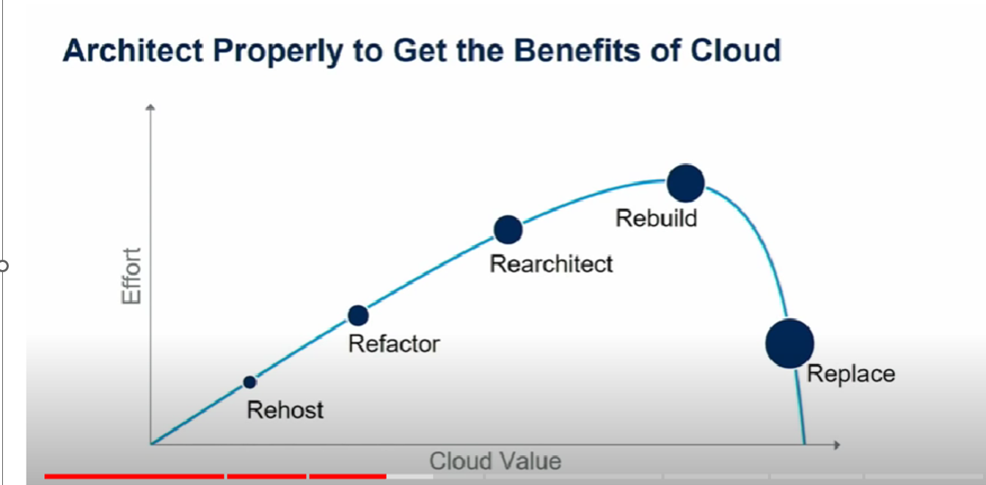

Rehost == Okay

Replatform

Refactor

Rewrite

Retire / Retain

***[SLIDE]***

Adopting CLOUD involves People / Process / Technology and until these aspects are dealt wholistically its difficult to reap all the benefits

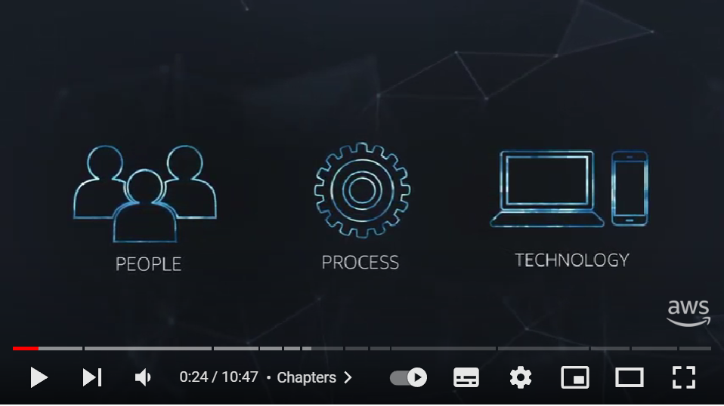

People – How do we Reskill our teams, leaders , business to reap benefits

* What kind of roles are needed and what does it mean from a Career planning
* Compensation

Process –

* What is the operating model ?
* Who will handle Infra issues in the Cloud
* Controls to manage cost
* What data can go to cloud and who validates this ?
* What regulatory aspects to keep in mind

Technology –

* How do I migrate to cloud and what technology decisions
* Architecture and design decisions

[LAB SLIDE]

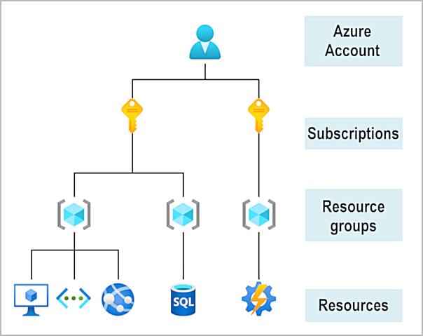

<https://learn.microsoft.com/en-us/training/modules/describe-core-architectural-components-of-azure/3-get-started-azure-accounts>

**[Slide LAB – Create a Virtual Machine]**

With Azure Virtual Machines (VMs), you can create and use VMs in the cloud. VMs provide infrastructure as a service (IaaS) in the form of a virtualized server

When you provision a VM, you’ll also have the chance to pick the resources that are associated with that VM, including:

* Size (purpose, number of processor cores, and amount of RAM)
* Storage disks (hard disk drives, solid state drives, etc.)
* Networking (virtual network, public IP address, and port configuration)