Simulation and analysis of Perturb & Observe and Incremental Conductance MPPT algorithms using Buck and Boost converters

Karan, Kunal Kumar Verma, Shreyash Kumar Singh, Shashank Pathak under Dr. V.N. Lal, Member, IEEE

Department of Electrical Engineering, Indian Institute of Technology (BHU), Varanasi

***Abstract $-$*  The DC-DC converters are widely used in photovoltaic systems as an interface between the PV panel and the load and are used to ensure the maximum power point (MPP) operation. Directly connecting the load to the PV panel will give MPP operation only in one load condition. To extract the maximum power for different load conditions, power processors (power electronic converters) can be used where one can vary the duty ratio and thereby the input impedance as seen by the PV panel can be varied. In this work, DC-DC buck converter and boost converter are used along with two maximum power tracking algorithms (MPPT), Perturb and Observe (P&O) and Incremental Conductance (INC) method. The MPPTs of the PV array are verified by the simulation results.**

***Index terms $–$* DC-DC power converters, Maximum power point trackers**

**I. INTRODUCTION**

Due to the current state of climate change, a need for change from non-renewable to renewable energy was felt. Solar energy is one of the best options available, owing to its readily available nature and low maintenance. Furthermore, one can tie their PV system to the grid, which can then generate revenue and/or act as a battery depending on the provider. However, it is not enough to simply connect the load to panels and draw power. As we will see in upcoming sections, doing so is inefficient. Maximum Power Point Tracking (MPPT) is a technique that enables maximum efficiency under all load and irradiance conditions by tracking Maximum Power Point (MPP) for any variations. In this paper, we will be discussing two of the most basic MPPT methods: Perturb and Observe (P&O) and Incremental Conductance (INC). In the section **Mathematical Modelling**, we will discuss the ideas and derivations of concepts that have been utilized. In the **Simulation** section we build upon these ideas and formulas and use them to simulate a real-world scenario using Simulink. The final **Conclusion** section hosts the summary and the results that we observed by simulating the system.

**II. MATHEMATICAL MODELLING**

**1. Photovoltaic Cell**

***1.1 Introduction***

Photovoltaics (PV) or solar cells are semiconductor devices that convert sunlight into direct current (DC) electricity. A photovoltaic cell absorbs the photons emitted by the sun and generates a flow of electrons.  When the photons strike a semiconductor material like silicon, they release the electrons from their atoms, leaving behind a vacant space. The stray electrons move around randomly looking for another “hole” to fill. The silicon layer exposed to sunlight is doped with phosphorus(n-side) which has one extra electron than silicon and the underlying silicon layer is doped with boron(p-side) which has one less electron than silicon. Now an electric field is created at the junction. Now, these excited electrons are swept to the n-side by an electric field, while the holes drift to the p-side. The electrons and holes are directed to the electrical contacts applied to both sides before flowing to the external circuit in the form of electrical energy. This produces direct current.

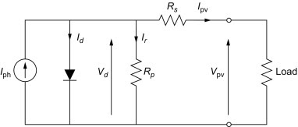

Figure : Equivalent circuit of a PV cell [3]

***1.2 Modules, Panels & Arrays***

Photovoltaic cells are connected electrically in series and/or parallel circuits to produce higher voltages, currents, and power levels.

Photovoltaic modules consist of PV cell circuits sealed in an environmentally protective laminate and are the fundamental building blocks of PV systems. Photovoltaic panels include one or more PV modules assembled as a pre-wired, field-installable unit. A photovoltaic array is the complete power-generating unit, consisting of any number of PV modules and panels.

***1.3 Cell relations***

Let the cell parameters be

$I_{ph}$ =  Photon current at an irradiance and temperature

$I_{d}$ =   Diode current

$I_{r}$ =   Leakage current

$I_{pv}$ = Load current

$I_{o}$ = Dark or reverse saturation current

$I_{sc}$ = Short circuit current

$R_{p}$ = Shunt resistance

$R_{s}$ = Series resistance

$V_{pv}$ = Load voltage

$V_{oc}$ = Open circuit voltage

We have,

$I_{d}=I_{o}\left(e^{\frac{q\left(V+I_{pv}R_{s}\right)}{akT}}-1\right)$ (1)[3]

Applying KCL,

${ I}_{ph}={I_{d}+I}_{pv}+I_{r}$

$⇒I_{pv}=I_{ph}-I_{d}-I_{r}$ (2)

Using (1) & (2),

$$I_{pv}=I_{ph}-I_{o}\left(e^{\frac{q\left(V+I_{pv}R_{s}\right)}{akT}}-1\right)-{(V}_{ph}+I_{pv}R_{s})/R_{p}$$

***1.4 Characteristics of PV cell***

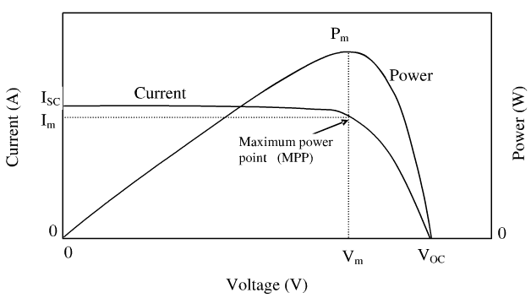

Figure : PV Characteristics

***1.5 Maximum Power Point***

As we can see from Figure 2, to get maximum power from a solar cell we should operate it around maximum power voltage $V_{m}$ as shown in the diagram above. Therefore, the maximum power is $P_{m}=V_{m}I_{m}$

***1.6 Effect of irradiance & temperature***

Irradiance is defined as the measure of the power density of sunlight received and is measured in watt per metre square. With the increasing solar irradiance both the open-circuit voltage and the short circuit current increase and hence the maximum power point varies. Temperature plays another major factor. As the temperature increases, the rate of photon generation increases thus reverse saturation current increases rapidly and this reduces the band gap. Hence this leads to marginal changes in current but major changes in voltage. The cell voltage reduces by 2.2Mv per degree rise of temperature. Temperature acts like a negative factor affecting solar cell performance. Therefore, solar cells give their full performance on cold and sunny days rather than on hot and sunny weather.

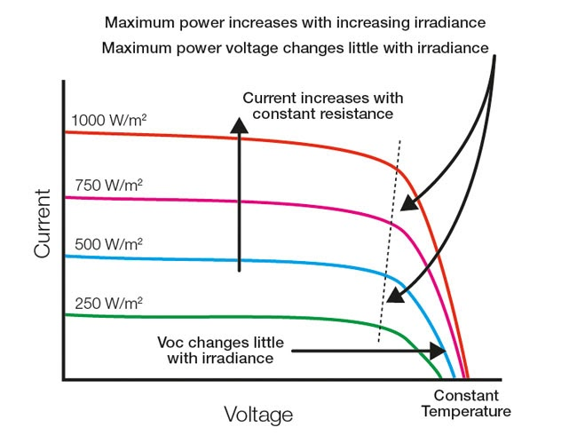

Figure : Effect of irradiance

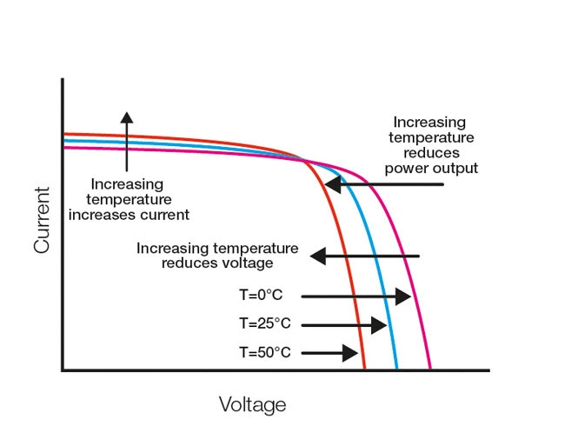

Figure : Effect of temperature

**2. Buck Converter**

***2.1 Introduction***

Buck Converter or Step Down Chopper is a type of DC-DC converter which reduces the input DC voltage to a specified DC output voltage.

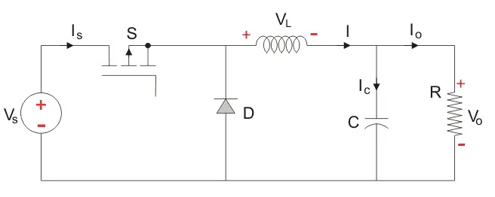

Figure : Schematic of buck converter [2]

As shown in the figure, the input voltage source is connected to a controllable solid-state device (MOSFET or IGBT) which operates as a switch. This controlled switch is turned on and off using Pulse Width Modulation (PWM), primarily a time-based modulation. The second switch used is a diode. The switch and the diode are connected to a low-pass LC filter which is appropriately designed to reduce the current and voltage ripples. The load is purely resistive, which can be seen as a current source.

***2.2 Steady state analysis***

While analyzing the buck converter we have assumed that the inductor current is continuous which rises and falls linearly.

* Time Period (T):The time period is defined as the total time for which the switch is on ($T_{ON}$) and off ($T_{OFF}$),
$$T={\frac{1}{f}=T}_{ON}+T_{OFF}$$

* Duty Cycle (D):It is the ratio of the time switch is on ($T_{ON}$) to the time period ($T$) of the circuit.

$$D=\frac{T_{ON}}{T}$$

Let the circuit parameters be,

$R$ = Resistive Load

$L$ = Inductor

$C$ = Capacitor

$V_{in}$ = DC Source Voltage

$V_{L}$ = Voltage across Inductor

$V_{C}$ = Voltage across Capacitor

$V_{o}$ = Output Voltage

$I_{L}$ = Inductor Current

$I_{C}$ = Capacitor Current

$I_{o}$ = Output Current

The Buck Converter has two modes of operation:

**Mode I**: Switch is ON, Diode is OFF

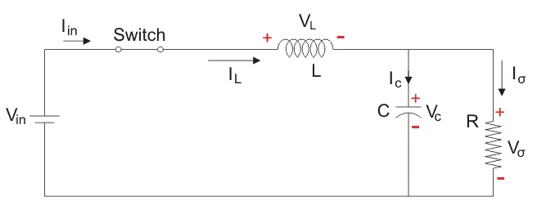

Figure : Equivalent circuit in Mode 1 [2]

In this mode, the controlled switch is on and lets current flow to the output capacitor, charging it up.     On the other hand, the diode being reverse biased is switch off.

The voltage across the capacitance in the steady state is equal to the output voltage.

Analysing the circuit at steady state using KVL**,**

$V_{in}=V_{L}+V_{o}$ (3)

$V_{L,ON}=V_{in}-V_{o}$ (4)

Also: $T_{ON}=DT$ (5)

**Mode II**: Switch is OFF, Diode is ON

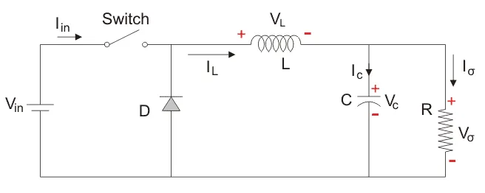

Figure : Equivalent circuit in Mode 2 [2]

In this mode, the energy stored in the inductor is released and is ultimately dissipated in the load resistance, and this helps to maintain the flow of current through the load.

Using KVL for analyzing the circuit in this mode,

$0=V_{L}+V_{o}$ (6)

$V_{L,OFF}=-V_{o}$ (7)

Also: $T_{OFF}=\left(1-D\right)T$ (8)

We can also infer that $I_{C,ON}=I_{C,OFF}=I_{L}-I_{o}$ (9)

Applying Volt-second balance [1],

$V_{L,ON}T_{ON}+V_{L,OFF}T_{OFF}=0$ (10)

Thus from (4), (5), (7) & (8),

$V_{o}=DV_{in}$ (11)

Applying Ampere-second balance [1],

$I_{C,ON}T_{ON}+I_{C,OFF}T_{OFF}=0$

Thus from (5), (8) & (9),

$⇒I_{L}=I_{o}$ (12)

i.e., average inductor and load currents are equal

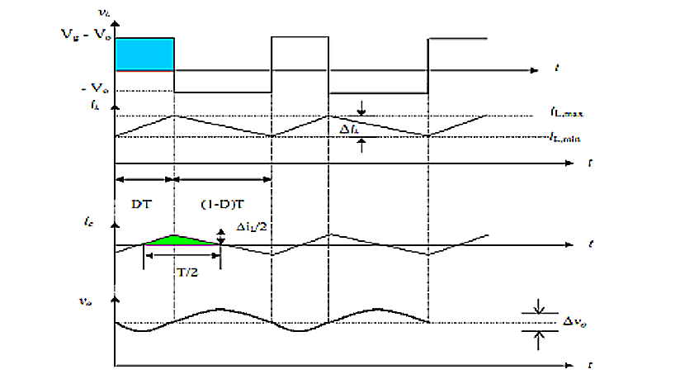

Figure : Current & voltage waveforms for buck

***2.3 Design analysis***

Inductor selection

The inductor value of the converter can be selected in accordance with the desired current ripple ($∆I_{L}$).

Now,

$∵V_{L,ON}=L\frac{dI_{L,ON}}{dT_{ON}} \& ∆I_{L,ON}=∆I_{L,OFF}=∆I_{L}$

$⇒L=\frac{V_{L,ON}∆T}{∆I_{L,ON}}=\left(\frac{V_{in}-V_{o}}{∆I_{L}}\right)DT$ (13.1)

Or, $⇒L=\left(\frac{D\left(1-D\right)}{f∆I_{L}}\right)V_{in}$ (13.2)

Capacitor selection

Just like the inductor value, the capacitor value of the converter is also selected with respect to the Capacitor voltage ripple ($∆V_{C}$).

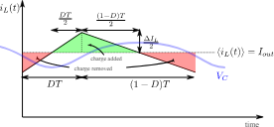

Area of triangle $=∆Q=\frac{T∆I_{L}}{4}=\frac{∆I_{L}}{8f}$

$∵Q=CV⇒∆Q=C∆V$

$∴C=\frac{D\left(1-D\right)V_{in}}{8f^{2}L∆V_{C}}$ (14)

***2.4 MPP Tracking***

Using the fact that input power is equal to output power we can get,

${∵P}_{in}=P_{out}$

$⇒\frac{V_{o}}{V_{in}}=\frac{I_{in}}{I_{o}}$

$⇒I_{in}=DI_{o}$

$∴R_{in}=\frac{V_{in}}{I_{in}}=\frac{V_{o}}{{D^{2}I}_{o}}=\frac{R}{D^{2}}$ (15)

Now we know that D varies from 0 to 1, hence Rin would vary from ∞ to R. [4]

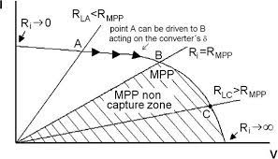

Figure : Capture zone for buck

If MPP resistance ($R_{MPP}$) does not belong to the set of values allowed for $R_{in}$, the capture of MPP will not be possible, thus defining a “non-capture zone” for $R>R_{MPP}$.

Therefore, the MPP capture will only be possible for $R≤R_{MPP}$ values.

**3. Boost Converter**

***3.1 Introduction***

Boost Converter or Step Up Chopper is a type of DC-DC converter which increases the input DC voltage to a specified DC output voltage.

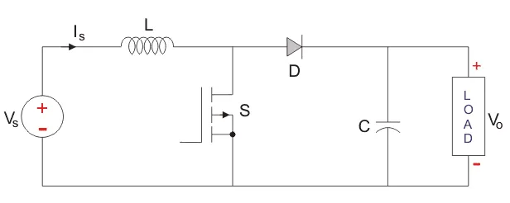

Figure : Schematic of boost converter [2]

As shown in the figure, similar to the buck converter the input voltage source is connected to MOSFET which acta as a switch. The second switch used is a diode. The diode is connected to a capacitor, and the load and the two are connected in parallel.

***3.2 Steady state analysis***

Similar to the buck converter, here also, we have assumed that the inductor current is continuous which rises and falls linearly and have used same terms and notions.

**Mode I**: Switch is ON, Diode is OFF

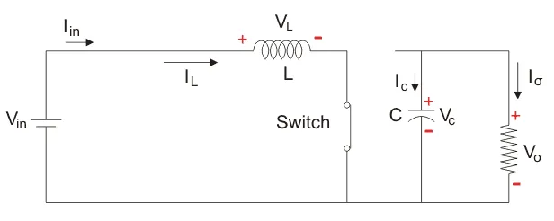

Figure : Equivalent circuit in Mode 1 [2]

In this mode, the switch is on and therefore represents a short circuit ideally offering zero resistance to the flow of current so when the switch is on all the current will flow through the switch and back to the DC input source.

Analyzing the circuit at steady state using KVL,

$V_{in}=V_{L,ON}$ (16)

$I_{C,ON}=I_{o}$ (17)

Also: $T_{ON}=DT$ (18)

**Mode II**: Switch is OFF, Diode is ON

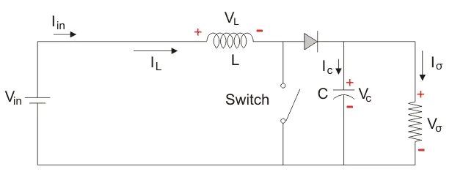

Figure : Equivalent circuit in Mode 2 [2]

In this mode, the polarity of the inductor is reversed. The energy stored in the inductor is released and is ultimately dissipated in the load resistance, and this helps to maintain the flow of current in the same direction through the load and also step-up the output voltage as the inductor is now also acting as a source in conjunction with the input source.

Using KVL for analyzing the circuit in this mode,

$V_{L,OFF}=V_{in}-V_{o}$ (19)

$I_{C,OFF}=I_{L}-I_{o}$ (20)

Also: $T_{OFF}=\left(1-D\right)T$ (21)

Applying Volt-second balance [1],

$V_{L,ON}T_{ON}+V_{L,OFF}T_{OFF}=0$

Thus from (16), (18), (19) & (21),

$V_{o}=\frac{V_{in}}{1-D}$ (22)

Applying Ampere-second balance [1],

$I_{C,ON}T_{ON}+I_{C,OFF}T_{OFF}=0$

Thus from (17), (18), (20) & (21),

$⇒I_{L}=\frac{I_{o}}{1-D}$ (23)

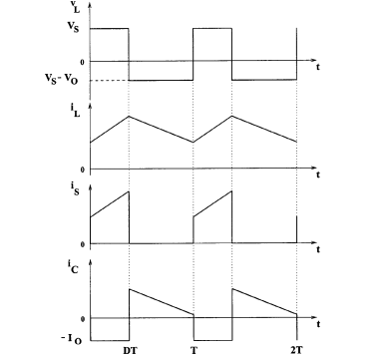

Figure : Current & voltage waveforms

***3.3 Design analysis***

Similar to buck converter the values of inductor and capacitor play a vital role in the performance of boost converter.

Inductor selection

The inductor value of the converter can be selected in accordance with the desired current ripple ($∆I_{L}$).

Now,

$$∵V_{L,ON}=V_{in}=L\frac{dI_{L,ON}}{dT_{ON}} and ∆I_{L,ON}=∆I_{L,OFF}=∆I_{L}$$

$⇒L=\frac{V_{L,ON}∆T}{∆I_{L,ON}}=\left(\frac{V_{in}}{∆I_{L}}\right)DT$ (24.1)

Or, $⇒L=\left(\frac{D}{f∆I_{L}}\right)V_{in}$ (24.2)

Capacitor selection

Just like the inductor value, the capacitor value of the converter is also selected with respect to the capacitor voltage ripple ($∆V_{C}$).

During the ON state capacitor will deliver power to the load

$I_{C}=-I_{o}$

$C\left(dV_{C}\right)=-I_{o}dt$ (25.1)

Integrating both sides of (25.1) for the following limits

* $V_{max}$ to $V_{min}$ for $dV_{C}$
* $0$ to $DT$ for $dt$

$$⇒V_{min}- V_{max}=\left(-\frac{I_{o}}{C}\right)DT$$

$⇒∆V_{C}=\left(\frac{I_{o}}{C}\right)DT=\frac{DI_{o}}{fC}$

$∴C=\frac{DI_{o}}{f∆V_{C}}$ (25.2)

***3.4 MPP Tracking***

Using the fact that input power is equal to output power we can get,

${∵P}_{in}=P_{out}$

$⇒\frac{V_{o}}{V_{in}}=\frac{I_{in}}{I_{o}}=\frac{1}{1-D}$

$⇒I_{in}=\frac{I_{o}}{1-D}$

$$∴R_{in}=\frac{V_{in}}{I_{in}}=\frac{V_{o}{\left(1-D\right)}^{2}}{I_{o}}=R{\left(1-D\right)}^{2}$$

Now as D varies from 0 to 1, hence $R_{in}$ would vary from 0 to R. The MPPT system will modify the value of $R_{in}$, trying to get $R_{in}=R_{MPP}$. However, from the graph, we can see that the system will not reach MPP if $R<R_{MPP}$. This behavior is opposite to that shown by the buck converter and therefore we can observe the inversion of zones with respect to the buck converter. Thus for this converter, the MPP capture will only be possible for $R≥R_{MPPP}$ values. [4]

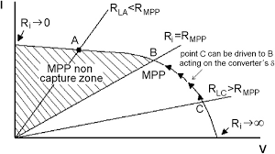

Figure : Capture zone for boost converter

**4. Perturb and Observe**

To understand the working principle of the Perturb and Observe method, we first need to understand the PV array’s output characteristics curve of Power v/s Voltage

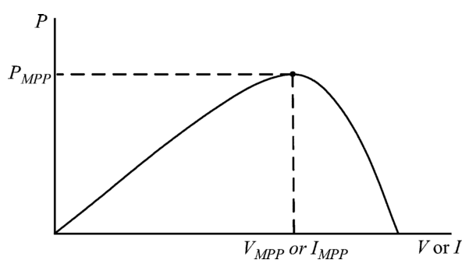

Figure : P-V Curve of a solar cell

In the given curve, D = 1.0 at the origin, and D = 0.0 at $V_{max}$ thus, the value of D decreases as we move from left to right in the curve. Now, we can divide the power curve into 2 parts for analysis. The part to the left of the maximum power point, and the part to the right of it. In the left part, the power output increases as we increase the voltage, or in other words, the power output increases with a decrease in the value of D. Contrast to this, in the right part of the curve, the increasing voltage (or the decreasing D) leads to a decrease in the power output. Keeping these points in mind, we can understand the P&O algorithm using the following flowchart.

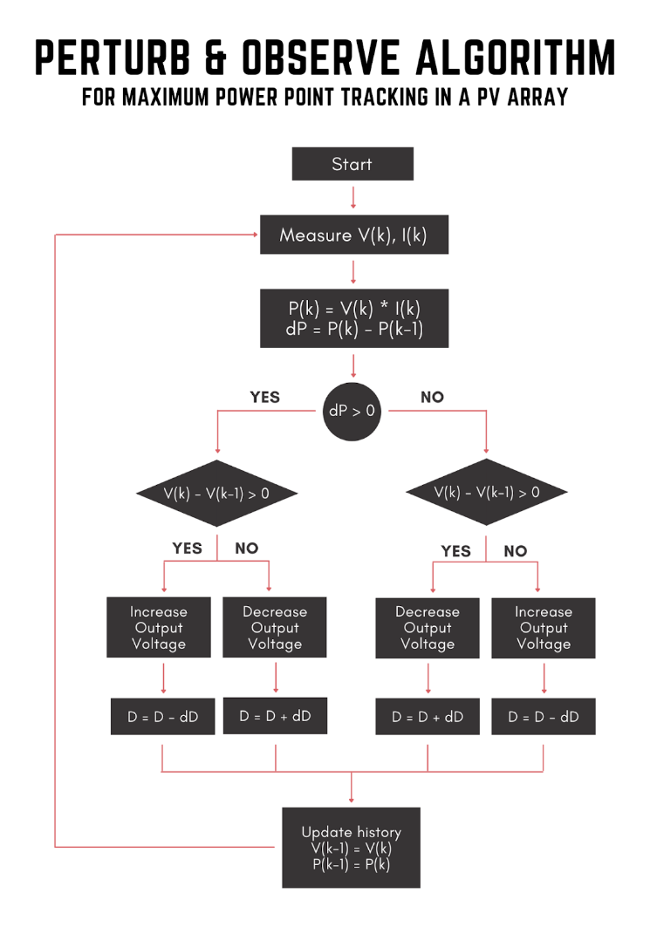

Figure : P&O flowchart [3]

As shown in the above flowchart, the Perturb & Observe algorithm runs continuously in a loop. The steps of the algorithm are as follows:

* The current power output is measured using the formula $P=VI$ and the difference between current power and the power in the previous step is calculated. We also calculate the difference between the current output voltage and the voltage output in the previous step
* If this difference is greater than zero, it means that the power is increasing, i.e., we are climbing the hill. In such a case:
  1. If the voltage is increasing, it means that we are in the left part of the power curve. Thus, we need to decrease the value of D to move towards the maximum power point
  2. If the voltage is decreasing, it means that we are in the right part of the power curve. Hence, to move towards the maximum power point, we need to increase the value of D.
* If this difference is less than zero, it means that the power is decreasing, i.e., we are climbing down the hill. In such a case:
  1. If the voltage is increasing, it means that we are in the right part of the power curve and hence we need to increase the value of D to approach the maximum power point.
  2. If the voltage is decreasing, it means that we are in the left part of the power curve. This, decreasing the value of D will move us towards the maximum power point
* After incrementing or decrementing the value of D accordingly, we update the values of P(k-1) and V(k-1) to the current values and then start again from step 1.

Hence, it is evident that using the Perturb and Observe method, we ensure that the circuit adjusts itself in such a way that the output power approaches the maximum power point, hence fulfilling our purpose.

After some time, we start MPPT, the power output of the PV array adjusts itself to the maximum power. Now, whenever the irradiance or temperature of solar energy changes due to some factor like clouds, rain, fog, etc. the P&O algorithm sets into motion and achieves a steady-state wherein the power output becomes equal to the maximum power output possible under the given conditions of irradiance and temperature.

There is one small drawback of the P&O algorithm that at the steady-state, the value of power output oscillates around the maximum power. However, we can reduce this ripple value by making the increments/decrements in D smaller.



Figure : Implementation in MATLAB

**5. Incremental Conductance**

If we observe the P-V curve of a solar cell (Fig. 15), we can notice that the curve has a positive slope to the left of MPP, a negative slope to the right of MPP and the slope is zero at MPP. Incremental conductance algorithm (we will use INC as its alias) is based on the above fact.[5]

We know,

$P=VI$

Taking its partial derivative i.e., the slope of P-V curve,

$Slope=\frac{∂P}{∂V}=I+V\frac{∂I}{∂V}$

Since $\frac{∂P}{∂V}=0$ at MPP (from Fig. 15), therefore,

$I+V\frac{∂I}{∂V}=0 ⇒ \frac{∂I}{∂V}+\frac{I}{V}=0$ for MPP

The aim of INC is to change the duty ratio $D$ until $\frac{∂P}{∂V}=0$ is attained. To do so, we use the flowchart in Fig. 18

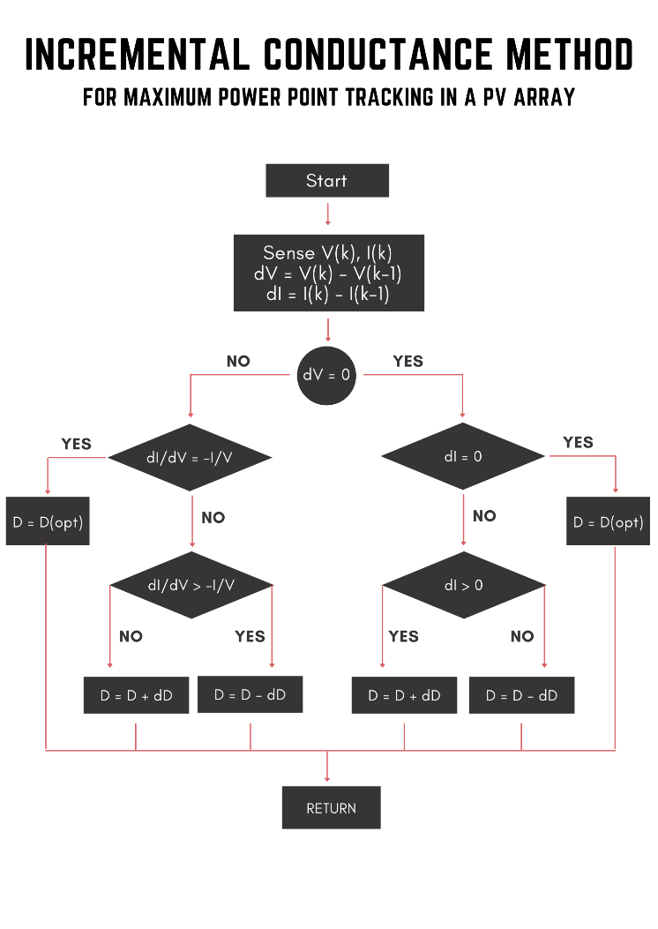

Figure : INC flowchart [5]

The algorithm will try to:

1. Increase voltage i.e., decrease $D$ if $\frac{∂P}{∂V}>0$ (left side of MPP).
2. Decrease voltage i.e., increase $D$ if $\frac{∂P}{∂V}<0$ (right side of MPP).
3. Do nothing if $\frac{∂P}{∂V}=0$ (at the MPP).

Practically, it is difficult to achieve $\frac{∂I}{∂V}+\frac{I}{V}=0$ due to precision issues, so we will approximate that by an error bound (the variable EPS in Fig. 19). Also, as division by zero is erroneous, we need to handle that case separately.

1. If $∆V=∆I=0$, then we have attained MPP.
2. If $∆V=0 \& ∆I>0$, that means $\frac{∂I}{∂V}+\frac{I}{V}=\frac{∂P}{∂V}$ is large some large positive number (left side of MPP) and we need to decrease $D$ to increase $V$.
3. Similarly, if $∆V=0 \& ∆I<0$, that means $\frac{∂I}{∂V}+\frac{I}{V}=\frac{∂P}{∂V}$ is some large negative number (right side of MPP) and we need to increase $D$ to decrease V.

The major advantage of using INC over P&O is that INC is more stable once MPP is reached. It can detect if the MPP has been attained and stop altering duty ratio, whereas in P&O it is rarely that we get $∆P=0$ i.e., almost always the duty ratio oscillates around the optimal value.



Figure : Implementation in MATLAB

**III. SIMULATION**

**1. Perturb and observe**

***1.1 Using boost converter***

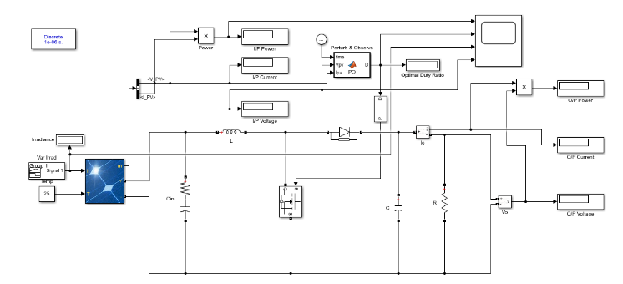

Figure : MPPT using boost converter

The above circuit diagram shows the circuit used for MPPT using the P&O method in a PV system connected to a boost converter. The voltage and current outputs of the PV array are taken as inputs for the MATLAB function, which contains the code shown in Fig 15. This function determines the optimal duty cycle to obtain maximum power under the given conditions. This value is then fed into the MOSFET of the boost converter through a PWM generator. A signal generator with time-varying signal is connected to the irradiance input of the PV array.

*1.1.1 Circuit parameters*

$$Temperature=25℃$$

$$R=10Ω$$

$$C_{in}=1mF$$

$$R_{in}=1mΩ$$

$$f=5kHz$$

$$D_{initial}=0.5$$

Using formulas derived in section 2.3 & 3.3

$L=2.5mH$

$C=100μF$

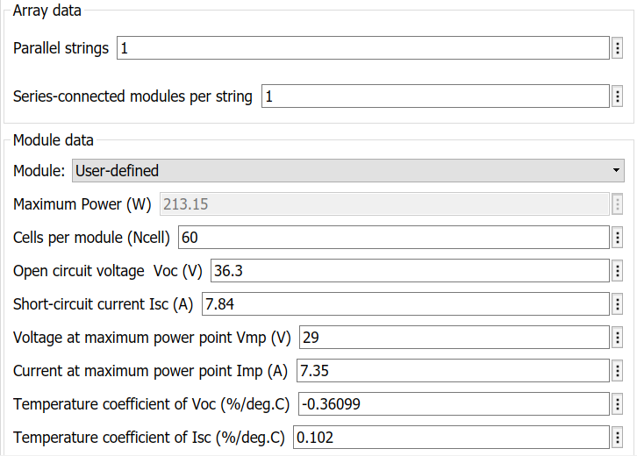

Figure .1: PV array & module parameters

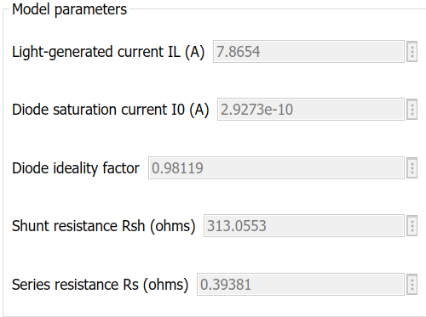

Figure 21.2: PV cell parameters

*1.1.2 Scope Output*

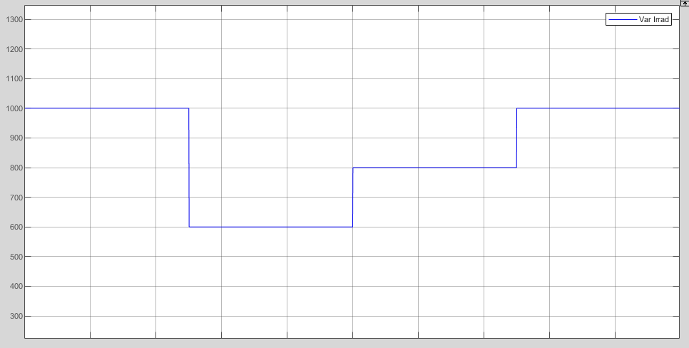

Figure : Varying irradiance

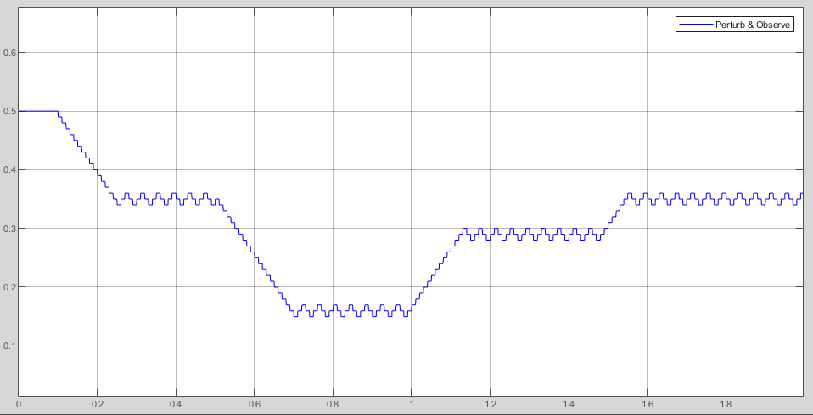

Figure 23: Duty ratio via P&O

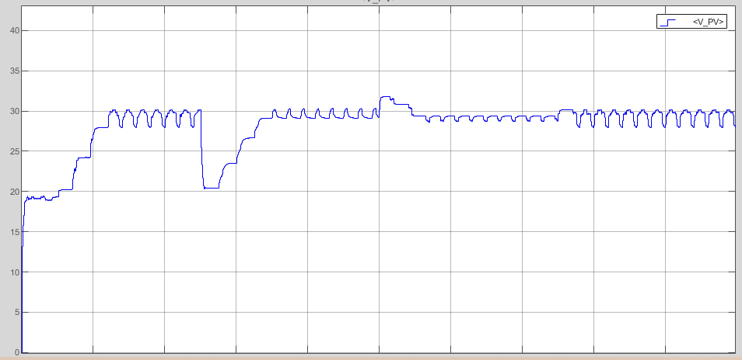

Figure 24: PV array voltage

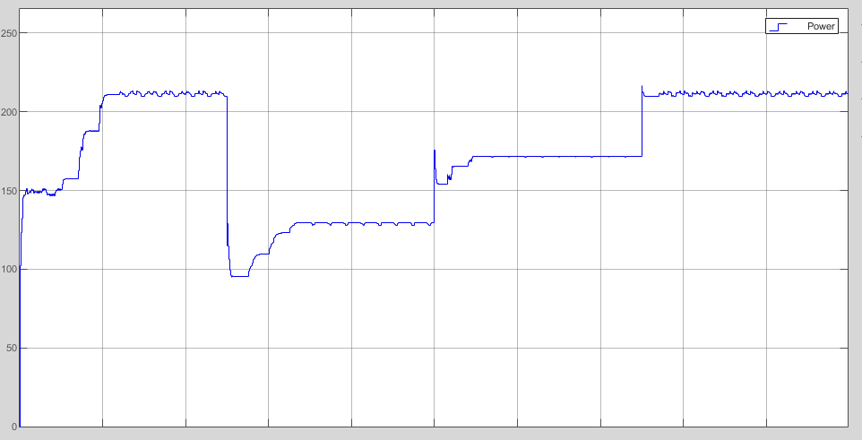

Figure 25: Output power of PV array

***1.2. Using buck converter***

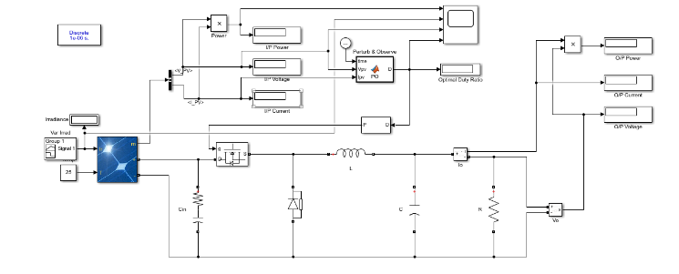

Figure 26: MPPT using buck converter

The above circuit diagram shows the circuit used for MPPT using the P&O method in a PV system connected to a buck converter. The voltage and current outputs of the PV array are taken as inputs for the MATLAB function, which contains the code shown in Fig 15. This function determines the optimal duty cycle to obtain maximum power under the given conditions. This value is then fed into the MOSFET of the boost converter through a PWM generator. A signal generator with time-varying signal is connected to the irradiance input of the PV array.

*1.2.1 Circuit parameters*

$$Temperature=25℃$$

$$R=10Ω$$

$$C_{in}=1mF$$

$$R_{in}=1mΩ$$

$$f=5kHz$$

$$D_{initial}=0.5$$

Using formulas derived in section 2.3 & 3.3,



$L=2mH$

$C=8.33μF$

Figure 27.1: PV array & module parameters



Figure 27.2: PV cell parameters

*1.2.2 Scope Output*



Figure 28: Varying irradiance

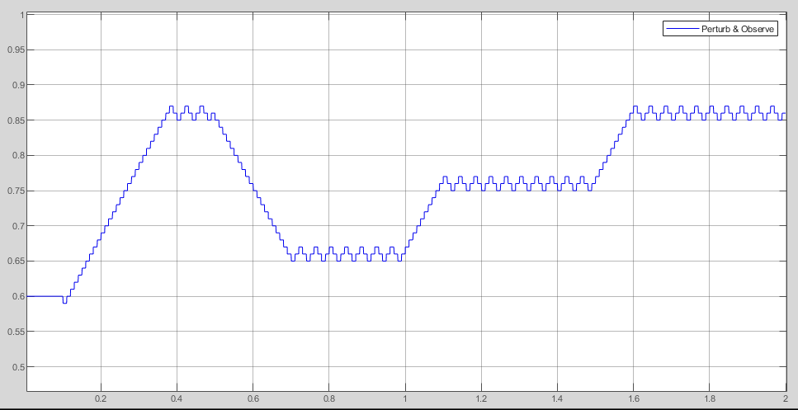

Figure 29: Duty ratio via P&O

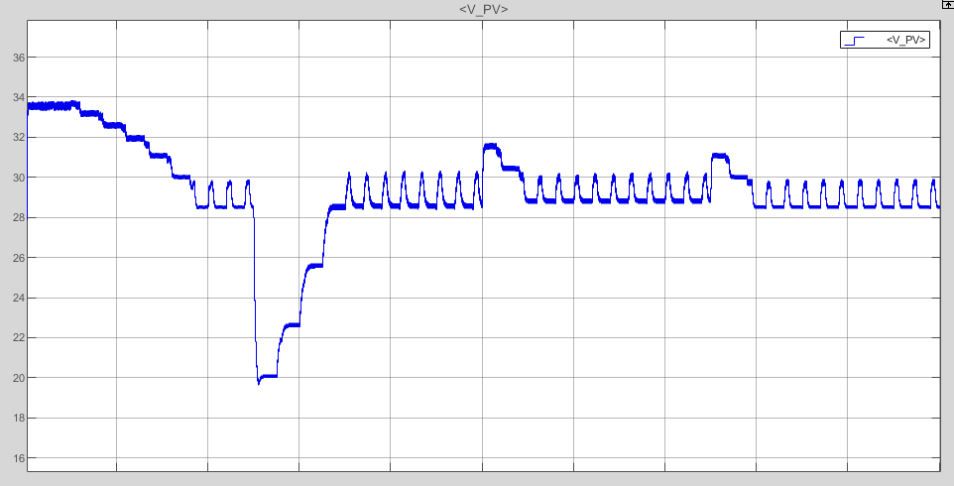

Figure 30: PV array voltage

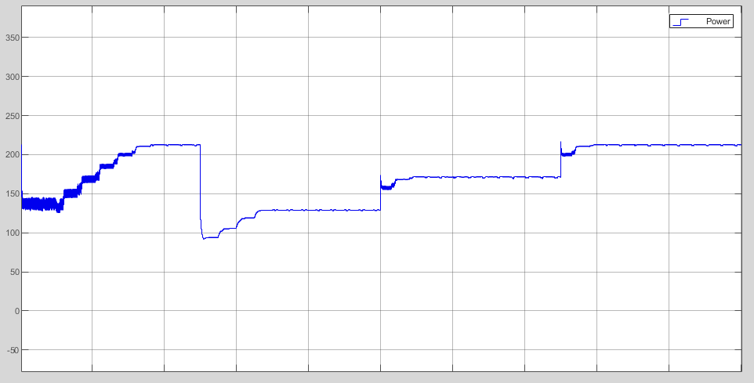

Figure 31: Output power of PV array

**2. Incremental conductance**

***2.1 Using boost converter***

We will use the same circuit model and parameters as we have used in subsection 1.1 of section III, except that the code within the *MATLAB function* block will be changed to the one mentioned in Fig. 19.

*2.1.1 Scope Output*



Figure 32: Varying irradiance

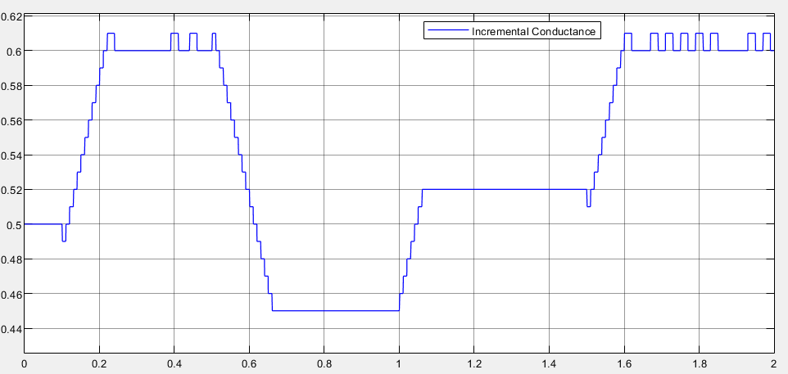

Figure 33: Duty ratio via INC

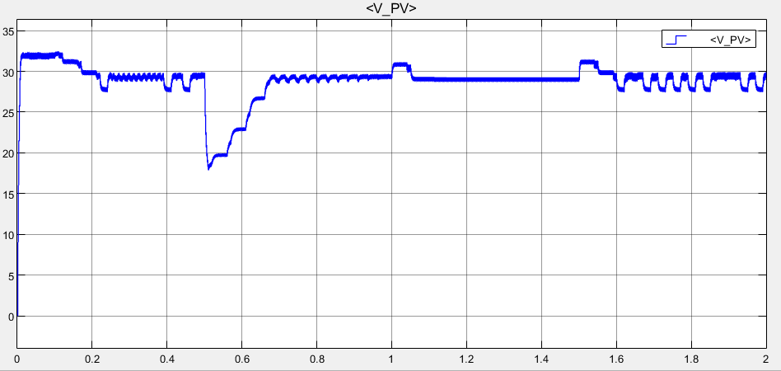

Figure 34: PV array voltage

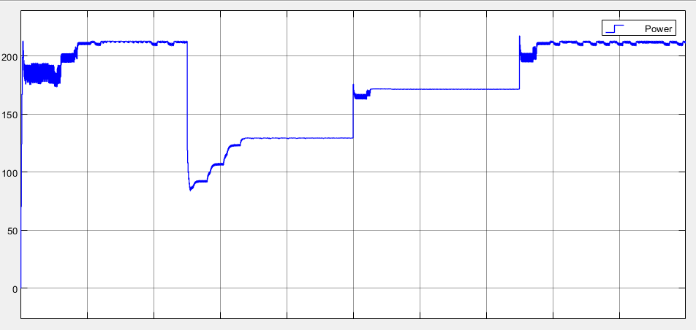

Figure 35: Output power of PV array

***2.2. Using buck converter***

We will use the same circuit model and parameters as we have used in subsection 1.2 of section III, except that the code within the *MATLAB function* block will be changed to the one mentioned in Fig. 19.

*2.2.1 Scope Output*



Figure 36: Varying irradiance

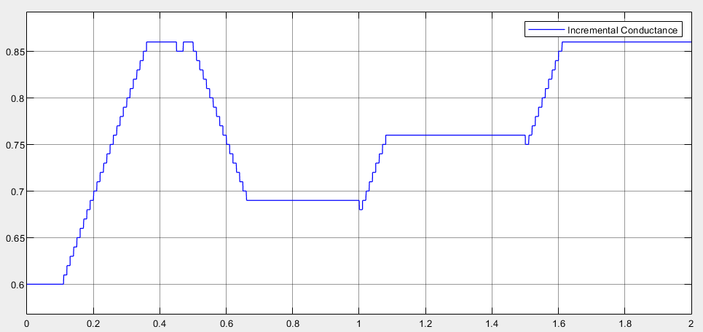

Figure 37: Duty ratio via INC

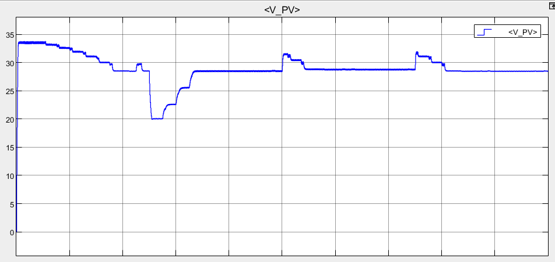

Figure 38: PV array voltage

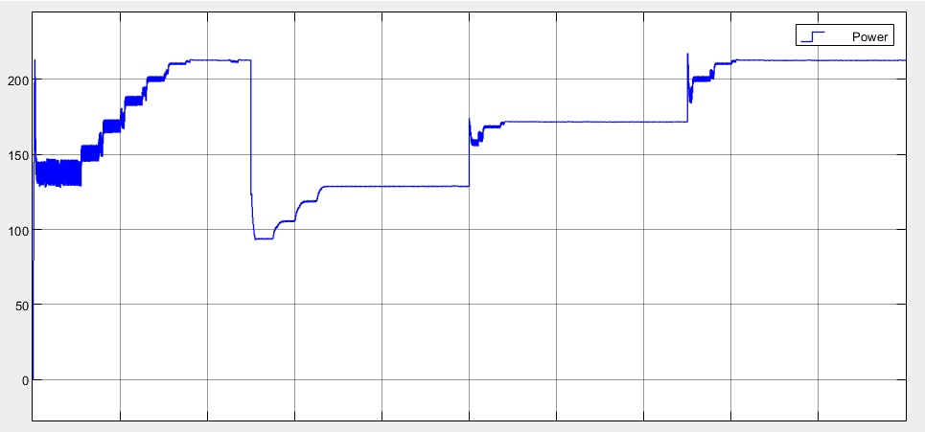

Figure 39: Output power of PV array

**IV. CONCLUSION**

Hence from the simulations, it is evident that MPPT algorithms eventually reach the optimal duty ratio required for extracting maximum power. P&O & INC both do so by changing the duty ratio slightly and observing changes. The result of this is a hill-climbing like pattern that can be seen in Fig. 23, Fig. 29, Fig. 33 and Fig. 37. However, INC goes one step further by actually detecting that MPP has been reached and stopping changes to $D$. Hence, at steady state, the duty ratio oscillates around the optimal value in P&O whereas it is more stable when INC is used. The advantage of employing buck and boost converters for MPPT is the high efficiency that can be obtained due to absence of resistive components.

**V. REFERENCES**

1. R. W. Erickson and D. Maksimovic, *Fundamentals of Power Electronics*, 2nd ed. New York, NY, USA: Springer, 2001
2. M. H. Rashid, *Power Electronics Circuits Devices and Applications,* 4th ed. Boston, MA, USA: Pearson, 2014
3. Patel Mamta Z., T. B. Maniar, "Design and Simulation of Boost Converter Using P & O Technique for PV System", *International Journal of Science and Research (IJSR)*, vol. 5, no. 5, pp. 62 – 66, May 2016
4. V. C. Kotak, P. Tyagi, “DC to DC Converter in Maximum Power Point Tracker”, *International Journal of Advanced Research in Electrical, Electronics and Instrumentation Engineering (IJAREEIE)*, vol. 2, no. 12, pp. 6115 – 6125, December 2013
5. S. R. Chafle, U. B. Vaidya, “Incremental Conductance MPPT Technique for PV system”, *International Journal of Advanced Research in Electrical, Electronics and Instrumentation Engineering (IJAREEIE)*, vol. 2, no. 6, pp. 2719 –2726, June 2013