**2x3**

|  |  |  |
| --- | --- | --- |
| Subj_idx | Block | n |
| 2x3-01 | 1 | 24 |
| 2x3-01 | 2 | 24 |
| 2x3-02 | 1 | 24 |
| 2x3-02 | 2 | 24 |
| 2x3-03 | 1 | 24 |
| 2x3-03 | 2 | 24 |
| 2x3-04 | 1 | 24 |
| 2x3-05 | 1 | 24 |
| 2x3-06 | 1 | 24 |
| 2x3-06 | 2 | 24 |
| 2x3-07 | 1 | 24 |
| 2x3-07 | 2 | 20 |
| 2x3-08 | 1 | 24 |
| 2x3-08 | 2 | 24 |
| 2x3-11 | 1 | 24 |
| 2x3-12 | 1 | 24 |
| 2x3-12 | 2 | 24 |
| 2x3-13 | 1 | 17 |
| 2x3-14 | 1 | 24 |
| 2x3-14 | 2 | 24 |
| 2x3-15 | 1 | 24 |
| 2x3-15 | 2 | 2 |
| 2x3-15 | 3 | 24 |
| 2x3-16 | 1 | 48 |
| 2x3-16 | 2 | 11 |
| 2x3-17 | 2 | 24 |
| 2x3-18 | 1 | 24 |
| 2x3-18 | 2 | 24 |

|  |  |
| --- | --- |
| Subj_idx | n |
| 2x3-01 | 48 |
| 2x3-02 | 48 |
| 2x3-03 | 48 |
| 2x3-04 | 24 |
| 2x3-05 | 24 |
| 2x3-06 | 48 |
| 2x3-07 | 24 |
| 2x3-08 | 48 |
| 2x3-11 | 24 |
| 2x3-12 | 48 |
| 2x3-14 | 48 |
| 2x3-15 | 48 |
| 2x3-16 | 24 |
| 2x3-17 | 24 |
| 2x3-18 | 48 |

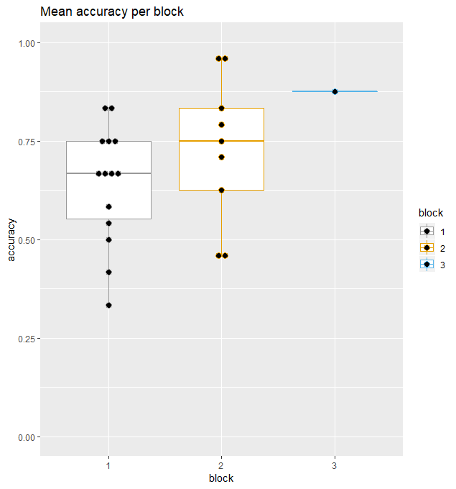

* 5 incomplete blocks
* 6 subjects only completed 1 block
* Mean accuracy
  + B1: 0.64
  + B2: 0.73
  + B3: 0.88 (only 1 kid)

**2x4**

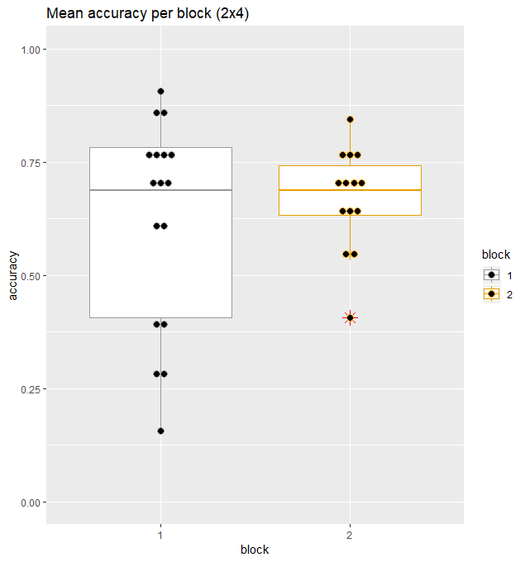

|  |  |  |
| --- | --- | --- |
| 2x4-01 | 1 | 32 |
| 2x4-01 | 2 | 32 |
| 2x4-02 | 1 | 32 |
| 2x4-02 | 2 | 32 |
| 2x4-03 | 1 | 32 |
| 2x4-03 | 2 | 32 |
| 2x4-06 | 1 | 32 |
| 2x4-06 | 2 | 32 |
| 2x4-07 | 1 | 32 |
| 2x4-07 | 2 | 32 |
| 2x4-08 | 1 | 32 |
| 2x4-08 | 2 | 32 |
| 2x4-09 | 1 | 32 |
| 2x4-10 | 1 | 32 |
| 2x4-10 | 2 | 32 |
| 2x4-11 | 1 | 32 |
| 2x4-11 | 2 | 32 |
| 2x4-12 | 1 | 32 |
| 2x4-13 | 1 | 32 |
| 2x4-13 | 2 | 32 |
| 2x4-14 | 1 | 32 |
| 2x4-16 | 1 | 32 |
| 2x4-16 | 2 | 32 |
| 2x4-17 | 1 | 32 |
| 2x4-17 | 2 | 32 |
| 2x4-18 | 1 | 32 |
| 2x4-18 | 2 | 32 |
| 2x4-19 | 1 | 32 |
| 2x4-19 | 2 | 32 |
| 2x4-20 | 1 | 32 |
| 2x4-20 | 2 | 32 |

|  |  |
| --- | --- |
| 2x4-01 | 64 |
| 2x4-02 | 64 |
| 2x4-03 | 64 |
| 2x4-06 | 64 |
| 2x4-07 | 64 |
| 2x4-08 | 64 |
| 2x4-09 | 32 |
| 2x4-10 | 64 |
| 2x4-11 | 64 |
| 2x4-12 | 32 |
| 2x4-13 | 64 |
| 2x4-14 | 32 |
| 2x4-16 | 64 |
| 2x4-17 | 64 |
| 2x4-18 | 64 |
| 2x4-19 | 64 |
| 2x4-20 | 64 |

* All blocks completed
* 3 subjects only completed 1 block
* Mean accuracy:
  + B1: 0.62
  + B2: 0.67
  + Overall: 0.64