# 

# GROUP – 12

# PROJECT FINAL REPORT

# INFO 5707

# DATA MODELLING FOR INFORMATION PROFESSIONALS

# Project Title: Gaming Leaderboard Database system

# Team members:

# VIJAY RAJ PATHANI-11609155(Team Coordinator)

**UMA ABHISHEK POLAKONDA-11704249**

**MADDINENI SASHI KIRAN-11647598**

**GAYATHRI KATUKOJWALA-11550315**

**SCOPE**

Included in the project's scope is the creation of a comprehensive database system for a leaderboard in gaming, which will be accomplished via design and development. In order to accomplish this, it is necessary to identify the games that are supported, provide a description of player metrics, permit real-time updates, incorporate multiplayer features, establish user profiles and achievements, ensure that privacy settings and security precautions are adhered to, organize for scalability, incorporate a notification system, and provide analytics for insights. The objective is to provide a leaderboard system that is both dynamic and engaging, with the purpose of highlighting player accomplishments, encouraging community interaction, and ensuring a gaming experience that is both safe and fair.

And also include**s:**

**PARTICIPANTS**

* Details about registration.
* Details of authentication.
* Info on past performance

**GAMES**

* Information about every game that is accessible on the platform.
* Dates of release.
* Other details about the game.

**SCORES**

* Specific player and game-related individual score entries.
* Dates on which the scores were attained.

**LEADERBOARDS**

* Player ranks in each game as well as all games combined.
* leaderboards depending on various time periods displayed.

**PROTECTION**

* Access control using user authentication.
* ensuring the security and privacy of data.

**SCALABILITY**

* Capacity to manage an expanding user base and growing volumes of data linked to games.

# OBJECTIVES OF GAMING LEADERBOARD DATABASE:

1. **Store Player Information:**  
   Count the number of users who have logged onto the gaming platform.

Save any important player data, including login, email, registration date, and any additional essential information.

1. **Track Game Information:**  
   Maintain data on the games that are played on the platform.

Add information such as the title of the game, the date of release, and maybe additional facts.

1. **Record Player Scores:**

Monitor the points that players have earned in various games.

Connect every score entry to a particular player and match.

1. **Calculate Rankings:**

Determine and uphold ranks by using player scores.

Establish a method for identifying each game's best performers.

Permit ranking algorithms to be customized taking into account variables such as game complexity, time, or score.

1. **Display Leaderboards:**  
   Display leaderboards for each game or for all games.

Permit users to browse leaderboards according to various criteria (daily, weekly, monthly, etc.). Show scores, player usernames, and maybe other pertinent data.

1. **User Authentication and Security:**  
   Enable user authentication to provide safe database access.

To manage who may alter player information, game details, and scores, enforce the appropriate authorization levels.

1. **Scalability:**  
   Design the database system to handle a growing number of players, games, and scores.

Optimize queries and database structure to maintain performance as the dataset expands.

1. **Data Integrity:**  
   To provide safe database access, use user authentication.

Maintain appropriate authorization levels to manage who has access to player, game, and score information.

1. **Logging and Auditing:**  
   Keep a log of database activities for auditing and debugging purposes.

Monitor changes to player information, game details, and scores.

1. **Data Retrieval for Analytics:**

Enable data retrieval for analytics so that administrators and creators of games may better understand player behaviour and trends.

# USER REQUIREMENTS

1. **User Registration:**

The system should allow players to register accounts, providing essential information like username and email.

1. **Score Submission:**

Players should be able to submit their scores for various games, with the system recording the score, the associated player, and the game.

1. **Leaderboard Access:**

Users, both players, and potentially spectators, should have easy access to leaderboards for individual games and overall rankings.

1. **Score History:**

Players should be able to view their historical scores and performance over time.

1. **Game Information**:

Users should have access to information about available games, including game names, release.

1. **Ranking Calculation Transparency**:

The system should transparently communicate how player rankings are calculated, ensuring fairness, and understanding among users.

1. **Leaderboard Customization:**

Users may want to customize leaderboard views based on time intervals (daily, weekly, monthly) or other criteria.

1. **Security and Privacy:**

Ensure that user data is secure, and privacy is maintained. This includes secure authentication and protection against unauthorized access.

1. **Notification System:**

Implement a notification system to alert players about significant events, such as achieving a high rank or receiving in-game rewards.

**BUSINESS RULES**

Below is a list of the rules that the system follows:

1. To guarantee correct identification and avoid misunderstanding, every participant has to have an own username.
2. Player-submitted scores must be accurate and adhere to the guidelines and gameplay mechanics of the games in question.
3. Users who wish to access and use the gaming leaderboard system must first authenticate themselves.
4. Guarantee fairness and transparency, the ranking mechanism that determines player rankings must continue to be consistent.
5. Maintain the player database current, inactive user accounts may be subject to deactivation after a certain amount of time.
6. Release dates and other pertinent information about games must be maintained current and accurate.
7. Only authorized staff members should have access to some system features, such as administrative tools.
8. To preserve trust and safeguard user information, the system needs to abide by data privacy laws.
9. Anti-cheating mechanisms should be put in place to ensure that players compete fairly by identifying and stopping system abuse.
10. Establish a frequency for leaderboard refreshes so that they appropriately display the most recent ranks and scores.
11. Establish guidelines for informing users of important occurrences so that there is uniformity and no chance of spamming.

**ENTITY-RELATIONSHIP DIAGRAM (ERD):**

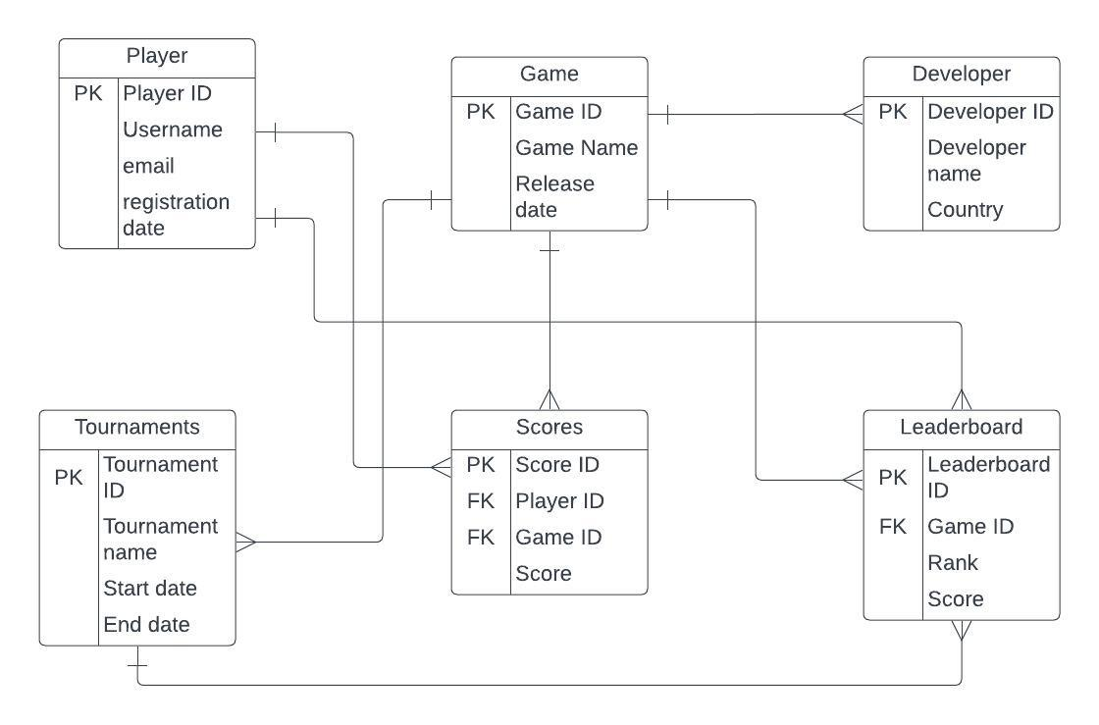

**ENTITY RELATIONSHIP DIAGRAM (ERD) OF GAMING LEADERBOARD DATABASE**

# DATA DICTIONARY FOR GAMING LEADERBOARD DATABASE

# CREATE DATABASE

# Query: Create database project_gaming_leaderboard;

# USE DATABASE

# Query: Use project_gaming_leaderboard;

# 

# DATA ENTRY AND UPDATE

# Player Table

# 

# ALTER TABLE

# INSERTING VALUES

# We have inserted all 25 values with the below code.

# 

# DATA RETRIEVAL:

# GAME TABLE

# 

# CREATING TABLE

# 

# INSERTING VALUES

# ALTER TABLE:

# 

# DATA RETRIVAL:

# DEVELOPER TABLE

# CREATING TABLE:

# 

# ALTERING TABLE:

# 

# INSERTING DATA:

# 

# DATA RETRIVAL:

# TOURNAMNETS

# CREATING TABLE

# 

# ALTER TABLE

# 

# DATA RETRIVAL:

# SCORE

# CREATING TABLE

# 

# ALTER TABLE

# INSERTING TABLE

# 

# DATA RETRIVAL

# LEADERBOARD

# CREATING TABLE

# 

# ALTER TABLE

# INSERTING VALUES

# 

# DATA RETRIVAL:

# QUESTIONS

# Display the GameID and Game Name where the first letter of the game name is 'C', you can use a SQL query.

# 2. Games released after July 1, 2015, as well as usernames of players playing games with the letter 'C' in the name

# What is the average player rank per month and year of game release across the dataset, displayed by release year and month?

# What is the highest score achieved in leaderboard. Display highest score and leaderboard ID from different tournaments?

# Which developers have created games with the highest average scores?

# Which players have participated in the most tournaments?

# Here we didn’t get any info in output since we don’t have players in common in different tournaments.

# which country developer has ranks below 10.provide the Developer name ,country?

# Which developer country has leaderboard scores more than the average of all leaderboard scores, provide gamename and developer country and leaderboard score?

# DBMS on a selection basis:

# MySQL was selected as the database management system that would be used for our project. For web-based applications, MySQL is a well-known database management system (DBMS) that is released under an open-source license. In addition to being durable and scalable, this database system is also capable of supporting a large number of users at the same time. Tools for data management, data security, and data analysis are also included in MySQL packages. Because it is compatible with a wide range of programming languages and frameworks, integrating it with a web-based application is a straightforward process.

# Conclusion:

# The game leaderboard database project has achieved its intended results, which included the development of an exceptionally comprehensive and precise database containing gaming leaderboard data. The database is an indispensable resource for both game developers and participants due to its straightforward interface and minimal maintenance needs.

# The database is effectively organized and employs a normalized schema to ensure data precision. The data is effectively structured and straightforward to retrieve, with the tables linked together by means of appropriate foreign key constraints. Furthermore, the data exhibits a high degree of organization.

# Furthermore, the project has incorporated several advantageous functionalities, one of which is the ability to calculate personalized average scores for every developer. By utilizing this function, players are capable of contrasting the efficacy of multiple developers' games. This information could potentially be valuable in ascertaining which developers possess the utmost proficiency within the industry.

# The gaming leaderboard database initiative is an exceptionally well-conceived and substantial contribution to the gaming community when all factors are considered. It provides a database for gaming leaderboard statistics that is not only comprehensive and precise, but also straightforward to operate and administer.