Tableau
Course-End Project Problem Statement



Course-End Project: Sales Analysis

Problem Statement:
DigiComp is a global enterprise that, among other things, caters to designing, developing, manufacturing and marketing products like - clothing materials.
DigiComp has expanded its presence across the globe, and the business wants to get an in-depth analysis of its sales so as to make better sales decisions. So, DigiComp has decided to use Tableau Dashboards to consolidate the data from multiple sources, and carry out the sales analysis. This will help the sales department to access the data from remote locations that would increase the overall timeliness, find inefficiencies, and make better decisions.
As a Tableau developer, you are tasked with creating an interactive Sales Dashboard in Tableau for the Sales department to use it for ad-hoc analysis and reporting.
Description of the Datasets:
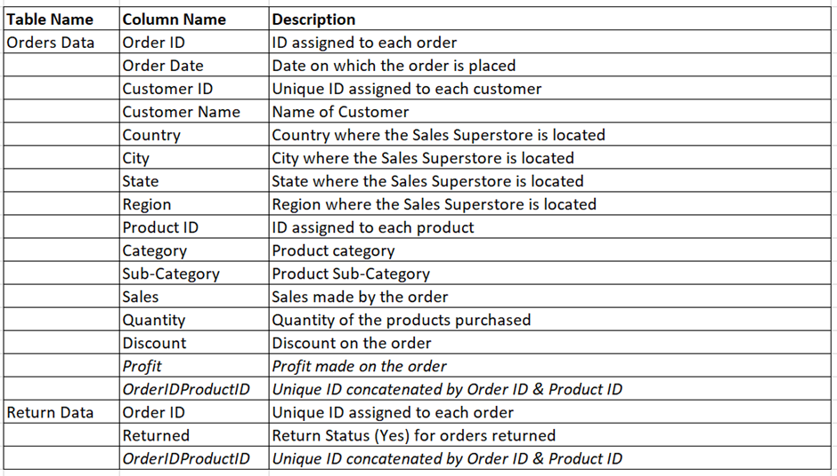
Perform Data Visualization:
Perform the following using charts and visuals:
*Note: The italicized words indicate the actual columns in the dataset.
- Analyse the Sales/Profit for all the months of 2017 as a continuous line chart and area chart.
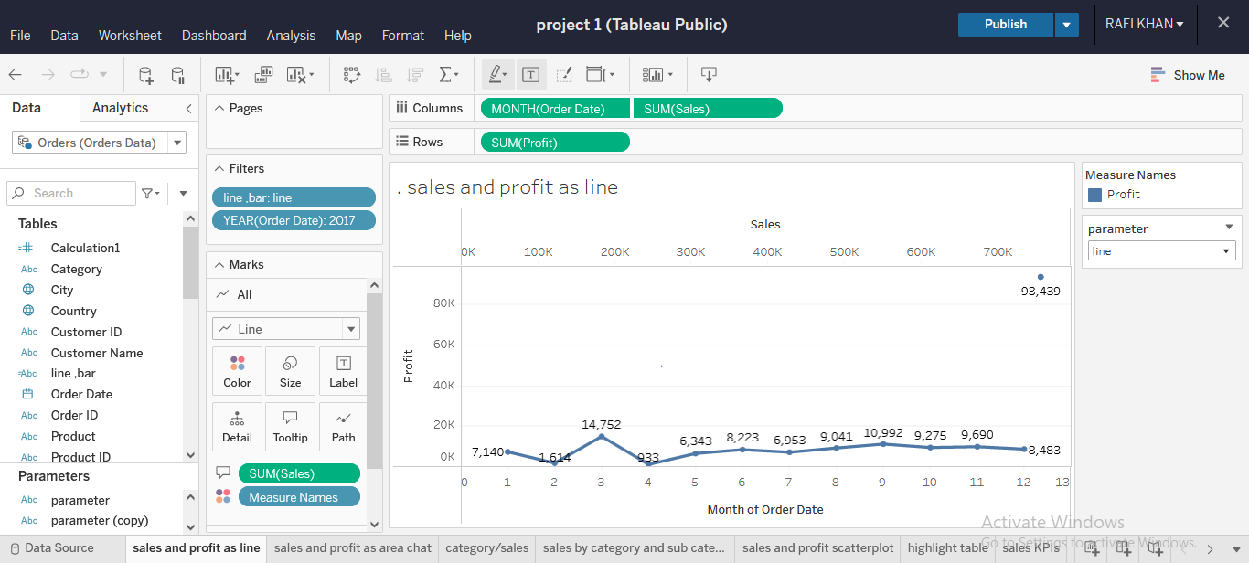

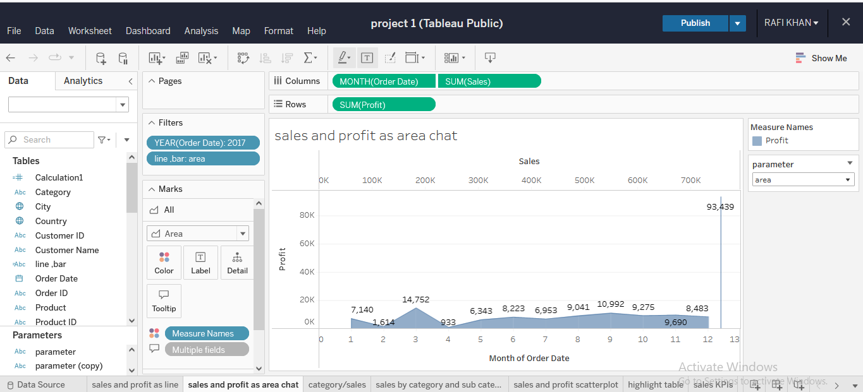

- Show Category-wise Sales as Packed Bubbles Chart suggesting categories with highest to lowest sales.

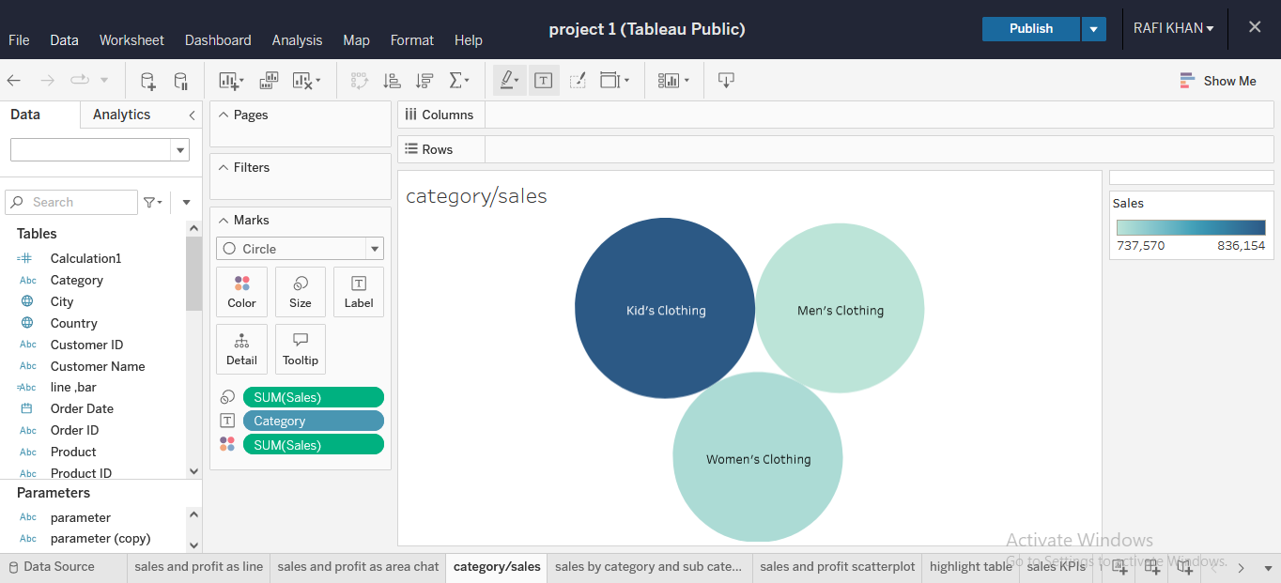

- Create a Treemap chart showing Sales by Category and Sub-Category.

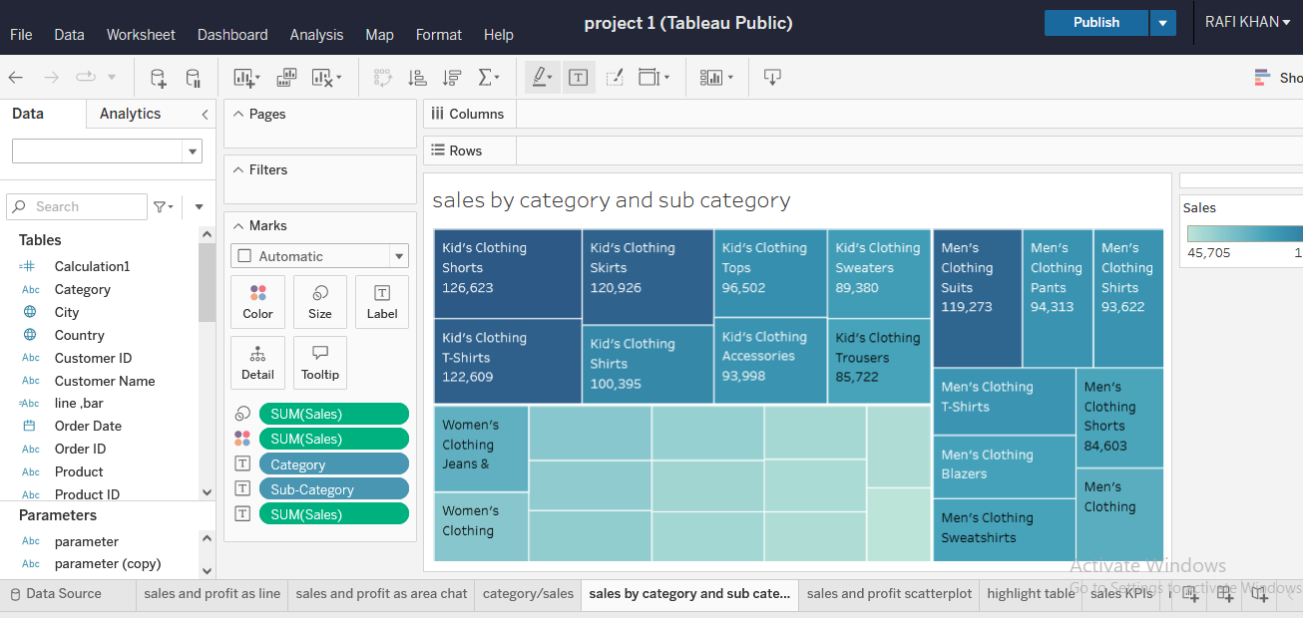

- Visualize Sales vs Profit on a Scatter Plot with Category and Sub-Category breakdown.

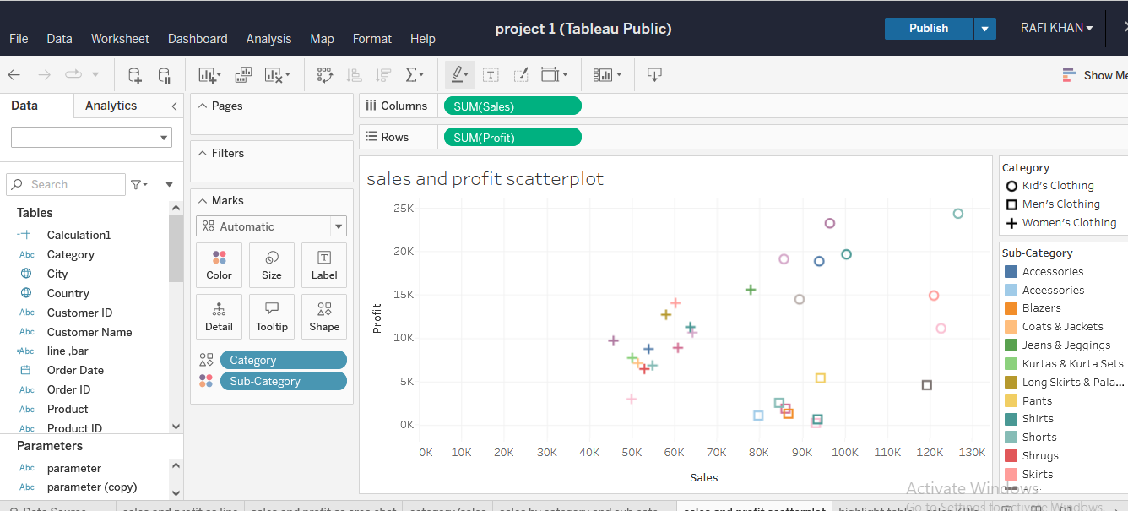

- Compute aggregated values for all Sales KPIs like Total Sales, Profit, Profit Ratio, Discount in a Table view.

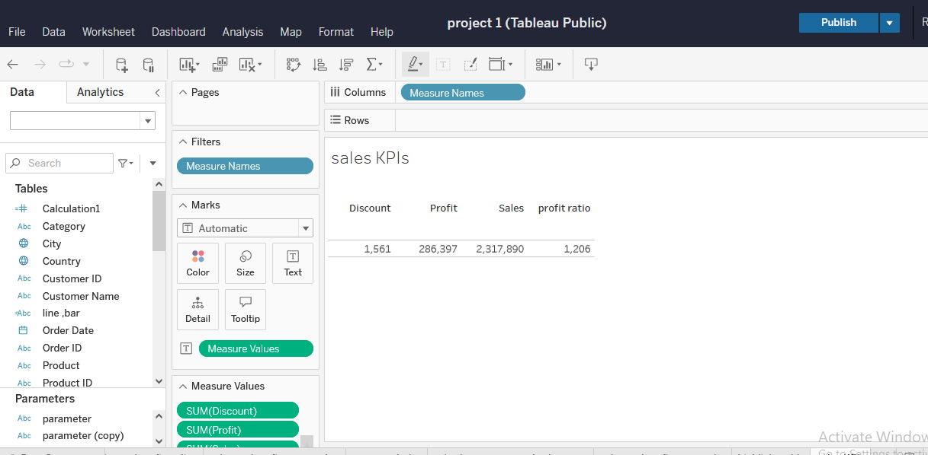

- Analyse the Sales for all the quarters of all the years across State, and Category as a Highlight Table. Highlight the columns by Profit.

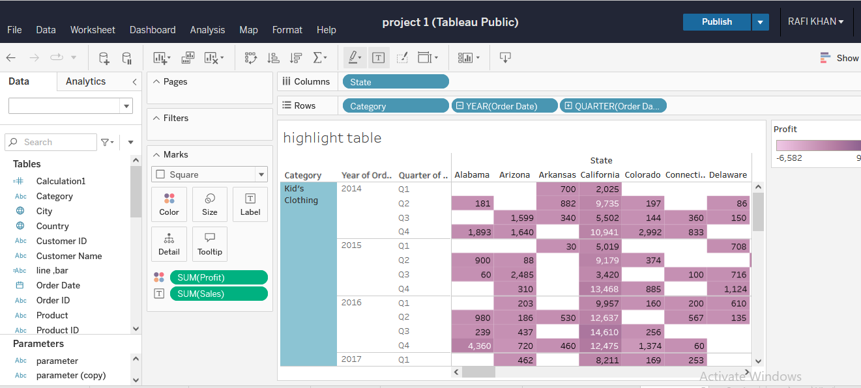

- Connect to the Return Data dataset, and blend it with Orders data to compute the number of orders returned for each Product Category in 2016.

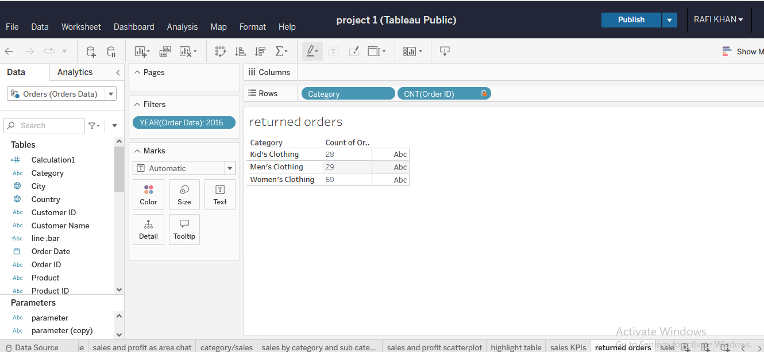
- Show Sales/Quantity of Product Category in each Region as a Stacked Bar Chart.

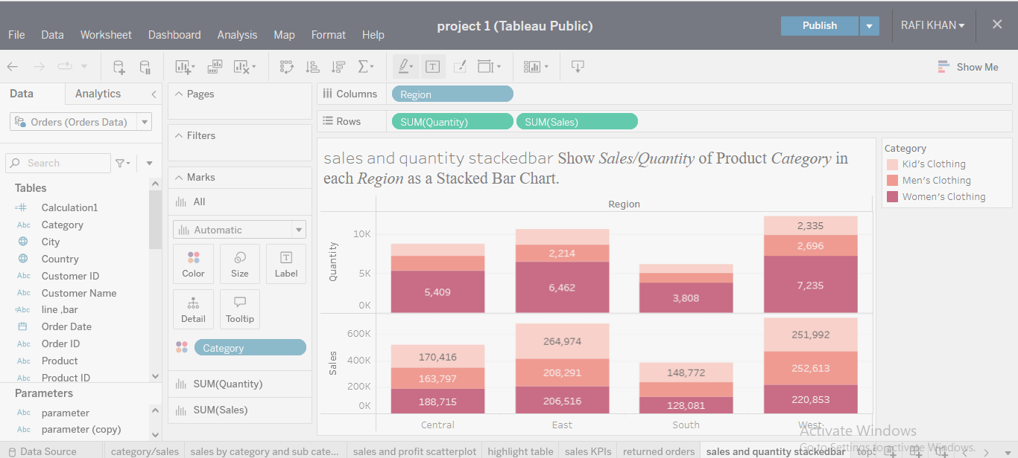

- Determine the top 5 products and top 5 customers by Sales, i.e., Products and Customers that are generating the highest revenue as a bar chart.

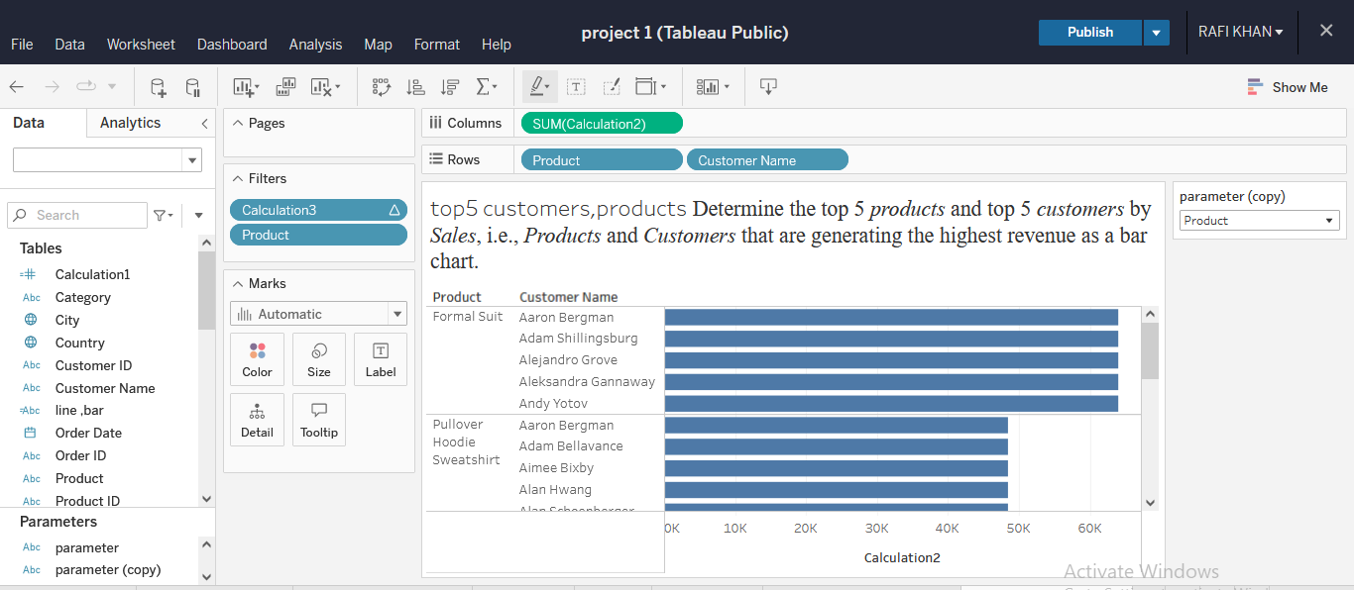
- Visualize Sales by State where the sales variation is highlighted by color as a Map Chart.

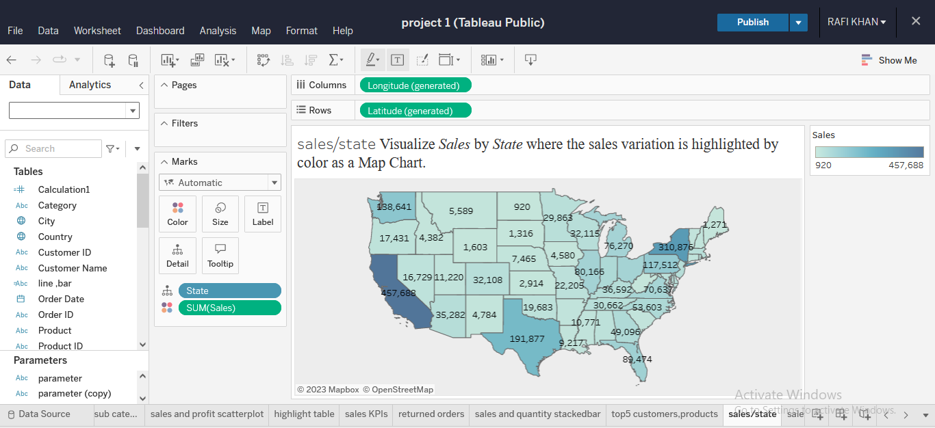

- Visualize Sales & Profit analysis by Customer on a Scatter Plot.

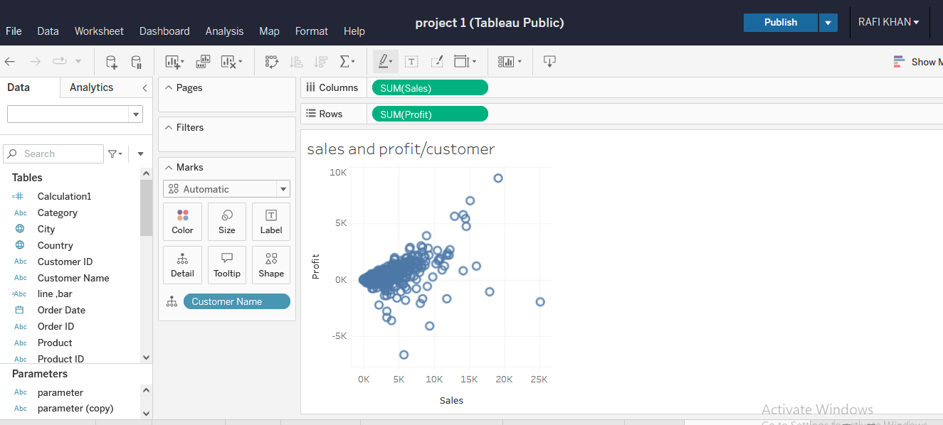
- Represent the Number of orders received by Quantity bins as a Histogram.
  - Create Quantity bins.
  - Use Measure Count of Quantity as calculation.
  - Drag Count of Quantity in Row Shelf and Quantity bins in column shelf

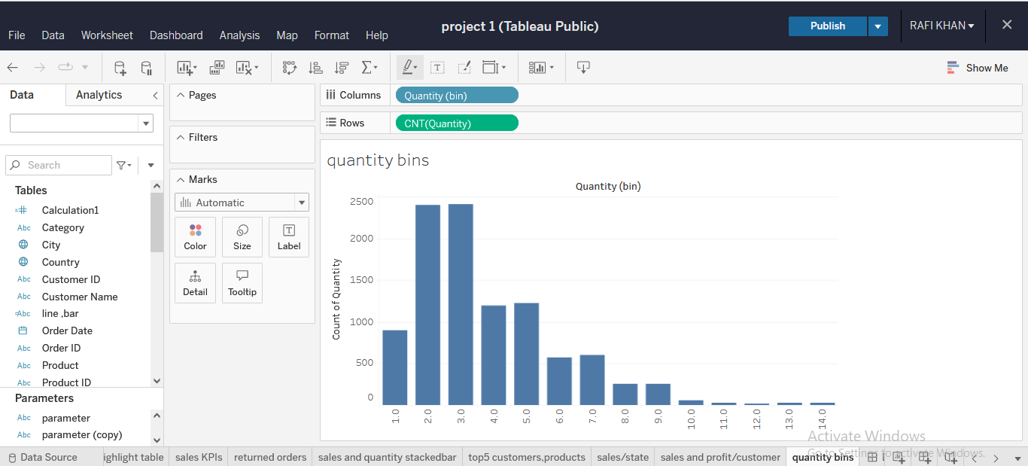

- Create an interactive fixed size floating layout Dashboard that can be shared with the leaders using the above analysis.

- Create a story with the following visuals:
*Note: The below-listed visuals are done as part of tasks 1 to 6.
  - Sales/Profit for all the months of 2017
  - Category-wise Sales
  - Sales by Category and Sub-Category.
  - Sales vs Profit
  - Aggregated values for all Sales KPIs and
  - Sales for all the quarters for all the years across State, and Category.

