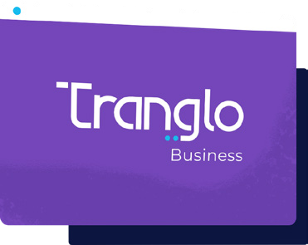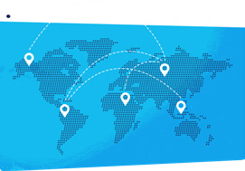

Service

Specification

Our payout corridors by country, speed and transaction limit.

# Tranglo connects

your business to the world

Our all-in-one cross-border collection and payout solution gives you the most

cost-effective way to send and receive money without sacrificing speed and security. Collect payments from Indonesia and Singapore and send them out to over 25 countries. All major currencies supported.

# 5 advantages

of Tranglo Business

#### Single API access



Our proprietary technology seamlessly integrates and handles your end-to-end payment journey, making it easy for you to collect your payments and send them out reliably.

#### World-class compliance and security

Real-time monitoring, screening and blocking service that ensures full compliance with international and local financial regulations.

#### Competitive FX rates



Great pricing that saves you money the more you transact through us.

#### Best coverage for APAC and SEA corridors

Over a decade of processing cross-border payments in high-traffic corridors like Philippines, Indonesia and Vietnam.

#### Complimentary marketing and technical support



Data-based insights for you to ease reconciliation and account keeping. Our technical and customer support team is available 24/7.

# Payment corridors

We support bank transfers to these countries.

### AFRIC A

Egypt

### ASIA P A CIFIC

Bangladesh China Hong Kong



Indonesia Malaysia Mongolia



Nepal



Pakistan

Philippines

Singapore South Korea Sri Lanka



Thailand

Vietnam



Turkey

UAE

### EUROP E (SEP A)

United Kingdom



# Service specification

Note: This information is accurate to the date of publication. For the latest updates to our service specification, visit our website at tranglo.com > docs > tranglo-business > service-specification

|  |  |  |  |  |  |  |
| --- | --- | --- | --- | --- | --- | --- |
| Country | | | Transaction limit‘ | TAT² | Business payout | Individual payout |
| AFRIC A | | | | | | |
| Egypt | | | EGP 110,000 | T+0 |  |  |
| ASIA P A CIFIC | | | | | | |
|  |  | Bangladesh | BDT 200,000 | real-time |  |  |
|  | | |
|  |  | China | USD 500,000 | T+0 |  |  |
| Hong Kong | | | HKD 200,000 | real-time |  |  |
|  |  | Indonesia | IDR 50,000,000 | real-time |  |  |
|  |
|  | | |
| Malaysia | | | MYR 1,000,000 | real-time |  |  |
| Mongolia | | | MNT 14,000,000 | real-time |  |  |
| Nepal | | | NPR 1,000,000 | real-time |  |  |
| Pakistan | | | PKR 1,000,000 | T+0 |  |  |
| Philippines | | | PHP 500,000 | real-time |  |  |
|  |  | Singapore | SGD 1,000,000 | real-time |  |  |
|  |
|  | | |
| South Korea | | | KRW 6,000,000 *(individual)*  KRW 500,000,000 *(business)* | real-time |  |  |
| Sri Lanka | | | LKR 1,000,000 | T+0 |  |  |
| Thailand | | | THB 49,999 | real-time |  |  |
|  | | | TRY 250,000 | real-time |  |  |
|  |  | Turkey |
| United Arab Emirates | | | AED 25,000 | T+0 |  |  |
|  |  | Vietnam | VND 499,999,999 | T+0 |  |  |
| EUROP E (SEP A) | | | | | | |
| United Kingdom | | | GBP 999,999 | real-time |  |  |

‘ The maximum amount per transaction unless stated otherwise.

² Refer to the quickest transaction turnaround time supported. Real-time means payout within 15 minutes.

Get Started



Ready for next-level payments?

## Contact us

1

at https://tranglo.com/contact-sales/

## Submit document

2

at our Tranglo Business Portal

Integrate API /

3

Get platform access

once application approved

## Go live

4

to send and receive payments

Copyright © Tranglo. All rights reserved.