**What is MongoDB?**

MongoDB is an open-source, cross-platform, and distributed **document-based database** designed for ease of application development. It is a **NoSQL database** developed by [MongoDB Inc](https://www.mongodb.com/company)

MongoDB name is derived from the word "Humongous" which means huge, enormous. MongoDB database is built to store a huge amount of data and also perform fast.

MongoDB is not a Relational Database Management System (RDBMS). It's called a "NoSQL" database. It is opposite to SQL based databases where it does not normalize data under schemas and tables where every table has a fixed structure. Instead, it stores data in the collections as JSON based documents and does not enforce schemas. It does not have tables, rows, and columns as other SQL (RDBMS) databases.

The following table lists the relation between MongoDB and RDBMS terminologies.

| MongoDB (NoSQL Database) | RDBMS (SQL Server, Oracle, etc.) |
| --- | --- |
| Database | Database |
| Collection | Table |
| Document | Row (Record) |
| Field | Column |

In the RDBMS database, a table can have multiple rows and columns. Similarly in MongoDB, a collection can have multiple documents which are equivalent to the rows. Each document has multiple "fields" which are equivalent to the columns. Documents in a single collection can have different fields.

The following is an example of JSON based document.

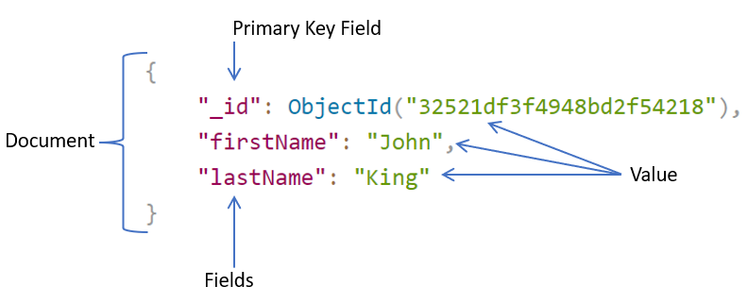

**Install MongoDB Server**

Visit [www.mongodb.com](https://www.mongodb.com/) to download the MongoDB installer for your required platform.

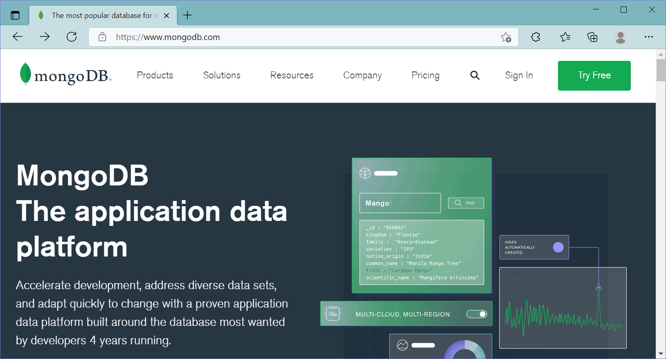

Here, we are going to install a free MongoDB database server on our local Windows machine. So, click on the Product menu -> Community Server, as shown below.

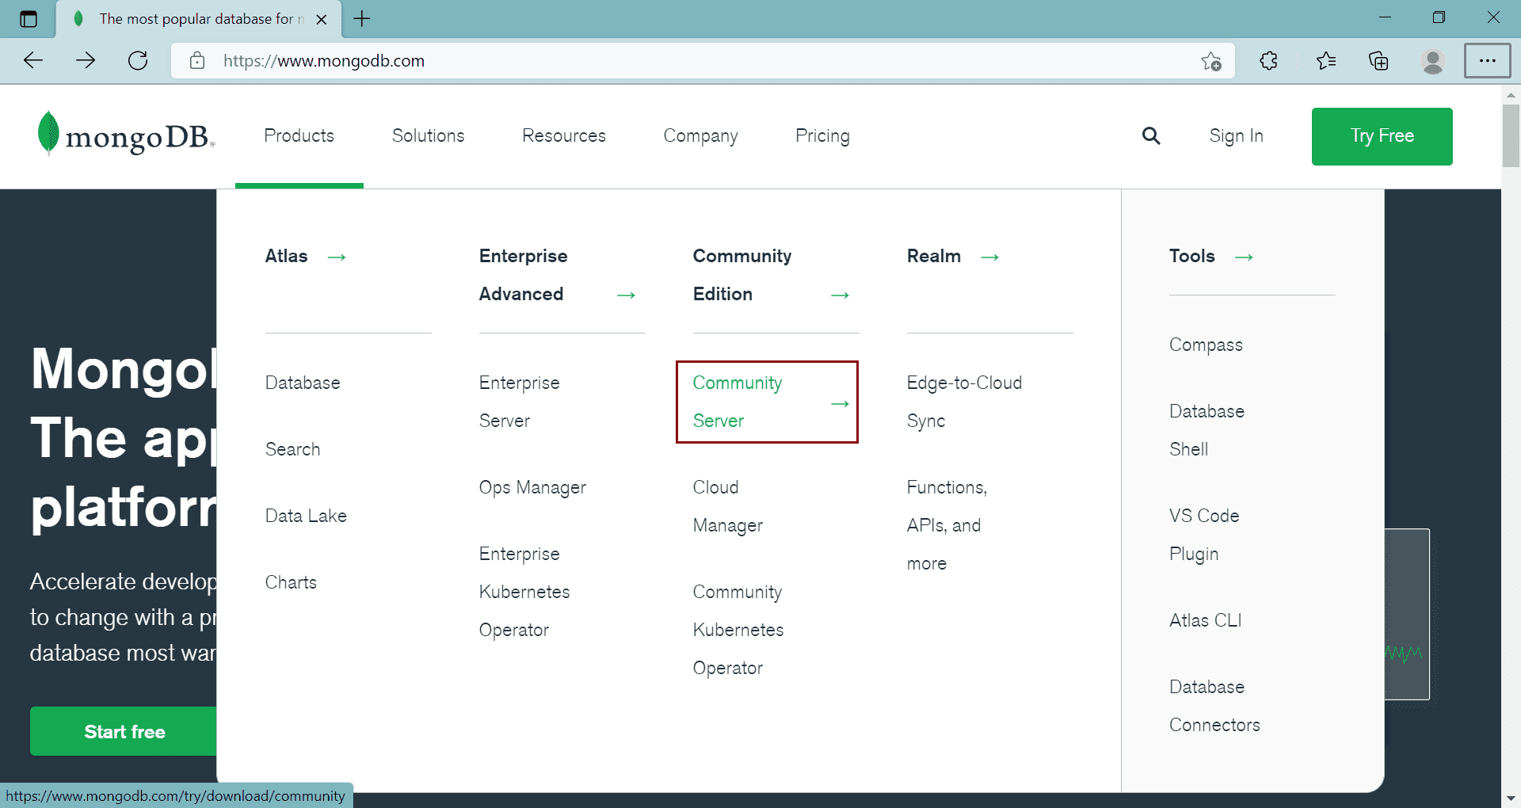

This will open a download page where you can select the version, platform, and package options.

Here, we will download the latest version of MongoDB, Windows platform, and msi file as a package, as shown below.

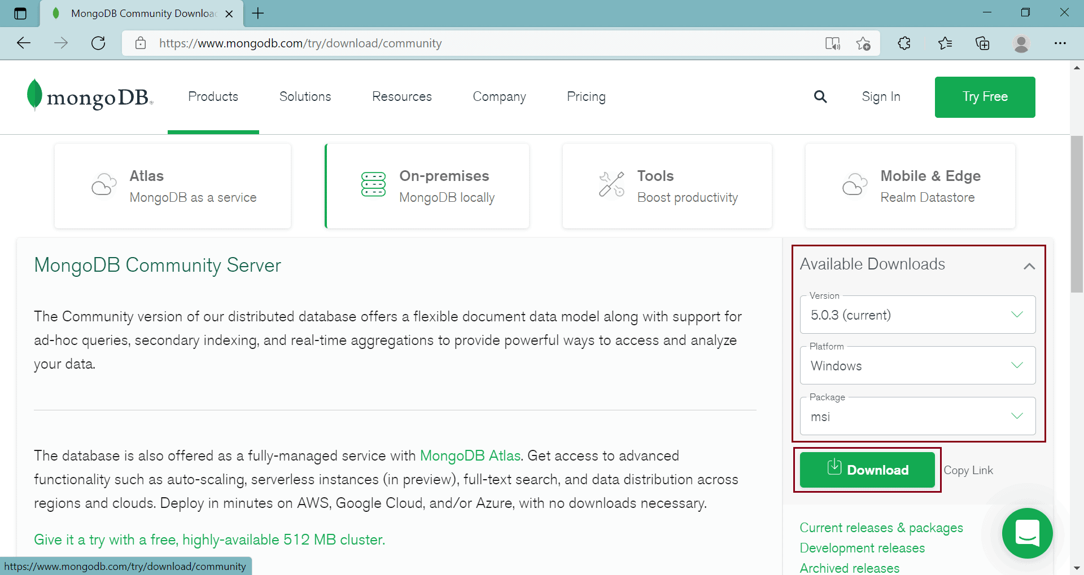

Click on the Download button to download the installer file.

Once fully downloaded, click on the msi file to start the installation wizard, as shown below.

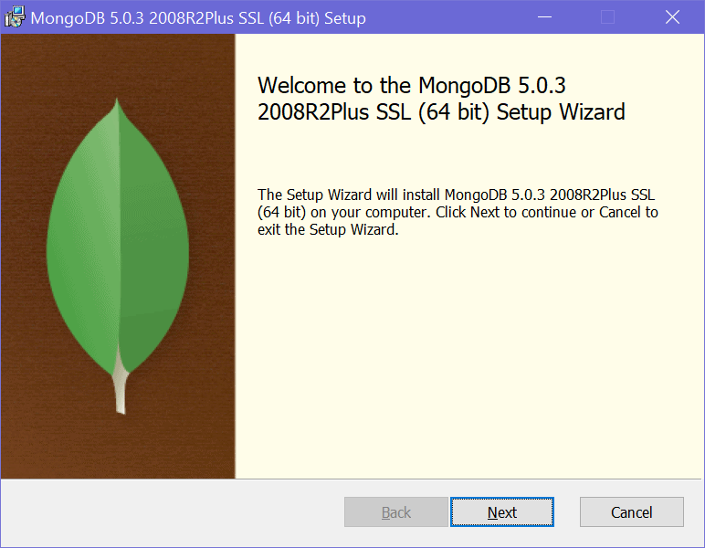

Click Next to start the installation.

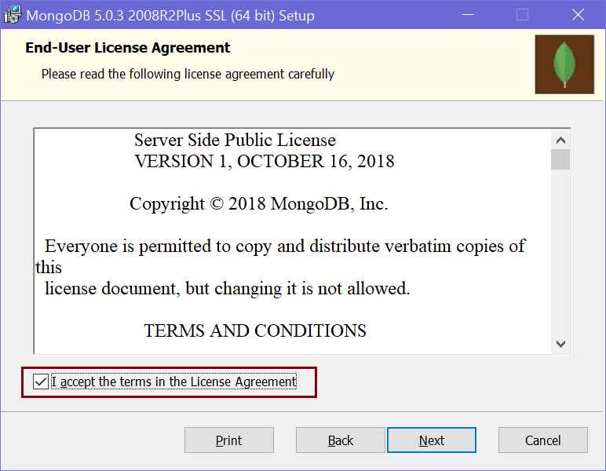

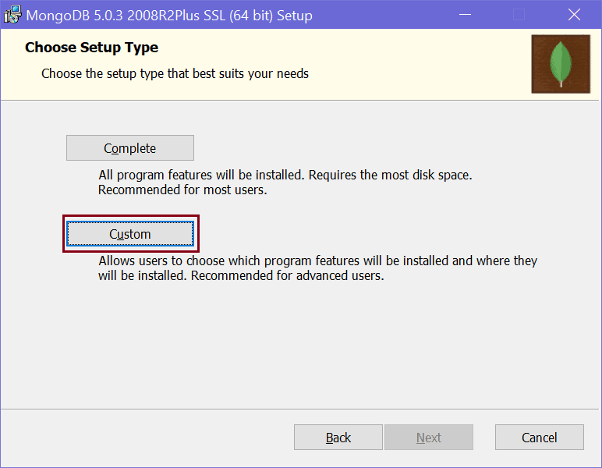

Here, you will have two options for installation: Complete and Custom. The complete option will install all the features. The custom option allows you to select only required features.

You can select either of these two options. Here, we will select the custom option just to show you what all things it will install. So, click on the Custom option which will take you to the next step, as shown below.

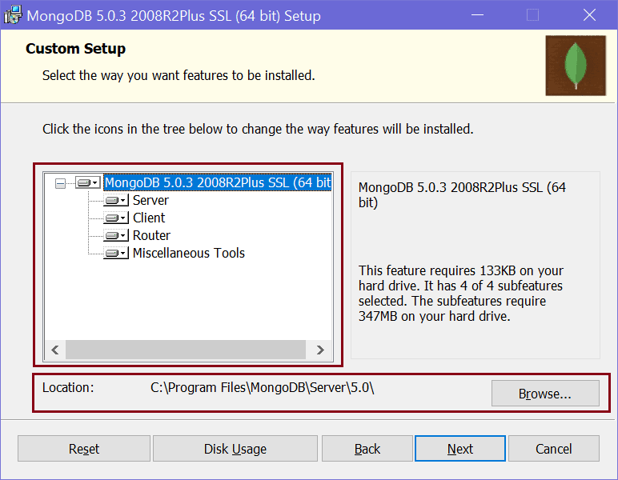

In the custom setup page, expand the MongoDB node to see what all features will be installed. It will install Server, Client, Router, and Miscellaneous Tools for the MongoDB database. It also displays the location where the MongoDB is going to be installed. You may change it or keep the default location and click Next.

Click Next to configure the MongoDB service, as shown below.

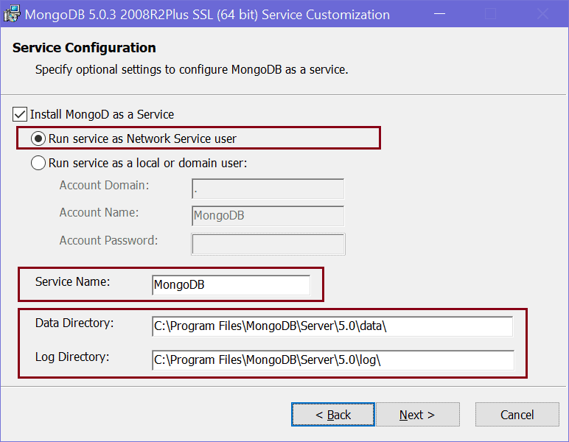

On the next page, select "Install MongoDB Compass" checkbox and click Next. MongoDB Compass is a GUI tool for MongoDB database where you can visually explore data, run queries, and optimize performance.

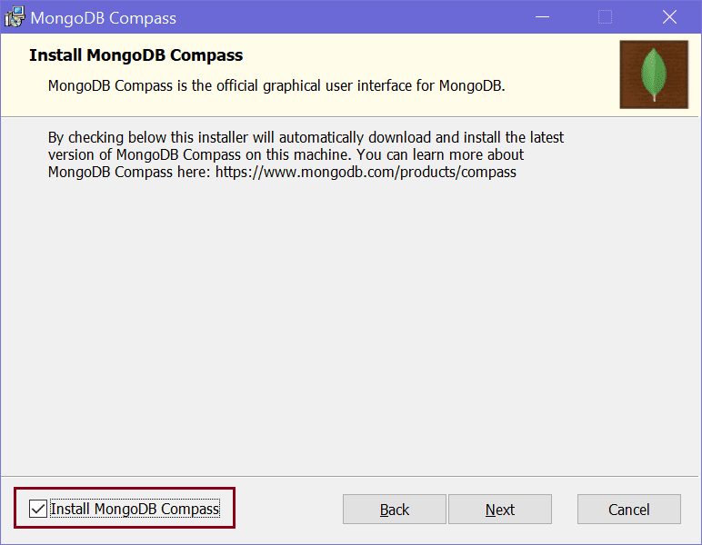

Next, click on the Install button to start the installation.

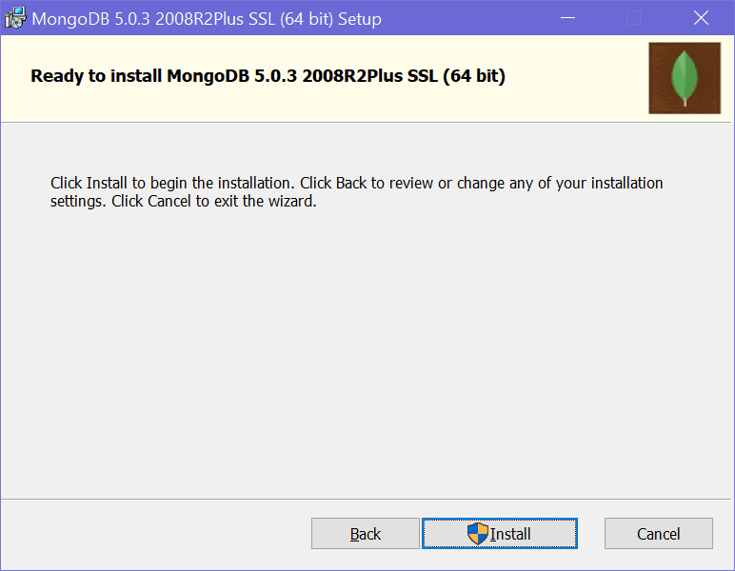

It will take a few minutes to install. Once installed succefully, click on the Finish button to close the wizard.

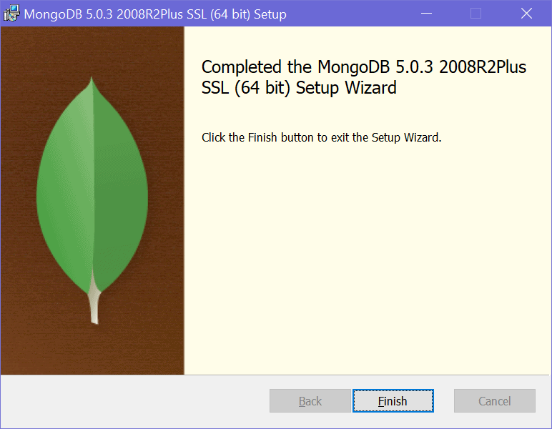

Open MongoDB Shell

Open Command prompt 🡪 CMD

C:\Program Files\MongoDB\Server\4.2\bin

At the prompt type mongo to open mongo DB shell/console

Mongodb shell commands

|  |  |
| --- | --- |
| show dbs | Print a list of all databases on the server. |
| use <db> | Switch current database to <db>. The [mongo](https://www.mongodb.com/docs/manual/reference/program/mongo/#mongodb-binary-bin.mongo) shell variable db is set to the current database. |
| show databases | Print a list of all available databases. |

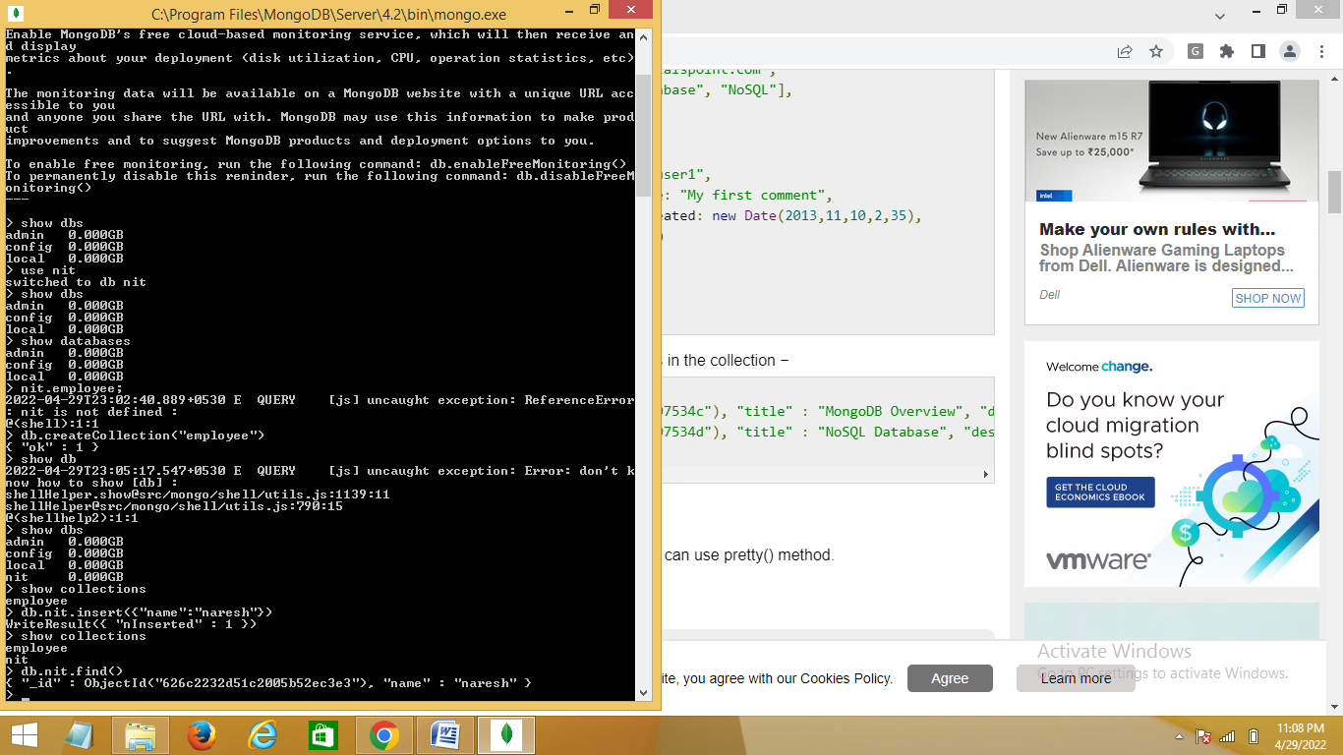

CRUD

How python communicate with mongodb

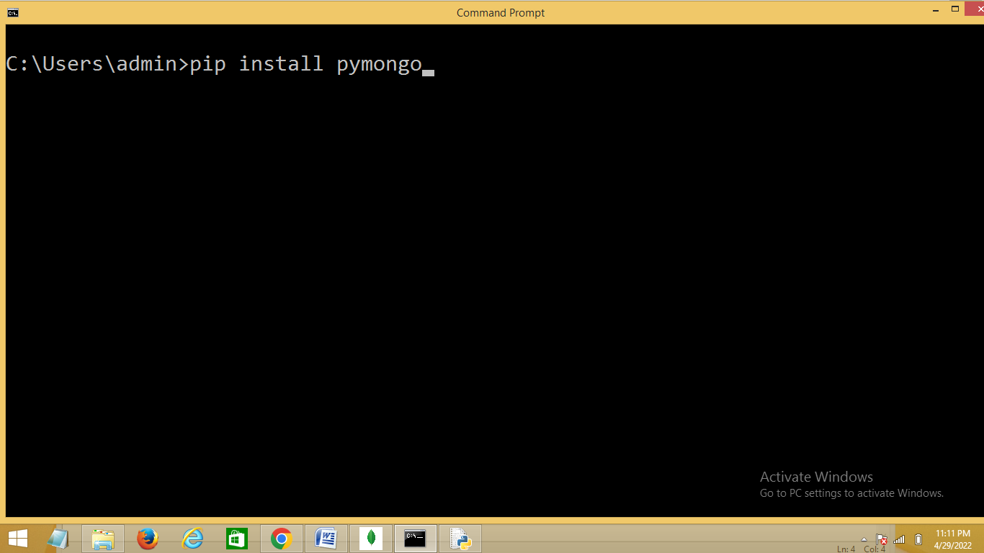

Basic steps to communicate with mongo db

1. Establish connection to database/Creating client
2. Creating Database
3. Creating collection
4. CRUD (Inserting,Reading, Updating and deleting)

**Creating a Database**

To create a database in MongoDB, start by creating a MongoClient object, then specify a connection URL with the correct ip address and the name of the database you want to create.

import pymongo  
  
myclient= pymongo.MongoClient("mongodb://localhost:27017/")  
  
mydb = myclient["mydatabase"]

You can check if a database exist by listing all databases in you system:

print(myclient.list_database_names())

**Creating a Collection**

To create a collection in MongoDB, use database object and specify the name of the collection you want to create.

import pymongo  
  
myclient = pymongo.MongoClient("mongodb://localhost:27017/")  
mydb = myclient["mydatabase"]  
  
mycol = mydb["customers"]

**Check if Collection Exists**

print(mydb.list_collection_names())

Check if the "customers" collection exists:

collist = mydb.list_collection_names()  
if "customers" in collist:  
  print("The collection exists.")