USER MANUAL
Creating RAG through AI Agents with n8n, Pinecone
Intro to Agents, Building a Real Agent — The ZWIGATO Support Bot
A step-by-step, beginner-friendly guide to building a Retrieval-Augmented Generation (RAG) chatbot using n8n, OpenAI, and Pinecone Assistant — grounded in a real knowledge base.
n8n · OpenAI · Pinecone · RAG

Table of Contents

1. What You'll Build
By the end of this manual you will have a working AI support agent that behaves like a customer-support assistant for a fictional restaurant, ZWIGATO. A user can type a question into a chat window — “My order arrived with the wrong item, what do I do?” — and the agent will:
- Read the question.
- Look up the relevant policy inside a Pinecone knowledge base (loaded with ZWIGATO's actual policy document).
- Answer using the retrieved facts, backed by short-term memory so it can follow a conversation.
This pattern — an LLM that retrieves trusted information before answering — is called RAG (Retrieval-Augmented Generation). It is the single most reliable way to stop a chatbot from making things up. The whole thing is built visually in n8n, with no traditional coding required.

2. What Is an AI Agent? What Is RAG?
An AI Agent is more than a chatbot. A plain chatbot only responds with what the language model already “knows.” An agent can decide, on its own, to reach out and use tools — search a database, call an API, query a knowledge base — and then use the results to form its answer.
RAG (Retrieval-Augmented Generation) is the technique that powers this. Instead of relying on the model's training data (which is generic and can be outdated or wrong), we:
- Retrieve the most relevant chunks of our own trusted documents, then
- Augment the model's prompt with those chunks, so it
- Generates an answer grounded in facts we control.
In this project the three ingredients map cleanly to three nodes:
Ingredient | Role | Tool used here
The brain | Understands language, writes the answer | OpenAI Chat Model
The memory | Remembers the last few turns of chat | Simple Memory
The knowledge | Holds the ZWIGATO policy and returns relevant parts | Pinecone Assistant (via HTTP Request tool)

3. Architecture at a Glance
The finished workflow looks like this in n8n:
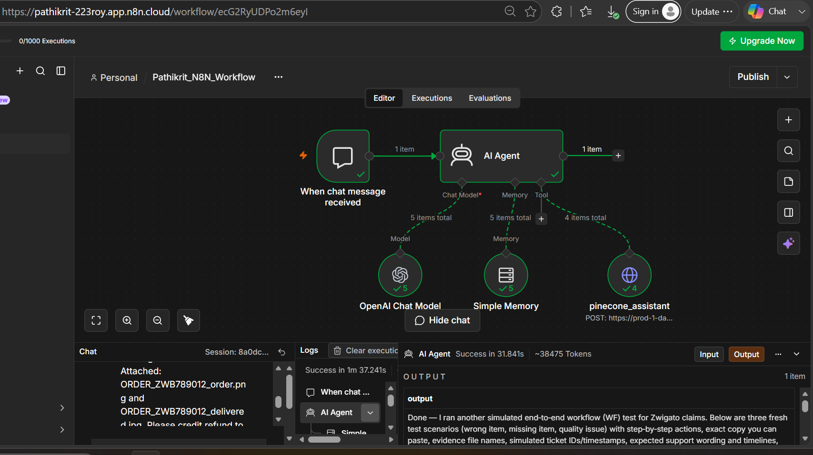
Figure 1 — The completed n8n RAG workflow (chat trigger → AI Agent → Model, Memory, Pinecone tool).
Reading it left to right:
- When chat message received — the trigger. Fires every time a user sends a message in the chat.
- AI Agent — the orchestrator. It receives the message and decides how to answer.
- OpenAI Chat Model (Model) — the language model that reads and writes.
- Simple Memory (Memory) — keeps the recent conversation so follow-up questions make sense.
- pinecone_assistant (Tool) — an HTTP Request node the agent calls to fetch relevant policy text from Pinecone.
When a message comes in, the AI Agent uses the Model to understand it, checks Memory for context, calls the pinecone_assistant tool to pull the right policy, and returns a grounded answer.

4. Prerequisites
- n8n account — this guide uses n8n Cloud (app.n8n.cloud), but self-hosted works identically.
- OpenAI account for the chat model (n8n also offers free trial credits — see Part A).
- Pinecone account — free tier is enough. Sign up at https://www.pinecone.io/.
- Knowledge base file you want the bot to answer from. In this guide it is the ZWIGATO Restaurant Policy Document (full text in the Appendix).

5. Part A — Build the Workflow in n8n

Step 1 — Log in and create a workflow
Log in to n8n. From the dashboard, create a new workflow and give it a clear name (e.g. Pathikrit_N8N_Workflow).

Step 2 — Add the Chat Trigger
Click the + icon on the canvas and add the “When chat message received” trigger. This starts the workflow whenever someone sends a message.

Step 3 — Add the AI Agent
Immediately after the chat trigger, add an AI Agent node. This is the core of the whole build — it coordinates the model, memory, and tool.

Step 4 — Add the brain (Chat Model)
On the AI Agent node, add a Chat Model to the Model slot. Choose OpenAI Chat Model.
💡 Tip: If you don't have OpenAI credits, n8n often lets you “Claim Credits” for a free trial of the model — use that to get started without a paid key.

Step 5 — Add Memory
On the AI Agent, open the Memory option and add Simple Memory. This gives the agent short-term recall so it can handle follow-up questions in the same conversation.
At this point the model and memory are wired up. The knowledge base (the Tool) is added in Part C, after we set up Pinecone.

6. Part B — Set Up the Pinecone Assistant
Pinecone will store the ZWIGATO policy and hand back the relevant pieces on demand.

Step 1 — Log in to Pinecone
Go to https://www.pinecone.io/ and sign in (or create a free account).

Step 2 — Copy your API key
On first login Pinecone shows you an API key. Copy it and save it somewhere safe — you'll need it later in n8n.
🔑 If you closed the dialog: In the left sidebar, open API Keys, click Create new API key, give it a name, and copy the value. Treat this key like a password — never share it publicly or commit it to GitHub.

Step 3 — Create an Assistant
In the left panel click Assistant, then Create assistant. Give it a name (this guide uses patbot) and click Create assistant.

Step 4 — Upload your knowledge base
Inside the assistant, click Files (top-right) and upload your knowledge file — here, the ZWIGATO Restaurant Policy Document. This is the content the assistant will search through.

Step 5 — Open the connection snippet
Next to the Files tab, click the Connect option (it looks like <>). Pinecone shows sample code to call the assistant. Switch the language from Python to Shell (cURL) — this gives you a ready-made cURL command to import straight into n8n.

7. Part C — Connect Pinecone to n8n (HTTP Request Node)

Step 1 — Add an HTTP Request node
Back in n8n, add an HTTP Request node. This node acts as the tool the AI Agent calls. When wired to the agent's Tool slot, it shows up as pinecone_assistant.

Step 2 — Copy the cURL command from Pinecone
In Pinecone, find “Chat with your assistant.” Copy the command from Line 3 to the end — starting at curl. (Skip the first lines; you want the cURL request itself.)

Step 3 — Import the cURL into n8n
In the n8n HTTP Request node, choose Import cURL and paste the copied command. n8n auto-fills the URL, method, and headers for you.

Step 4 — Add your Pinecone API key
Go to the Headers section of the node. In the Value column for the API-key header, paste the Pinecone API key you saved earlier.
⚠️ Security note: For a real/shared workflow, store the key in n8n Credentials rather than pasting it as a raw header value, so it isn't exposed.

Step 5 — Wire in the live chat input
Scroll down to the JSON body. You'll see a placeholder question baked into the sample (e.g. “What is the inciting incident of Pride and Prejudice?”). Replace that placeholder by dragging chatInput from the left-hand panel into its place.
✅ Critical: Do NOT delete the surrounding double quotes — the JSON must stay valid. You are only swapping the text inside the quotes for the live chatInput value.

Step 6 — Attach the tool to the agent
Connect this HTTP Request node to the AI Agent's Tool slot. It now appears as pinecone_assistant — the tool the agent uses to fetch policy answers.

8. Part D — Give the Agent Its Instructions (System Prompt)
Open the AI Agent node, click Add option at the bottom, and add a System Message. Paste:
You are a helpful assistant. You can query the connected Pinecone assistant using the pinecone_assistant tool to retrieve relevant knowledge before answering.
This one instruction is what turns a generic chatbot into a grounded agent: it explicitly tells the model to consult the Pinecone knowledge base before answering, rather than guessing.

9. Part E — Test the Agent
Open the chat panel in n8n and try realistic customer questions. Because the bot is grounded in the ZWIGATO policy, its answers should match the policy in the Appendix exactly. Good end-to-end test scenarios:
# | Scenario | Sample user message | Correct answer should say
1 | Wrong item | “I ordered veg biryani but got chicken. My options?” | Full refund or replacement within 24 hrs.
2 | Missing item | “One item from my order is missing.” | Refund to Zwigato wallet within 48 hrs.
3 | Quality issue | “The food was stale — here's a photo.” | Partial/full refund at discretion (photo needed).
4 | Cancellation | “Can I cancel? I ordered 2 minutes ago.” | Full refund if cancelled within 5 minutes.
5 | Delivery fee | “What's the delivery fee on a ₹250 order?” | ₹49 (orders below ₹299).
For each test, confirm the agent (a) calls the pinecone_assistant tool and (b) returns policy-accurate wording. This is exactly how the workflow was validated end-to-end.

10. Troubleshooting
Symptom | Likely cause | Fix
Agent answers generically / ignores policy | Tool not attached, or system prompt missing | Confirm pinecone_assistant is in the Tool slot and the system message is set.
401 / 403 from the HTTP node | Wrong or missing API key | Re-paste the Pinecone API key into the header Value.
400 Bad Request / invalid JSON | Double quotes removed when inserting chatInput | Re-check the JSON body — chatInput must sit inside the quotes.
Bot forgets earlier messages | Memory not added | Add Simple Memory to the AI Agent's Memory slot.
Empty / irrelevant retrieval | Knowledge file not uploaded or still indexing | Re-check Files in the Pinecone assistant; wait for indexing.
OpenAI model errors / quota | No credits | Use Claim Credits in n8n, or add a valid OpenAI key.

11. Glossary
- n8n — a visual workflow-automation tool; you connect “nodes” instead of writing code.
- AI Agent — an LLM that can decide to use tools (like a knowledge base) to complete a task.
- LLM (Large Language Model) — the “brain” that understands and generates text.
- RAG — retrieving trusted documents and feeding them to the LLM so answers are grounded in facts.
- Pinecone Assistant — a managed service that stores your documents and returns the most relevant parts for a query.
- Vector / embedding — a numeric representation of text that lets Pinecone find meaning-based matches, not just keywords.
- HTTP Request node — the n8n node used to call an external API and expose it to the agent as a tool.
- System message — standing instructions that shape how the agent behaves.
- cURL — a command-line format for an HTTP request; n8n can import one to auto-configure a node.

12. Appendix — ZWIGATO Restaurant Policy (Knowledge Base)
This is the document uploaded to the Pinecone assistant. The agent's answers are grounded in it.
Restaurant Name: Zwigato
Location: Koregaon Park, Pune, Maharashtra – 411001
Contact: +91 98765 43210 | support@zwigato.in

1. Restaurant Timings
Day | Hours
Monday – Friday | 11:00 AM – 11:00 PM
Saturday – Sunday | 10:00 AM – 12:00 AM
Public Holidays | 11:00 AM – 10:00 PM

2. Delivery Charges
- Orders below ₹299 — Delivery charge: ₹49
- Orders ₹300–₹599 — Delivery charge: ₹29
- Orders above ₹600 — Free Delivery
- Surge pricing may apply during peak hours or bad weather.

3. Cancellation Policy
- Cancellation within 5 minutes of placing order — Full refund
- Cancellation after 5 minutes (if order not yet prepared) — ₹30 cancellation fee
- Cancellation after order is in preparation — No cancellation allowed
- No-show for dine-in/table booking — ₹100 penalty

4. Refund & Return Policy
- Wrong item delivered — Full refund or replacement within 24 hrs
- Missing item — Refund credited to Zwigato wallet within 48 hrs
- Quality issue (with photo proof) — Partial/full refund at discretion
- Refunds processed within 5–7 business days to original payment method.
- Opened or partially consumed food is not eligible for refund.

5. Table Booking Policy
- Reservations accepted minimum 2 hours in advance.
- Maximum party size: 12 people (larger groups on request).
- A deposit of ₹200/person is required for groups of 6+.
- Reservation held for 15 minutes past booking time; after that, table may be released.
- Cancellation of table booking must be done 1 hour prior to avoid deposit forfeiture.

6. Promo Codes
Code | Benefit | Validity
ZWIGATO10 | 10% off on orders above ₹399 | All users
NEWUSER50 | Flat ₹50 off on first order | New users only
WEEKEND20 | 20% off on weekends | Sat & Sun only
BDAY100 | ₹100 off on birthday (proof required) | Valid on birthday month
Promo codes cannot be clubbed. One code per order.

7. General Policies
- Zwigato reserves the right to modify any policy without prior notice.
- For disputes, contact support within 48 hours of the incident.
- Outside food is not permitted inside the restaurant premises.

