**Retail DB Data Model**

Below is the retail DB data model published by cloudera for their use cases on big data

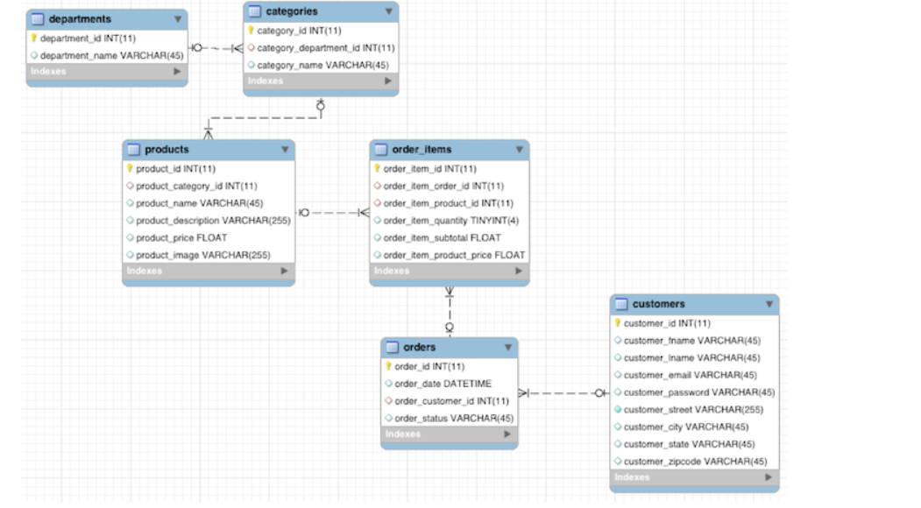

**RETAIL DB HIERARCHY**

**departments**

Department_id (pk)

Department_name

**categories**

category_id (pk)

category_department_id (fk)

category_name

**products**

product_id (pk)

product_category_id (fk)

product_name

product_description

product_price

product_image

**order_items**

order_item_id (pk)

order_item_order_id (fk)

order_item_product_id (fk)

order_item_quantity

order_item_subtotal

order_item_product_price

**orders**

order_id (pk)

order_date

order_customer_id (fk)

order_status

**customers**

customer_id (pk)

customer_fnam

customer_lname

customer_email

customer_password

customer_street

customer_city

customer_state

customer_zipcode