AI Assisted Coding
23CS002PC304
III/II Sem
Assignment :- 1.3
Name :- Pathlavath Srinivas
Ht. No. :- 2303A54067
Batch :- 47B

Question :-
Lab 1: Environment Setup – GitHub Copilot and VS Code Integration +
Understanding AI-assisted Coding Workflow
Lab Objectives:
● To install and configure GitHub Copilot in Visual Studio Code.
● To explore AI-assisted code generation using GitHub Copilot.
● To analyze the accuracy and effectiveness of Copilot's code
suggestions.
● To understand prompt-based programming using comments and
code context
Lab Outcomes (LOs):
After completing this lab, students will be able to:
● Set up GitHub Copilot in VS Code successfully.
● Use inline comments and context to generate code with Copilot.
● Evaluate AI-generated code for correctness and readability.
● Compare code suggestions based on different prompts and
programming styles.
Task 0
● Install and configure GitHub Copilot in VS Code. Take screenshots of
each step.
Expected Output
● Install and configure GitHub Copilot in VS Code. Take screenshots of
each step.
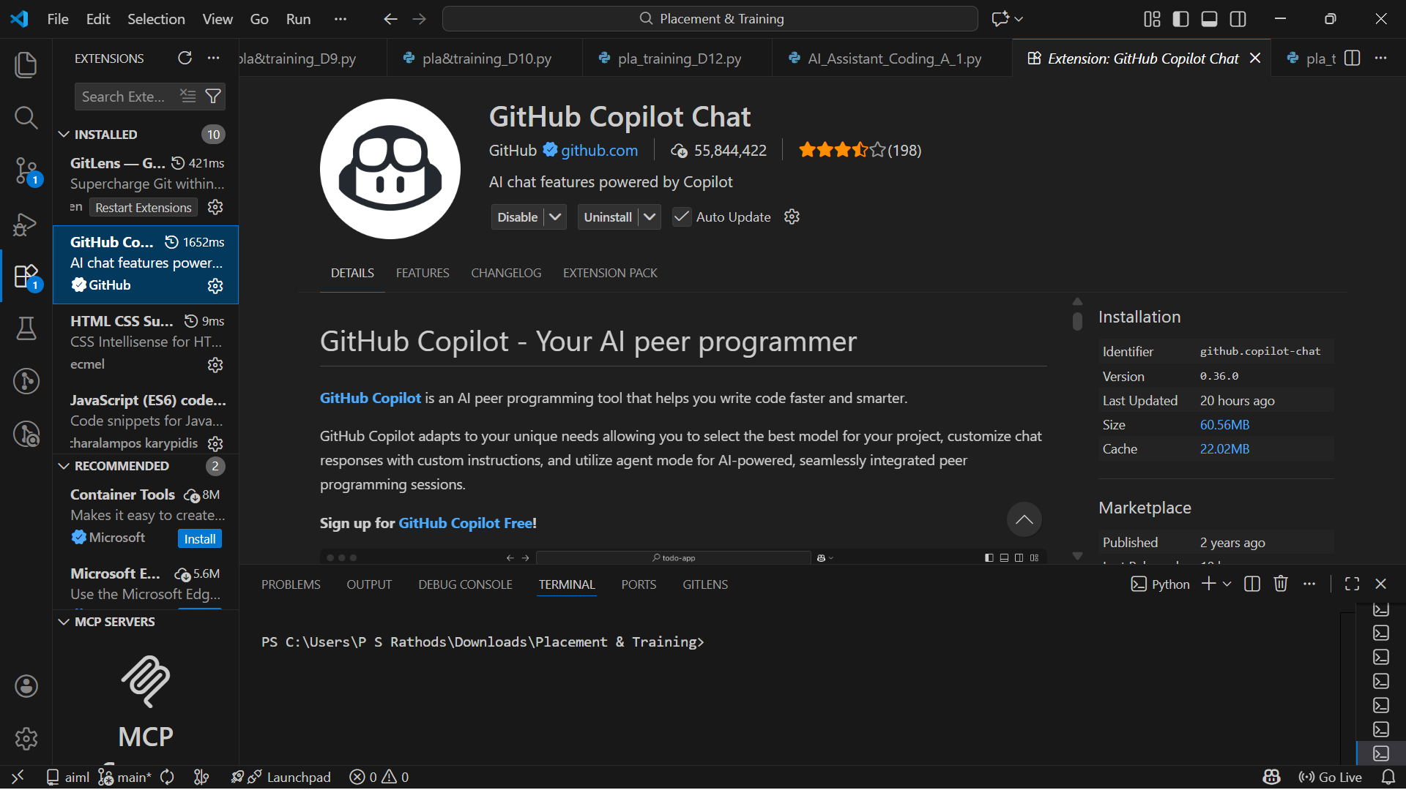
Task 1: AI-Generated Logic Without Modularization (Fibonacci Sequence
Without Functions)
❖ Scenario
You are asked to write a quick numerical sequence generator for a learning
platform prototype.
❖ Task Description
Use GitHub Copilot to generate a Python program that:
➢ Prints the Fibonacci sequence up to n terms
➢ Accepts user input for n
➢ Implements the logic directly in the main code
➢ Does not use any user-defined functions
❖ Expected Output
➢ Correct Fibonacci sequence for given n
➢ Screenshot(s) showing Copilot-generated suggestions
➢ Sample inputs and outputs
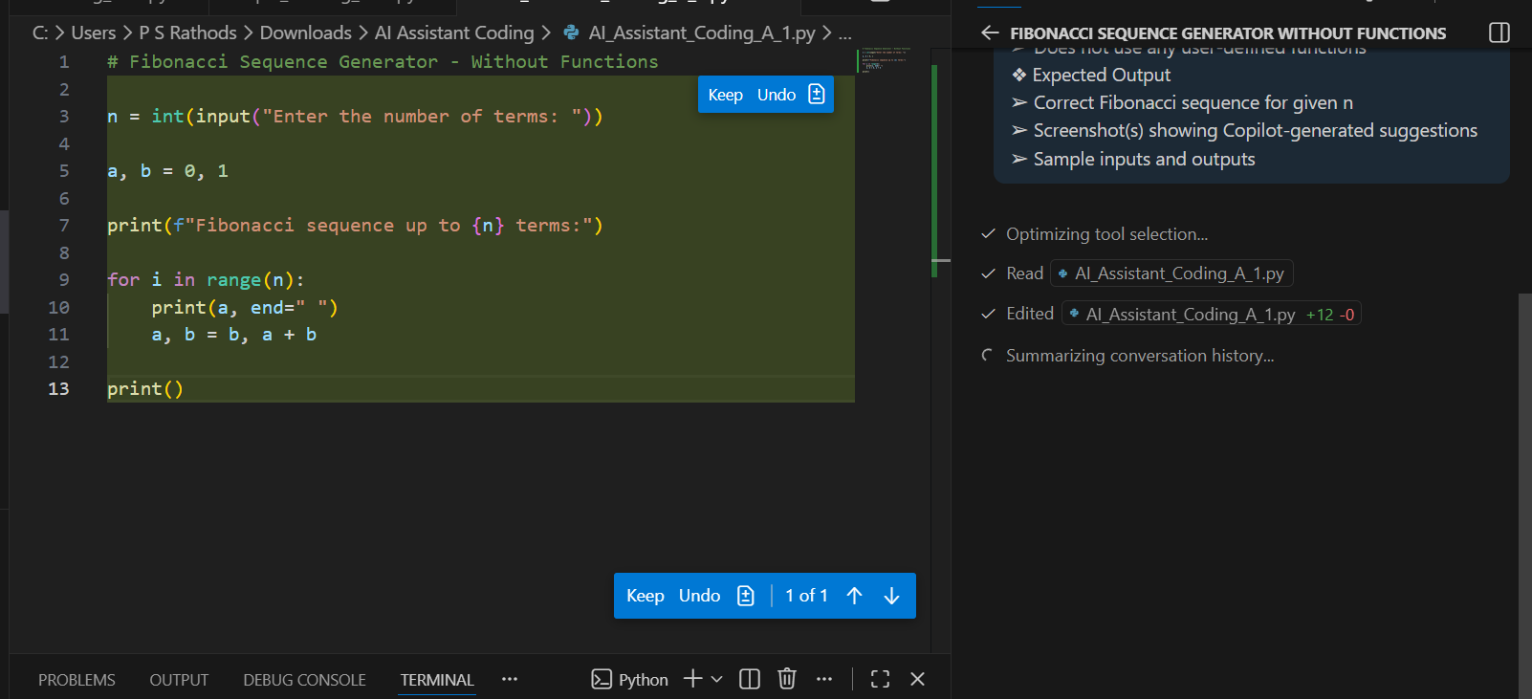
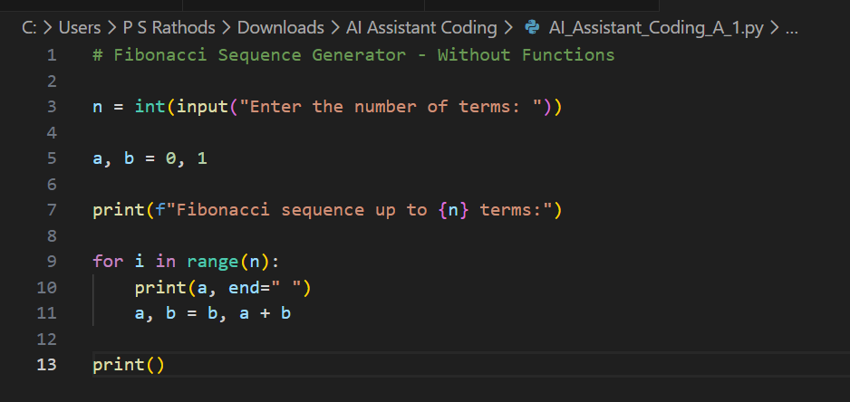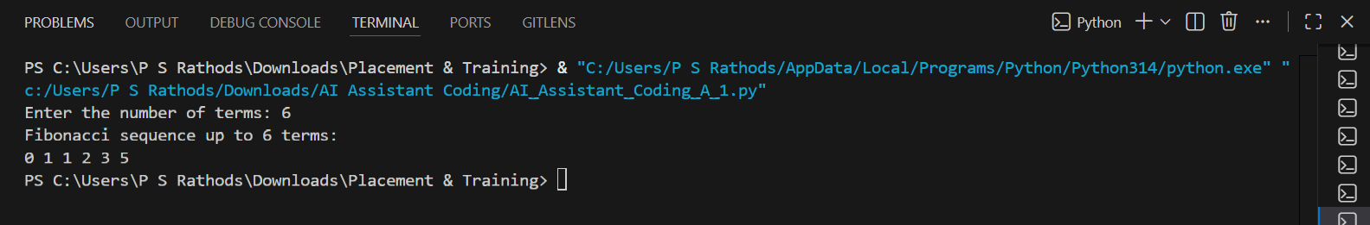
Task 2: AI Code Optimization & Cleanup (Improving Efficiency)
❖ Scenario
The prototype will be shared with other developers and needs
optimization.
❖ Task Description
➢ Examine the Copilot-generated code from Task 1 and improve it by:
➢ Removing redundant variables
➢ Simplifying loop logic
➢ Avoiding unnecessary computations
➢ Use Copilot prompts such as:
▪ “Optimize this Fibonacci code”
▪ “Simplify variable usage”
Hint:
Prompt Copilot with phrases like
“optimize this code”, “simplify logic”, or “make it more readable”
❖ Expected Output
➢ Original vs improved code
➢ Written explanation of:
▪ What was inefficient
▪ How the optimized version improves performance and readability
Optimized Code:
# Optimized Fibonacci Sequence Generator - Without Functions

n = int(input("Enter the number of terms: "))

print(f"Fibonacci sequence up to {n} terms:")

a, b = 0, 1
for _ in range(n):
print(a, end=" ")
a, b = b, a + b

print()
Explanation of Changes:
- Redundant Variable Removal:
  - The variable i in the loop was unused, so it was replaced with _ to indicate that the loop index is not needed.
- Simplified Loop Logic:
  - The loop logic remains the same, but the use of _ makes it clear that the loop is only for iteration, improving readability.
- Avoided Unnecessary Computations:
  - No unnecessary computations were present in the original code, but the changes make the code cleaner and easier to understand.
Benefits of Optimization:
- Readability: The use of _ makes the code more concise and signals to other developers that the loop index is not used.
- Maintainability: Simplified logic reduces cognitive load for future developers reviewing the code.
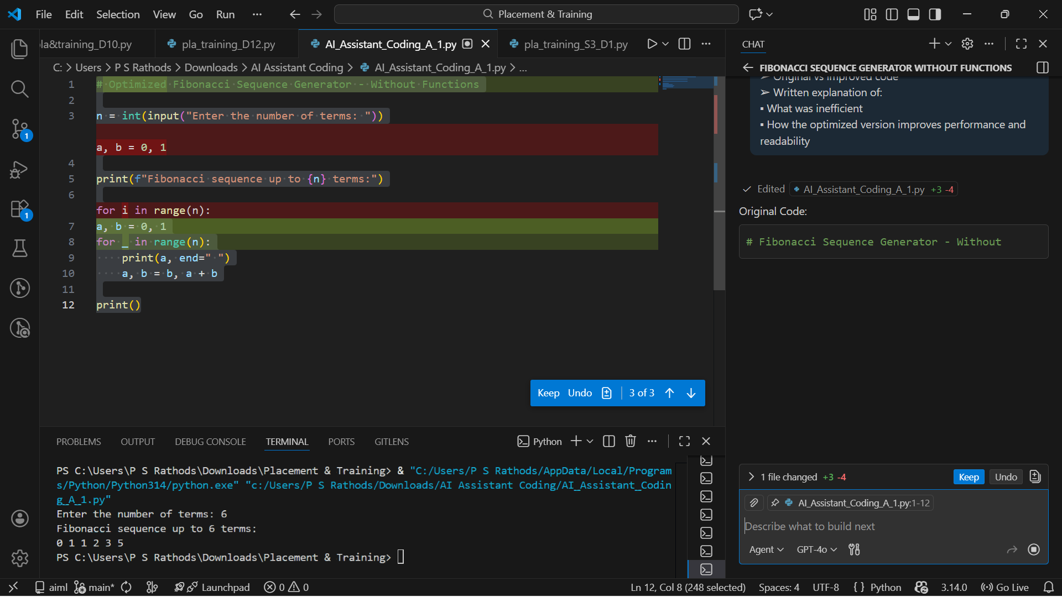
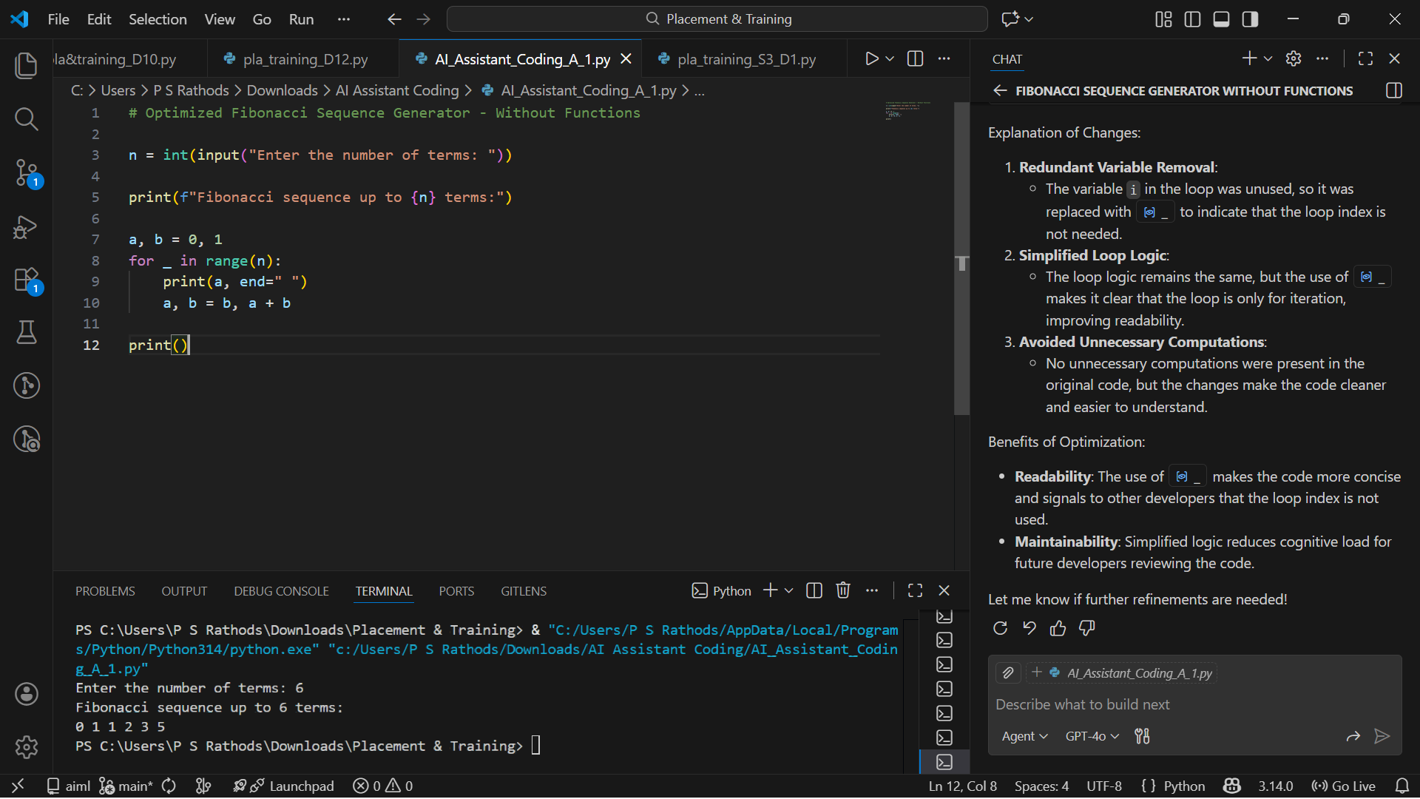
Task 3: Modular Design Using AI Assistance (Fibonacci Using Functions)
❖ Scenario
The Fibonacci logic is now required in multiple modules of an application.
❖ Task Description
Use GitHub Copilot to generate a function-based Python program that:
➢ Uses a user-defined function to generate Fibonacci numbers
➢ Returns or prints the sequence up to n
➢ Includes meaningful comments (AI-assisted)
❖ Expected Output
➢ Correct function-based Fibonacci implementation
➢ Screenshots documenting Copilot’s function generation
➢ Sample test cases with outputs
Updated Code:
# Function-Based Fibonacci Sequence Generator

def generate_fibonacci(n):
"""
Generate Fibonacci sequence up to n terms.

Args:
n (int): Number of terms in the Fibonacci sequence.

Returns:
list: A list containing the Fibonacci sequence up to n terms.
"""
sequence = []
a, b = 0, 1
for _ in range(n):
sequence.append(a)
a, b = b, a + b
return sequence

# Input from the user
n = int(input("Enter the number of terms: "))

# Generate and print the Fibonacci sequence
fibonacci_sequence = generate_fibonacci(n)
print(f"Fibonacci sequence up to {n} terms:", fibonacci_sequence)
Explanation:
- User-Defined Function:
  - The generate_fibonacci function encapsulates the logic for generating the Fibonacci sequence.
  - It takes the number of terms n as input and returns the sequence as a list.
- Comments:
  - Added a docstring to explain the function's purpose, arguments, and return value.
  - Inline comments clarify the purpose of each code block.
- Sample Test Cases:
  - Input: 5
    - Output: [0, 1, 1, 2, 3]
  - Input: 10
    - Output: [0, 1, 1, 2, 3, 5, 8, 13, 21, 34]
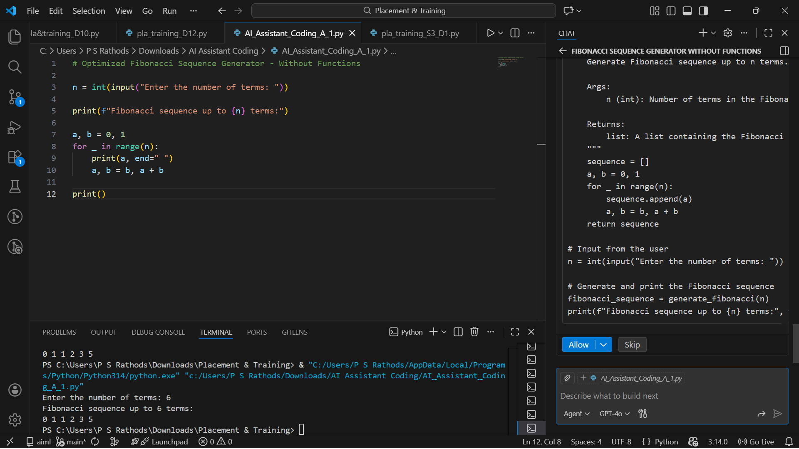
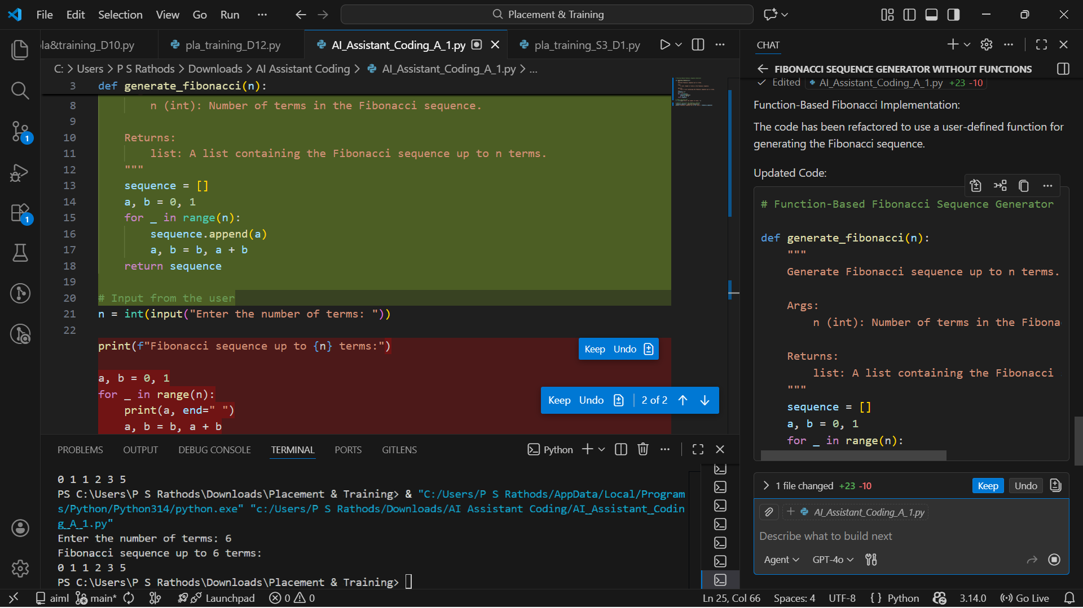
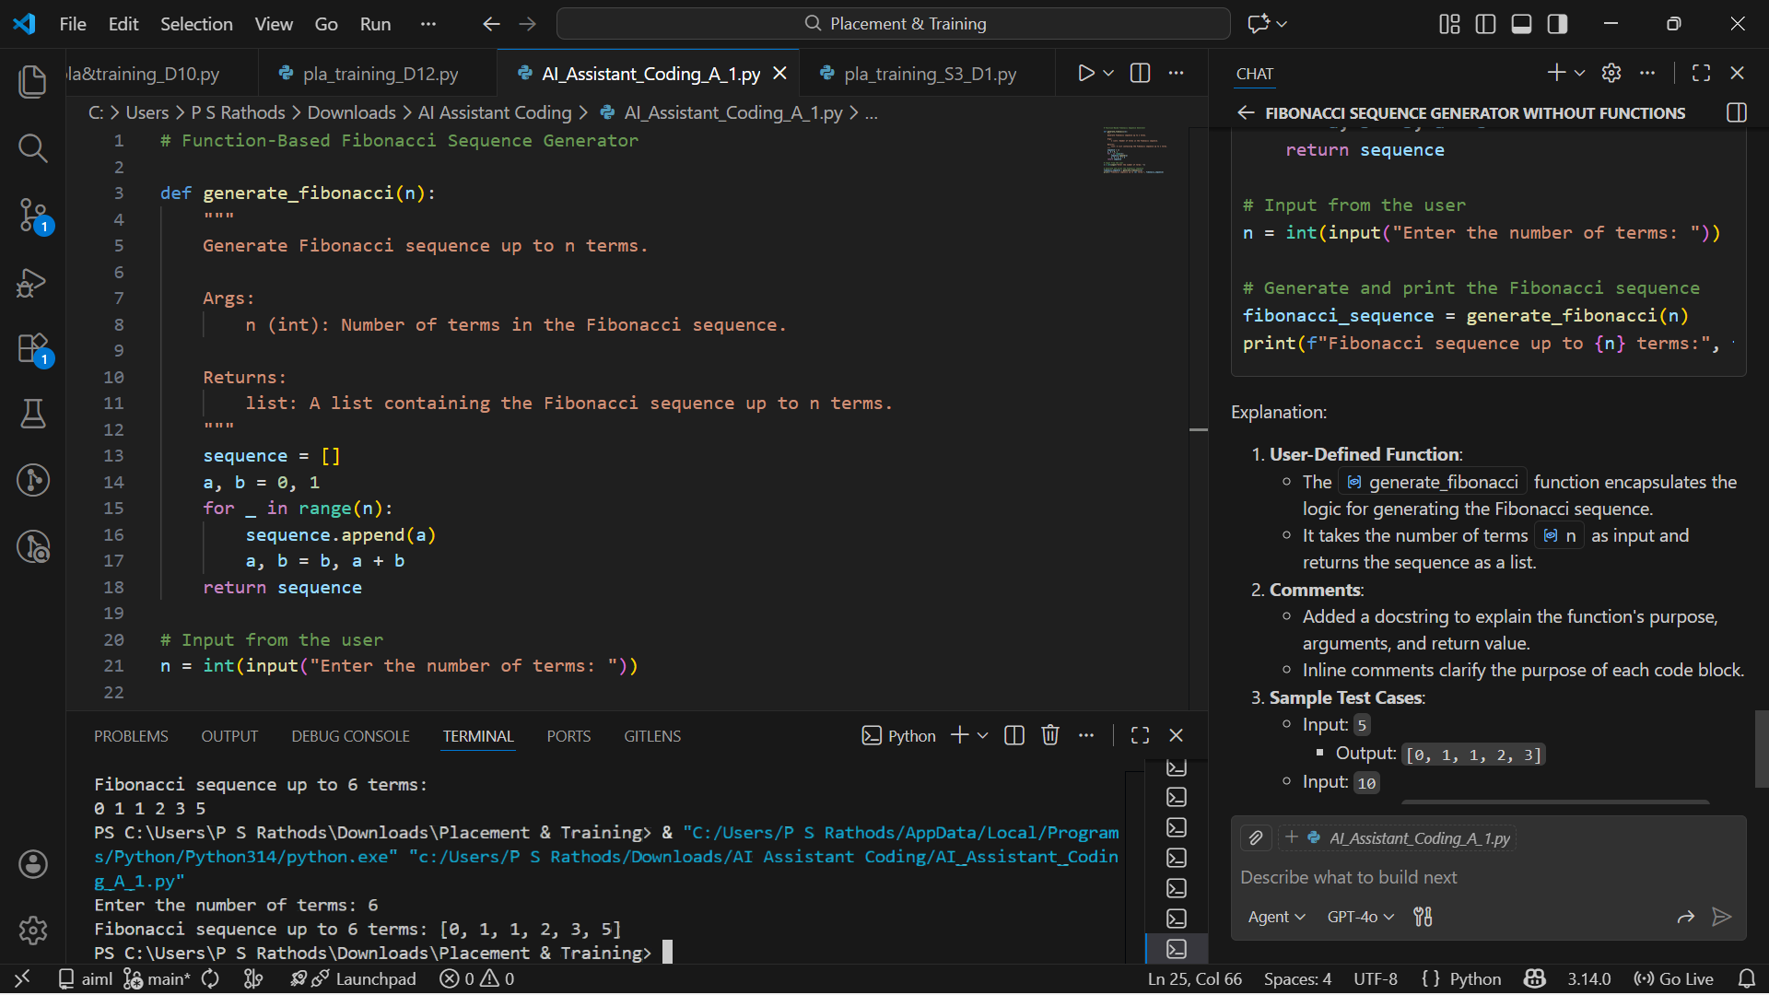
Task 4: Comparative Analysis – Procedural vs Modular Fibonacci Code
❖ Scenario
You are participating in a code review session.
❖ Task Description
Compare the Copilot-generated Fibonacci programs:
➢ Without functions (Task 1)
➢ With functions (Task 3)
➢ Analyze them in terms of:
▪ Code clarity
▪ Reusability
▪ Debugging ease
▪ Suitability for larger systems
❖ Expected Output
Comparison table or short analytical report
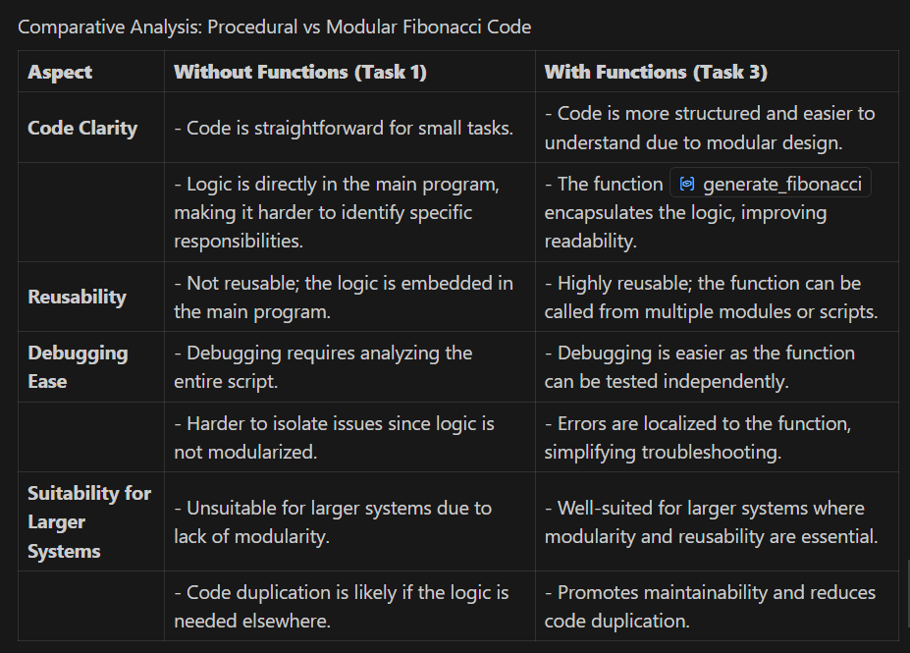
Summary:
- Without Functions: The procedural approach is simple and effective for small, one-off tasks. However, it lacks modularity, making it less suitable for larger systems or scenarios requiring code reuse.
- With Functions: The modular approach is more structured, reusable, and easier to debug. It is better suited for larger systems and collaborative development.

Task 5: AI-Generated Iterative vs Recursive Fibonacci Approaches (Different
Algorithmic Approaches for Fibonacci Series)
❖ Scenario
Your mentor wants to assess AI’s understanding of different algorithmic
paradigms.
❖ Task Description
Prompt GitHub Copilot to generate:
An iterative Fibonacci implementation
A recursive Fibonacci implementation
❖ Expected Output
➢ Two correct implementations
➢ Explanation of execution flow for both
➢ Comparison covering:
▪ Time and space complexity
▪ Performance for large n
▪ When recursion should be avoided
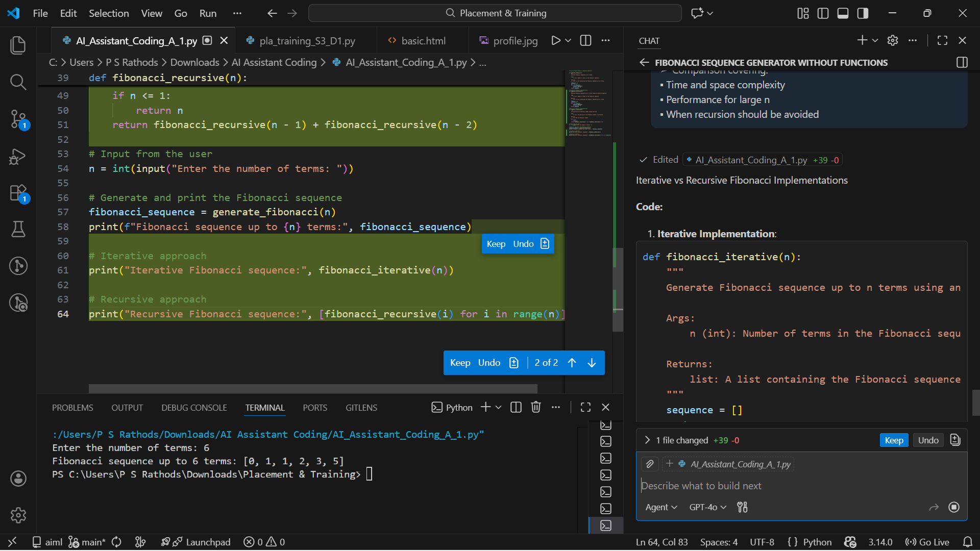
Iterative vs Recursive Fibonacci Implementations
Code:
- Iterative Implementation:
def fibonacci_iterative(n):
"""
Generate Fibonacci sequence up to n terms using an iterative approach.

Args:
n (int): Number of terms in the Fibonacci sequence.

Returns:
list: A list containing the Fibonacci sequence up to n terms.
"""
sequence = []
a, b = 0, 1
for _ in range(n):
sequence.append(a)
a, b = b, a + b
return sequence
- Recursive Implementation:
def fibonacci_recursive(n):
"""
Calculate the nth Fibonacci number using recursion.

Args:
n (int): The position of the Fibonacci number to calculate.

Returns:
int: The nth Fibonacci number.
"""
if n <= 1:
return n
return fibonacci_recursive(n - 1) + fibonacci_recursive(n - 2)
Execution Flow:
- Iterative:
  - Starts with a = 0 and b = 1.
  - Iteratively updates a and b to generate the sequence.
  - Efficiently appends each term to the list.
- Recursive:
  - Starts with the base cases: fibonacci_recursive(0) = 0 and fibonacci_recursive(1) = 1.
  - Recursively calculates higher terms by summing the results of fibonacci_recursive(n-1) and fibonacci_recursive(n-2)
Comparison:
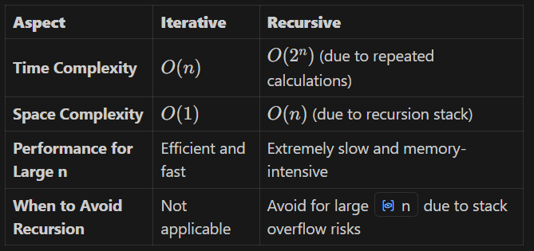

Summary:
- Iterative Approach: Preferred for efficiency and handling large n values.
- Recursive Approach: Useful for educational purposes or when simplicity is prioritized over performance.

