TASK 1. On logon

          SUB-TASK 1.      User with AUDITOR role should always navigate to audit page first and can navigate to dashboard page from the top menu.

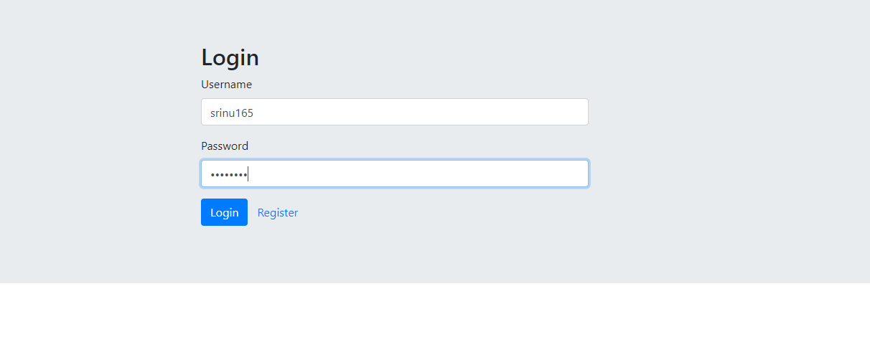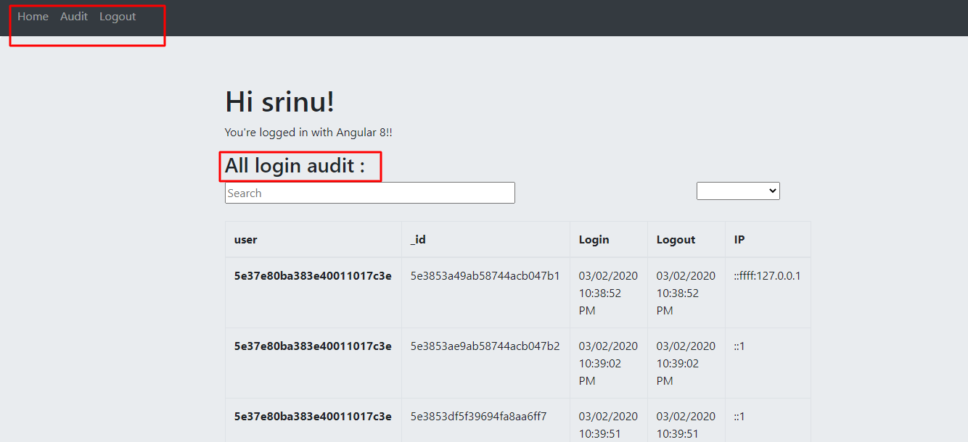

   TASK 2. Within the “Audit” pages

          SUB-TASK 1.       Data is displayed as a list - Implement a table with pagination – use a Data Table to display the data along with pagination, sorting and filtering/search

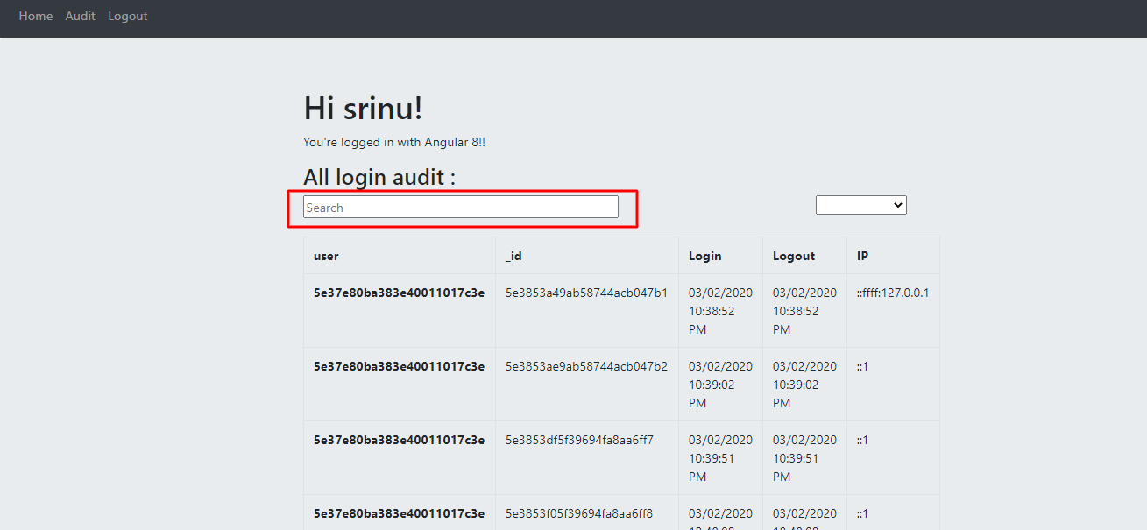

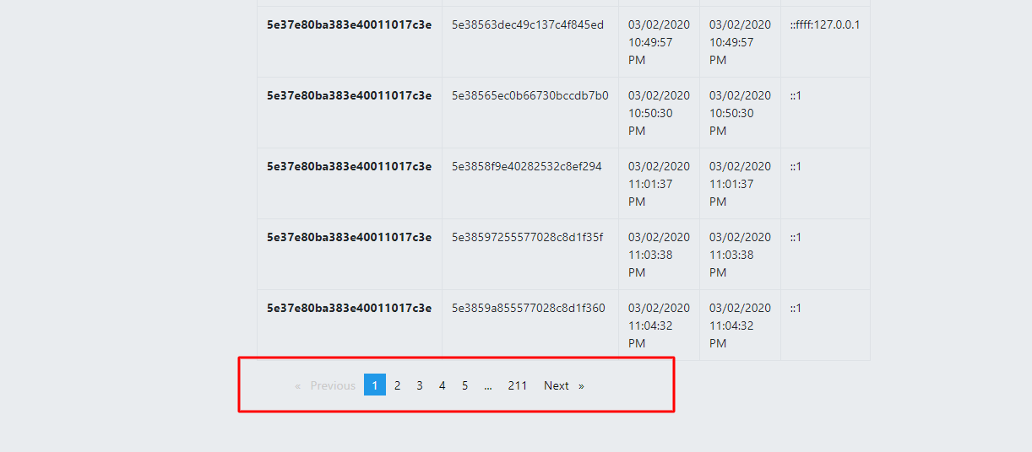

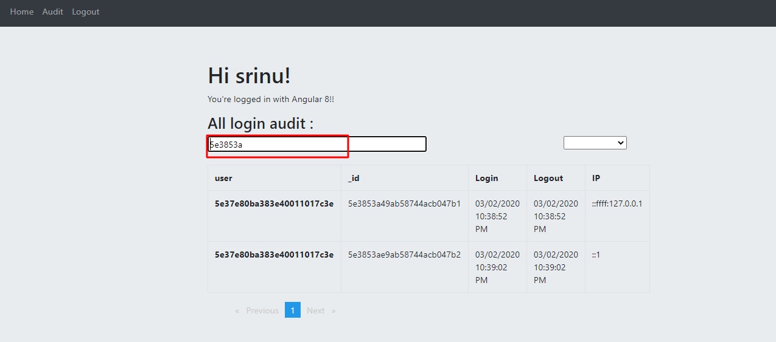

 SUB-TASK 2.       Format date as DD/MM/YYYY hh;mm:ss, add a dropdown above the table to change the date/time format from 12hr to 24hr

