JOINs

A JOIN clause is used to combine rows from two or more tables, based on a related column between them.

Different Types of SQL JOINs

* (INNER) JOIN: Returns records that have matching values in both tables
* LEFT (OUTER) JOIN: Returns all records from the left table, and the matched records from the right table
* RIGHT (OUTER) JOIN: Returns all records from the right table, and the matched records from the left table
* FULL (OUTER) JOIN: Returns all records when there is a match in either left or right table
* CROSS JOIN: Matches every row of the first table with every row of the second table.
  + Note: A cross join can also be accomplished with the following syntax: SELECT * FROM table_a, table_b;

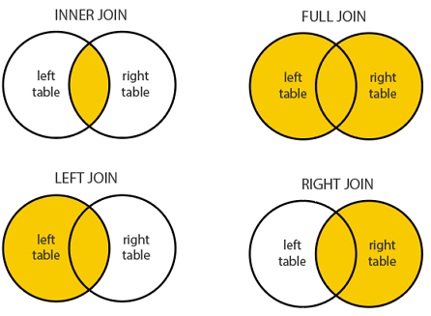

Example:

The following joins examples will use the table that we built in the [Sublanguages Examples](https://gitlab.com/revature_training/postgres-team/-/blob/master/postgres-sql-standard-examples/phase-1/sublanguages-constraints-examples.md)

1. Count users with the greatest number of posts:

SELECT users.id, first_name, last_name, count(*) AS count_num FROM users

LEFT JOIN posts ON posts.author_id = users.id

GROUP BY users.id

ORDER BY count_num DESC;

1. Select the most liked posts I want the top 10 most liked posts ordered from most liked to least liked:

*--In our case, a right join is effectively an inner join*

SELECT COUNT(*) FROM users

RIGHT JOIN posts ON users.id = posts.author_id;

1. Create a view from a query:

CREATE VIEW most_posts AS SELECT users.id, first_name, last_name, COUNT(*) AS count_num FROM users

LEFT JOIN posts ON posts.author_id = users.id

GROUP BY users.id

ORDER BY count_num DESC;

SELECT * FROM most_posts WHERE id > 500;

Task:

* Create the model for your banking application.
* Create a ERD to represent your model. ERD -> Entity Reliational Diagram
* Define all PKs, FKs, define multiplicity between tables/entities.
* Define all constraints necessary to weed out invalid data and mantain referential integrity.
* Define common ways data might be joined and define views to access those.

References:

* [PSQL JOINs](https://www.tutorialspoint.com/postgresql/postgresql_using_joins.htm#:~:text=Advertisements,The%20CROSS%20JOIN)