Normalization

Normalization is a database design technique that reduces data redundancy and eliminates undesirable characteristics like Insertion, Update and Deletion Anomalies.

* Normalization divides larger tables into smaller tables and links them using relationships.
* The purpose of Normalization is to eliminate redundant data and ensure data is stored logically.

All Normal Forms & Their Rules

Associates only need to know up to 3NF.

* **1NF (First Normal Form)**:
  + Each table cell should contain a single value.
  + Each record needs to be unique.

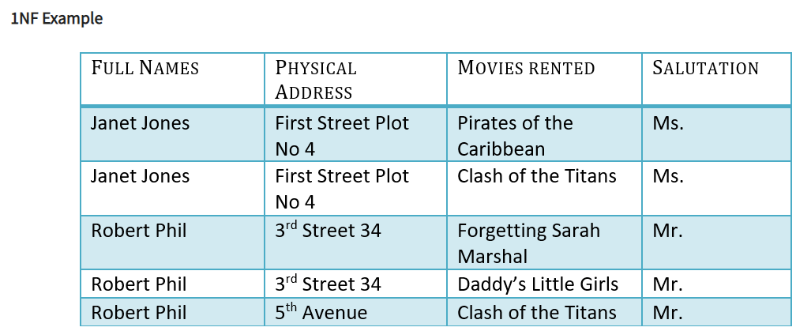

* **2NF (Second Normal Form)**:
  + Be in 1NF.
  + Single column primary key. (No partial dependencies)

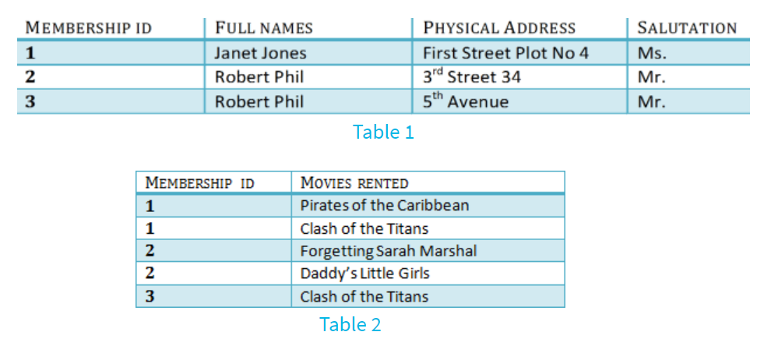

In order to achieve 2NF from the first table, we have divided it into two tables. Table 1 contains member information. Table 2 contains information on movies rented. In order to put this table into 2NF, we have created a new column called Membership_ID which is the **primary key** for Table 1. Records can be uniquely identified in Table 1 using Membership_ID.

In Table 2, Membership_ID is the **foreign key**.

* **3NF (Third Normal Form) Rules**
  + Be in 2NF.
  + Has no transitive dependencies.

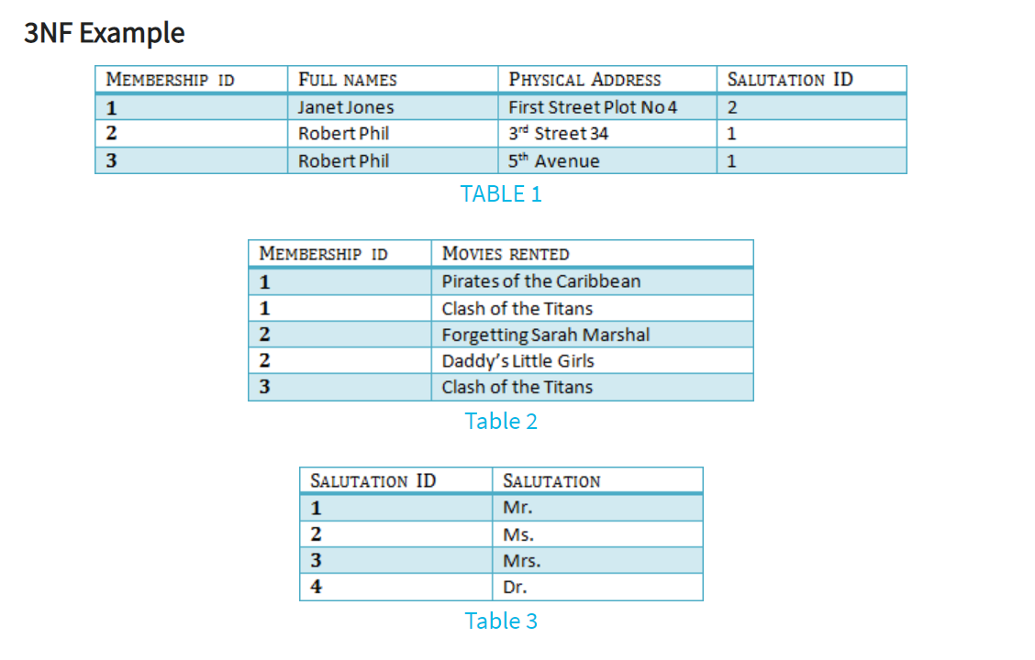

We have again divided our tables and created a new table which stores Salutations. There are no transitive functional dependencies, and hence our table is in 3NF. In Table 3 Salutation_ID is **primary key**, and in Table 1 Salutation ID is **foreign to primary key** in Table 3.

Normalization Demo in DBeaver:

1. First we will create a customers table that is NOT in 1NF because the name attribute is not atomic in nature. The Name could be broken into first name, last name - or first name, middle name, last name, etc. Run the following:

CREATE TABLE IF NOT EXISTS customers (

id SERIAL PRIMARY KEY,

name VARCHAR(40), *-- Could fix by breaking this column into several atomic columns (i.e, first, last)*

phone VARCHAR(10),

phone_type VARCHAR(20) *-- <-- Violates 3rd normal form, describes phones, not customers. makes no sense with no phone column*

);

*-- Then populate some rows*

INSERT INTO customers (name, phone) VALUES

('Abby Adams', '5554443333'),

('Billy Bob', '1112223333'),

('Cathy McCarthy', '2224446666');

1. We will now create a set of tables in 2NF and 3NF. Ask associates why some columns violate the NF rules:

CREATE TABLE IF NOT EXISTS store (

id SERIAL PRIMARY KEY,

name VARCHAR(15)

);

INSERT INTO store (name) VALUES ('Big Store'), ('Little Store'), ('Medium Store'), ('Jumbo Store');

CREATE TABLE IF NOT EXISTS purchases (

customer_id INTEGER REFERENCES customers(id),

store_id INTEGER REFERENCES store(id),

customer_email VARCHAR(40) UNIQUE, *-- <-- This column violates 2NF, customer_email is not about both parts of the key*

PRIMARY KEY(customer_id, store_id)

);

CREATE TABLE IF NOT EXISTS order_detail (

id SERIAL PRIMARY KEY,

purchase_id INTEGER,

price INTEGER,

quantity INTEGER,

total INTEGER *-- <-- Our problem. Total is functionally dependant upon price and quantity and violates 3NF*

*-- Total would need to be divided further in order*

);