# Introduction

Though generally at par with other countries in medical technology, the Philippines still lacks dissemination of quality healthcare services. About 30-40% of Filipinos are still dying without even seeing a healthcare provider [1]. Most of these are people from the rural areas who have very limited or no access to quality healthcare services. In an effort to provide solutions for this problem, the National Telehealth Service Program (NTSP) has teamed up with the Electrical and Electronics Engineering Institute (EEEI) to produce a telemedicine appliance for remote consultation and diagnostics named RxBox [2].

The RxBox is a Linux-based telemedicine device developed in the Instrumentations and Robotics Control Laboratory as a component of the NTSP. The system is capable of biomedical data acquisition through interfacing with medical-grade OEM modules. The RxBox processes readings from the said modules and implements it in a Graphical User Interface designed to address the user’s needs [3].

DxKit aims to develop a compact and portable telemedicine appliance. The group aims to address the issues on size and mobility of the RxBox. Medical modules present in the RxBox will be integrated to an Android pad/tablet via an Arduino based accessory development kit (ADK). A fetal heart monitoring module and a glucometer will also be interfaced addressing the needs of the rural health centers as suggested by the doctors and health workers.

# Review of Related Work

## Portable Medical Devices

### RxBox

In one of its initial stages, Broma and Santos [4] developed a LifeLink portable telehealth device that acquires patient health data using medical-grade modules. The system was capable of data acquisition, data presentation, and EDF file generation. However the modules were not benchmarked against the commercially used medical devices. The system did not have a standard 12-lead ECG implementation and filters were still needed to provide more accurate ECG waveforms.

Chiong and Cornillez [5] upgraded the software by making the application programming interface (API) of some biomedical modules and the RxBox GUI conformant to the Model-View-Controller system architecture. The MVC system architecture enables flexibility of the software for future modifications. API of the OEM biomedical modules was also improved by adding new methods of error checking. The system also integrated a 12-lead API and the Snapshot API was improved to produce image files that are DICOM (Digital Imaging and Communications in Medicine) standard compliant. However the system was not yet able to implement video conferencing and instant messaging functionalities. Furthermore testing of the data acquisition display was done on the Windows operating system even though the device is developed in the Linux operating system.

Ebido and Soler [6] implemented the VoIP (Voice over Internet Protocol) capability and configuration parser which are some of the core functionalities of the RxBox. A local database that stores patient information and biomedical signals was also integrated. An improved user interface was also implemented by porting the entire Graphical User Interface (GUI) to Linux. The system has now fully implemented the Model-View-Controller. One of the most important developments in this project was the creation of simulators that mimic the actual operation of a live RxBOx. This would enable for faster developments. However they were not able to port the medical-OEM module API’s to Linux. A lot of improvements were needed in the packaging and the self-test device was yet integrated to the RxBox making it hard for the end users to gage the status of the device.

The final phase of the RxBox development made a lot of improvements from the previous models. Bangoy and Sy[3] were able to fully port the biomedical module APIs to Linux and migrate to an X50 shuttle computer allowing a more portable and robust packaging. The system was also restructured allowing for code optimization, performance upgrade and an increase in the quality of service.

The integration of a Finite State Machine (FSM) architecture was a crucial factor in the improvement of performance. FSM makes the system simple and organized enabling better stability and faster development. This made the development of APIs and integration of additional modules easier for future developers even without prior knowledge to the system. The system adapted the MVC architecture allowing modularity and isolation of error for debugging purposes. Pipe and filter architecture also allowed easier integration of third party applications like the VoIP, IM and C-based plotter. Figure 1 shows the overview of the optimized system.

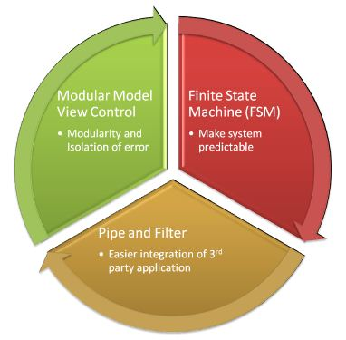

**Figure 1** System Architecure Overview

Aside from the upgrade in performance software, benchmarking and calibration of the medical modules were done to make the system more reliable. Filters were integrated for the ECG module making the waveforms more accurate and reliable for diagnosis. The BP modules were also benchmarked against a mercurial sphygmomanometer and calibrated for reliability. Though not as accurate as the commercially available modules, both modules passed the standards set by doctors from PGH.

The past developments paved the way for the RxBox to be a fully functional and reliable equipment for telemedicine. However a key design parameter in developing a telemedicine device is its size and mobility [7]. Considering the weight and size of the current RxBox, reduction is a key factor in achieving an optimum design. Aside from this, the system still lacked a number of essential modules needed by the doctors in remote areas. These include a fetal heart monitor, a glucometer and a thermometer.

### Portable embedded medical box for health monitoring applications in avionic environments

The portable embedded medical box is a health monitoring device used in large capacity aircraft environments [8]. The system uses a two-layered (Master-Slave) microcontroller architecture which is configured to process the sensor output frame and embed relevant information. Five medical instruments were also integrated into the system, namely ECG, pulse rate, blood pressure, oximetry and body temperature. A graphic display projects the passenger health state and trigger alarms when necessary. The key feature of this system is its use of microcontrollers which enables a minimal size and portable medical box instead of using a computer. However, the system architecture is designed for I2C communication and requires at least two microcontrollers whereas the current development on microcontrollers can further simplify this system.

### Bluetooth and Mobile Phone network Telemedicine Design

This telemedicine system design is based on wireless communication technologies [9].Figure 2 shows an overview of the design. In this design, the patient wears portable medical devices that measures the patient’s ECG, temperature, pulse and blood pressure. These devices are integrated into an embedded system where data is then stored, managed and sent to the Smartphone via Bluetooth. The Smartphone terminal then connects to the medical center using the mobile phone network to transmit the patient’s information and provide telemedicine services. This system is much similar to the RxBox [3] though the system is a smaller implementation of the latter device. Still, there are issues regarding the use of Smartphones in telemedicine, primarily the user interface. The size of display in Smartphones is not optimal and reliable for diagnosis in some medical cases such as cardiovascular diseases. This would require an optimal ECG waveform display in terms size and clarity

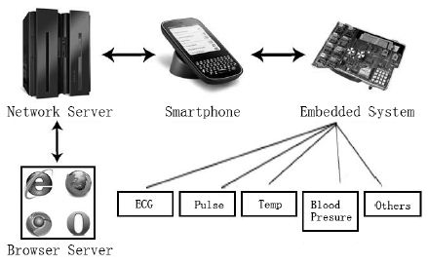

**Figure 2** Components of the Smartphone Telemedicine System

### Tempus IC Telemedicine Device

The Tempus IC [10] is a commercially available remote medical diagnostic system manufactured by Remote Diagnostic Technologies Limited (RDT). Tempus IC delivers clinical grade medical data for physicians to diagnose, treat and monitor patients virtually. The system is a compact and portable telemedicine device that houses medical modules such as 12-lead ECG, glucometer, end tidal CO2, tympanic temperature, blood pressure, and pulse oximetry. These medical modules are Bluetooth connected and placed in a separate compartment.

Tempus IC is also capable of real time video, voice and data. The data is sent wirelessly via a variety of communication devices such as integral GSM phone, integral WiFi, satellite phone systems and Ethernet**.** Figure 3 shows the Tempus IC device.

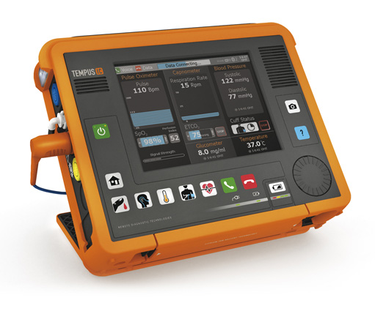

**Figure 3** Tempus IC Telemedicine Device

However the system is only designed for medical emergency purposes and does not hold a database for patient records which are needed in medical services for rural areas in the Philippines. The device itself is also very expensive.

## Current Technologies for Telemedicine

### Smartphones

Current portable medical devices lean towards the use of smartphones. Yang, Chu and Tsaur [10]created an application under the Android platform that makes use of Google Maps for Medical Information Service. Postolache et.al. [11] interfaced an HTC Desire, under Android 2.2 platform, with a smart wrist-worn device that contains an optical sensor architecture for Photoplethysmography (PPG) signals and 3D Micro Electro-Mechanical Systems (MEMS) accelerometer for motor activity. Oresko et.al. [12] ported Alive Technology’s Heart Monitor to an Amoi E72 Microsoft Windows Mobile 5 Smartphone. The phone performed feature extraction and classification by machine-learning. The work of Mitchell et.al. [13] gathers ECG and motion data and analyzes them to diagnose patients with case-specific alerts. DroidGlove [14] uses embedded sensors from an HTC G1 to engage the wrists in a gametherapy that is aimed for wrist rehabilitation.

### Microcontrollers

Microcontrollers are also being used for medical applications. The smart bracelet from the  Postolache et.al. [11]is connected to a PIC24F microcontroller. It performs the primary digital signal processing, data storage and communication to the smartphone. Chen et.al. [15]used an Arduino pro mini to handle signal acquisition from sensors distributed across a Neonatal Intensive Care Unit. Rhythm of Life Aid (ROLA) [16]employs the use of an Arduino mini as main computing unit.

## Additional Medical Modules

One of the latest recommendations in the development of RxBox is the addition of medical modules such as thermometer, glucometer and fetal heart rate monitoring [3]. The health workers we encountered in the recent deployment of RxBox at Sasmuan, Pampanga were also looking forward for the integration of these three modules to the device.

### Thermometer

Anastasopoulos et al., [8] used the commercially available EG00700 2-channel temperature module of Medlab GmbH for their medical box. They have chosen it for its acclaimed accuracy, ease of use and instant integration capability. Its low power feature makes it more suitable for areas with limited power environment.

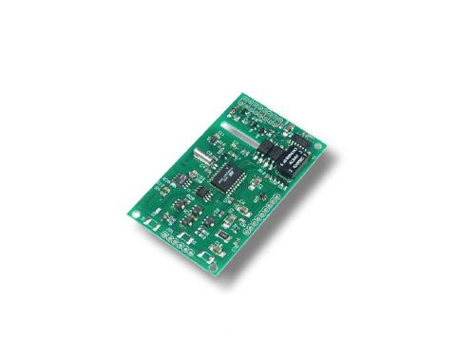

The EG00700 temperature module has an accuracy of ±0.1oC for an ambient temperature of 10oC to 40oC and a measurement range from 20oC to 44oC. It can be interfaced in serial RS232 and/or TTL. It has a galvanic isolation that ensures the patient safety. It is also compatible with all YSI 400 standard temperature probes [18].

### Glucometer

### Fetal Heart Monitoring System

Roham et al,.[19] proposed an end-to-end system consists of a wearable Doppler ultrasound and pressure sensing front-end equipped with short range radio, mobile cellular gateway for wide area communication, web server and browser based user interface for remote monitoring and diagnostics.

At the front-end of their system, they designed sensors resembling a standard fetal monitoring system. The Doppler ultrasound heartbeat detector consists of a set of two half disc 2MHz PZ-27 ultrasound ceramic transducers along with off-the-shell electronics to detect fetal heartbeat and to provide an audio feedback to help positioning of the device.









# Bibliography

x

|  |  |
| --- | --- |
| [1] | (2011, July) Ona calls for national and local government linkage towards universal health care. [Online]. <http://www.doh.gov.ph/node/3096.html> |
| [2] | The National Telehealth Initiative. [Online]. <http://code.google.com/p/telehealth/> |
| [3] | Mark Jan C. Bangoy and Luke Wicent F. Sy, "Rxbox 1.0 Beta: Live Data Telemetry, Restructuring, and FSM integration," University of the Philippines - Diliman, Quezon City, Undergraduate Student Project 2011. |
| [4] | J. Broma and A.R. Santos, "LifeLink: Development of a Portable Telehealth Device for Remote Monitoring of BioMedical Signals," University of the Philippines - Diliman, Quezon City, Undergraduate Student Project 2009. |
| [5] | C. Chiong and Cornillez D.S., "RxBox: Development of a Portable Medical Equipment for an Open Source Telemedicine System," University of the Philippines - Diliman, Quezon City, Undergraduate Student Project 2009. |
| [6] | T.J. Ebido and Soler T.R., "RxBox 0.3: Triage Interface, VoIP Integration and GUI-MVC Refactoring for the RxBox," University of the Philippines - Diliman, Quezon City, Undergraduate Student Project 2010. |
| [7] | Sonesh Surana, Rabin Patra, Melissa Ho, and Lakshminarayanan Subramanian, "Designing Healthcare Systems in the Developing World," May 2006. |
| [8] | Konstantinos Anastasopoulos et al., "Portable embedded medical box implementation for health monitoring applications in avionic environments," May 2009. |
| [9] | Jianming Liao and Can Wen, "Telemedicine System Design based on Bluetooth and Mobile," *IEEE*, pp. 183-186, 2010. |
| [10] | Chao-Tung Yang, Yen-yu Chu, and Shyh-Chang Tsaur, "Implementation of a Medical Information Service on Android Mobile Devices," *New Trends in Information Science and Service Science*, 2010. |
| [11] | Postolache O., Girao P.S., Ribeiro M., Santiago F., and Pena Antonio, "Enabling Telecare Assessment with Pervasive Sensing and Android OS Smartphone," *Medical Measurements and Applications Proceedings*, 2011. |
| [12] | Joseph J. Oresko et al., "A Wearable Smartphone-Based Platform for Real-Time Cardiovascular Disease Detection Via Electrocardiogram Processing," *Information Technology on Biomedicine*, vol. 14, no. 3, 2010. |
| [13] | Michael Mitchell, Frank Sposaro, An-I Andy Wang, and Tyson Gary, "BEAT: Bio-Environmental Android Tracking," *Radio and Wireless Symposium*, 2011. |
| [14] | Dario Deponti, Dario Maggiorini, and Claudio Palazzi, "DroidGlove: An Android-Based Application for Wrist Rehabilitation," *Ultra Modern Telecommunications and Workshops*, 2009. |
| [15] | Wei Chen, Son Tung Nguyen, Roland Coops, Sidarto Bambang Oetomo, and Loe Feijs, "Wireless Transmission Design for Health Monitoring at Neonatal Intensive Care Units," *Applied Sciences in Biomedical and Communication Technologies*, 2009. |
| [16] | Wei Chen et al., "Rhythm of Life Aid (ROLA): An Integrated Sensor System for Supporting Medical Staff During Cardiopulmonary Resuscitation (CPR) of Newborn Infants," *Information Technology in Biomedicine*, vol. 14, no. 6, 2010. |

x

Something Something