Name: - Prathamesh Ganeshrao Kulkarni

Email: - [prathamesh6252@gmail.com](mailto:prathamesh6252@gmail.com)

AWS Assignment Day 3

* 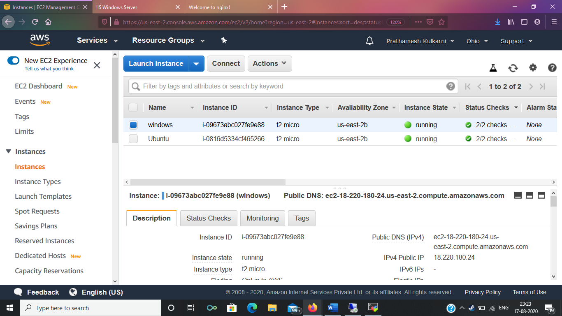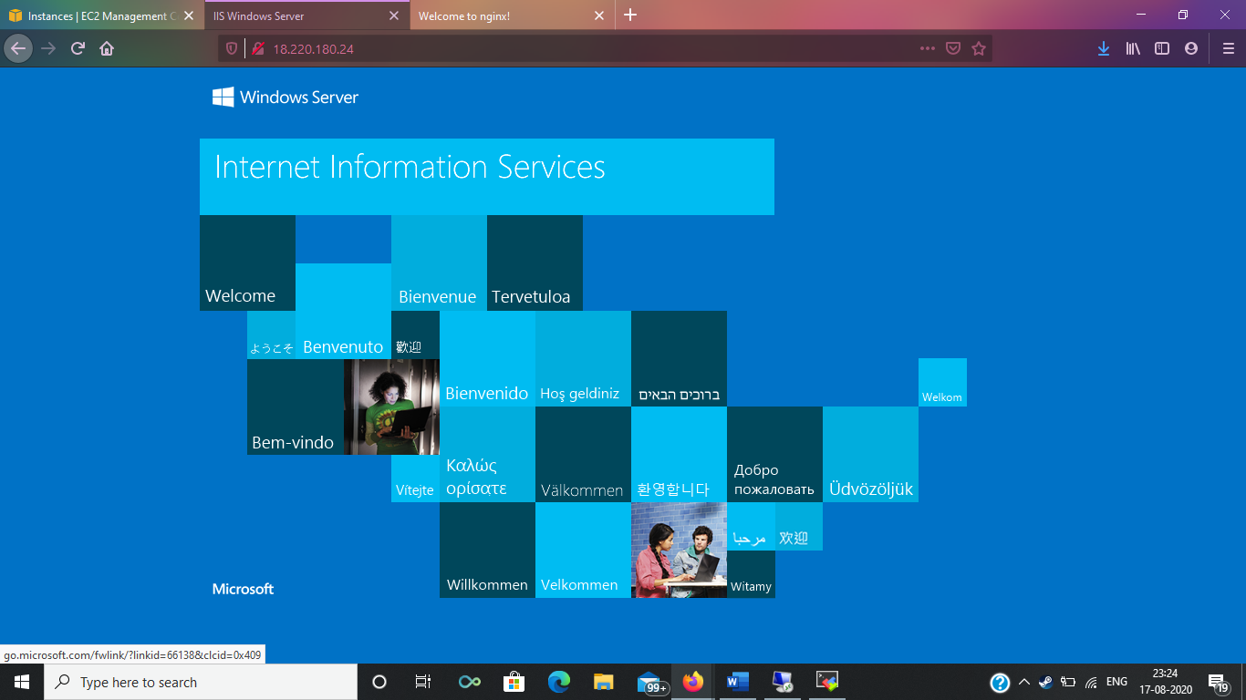Windows Machine: -
* 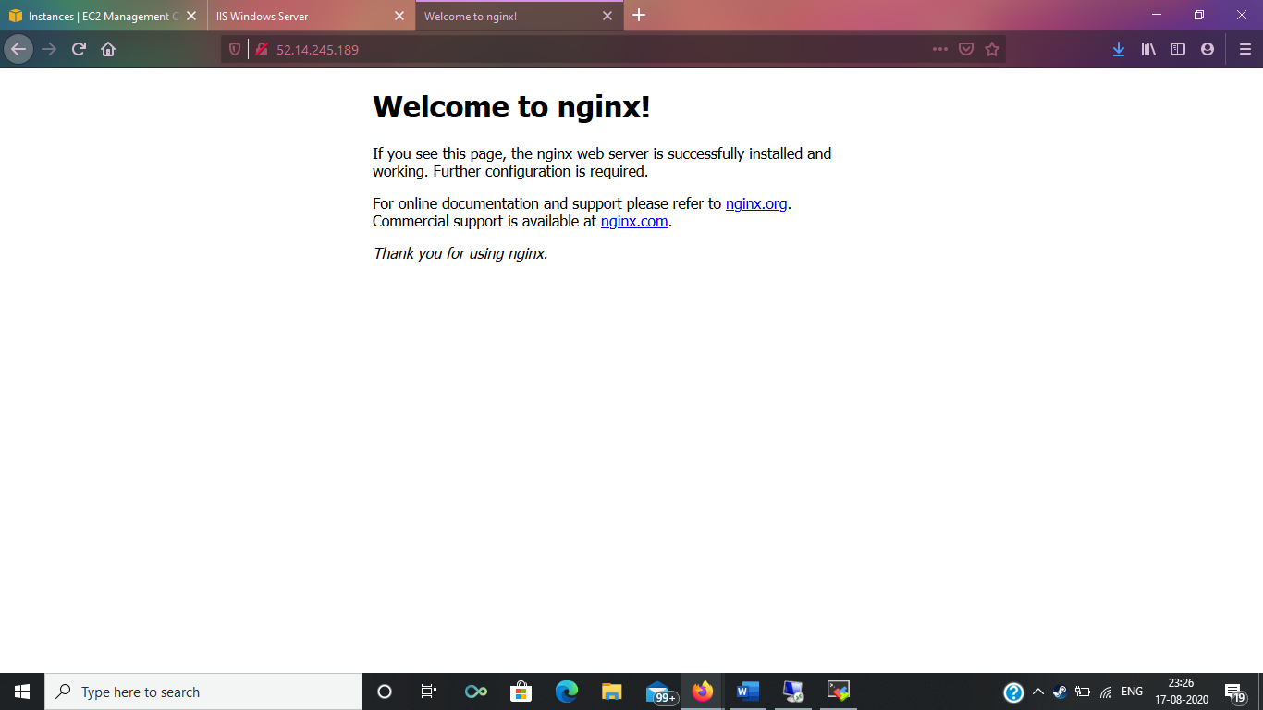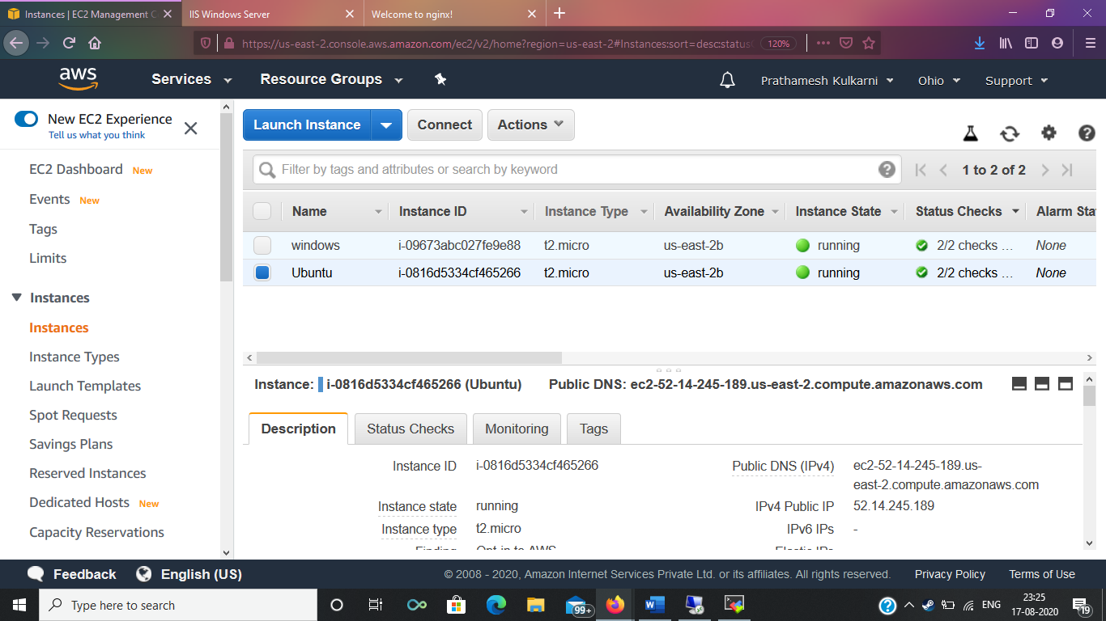Ubuntu Machine: -