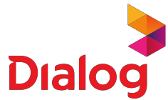

**Payment confirmation**

Transaction ID : 494726256

Here is a summary of your recent payment.

Payment information Payment details

Details of your payment from MyDialog App

# Date

2025-04-07 21:53:10

# Status

**Connection**

**Connection Reference**

**Amount (Rs.) Status**

Success

# Payment Method

eZcash

Mobile prepaid 764707053 1,500.00 Payment Success

**Total** 1,500.00